ÔN TẬP SPEAKING

**PART 1:**

**PLACES**

1. Where is your hometown?
2. What do you like best about your hometown?
3. How often do you visit your hometown?
4. What are some benefits of living in a big city?
5. What are some advantages of living in the countryside?

**FAMILY**

1. How many people are there in your family?
2. What do you like to do together with your family?
3. Do you get along well with your family members?
4. Do you look like anyone in your family?
5. How do you keep in touch with your family members?

**PLACES**

1. Do you prefer to live in a city or in the countryside?
2. Where do you live now?
3. What’s the biggest city you have ever visited?
4. What do you love about the place you live in now?
5. Is there anything you don’t like about the place you live now?

**FOOD**

1. What food can’t you live without?
2. What is your favorite food?
3. What are some traditional foods in your country?
4. Do you like tasting new food?
5. What time do you usually have dinner?

**FUTURE PLANS AND INTENTIONS**

1. What are you doing next weekend?
2. What are some of your future plans and intentions?
3. Are you going to take a trip next summer?
4. What are you doing to pass the final exam?
5. What arrangements do you have in the next few weeks?

**LIFE BALANCE**

1. How many hours do you study each week?
2. How often do you exercise?
3. Do you have enough time to do everything in one day? If not, how much extra time would you like in one week?
4. Do you usually look forward to the next day, or do you feel stressed about it?
5. Do you have a lot of time to spend with your family?

**FOOD:**

1. What do you like to eat for breakfast?
2. What are typical dishes in your country?
3. What foreign dishes are popular in your country now? Do you like them?
4. Do you eat a healthy diet? Why or why not?
5. Do you prefer to eat out or eat at home?
6. Do you like cooking? What kind of food can you cook?

**CLOTHES**

1. What is your favourite item of clothing?
2. Where do you often go shopping for clothes?
3. How do you feel about fast fashion?
4. Have you ever bought second-hand clothes? What did you buy?
5. Do you think that buying clothes is a waste of money?

**ROUTINES**

1. Do you have a routine you follow every day?
2. Do you enjoy having a routine or do you find it boring?
3. When do you go to school?
4. Which time do you like most in a day?
5. What time do you get up everyday?

**FAMILY**

1. What activities do you enjoy doing with your family?
2. Who are you closest to in your family?
3. How much time do you spend with your family?
4. Do you have a large family or a small family?
5. Do you live with your family?

**Living areas**

1. Where are you living now?
2. Do you like living in your neighbourhood? Why (not)
3. What do you like best about your neighbourhood?
4. Is there anything you don’t like about your neighbourhood?
5. Do you like living in the city or countryside? Why?

**Leisure activities**

1. How much free time do you have each week? Is it enough?
2. What is your favourite leisure activity? Why do you like it?
3. Do you enjoy reading books in your free time? Why (not)?
4. Do you enjoy doing sports in your free time? Why ( not)?
5. Who do you usually spend time with when you have free time?

**SUCCESS**

1. Is success important to you? Why(not)?
2. Who is the most successful person you know?
3. What can you do to be successful in your study?
4. What do you think are rules for success at job interviews?
5. What motivates you to succeed?

**IDENTITY**

1. ​​Can you list three words to describe your personality?
2. Do you think that you have the same or different identities when you are online and offline? And why do you think so?
3. What do you like most about yourself?
4. Where can you get inspiration for your character?
5. Are you an extrovert or an introvert?

**JOBS AND CAREERS**

1. What is your dream job?
2. What do you do to get your dream job?
3. Do you like to work indoors?
4. Would you like a job in which you traveled a lot?
5. Do you like working on weekends?

**HEALTH AND HAPPINESS**

1.     What do you do when you want to relax?

2.     How do you stay calm in a stressful situation?

3.     What do you think of the advantages and disadvantages of doing not thing?

4.     What should you do to become healthier?

5.     What do you do to make yourself feel more positive?

**Let’s talk about money**

1. Are you a saver or a spender?
2. What do you love spending money on?
3. Do you donate money to any charities?
4. Have you ever regretted spending money on something?
5. Does money bring happiness? Why (not)?

**Let’s talk about health and fitness**

1. What do you do to keep fit?
2. Is it easy for you to feep fit? Why (not)?
3. What’s the easiest way to keep fit?
4. What do you think is more important, eating healthy or doing exercise?
5. What are some benefits of keeping fit?

**Travelling**

1. Do you enjoy traveling? Why (not)?
2. Where is the most interesting place that you want to visit?
3. What do you usually do while travelling?
4. What are some advantages of traveling?
5. Have you ever had a bad travel experience?

**Shopping**

1. Do you enjoy shopping? Why (not)?
2. What do you usually buy when you go shopping?
3. How much time do you spend on shopping every week?
4. Do you enjoy going shopping alone or with your friends?
5. Which do you prefer, shopping online or in a store?

**PART 2:**

You and your friends are going to celebrate a special occasion this weekend. You are considering three kinds of restaurant to have meals out: A fast food restaurant, a buffet restaurant, and a vegetarian restaurant. Which do you think is the best option?

So if you can only choose 1 out of 3, based on the information you provided, the buffet restaurant may be the most suitable choice for your anniversary dinner with friends this weekend.

Reason

Diversity: Buffet offers many different dishes, suitable for the diverse preferences and tastes of everyone in the group.

Convenience: Everyone can freely choose their favorite dishes without having to wait too long.

Suitable for large groups: Buffets are ideal for large groups because people can easily share food and chat together.

Suitable for many occasions: Buffets can be suitable for many different occasions, from simple meals to important parties.

However, you also need to note the following points:

Quality: The quality of food at buffet restaurants can vary. You should choose a restaurant that is reputable and has good reviews.

Price: Buffet prices may be higher than regular restaurants. You should consider your budget before choosing.

Health: If you have health problems, you should consider carefully before eating buffet.

You are packing to go on a holiday. What is the most essential thing to take? You can choose to take a smartphone, some clothes, and a first-aid kit.

* + While all three items are important for a holiday, the most essential one to take would be your smartphone. Here's why:
  + Communication and Navigation: Your smartphone allows you to stay connected with family and friends back home, make calls or send messages for emergencies, and access the internet for navigation, maps, and travel information.
  + Important Information: It can store essential travel documents like boarding passes, hotel reservations, and even flight tickets (sometimes digitally), eliminating the risk of losing physical copies.
  + Entertainment and Information: It provides entertainment through games, music, movies, and even access to streaming services. Additionally, it can be a source of information for local attractions, restaurants, and cultural insights.
  + While clothes and a first-aid kit are crucial for your comfort and well-being, a phone's functionalities can be crucial for ensuring a smooth and connected travel experience.

Which means of transport is most suitable for a long-distance trip: a train, a plane or a coach?

Your cousin is the best student of the class this year. His mother is thinking about a present, there are three options: a laptop, a holiday, or some money. Which option would you suggest to her?

5Your friend usually gets stressed out because he / she is having a difficult time at work. Among the options: finding a new job, trying to have a hobby, and having a holiday ,what piece of advice would you give him/her?

* Out of the three options, I would advise trying to have a hobby.
* Here's why:
* Immediate benefits: Compared to finding a new job (time-consuming) or a holiday (temporary break), a hobby can offer stress relief and enjoyment instantly.
* Flexibility: There's a wide range of hobbies to choose from, catering to various interests, physical abilities, and time constraints.
* Long-term benefits: Besides reducing stress, hobbies can:
* Improve focus and mood
* Boost creativity
* Enhance social connections
* However, remember:
* Personal preference is key: Encourage your friend to explore different options and find something they genuinely enjoy and can stick with.
* Avoid pressure: Turning a hobby into another "obligation" can worsen their stress. Encourage relaxed participation with no pressure to achieve specific goals, focusing on the joy of the process.
* While suggesting a hobby, also listen supportively and offer encouragement as they navigate the work-related stress. Let them know you're there for them through this tough time.

You are choosing a part-time job to practice English. Which of these jobs do you find the most interesting: A telephone operator, a hotel receptionist or a tutor?

Which would be the most comfortable place to live for a family with children: a large city, a small town or quiet village?

Next summer you will have a vacation for 3 months. Which of the following places would you choose to go: a beautiful beach, a mountain or the countryside?

## My choice for the next summer vacation: Mountains

Among the three options, I choose **mountains** for my next summer vacation. Here are the reasons for my choice:

**1. Majestic scenery:** Mountains offer me a sense of awe with their magnificent natural beauty. The towering peaks, rugged cliffs, roaring waterfalls, and lush forests always fascinate me.

**2. Fresh air:** The air in the mountains is cleaner and cooler than in other places. This helps me relax and de-stress after tiring working days.

**3. Diverse activities:** Mountains offer various exciting activities for me to experience, such as mountain climbing, trekking, camping, cave exploring, or simply walking in the forest.

**4. Cultural experiences:** Mountains are home to many ethnic minorities with unique cultural features. I can participate in traditional festivals, enjoy local cuisine, and learn about their customs and practices.

**5. Challenging myself:** Mountain climbing is a physical activity that helps me improve my health and challenge myself. Overcoming the difficulties while climbing will bring me a sense of pride and accomplishment.

However, I am also aware of the limitations of mountain travel. For example:

**1. Difficult terrain:** The rugged mountain terrain can make it difficult to travel and live.

**2. Unpredictable weather:** The weather in the mountains can change rapidly, so it is necessary to be well-prepared before going.

**3. Limited amenities:** Compared to other tourist destinations, mountains often have fewer amenities and services.

Despite these limitations, I believe that the benefits of mountain travel outweigh them. Next summer, I will plan an exciting and memorable mountain trip.

Which of the following activities would be the most entertaining and enjoyable for the holidays: going to the beach, going shopping or going to the cinema?

* Out of the three options, going to the cinema seems the most potentially entertaining and enjoyable for the holidays, given my current knowledge base. Here's why:
* Variety of options: Cinemas offer a wide variety of movies across various genres, catering to diverse preferences. This allows you to choose a film that aligns with your interests and ensures a more enjoyable experience.
* Shared experience: Watching a movie can be a shared experience, fostering connection with family and friends, especially if you discuss the film afterwards.
* Escape from the holiday rush: Cinemas provide a comfortable and controlled environment, offering a temporary escape from the hustle and bustle of the holiday season.

You have just received a sum of money as a birthday present. There are three options: buying a laptop, buying a smartphone or saving for the future. How would you use the money?

**PART 3**

**Traveling has several advantages.**

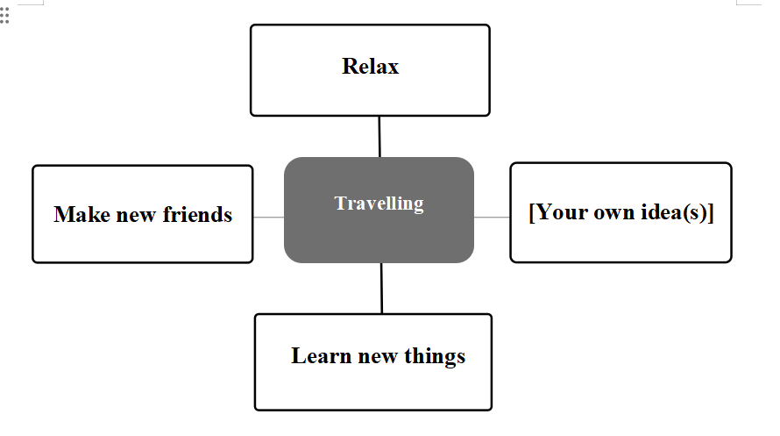

**Follow-up questions:**

1. Do you like travelling?
2. Do you prefer to travel with your family or friends?
3. What activities do you often do when you travel?
4. Where would you like to travel in the future?

**Music should be taught in schools**

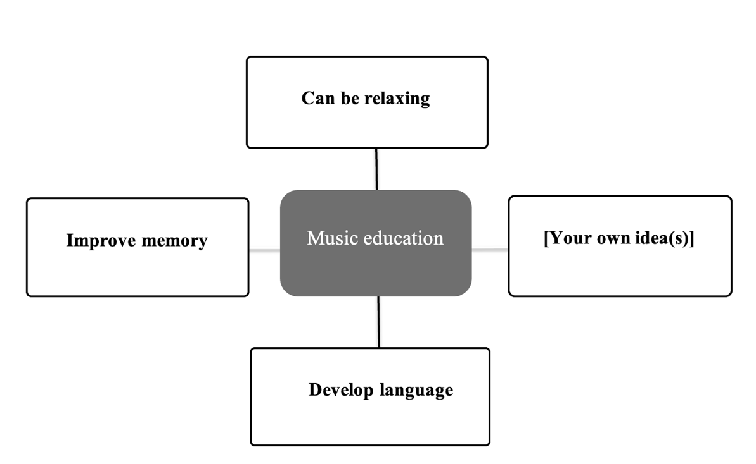

**Follow-up questions:**

1. Do you like listening to music?
2. What kinds of music do you like?
3. What is your favorite singer?
4. When do you listen to music?

Benefits of music education

The above paragraph summarizes the main benefits of music education. In my opinion, music education also has the following unique features:

First, music is the common language of humanity. Music can connect people from all different cultures, languages, and backgrounds. Music helps us understand each other better, share emotions and build community.

Second, music is a great tool to educate children about moral and cultural values. Through music, children can learn about love, empathy, respect and responsibility. Music also helps children develop the ability to appreciate the beauty and diversity of the world around them.

Third, music is an endless source of inspiration. Music can awaken creativity, passion and hope in each person. Music helps us overcome difficulties in life and move towards a brighter future.

As a music lover, I believe that music education is an essential part of everyone's life. Music not only brings joy and relaxation but also helps us develop comprehensively intellectually, spiritually and emotionally.

Here are some ideas to encourage music education:

Expose children to music from an early age

Create opportunities for children to participate in musical activities such as singing, playing musical instruments, and composing music

Support music education programs in schools and communities

Honoring those who have contributed to the music industry

**There are different ways to reduce clothing waste.**

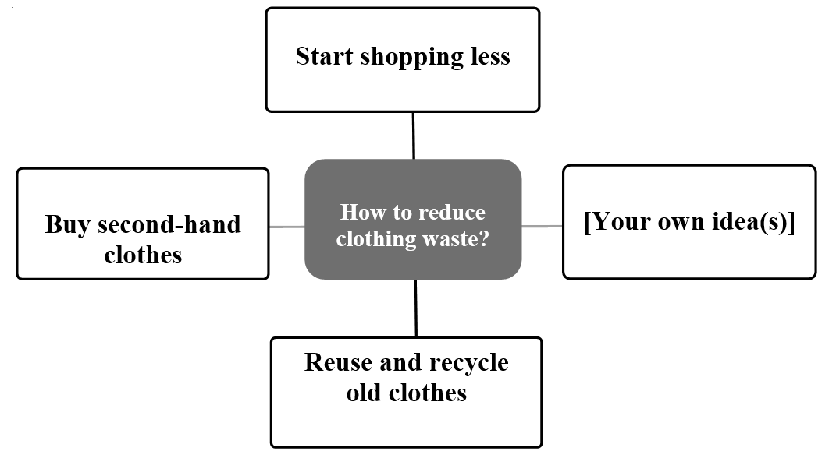

**Follow-up questions:**

Do you enjoy shopping for clothes? Why (not)?

What is your favourite clothing item?

Have you ever bought second-hand clothes?

What do you usually do with old clothes?

Ngành công nghiệp thời trang là một trong những ngành công nghiệp gây ô nhiễm môi trường nhất thế giới. Việc sản xuất và tiêu thụ quần áo tạo ra một lượng rác thải khổng lồ, gây ảnh hưởng đến môi trường và sức khỏe con người.

Hình ảnh trên cho thấy một số cách đơn giản để giảm thiểu rác thải từ quần áo:

**1. Mua sắm ít hơn:**

* Chỉ mua những thứ bạn thực sự cần và yêu thích.
* Cân nhắc kỹ trước khi mua một món đồ mới.
* Mua sắm quần áo secondhand hoặc vintage.

**2. Sử dụng lâu hơn:**

* Chăm sóc quần áo cẩn thận để sử dụng được lâu hơn.
* Sửa chữa quần áo khi bị rách hoặc hư hỏng.
* Tái sử dụng quần áo theo những cách sáng tạo.

**3. Tái chế:**

* Tái chế quần áo cũ không còn sử dụng được.
* Ủng hộ các thương hiệu thời trang bền vững.

**4. Giáo dục và nâng cao nhận thức:**

* Chia sẻ kiến thức về tác động môi trường của ngành công nghiệp thời trang.
* Khuyến khích bạn bè và gia đình giảm thiểu rác thải từ quần áo.

**Bằng cách thực hiện những hành động đơn giản này, chúng ta có thể góp phần bảo vệ môi trường và tạo ra một tương lai bền vững hơn.**

**Playing sports is beneficial for young people.**

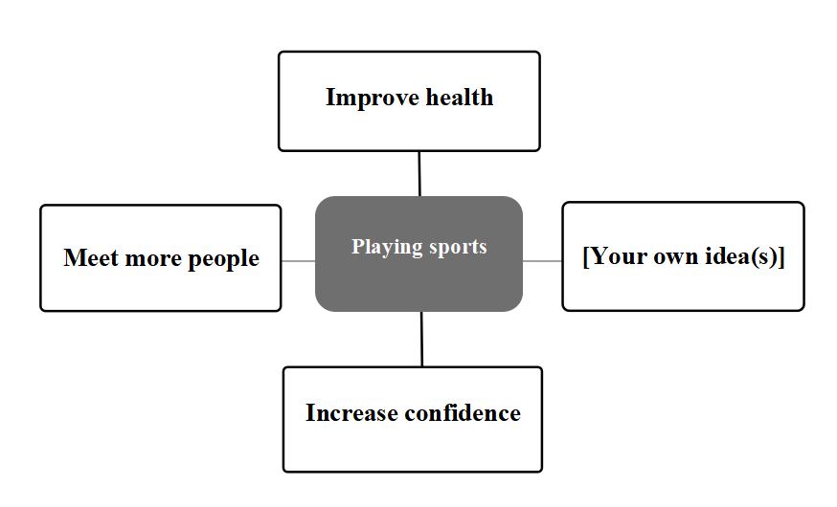

**Follow-up questions:**

1. Are you interested in sports?
2. How much exercise do you do each week?
3. What is the most popular sport in your country?
4. Do you enjoy watching sports or playing sports?

Benefits of playing sports

Playing sports brings many benefits to people's physical and mental health. Here are some of the benefits shown in the photo:

Improve health:

Enhance cardiovascular health: When playing sports, your heart will work harder, helping to improve cardiovascular health and reduce the risk of cardiovascular diseases.

Enhance muscle strength: Playing sports helps build and maintain muscle, helping you move more easily and reduce the risk of injury.

Improve bone and joint health: Playing sports helps increase bone density, helping to reduce the risk of osteoporosis and fractures.

Strengthens the immune system: Playing sports helps strengthen the immune system, helping you fight diseases better.

Spiritual benefits:

Reduce stress: Playing sports helps release endorphins, a hormone that helps reduce stress and improve mood.

Enhance confidence: Playing sports helps you achieve your goals and improve your abilities, thereby increasing your confidence.

Helps you sleep better: Playing sports helps you fall asleep easier and sleep deeper.

Social benefits:

Meet people: Playing sports is a great way to meet new people and make friends.

Learn how to work in groups: Playing sports helps you learn how to work in groups and cooperate with others.

Develop sportsmanship: Playing sports helps you develop sportsmanship, including respect for opponents, fairness and courage.

**There are several ways for people to make friends.**

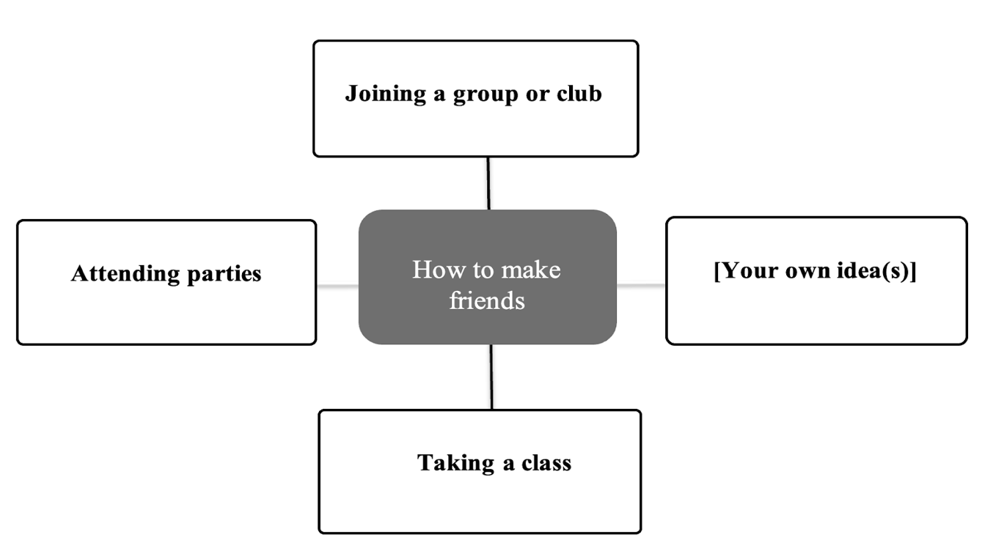

**Follow-up questions:**

1. Do you have a best friend?
2. Which one is more important: family or friends?
3. Have you made any friends over the Internet?
4. Why do you need a friend?

How to make friends

Making friends is an important part of life. Friends give us companionship, sharing and support. So how to make new friends?

Here are some simple ways:

Join groups or clubs: This is where you can meet people with common interests.

Attend parties: Parties are places where you can meet many new people at the same time.

Take a class: Taking a class is a great way to meet people who share similar learning goals.

Use social media: Join social media groups or use dating apps to make new friends.

Start a conversation with strangers: Don't be afraid to talk to strangers at a coffee shop, library, or anywhere else.

The most important thing is to be open, friendly and willing to share. Give people a chance to get to know you.

**There are different ways to balance your budget.**

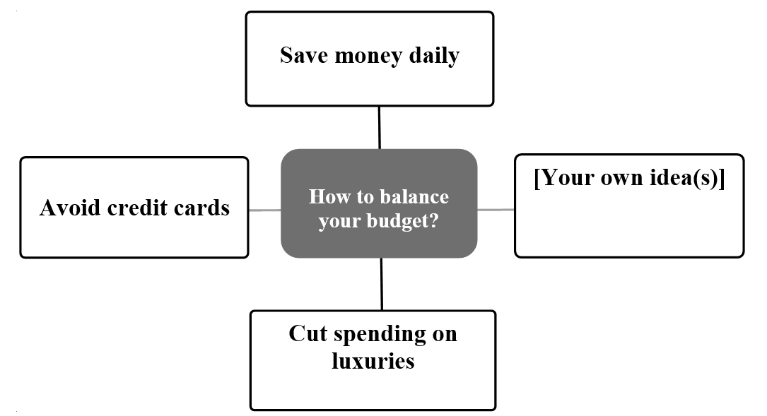

**Follow-up questions:**

Are you good at saving money? Why (not)?

Do you often spend money on luxuries? What are they?

Which do you prefer, spending or saving money?

Do you think credit cards are useful? Why (not)?

**Saving:**

* **Save money daily:** Setting aside a small amount of money each day, even just a few thousand dong, will help you have a decent amount after a while.
* **Make a spending plan:** Making a spending plan will help you control your earnings and spend wisely.
* **Cut back on unnecessary expenses:** Avoid buying things you don't really need to save money.
* **Look for reasonable spending:** Look for promotions and discounts to save money on shopping.

**Increase income:**

* **Find extra work:** If you have free time, look for extra work to increase your income.
* **Sell things you don't use:** Sell things you don't use to earn extra income.
* **Invest:** Invest money in safe and effective investment channels to increase your wealth.

**Track and manage your budget:**

* **Record all expenses:** Record all expenses to know how much you have spent on each item.
* **Use financial management apps:** Use financial management apps to track spending and plan budgets more effectively.
* **Review and adjust your budget regularly:** Review and adjust your budget regularly to suit your financial situation.

**Conclusion:**

Balancing your budget is an important thing to help you control your finances and achieve your financial goals. Applying the above tips will help you balance your budget effectively and achieve your financial goals.

**There are some roles of social media**

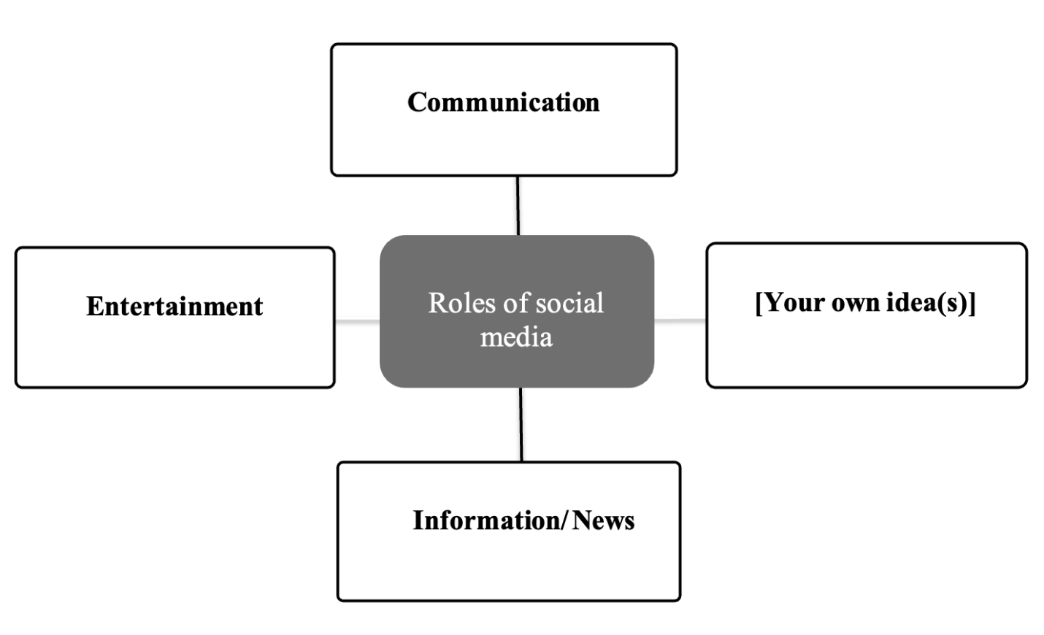

**Follow-up questions:**

1. How much time do you spend using social media every day?
2. Which social network platform do you use?
3. What was the first social media website you had an account with?
4. Have you ever argued with anyone online?

Communication: Social networks make it easier to connect people, regardless of geographical distance. People can chat, share information, images and videos with each other quickly and conveniently.

Entertainment: Social networks provide a variety of entertainment content such as funny videos, music, games, etc. helps people relax after stressful hours of study and work.

Information/News: Social networks are a quick and effective channel for updating news. People can follow news about domestic and international events, as well as stay informed about the fields they are interested in.

[Your idea]:

Business: Social networks are effective promotional channels for businesses. Businesses can use social networks to introduce products and services, attract potential customers and increase revenue.

Education: Social networks can be used to support teaching and learning. Teachers can use social networks to share teaching materials, assign assignments, and interact with students.

Community connection: Social networks help connect people with common interests, passions and goals. People can join community groups on social networks to share experiences, learn from each other and carry out projects together.

**There are some benefits of healthy eating**

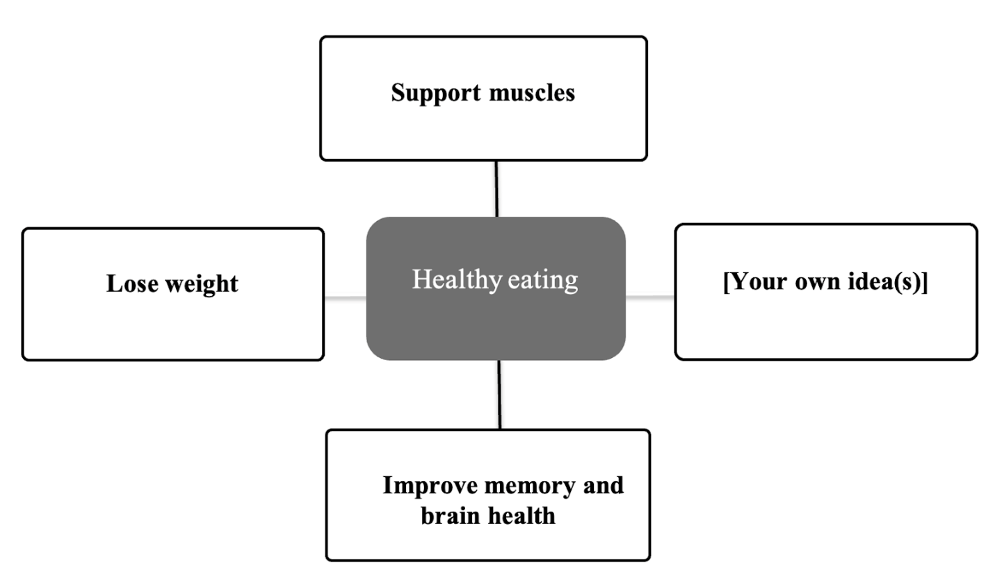

**Follow-up questions:**

1. Do you like eating vegetables?
2. What food do you not like to eat?
3. Do you eat fruit every day?
4. Do you like trying new foods?

**How do people create a work-life balance?**

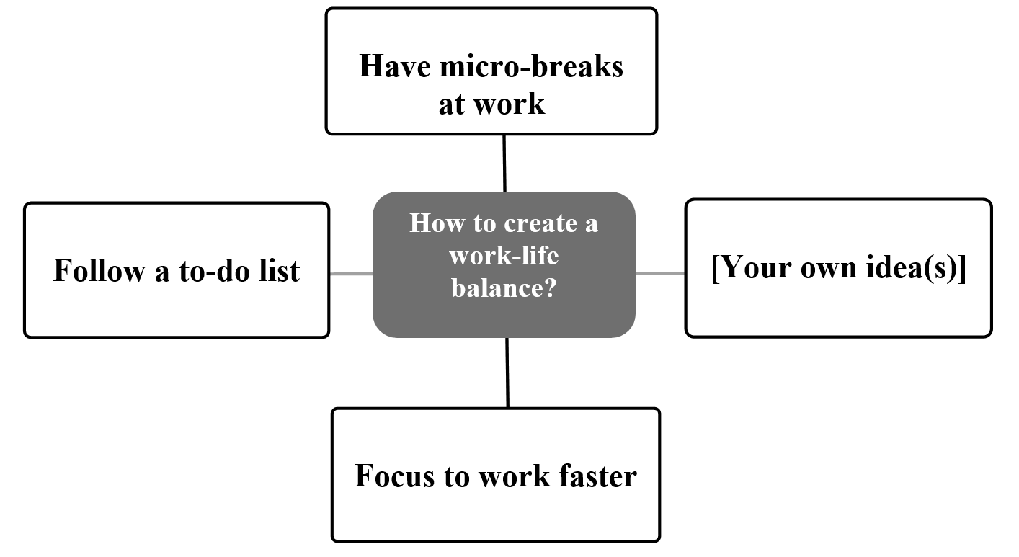

## The Secret to a Balanced Lifestyle

The image depicts a circle divided into different sections, representing the important aspects of life. Each section plays a vital role in creating a balanced and happy lifestyle.

**1. Health:**

* **Balanced diet:** Eat plenty of fruits, vegetables, whole grains, and lean protein.
* **Adequate sleep:** Get 7-8 hours of sleep per night to allow your body to recover and recharge.
* **Regular exercise:** Stay active for at least 30 minutes each day to improve your health and resistance.

**2. Relationships:**

* **Spend time with family and friends:** Nurture close and loving relationships.
* **Participate in social activities:** Meet new people and expand your network.
* **Help others:** Bring joy and happiness to yourself and those around you.

**3. Work:**

* **Find a suitable job:** Choose a career you love and that brings you satisfaction.
* **Work-life balance:** Avoid overworking and make time for yourself and your family.
* **Improve your skills:** Gain knowledge and skills to grow in your career.

**4. Personal Interests:**

* **Dedicate time to activities you enjoy:** Reading, listening to music, playing sports, etc.
* **Learn new things:** Explore yourself and develop your potential.
* **Relax and have fun:** Help you reduce stress and regain energy.

**5. Spirituality:**

* **Seek inner peace:** Meditation, yoga, prayer, etc.
* **Live with purpose:** Define your values and goals in life.
* **Help the community:** Contribute to a better society.

**By devoting time and attention to each section of this circle, you can build a balanced and happy lifestyle for yourself.** Remember, everyone has different priorities and circumstances, so adjust these sections to fit your needs.

**Start building a balanced and happy life today!**

**Follow-up questions:**

1. Do you work or are you a student?
2. How much time do you often spend on your work and study?
3. Do you usually have breaks when you work or study?
4. What can you do to avoid being stressed out at work or when you study?

**How do people maintain a healthy lifestyle?**

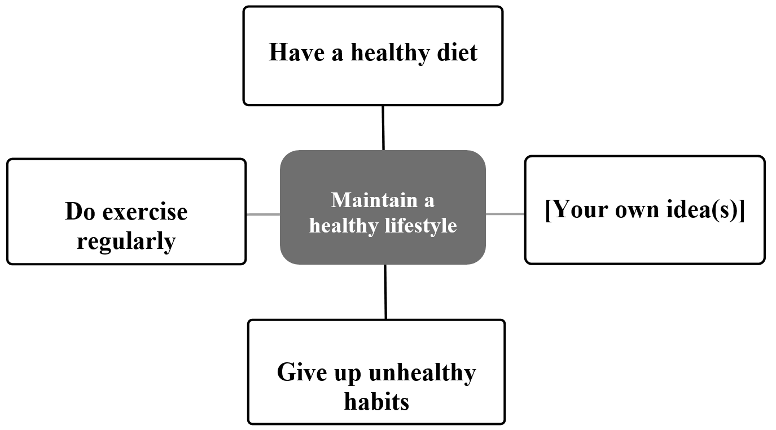

**Follow-up questions:**

1. Do you have a healthy lifestyle? Why (not)
2. What is one bad habit that you want to give up?
3. Do you exercise regularly to keep fit?
4. Do you think it is unhealthy to stay up late at night?

My answers to your questions:

1. I try to maintain a healthy lifestyle. I eat a balanced diet, get enough sleep, and exercise regularly. However, due to my busy work schedule, sometimes it is difficult for me to avoid staying up late or eating fast food.

2. The bad habit I want to give up the most is staying up late. Staying up late makes me feel tired, sleep-deprived, and affects my health and work.

3. I exercise regularly. I usually go for a run or go to the gym 3-4 times a week. Exercise helps me stay healthy, flexible, and reduces stress.

4. In my opinion, staying up late can be bad for your health. When you stay up late, your body doesn't get enough rest, which leads to fatigue, sleep deprivation, decreased memory and concentration. Over time, staying up late can lead to cardiovascular disease, obesity, diabetes, etc.

The Secret to a Healthy Lifestyle

To live a healthy and energetic life, building a healthy lifestyle is essential. The image summarizes the key factors to help you achieve this goal.

First, a balanced diet plays a vital role. Prioritize fresh foods like vegetables, fruits, and whole grains, while limiting fast food and processed foods. Drinking enough water also helps the body detoxify and metabolize effectively.

Second, regular exercise helps improve strength, flexibility, and resistance. Spend at least 30 minutes each day on physical activities that suit your interests and physical condition.

Third, maintaining a scientific lifestyle is also an important factor. Getting enough sleep, reducing stress, and avoiding bad habits like smoking and alcohol abuse will help you improve your health and well-being.

In addition to the above factors, you should also get regular health check-ups, participate in social activities, and seek support from family, friends, and professionals.

Make these good habits an indispensable part of your life to enjoy a healthy and happy life!

Remember, health is the most precious asset of each person. Cherish and take care of yourself today!