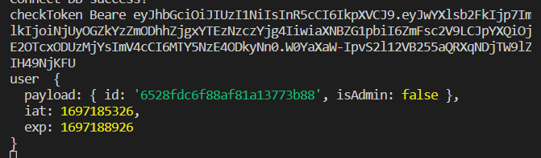

Headers.token : phan quyen admin -> delete

Access_token giai ma bang jwtio -> id user

Refresh token

Pagnigated : phan trang bang nodejs , video: product, bo sung user

{

"name": "product4",

"image": "link-image-4",

"type": "game",

"price": 400,

"countInStock": 10,

"rating": 3.4,

"description": "good"

}

 const allProductSort = await Product.find()

          .limit(limit)

          .skip(page * limit)

          .sort({ name: sort });

Video #26: tich hop FE-BE