Cấu trúc dự án

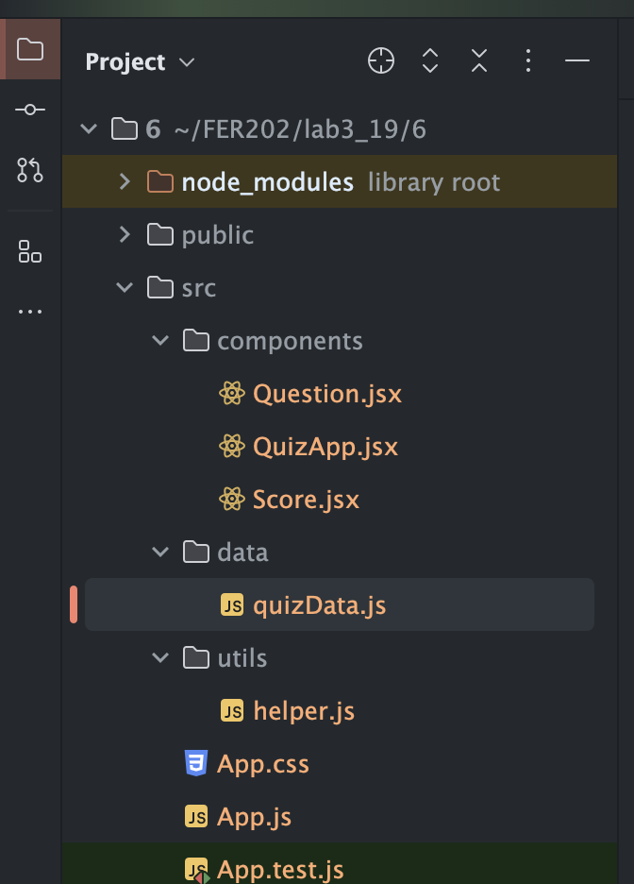

Overview UI :

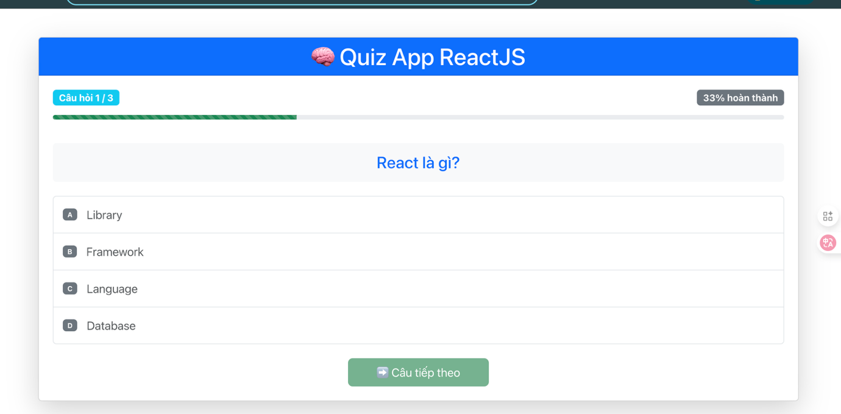

Question.jsx

import *React* from 'react';  
import { Card, *Button*, ListGroup, *ProgressBar*, *Badge*, *Row*, *Col* } from 'react-bootstrap';  
  
const *Question* = ({  
 question,  
 onAnswerSelected,  
 selectedAnswer,  
 onClickNext,  
 activeQuestion,  
 totalQuestions  
 }) => {  
 const progress = ((activeQuestion + 1) / totalQuestions) \* 100;  
  
 return (  
 <div>  
 {*/\* Header với progress bar \*/*}  
 <Row className="mb-4">  
 <Col>  
 <div className="d-flex justify-content-between align-items-center mb-3">  
 <Badge bg="info" className="fs-6">  
 Câu hỏi {activeQuestion + 1} / {totalQuestions}  
 </Badge>  
 <Badge bg="secondary" className="fs-6">  
 {Math.round(progress)}% hoàn thành  
 </Badge>  
 </div>  
 <ProgressBar  
 now={progress}  
 variant="success"  
 animated  
 className="mb-3"  
 style={{ height: '8px' }}  
 />  
 </Col>  
 </Row>  
  
 {*/\* Câu hỏi \*/*}  
 <Card className="mb-4 border-0 bg-light">  
 <Card.Body>  
 <h3 className="text-center text-primary mb-0">  
 {question.question}  
 </h3>  
 </Card.Body>  
 </Card>  
  
 {*/\* Các lựa chọn \*/*}  
 <ListGroup className="mb-4">  
 {question.choices.map((choice, index) => (  
 <ListGroup.Item  
 key={index}  
 action  
 active={selectedAnswer === choice}  
 onClick={() => onAnswerSelected(choice)}  
 className={`d-flex align-items-center py-3 ${  
 selectedAnswer === choice ? 'border-primary' : ''  
 }`}  
 style={{ cursor: 'pointer' }}  
 >  
 <Badge  
 bg={selectedAnswer === choice ? 'primary' : 'secondary'}  
 className="me-3"  
 >  
 {*String*.fromCharCode(65 + index)}  
 </Badge>  
 <span className="fs-5">{choice}</span>  
 </ListGroup.Item>  
 ))}  
 </ListGroup>  
  
 {*/\* Nút Next \*/*}  
 <div className="text-center">  
 <Button  
 variant="success"  
 size="lg"  
 onClick={onClickNext}  
 disabled={!selectedAnswer}  
 className="px-5"  
 >  
 {activeQuestion === totalQuestions - 1 ? (  
 <>🏁 Hoàn thành Quiz</>  
 ) : (  
 <>➡️ Câu tiếp theo</>  
 )}  
 </Button>  
 </div>  
 </div>  
 );  
};  
  
export default *Question*;

QuizApp.jsx

import *React*, { *useState* } from 'react';  
import { *Container*, Card } from 'react-bootstrap';  
import *Question* from "./Question";  
import quizData from "../data/quizData";  
import *Score* from "./Score";  
  
  
const *QuizApp* = () => {  
 const [activeQuestion, setActiveQuestion] = *useState*(0);  
 const [selectedAnswer, setSelectedAnswer] = *useState*('');  
 const [result, setResult] = *useState*({  
 score: 0,  
 correctAnswers: 0,  
 wrongAnswers: 0  
 });  
 const [showResult, setShowResult] = *useState*(false);  
  
 // Dữ liệu câu hỏi mẫu  
 const questions = [  
 {  
 question: "React là gì?",  
 choices: ["Library", "Framework", "Language", "Database"],  
 correctAnswer: "Library"  
 },  
 {  
 question: "JSX viết tắt của gì?",  
 choices: ["JavaScript XML", "Java Syntax", "JSON XML", "JavaScript Extension"],  
 correctAnswer: "JavaScript XML"  
 },  
 {  
 question: "Hook nào được sử dụng để quản lý state?",  
 choices: ["useEffect", "useState", "useContext", "useReducer"],  
 correctAnswer: "useState"  
 }  
 ];  
  
 const onAnswerSelected = (answer) => {  
 setSelectedAnswer(answer);  
 };  
  
 const onClickNext = () => {  
 const isCorrect = selectedAnswer === questions[activeQuestion].correctAnswer;  
  
 if (isCorrect) {  
 setResult(prev => ({  
 ...prev,  
 score: prev.score + 1,  
 correctAnswers: prev.correctAnswers + 1  
 }));  
 } else {  
 setResult(prev => ({  
 ...prev,  
 wrongAnswers: prev.wrongAnswers + 1  
 }));  
 }  
  
 if (activeQuestion !== questions.length - 1) {  
 setActiveQuestion(prev => prev + 1);  
 } else {  
 setShowResult(true);  
 }  
  
 setSelectedAnswer('');  
 };  
  
 const resetQuiz = () => {  
 setActiveQuestion(0);  
 setSelectedAnswer('');  
 setResult({  
 score: 0,  
 correctAnswers: 0,  
 wrongAnswers: 0  
 });  
 setShowResult(false);  
 };  
  
 return (  
 <Container className="py-5">  
 <Card className="shadow-lg">  
 <Card.Header className="bg-primary text-white text-center">  
 <h1 className="mb-0">🧠 Quiz App ReactJS</h1>  
 </Card.Header>  
 <Card.Body className="p-4">  
 {!showResult ? (  
 <Question  
 question={questions[activeQuestion]}  
 onAnswerSelected={onAnswerSelected}  
 selectedAnswer={selectedAnswer}  
 onClickNext={onClickNext}  
 activeQuestion={activeQuestion}  
 totalQuestions={questions.length}  
 />  
 ) : (  
 <Score  
 result={result}  
 totalQuestions={questions.length}  
 resetQuiz={resetQuiz}  
 />  
 )}  
 </Card.Body>  
 </Card>  
 </Container>  
 );  
};  
  
export default *QuizApp*;

Score.jsx

import *React* from 'react';  
import { Card, *Button*, *Row*, *Col*, *Badge*, Alert } from 'react-bootstrap';  
  
const *Score* = ({ result, totalQuestions, resetQuiz }) => {  
 const percentage = Math.round((result.score / totalQuestions) \* 100);  
  
 // Xác định màu sắc và thông điệp dựa trên điểm số  
 const getResultVariant = () => {  
 if (percentage >= 80) return 'success';  
 if (percentage >= 60) return 'warning';  
 return 'danger';  
 };  
  
 const getResultMessage = () => {  
 if (percentage >= 80) return 'Xuất sắc! 🎉';  
 if (percentage >= 60) return 'Khá tốt! 👍';  
 return 'Cần cố gắng thêm! 💪';  
 };  
  
 return (  
 <div className="text-center">  
 <Card className="border-0">  
 <Card.Body>  
 <h2 className="mb-4 text-primary">🏆 Kết quả Quiz</h2>  
  
 {*/\* Alert thông báo \*/*}  
 <Alert variant={getResultVariant()} className="mb-4">  
 <h4 className="mb-0">{getResultMessage()}</h4>  
 </Alert>  
  
 {*/\* Điểm số chính \*/*}  
 <div className="mb-4">  
 <h1 className="display-1 text-primary mb-2">  
 {result.score}/{totalQuestions}  
 </h1>  
 <Badge  
 bg={getResultVariant()}  
 className="fs-3 px-4 py-2"  
 >  
 {percentage}%  
 </Badge>  
 </div>  
  
 {*/\* Chi tiết kết quả \*/*}  
 <Row className="mb-4">  
 <Col md={4}>  
 <Card className="h-100 border-success">  
 <Card.Body className="text-center">  
 <div className="text-success mb-2">  
 <i className="fas fa-check-circle fa-2x"></i>  
 </div>  
 <h5 className="text-success">Đúng</h5>  
 <h3 className="text-success">{result.correctAnswers}</h3>  
 </Card.Body>  
 </Card>  
 </Col>  
 <Col md={4}>  
 <Card className="h-100 border-danger">  
 <Card.Body className="text-center">  
 <div className="text-danger mb-2">  
 <i className="fas fa-times-circle fa-2x"></i>  
 </div>  
 <h5 className="text-danger">Sai</h5>  
 <h3 className="text-danger">{result.wrongAnswers}</h3>  
 </Card.Body>  
 </Card>  
 </Col>  
 <Col md={4}>  
 <Card className="h-100 border-info">  
 <Card.Body className="text-center">  
 <div className="text-info mb-2">  
 <i className="fas fa-question-circle fa-2x"></i>  
 </div>  
 <h5 className="text-info">Tổng câu</h5>  
 <h3 className="text-info">{totalQuestions}</h3>  
 </Card.Body>  
 </Card>  
 </Col>  
 </Row>  
  
 {*/\* Nút làm lại \*/*}  
 <Button  
 variant="primary"  
 size="lg"  
 onClick={resetQuiz}  
 className="px-5"  
 >  
 🔄 Làm lại Quiz  
 </Button>  
 </Card.Body>  
 </Card>  
 </div>  
 );  
};  
  
export default *Score*;

helper.js

// src/utils/helpers.js  
export const *calculateScore* = (correctAnswers, totalQuestions) => {  
 return Math.round((correctAnswers / totalQuestions) \* 100);  
};  
  
export const *getResultMessage* = (percentage) => {  
 if (percentage >= 80) return 'Xuất sắc! 🎉';  
 if (percentage >= 60) return 'Khá tốt! 👍';  
 return 'Cần cố gắng thêm! 💪';  
};  
  
export const *getResultVariant* = (percentage) => {  
 if (percentage >= 80) return 'success';  
 if (percentage >= 60) return 'warning';  
 return 'danger';  
};

App.js

// src/App.js  
import *React* from 'react';  
import 'bootstrap/dist/css/bootstrap.min.css';  
import *QuizApp* from './components/QuizApp';  
  
function *App*() {  
 return (  
 <div className="App">  
 <QuizApp />  
 </div>  
 );  
}  
  
export default *App*;