Cấu trúc dự án :

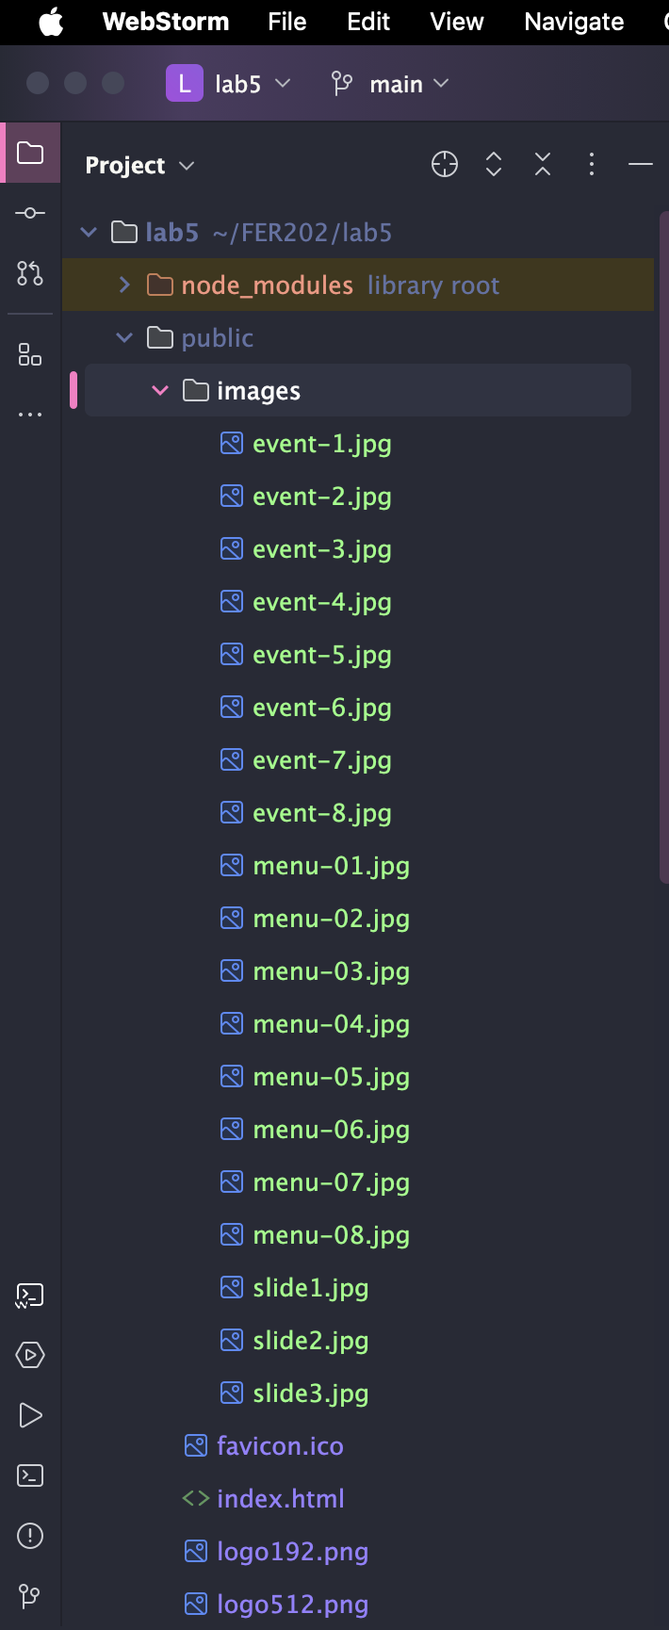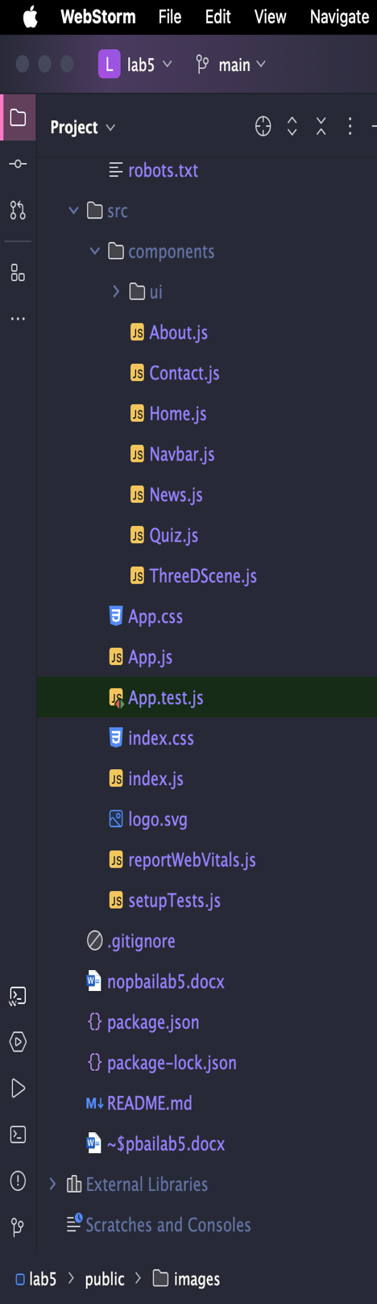

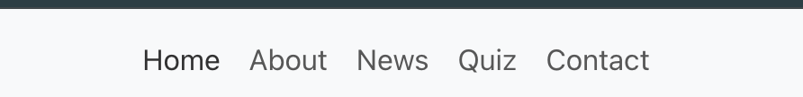

Navbar.js

import { *Link* } from 'react-router-dom';  
import { Navbar as BsNavbar, Nav, *Container* } from 'react-bootstrap';  
  
function *Navbar*() {  
 return (  
 <BsNavbar bg="light" expand="lg">  
 <Container>  
 <BsNavbar.Toggle aria-controls="basic-navbar-nav" />  
 <BsNavbar.Collapse id="basic-navbar-nav">  
 <Nav className="me-auto">  
 <Nav.Link as={*Link*} to="/">Home</Nav.Link>  
 <Nav.Link as={*Link*} to="/about">About</Nav.Link>  
 <Nav.Link as={*Link*} to="/news">News</Nav.Link>  
 <Nav.Link as={*Link*} to="/quiz">Quiz</Nav.Link>  
 <Nav.Link as={*Link*} to="/contact">Contact</Nav.Link>  
 </Nav>  
 </BsNavbar.Collapse>  
 </Container>  
 </BsNavbar>  
 );  
}  
  
export default *Navbar*;

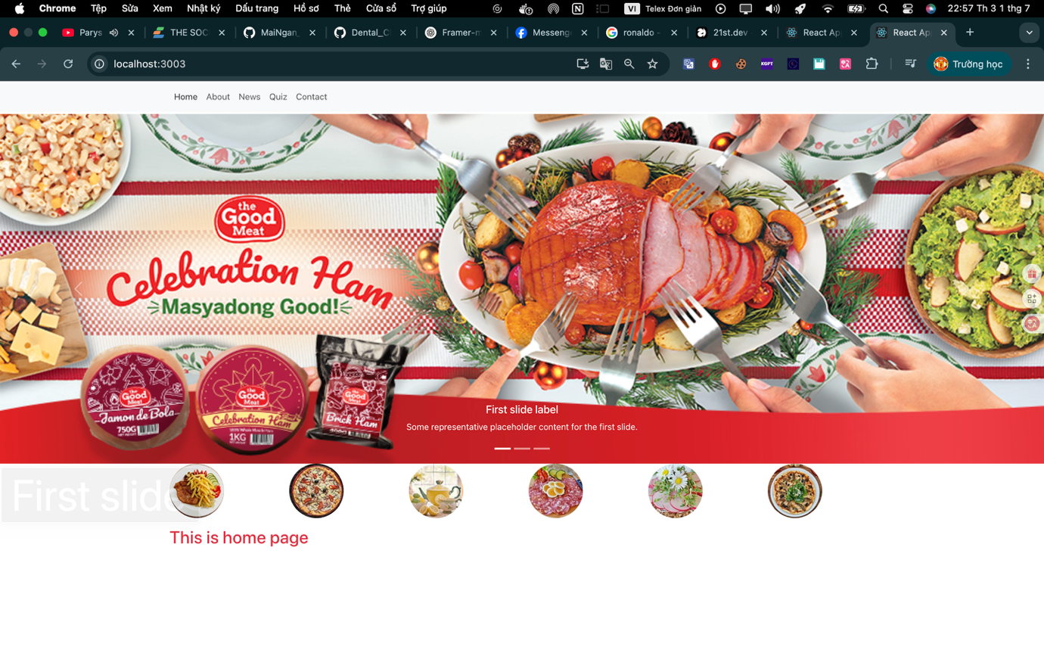

Home.js

import *React* from 'react';  
import { Carousel, *Image*, *Container*, *Row*, *Col* } from 'react-bootstrap';  
  
const *Home* = () => {  
 return (  
 <div>  
 <Carousel id="carouselExampleCaptions" className="mt-1" variant="light" interval={8000}>  
 <Carousel.Item>  
 <Image src="/images/slide1.jpg" className="d-block w-100" alt="First slide" />  
 <Carousel.Caption>  
 <h5>First slide label</h5>  
 <p>Some representative placeholder content for the first slide.</p>  
 </Carousel.Caption>  
 </Carousel.Item>  
 <Carousel.Item>  
 <Image src="/images/slide2.jpg" className="d-block w-100" alt="Second slide" />  
 <Carousel.Caption>  
 <h5>Second slide label</h5>  
 <p>Some representative placeholder content for the second slide.</p>  
 </Carousel.Caption>  
 </Carousel.Item>  
 <Carousel.Item>  
 <Image src="/images/slide3.jpg" className="d-block w-100" alt="Third slide" />  
 <Carousel.Caption>  
 <h5>Third slide label</h5>  
 <p>Some representative placeholder content for the third slide.</p>  
 </Carousel.Caption>  
 </Carousel.Item>  
 </Carousel>  
 <Container>  
 <Row>  
 <Col>  
 <Image src="/images/menu-01.jpg" roundedCircle />  
 </Col>  
 <Col>  
 <Image src="/images/menu-02.jpg" roundedCircle />  
 </Col>  
 <Col>  
 <Image src="/images/menu-03.jpg" roundedCircle />  
 </Col>  
 <Col>  
 <Image src="/images/menu-04.jpg" roundedCircle />  
 </Col>  
 <Col>  
 <Image src="/images/menu-05.jpg" roundedCircle />  
 </Col>  
 <Col>  
 <Image src="/images/menu-06.jpg" roundedCircle />  
 </Col>  
 </Row>  
 <h2 className="text-danger mt-3">This is home page</h2>  
 </Container>  
 </div>  
 );  
}  
  
export default *Home*;

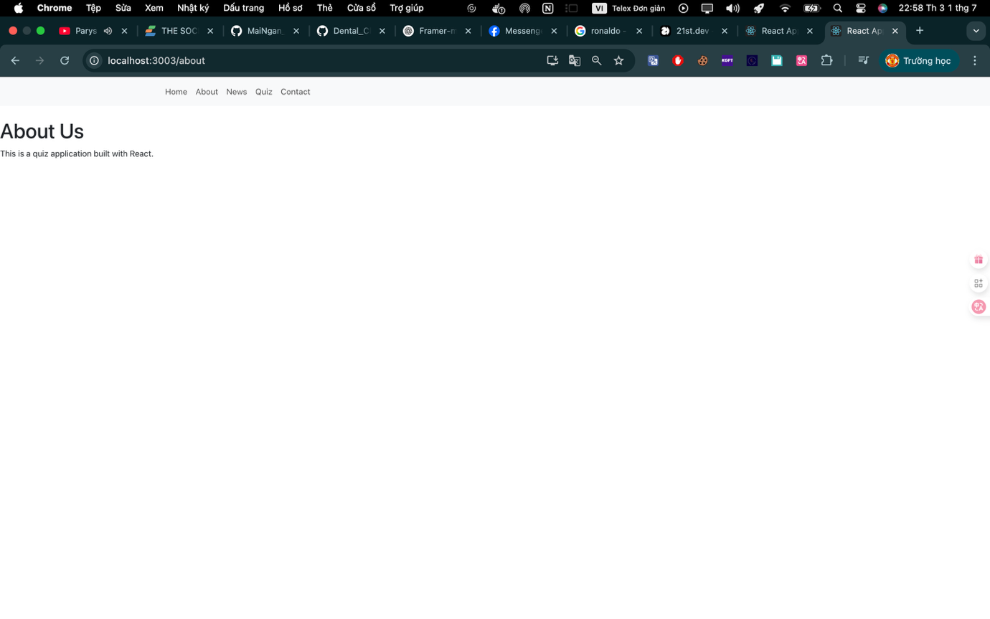

About.js

function *About*() {  
 return (  
 <div className="mt-4">  
 <h1>About Us</h1>  
 <p>This is a quiz application built with React.</p>  
 </div>  
 );  
}  
  
export default *About*;

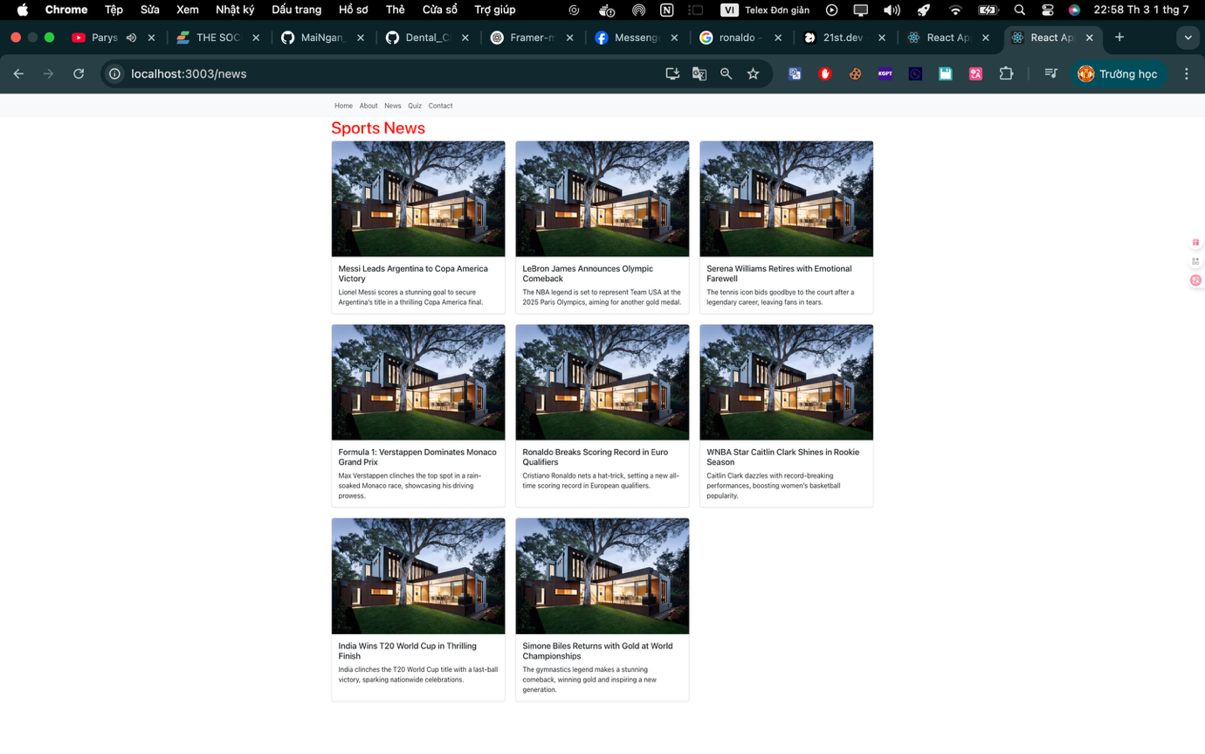

News.js

import *React* from 'react';  
import { Card, *Container*, *Row*, *Col* } from 'react-bootstrap';  
  
const *News* = () => {  
 *// Mảng dữ liệu tin tức thể thao* const newLists = [  
 {  
 id: 1,  
 title: 'Messi Leads Argentina to Copa America Victory',  
 description: 'Lionel Messi scores a stunning goal to secure Argentina’s title in a thrilling Copa America final.',  
 images: 'https://images.unsplash.com/photo-1600585154340-be6161a56a0c?auto=format&fit=crop&w=640&q=80'  
 },  
 {  
 id: 2,  
 title: 'LeBron James Announces Olympic Comeback',  
 description: 'The NBA legend is set to represent Team USA at the 2025 Paris Olympics, aiming for another gold medal.',  
 images: 'https://images.unsplash.com/photo-1600585154340-be6161a56a0c?auto=format&fit=crop&w=640&q=80'  
 },  
 {  
 id: 3,  
 title: 'Serena Williams Retires with Emotional Farewell',  
 description: 'The tennis icon bids goodbye to the court after a legendary career, leaving fans in tears.',  
 images: 'https://images.unsplash.com/photo-1600585154340-be6161a56a0c?auto=format&fit=crop&w=640&q=80'  
 },  
 {  
 id: 4,  
 title: 'Formula 1: Verstappen Dominates Monaco Grand Prix',  
 description: 'Max Verstappen clinches the top spot in a rain-soaked Monaco race, showcasing his driving prowess.',  
 images: 'https://images.unsplash.com/photo-1600585154340-be6161a56a0c?auto=format&fit=crop&w=640&q=80'  
 },  
 {  
 id: 5,  
 title: 'Ronaldo Breaks Scoring Record in Euro Qualifiers',  
 description: 'Cristiano Ronaldo nets a hat-trick, setting a new all-time scoring record in European qualifiers.',  
 images: 'https://images.unsplash.com/photo-1600585154340-be6161a56a0c?auto=format&fit=crop&w=640&q=80'  
 },  
 {  
 id: 6,  
 title: 'WNBA Star Caitlin Clark Shines in Rookie Season',  
 description: 'Caitlin Clark dazzles with record-breaking performances, boosting women’s basketball popularity.',  
 images: 'https://images.unsplash.com/photo-1600585154340-be6161a56a0c?auto=format&fit=crop&w=640&q=80'  
 },  
 {  
 id: 7,  
 title: 'India Wins T20 World Cup in Thrilling Finish',  
 description: 'India clinches the T20 World Cup title with a last-ball victory, sparking nationwide celebrations.',  
 images: 'https://images.unsplash.com/photo-1600585154340-be6161a56a0c?auto=format&fit=crop&w=640&q=80'  
 },  
 {  
 id: 8,  
 title: 'Simone Biles Returns with Gold at World Championships',  
 description: 'The gymnastics legend makes a stunning comeback, winning gold and inspiring a new generation.',  
 images: 'https://images.unsplash.com/photo-1600585154340-be6161a56a0c?auto=format&fit=crop&w=640&q=80'  
 },  
 ];  
  
 return (  
 <Container className="news-container">  
 <h1 style={{ color: 'red' }}>Sports News</h1>  
 <Row xs={1} md={2} lg={3} className="g-4">  
 {newLists.map((news) => (  
 <Col key={news.id}>  
 <Card className="h-100 news-card">  
 <Card.Img  
 variant="top"  
 src={news.images}  
 alt={news.title}  
 className="news-image"  
 />  
 <Card.Body>  
 <Card.Title className="news-title">{news.title}</Card.Title>  
 <Card.Text className="news-description">{news.description}</Card.Text>  
 </Card.Body>  
 </Card>  
 </Col>  
 ))}  
 </Row>  
 </Container>  
 );  
};  
  
export default *News*;

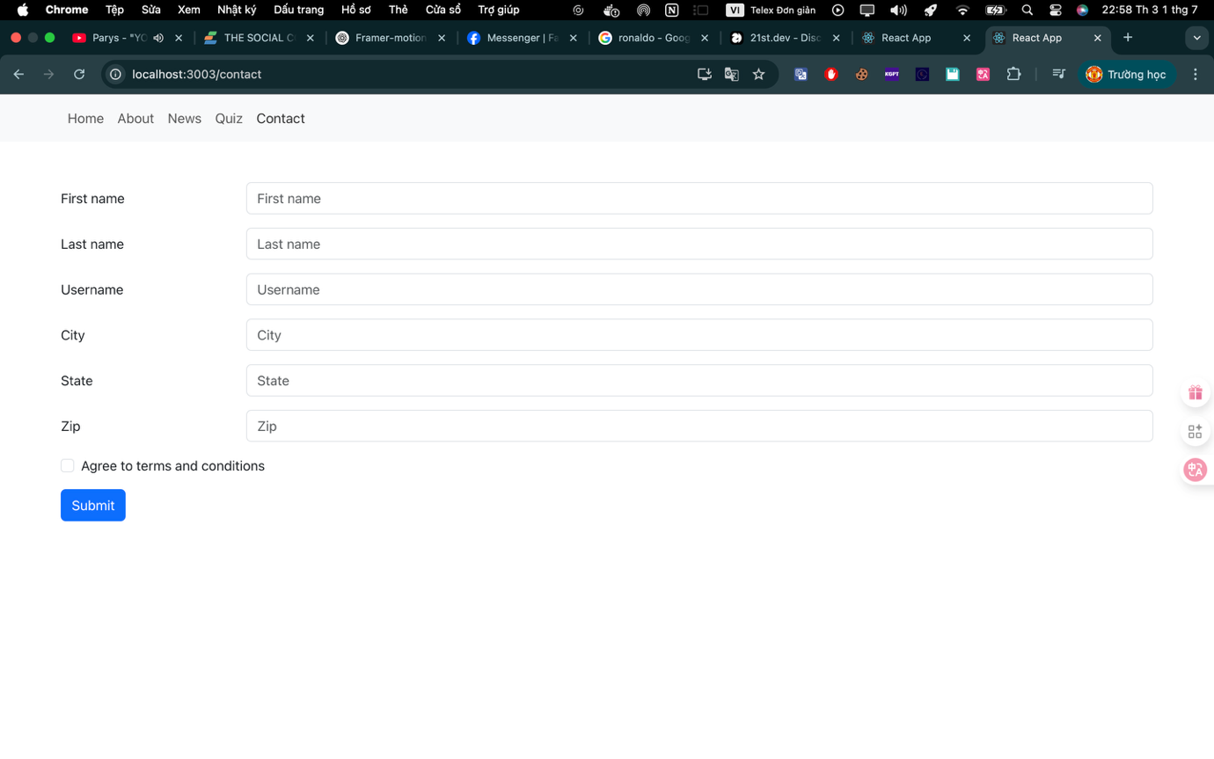

Contact.js

import *React*, { *useState* } from 'react';  
import { Form, *Button*, *Container*, *Row*, *Col* } from 'react-bootstrap';  
  
const *Contact* = () => {  
 const [formData, setFormData] = *useState*({  
 firstName: '',  
 lastName: '',  
 username: '',  
 city: '',  
 state: '',  
 zip: '',  
 agreeTerms: false  
 });  
  
 const [validated, setValidated] = *useState*(false);  
  
 const handleChange = (e) => {  
 const { name, value, type, checked } = e.target;  
 setFormData({  
 ...formData,  
 [name]: type === 'checkbox' ? checked : value  
 });  
 };  
  
 const handleSubmit = (e) => {  
 e.preventDefault();  
 const form = e.currentTarget;  
 if (form.checkValidity() === false) {  
 e.stopPropagation();  
 }  
 setValidated(true);  
 };  
  
  
 return (  
 <Container className="my-5">  
  
  
 <Form noValidate validated={validated} onSubmit={handleSubmit}>  
 {*/\* First Name \*/*}  
 <Form.Group as={*Row*} className="mb-3" controlId="formFirstName">  
 <Form.Label column sm={2}>First name</Form.Label>  
 <Col sm={10}>  
 <Form.Control  
 required  
 type="text"  
 name="firstName"  
 value={formData.firstName}  
 onChange={handleChange}  
 placeholder="First name"  
 />  
 <Form.Control.Feedback type="valid">Looks good!</Form.Control.Feedback>  
 <Form.Control.Feedback type="invalid">  
 Please provide your first name.  
 </Form.Control.Feedback>  
 </Col>  
 </Form.Group>  
  
 {*/\* Last Name \*/*}  
 <Form.Group as={*Row*} className="mb-3" controlId="formLastName">  
 <Form.Label column sm={2}>Last name</Form.Label>  
 <Col sm={10}>  
 <Form.Control  
 required  
 type="text"  
 name="lastName"  
 value={formData.lastName}  
 onChange={handleChange}  
 placeholder="Last name"  
 />  
 <Form.Control.Feedback type="valid">Looks good!</Form.Control.Feedback>  
 <Form.Control.Feedback type="invalid">  
 Please provide your last name.  
 </Form.Control.Feedback>  
 </Col>  
 </Form.Group>  
  
 {*/\* Username \*/*}  
 <Form.Group as={*Row*} className="mb-3" controlId="formUsername">  
 <Form.Label column sm={2}>Username</Form.Label>  
 <Col sm={10}>  
 <Form.Control  
 required  
 type="text"  
 name="username"  
 value={formData.username}  
 onChange={handleChange}  
 placeholder="Username"  
 minLength={3}  
 />  
 <Form.Control.Feedback type="invalid">  
 Username must be at least 3 characters.  
 </Form.Control.Feedback>  
 </Col>  
 </Form.Group>  
  
 {*/\* City \*/*}  
 <Form.Group as={*Row*} className="mb-3" controlId="formCity">  
 <Form.Label column sm={2}>City</Form.Label>  
 <Col sm={10}>  
 <Form.Control  
 required  
 type="text"  
 name="city"  
 value={formData.city}  
 onChange={handleChange}  
 placeholder="City"  
 />  
 <Form.Control.Feedback type="invalid">  
 Please provide a valid city.  
 </Form.Control.Feedback>  
 </Col>  
 </Form.Group>  
  
 {*/\* State \*/*}  
 <Form.Group as={*Row*} className="mb-3" controlId="formState">  
 <Form.Label column sm={2}>State</Form.Label>  
 <Col sm={10}>  
 <Form.Control  
 required  
 type="text"  
 name="state"  
 value={formData.state}  
 onChange={handleChange}  
 placeholder="State"  
 />  
 <Form.Control.Feedback type="invalid">  
 Please provide a valid state.  
 </Form.Control.Feedback>  
 </Col>  
 </Form.Group>  
  
 {*/\* Zip \*/*}  
 <Form.Group as={*Row*} className="mb-3" controlId="formZip">  
 <Form.Label column sm={2}>Zip</Form.Label>  
 <Col sm={10}>  
 <Form.Control  
 required  
 type="text"  
 name="zip"  
 value={formData.zip}  
 onChange={handleChange}  
 placeholder="Zip"  
 pattern="\d{5}"  
 />  
 <Form.Control.Feedback type="invalid">  
 Please provide a 5-digit zip code.  
 </Form.Control.Feedback>  
 </Col>  
 </Form.Group>  
  
 {*/\* Terms and Conditions \*/*}  
 <Form.Group className="mb-3" controlId="formTerms">  
 <Form.Check  
 required  
 name="agreeTerms"  
 checked={formData.agreeTerms}  
 onChange={handleChange}  
 label="Agree to terms and conditions"  
 />  
 <Form.Control.Feedback type="invalid">  
 You must agree before submitting.  
 </Form.Control.Feedback>  
 </Form.Group>  
  
 <Button variant="primary" type="submit">  
 Submit  
 </Button>  
 </Form>  
 </Container>  
 );  
};  
  
export default *Contact*;

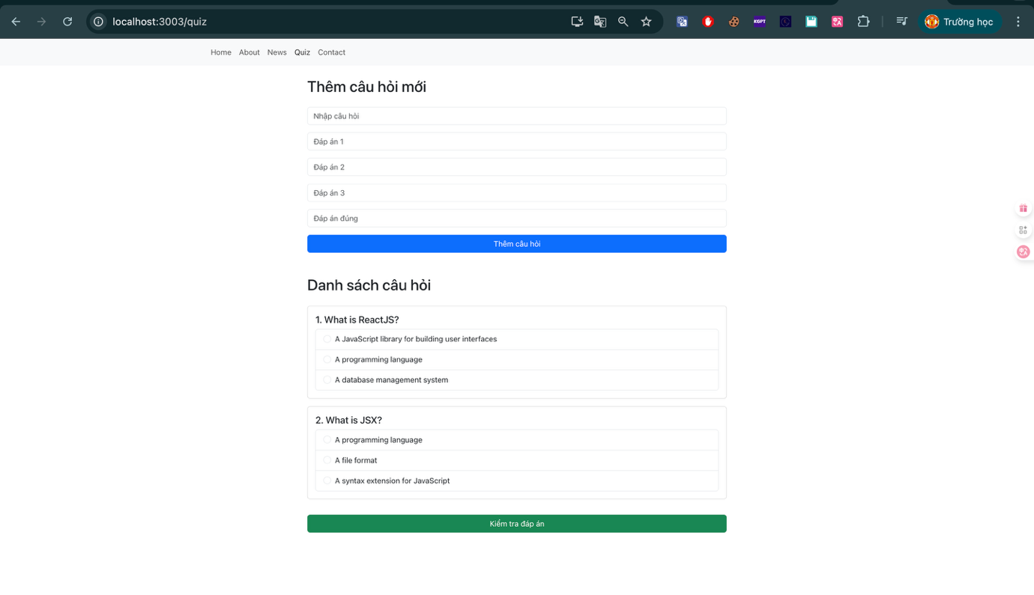

Quiz.js

import *React*, { *useState*, *useEffect*, *createContext*, *useContext* } from 'react';  
import { *Container*, Form, *Button*, Card, ListGroup, Alert } from 'react-bootstrap';  
import 'bootstrap/dist/css/bootstrap.min.css';  
  
const QuizContext = *createContext*();  
  
export const quizData = [  
 {  
 question: 'What is ReactJS?',  
 answers: ['A JavaScript library for building user interfaces', 'A programming language', 'A database management system'],  
 correctAnswer: 'A JavaScript library for building user interfaces'  
 },  
 {  
 question: 'What is JSX?',  
 answers: ['A programming language', 'A file format', 'A syntax extension for JavaScript'],  
 correctAnswer: 'A syntax extension for JavaScript'  
 }  
];  
  
  
function *Quiz*() {  
 const [questions, setQuestions] = *useState*(quizData);  
 const [userAnswers, setUserAnswers] = *useState*({});  
 const [results, setResults] = *useState*({});  
 const [newQuestion, setNewQuestion] = *useState*('');  
 const [newAnswers, setNewAnswers] = *useState*(['', '', '']);  
 const [newCorrectAnswer, setNewCorrectAnswer] = *useState*('');  
 const [score, setScore] = *useState*(null);  
 const [quizCompleted, setQuizCompleted] = *useState*(false);  
  
 *useEffect*(() => {  
 setQuestions(quizData);  
 }, []);  
  
 const handleAddQuestion = () => {  
 if (newQuestion && newAnswers.every(ans => ans) && newCorrectAnswer) {  
 setQuestions([...questions, {  
 question: newQuestion,  
 answers: newAnswers,  
 correctAnswer: newCorrectAnswer  
 }]);  
 setNewQuestion('');  
 setNewAnswers(['', '', '']);  
 setNewCorrectAnswer('');  
 }  
 };  
  
 const checkAnswers = () => {  
 const newResults = {};  
 let correctCount = 0;  
 questions.forEach((q, index) => {  
 const isCorrect = userAnswers[index] === q.correctAnswer;  
 newResults[index] = isCorrect ? 'Đúng' : 'Sai';  
 if (isCorrect) correctCount++;  
 });  
 setResults(newResults);  
 setScore(correctCount);  
 setQuizCompleted(true);  
 };  
  
  
 const resetQuiz = () => {  
 setUserAnswers({});  
 setResults({});  
 setScore(null);  
 setQuizCompleted(false);  
 };  
  
 return (  
 <QuizContext.Provider value={{ userAnswers, setUserAnswers }}>  
 <Container className="mt-4" style={{ maxWidth: '900px' }}>  
 <h2 className="text-left mb-4">Thêm câu hỏi mới</h2>  
 <Form>  
 <Form.Group className="mb-3">  
 <Form.Control  
 type="text"  
 value={newQuestion}  
 onChange={(e) => setNewQuestion(e.target.value)}  
 placeholder="Nhập câu hỏi"  
 />  
 </Form.Group>  
 {newAnswers.map((answer, index) => (  
 <Form.Group className="mb-3" key={index}>  
 <Form.Control  
 type="text"  
 value={answer}  
 onChange={(e) => {  
 const updatedAnswers = [...newAnswers];  
 updatedAnswers[index] = e.target.value;  
 setNewAnswers(updatedAnswers);  
 }}  
 placeholder={`Đáp án ${index + 1}`}  
 />  
 </Form.Group>  
 ))}  
 <Form.Group className="mb-3">  
 <Form.Control  
 type="text"  
 value={newCorrectAnswer}  
 onChange={(e) => setNewCorrectAnswer(e.target.value)}  
 placeholder="Đáp án đúng"  
 />  
 </Form.Group>  
 <Button variant="primary" onClick={handleAddQuestion} className="w-100">  
 Thêm câu hỏi  
 </Button>  
 </Form>  
  
 <h2 className="text-left mt-5 mb-4">Danh sách câu hỏi</h2>  
 {questions.map((q, index) => (  
 <Question key={index} index={index} question={q} />  
 ))}  
  
 <Button variant="success" onClick={checkAnswers} className="w-100 mt-3">  
 Kiểm tra đáp án  
 </Button>  
  
 {quizCompleted && (  
 <Alert variant="danger" className="mt-3 text-center">  
 <h2>Quiz Completed!</h2>  
 <p>Your score: {score} / {questions.length}</p>  
 <Button variant="danger" onClick={resetQuiz}>New</Button>  
 </Alert>  
 )}  
  
 {Object.keys(results).map((index) => (  
 <p  
 key={index}  
 className={`mt-3 text-center ${results[index] === 'Đúng' ? 'text-success' : 'text-danger'}`}  
 >  
 Câu {*parseInt*(index) + 1}: {results[index]}  
 </p>  
 ))}  
 </Container>  
 </QuizContext.Provider>  
 );  
}  
  
*// Component con để hiển thị câu hỏi và đáp án*function Question({ index, question }) {  
 const { userAnswers, setUserAnswers } = *useContext*(QuizContext);  
  
 return (  
 <Card className="mb-3">  
 <Card.Body>  
 <Card.Title>{index + 1}. {question.question}</Card.Title>  
 <ListGroup>  
 {question.answers.map((answer, ansIndex) => (  
 <ListGroup.Item key={ansIndex}>  
 <Form.Check  
 type="radio"  
 name={`question-${index}`}  
 value={answer}  
 label={answer}  
 onChange={() => {  
 setUserAnswers({ ...userAnswers, [index]: answer });  
 }}  
 checked={userAnswers[index] === answer}  
 />  
 </ListGroup.Item>  
 ))}  
 </ListGroup>  
 </Card.Body>  
 </Card>  
 );  
}  
  
export default *Quiz*;