Code Packages

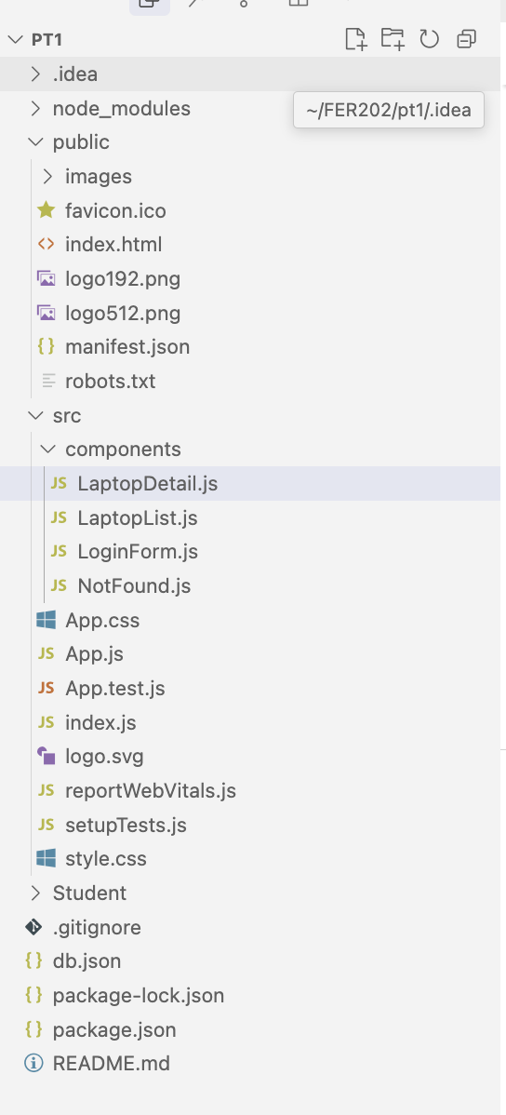

**3.Create a Login Form**

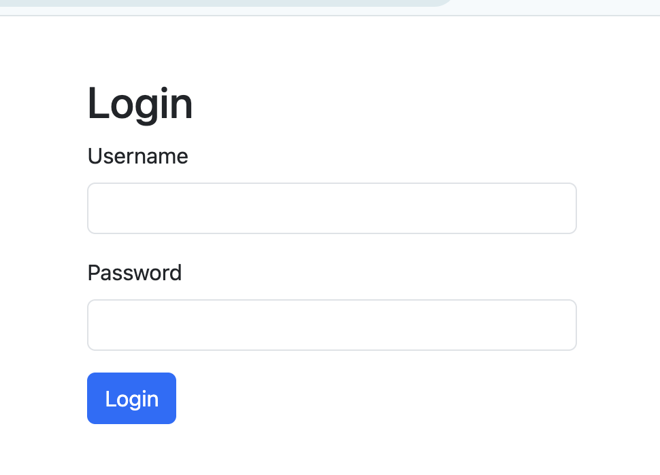

import React, { useState } from 'react';

import { useNavigate } from 'react-router-dom';

import { Form, Button, Modal, Alert } from 'react-bootstrap';

import PropTypes from 'prop-types';

import axios from 'axios';

function LoginForm({ setUser }) {

const [username, setUsername] = useState('');

const [password, setPassword] = useState('');

const [showModal, setShowModal] = useState(false);

const [showAlert, setShowAlert] = useState(false);

const navigate = useNavigate();

const handleSubmit = async (e) => {

e.preventDefault();

try {

const response = await axios.get('http://localhost:3002/UserAccounts', {

params: { username, password }

});

const user = response.data.find(

(u) => u.username === username && u.password === password

);

if (user) {

setUser(user);

setShowModal(true);

setTimeout(() => {

setShowModal(false);

navigate('/laptops');

}, 2000);

} else {

setShowAlert(true);

setTimeout(() => setShowAlert(false), 3000);

}

} catch (error) {

setShowAlert(true);

setTimeout(() => setShowAlert(false), 3000);

}

};

return (

<div className="login-container">

<h2>Login</h2>

{showAlert && <Alert variant="danger">Invalid username or password!</Alert>}

<Form onSubmit={handleSubmit}>

<Form.Group className="mb-3" controlId="formUsername">

<Form.Label>Username</Form.Label>

<Form.Control

type="text"

value={username}

onChange={(e) => setUsername(e.target.value)}

required

/>

</Form.Group>

<Form.Group className="mb-3" controlId="formPassword">

<Form.Label>Password</Form.Label>

<Form.Control

type="password"

value={password}

onChange={(e) => setPassword(e.target.value)}

required

/>

</Form.Group>

<Button variant="primary" type="submit">

Login

</Button>

</Form>

<Modal show={showModal} onHide={() => setShowModal(false)}>

<Modal.Header>

<Modal.Title>Login Successful</Modal.Title>

</Modal.Header>

<Modal.Body>Welcome, {username} login Successful!</Modal.Body>

</Modal>

</div>

);

}

LoginForm.propTypes = {

setUser: PropTypes.func.isRequired,

};

export default LoginForm;

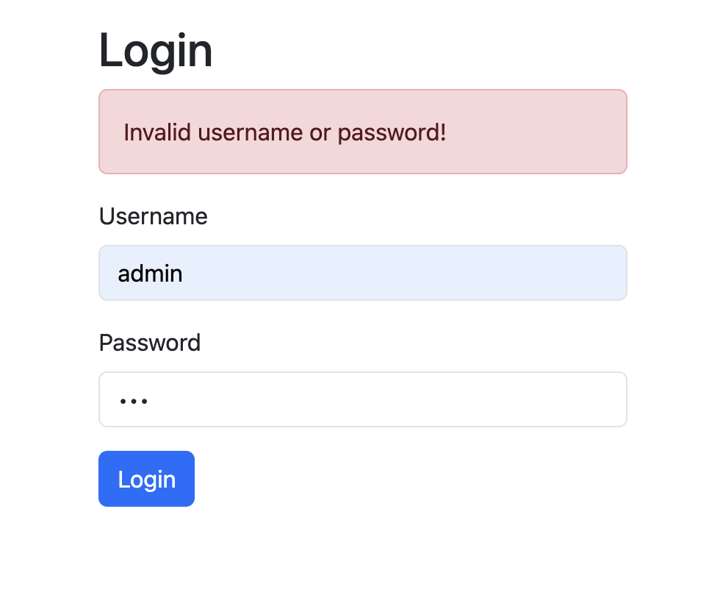

**4.Create Laptop Management Form**

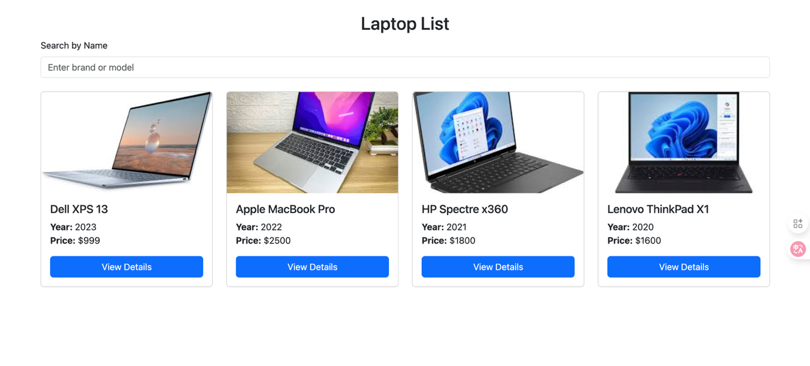

**LoginList.js**

import React, { useState, useEffect } from 'react';

import { Row, Col, Card, Button, Form } from 'react-bootstrap';

import { useNavigate } from 'react-router-dom';

import axios from 'axios';

function LaptopList() {

const [laptops, setLaptops] = useState([]);

const [searchTerm, setSearchTerm] = useState('');

const [filteredLaptops, setFilteredLaptops] = useState([]);

const navigate = useNavigate();

useEffect(() => {

axios.get('http://localhost:3002/Laptops')

.then(res => {

setLaptops(res.data);

setFilteredLaptops(res.data);

})

.catch(err => console.error(err));

}, []);

useEffect(() => {

// Filter mỗi khi searchTerm thay đổi

const filtered = laptops.filter(

(laptop) =>

laptop.brand.toLowerCase().includes(searchTerm.toLowerCase()) ||

laptop.model.toLowerCase().includes(searchTerm.toLowerCase())

);

setFilteredLaptops(filtered);

}, [searchTerm, laptops]);

return (

<div>

<h2 className="text-center">Laptop List</h2>

<Form className="mb-4">

<Form.Group controlId="searchLaptop">

<Form.Label>Search by Name</Form.Label>

<Form.Control

type="text"

value={searchTerm}

onChange={(e) => setSearchTerm(e.target.value)}

placeholder="Enter brand or model"

/>

</Form.Group>

</Form>

<Row>

{filteredLaptops.map(laptop => (

<Col key={laptop.id} md={3} className="mb-4 d-flex">

<Card className="h-100 d-flex flex-column w-100">

<Card.Img

variant="top"

src={laptop.image}

style={{ width: '100%', height: '180px', objectFit: 'cover', objectPosition: 'center' }}

/>

<Card.Body className="d-flex flex-column">

<Card.Title>{laptop.brand} {laptop.model}</Card.Title>

<Card.Text>

<b>Year:</b> {laptop.year} <br />

<b>Price:</b> {laptop.price}

</Card.Text>

<Button

variant="primary"

className="mt-auto"

onClick={() => navigate(`/laptops/${laptop.id}`)}

>

View Details

</Button>

</Card.Body>

</Card>

</Col>

))}

</Row>

</div>

);

}

export default LaptopList;

**Search by Name**

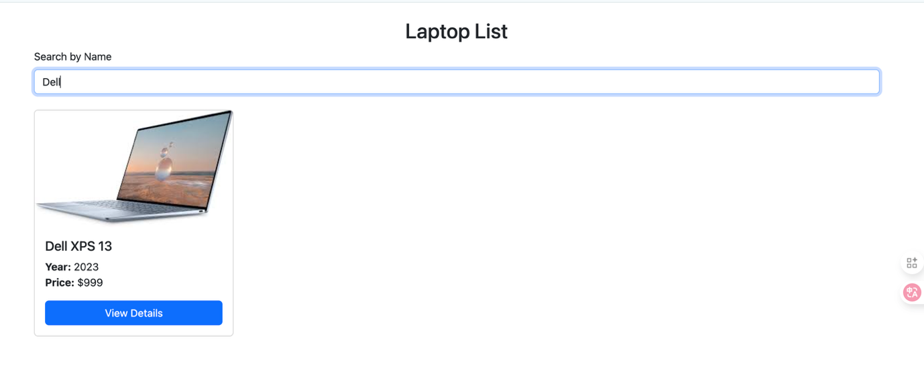

useEffect(() => {

// Filter mỗi khi searchTerm thay đổi

const filtered = laptops.filter(

(laptop) =>

laptop.brand.toLowerCase().includes(searchTerm.toLowerCase()) ||

laptop.model.toLowerCase().includes(searchTerm.toLowerCase())

);

setFilteredLaptops(filtered);

}, [searchTerm, laptops]);

<Form className="mb-4">

<Form.Group controlId="searchLaptop">

<Form.Label>Search by Name</Form.Label>

<Form.Control

type="text"

value={searchTerm}

onChange={(e) => setSearchTerm(e.target.value)}

placeholder="Enter brand or model"

/>

</Form.Group>

</Form>

**View Details**

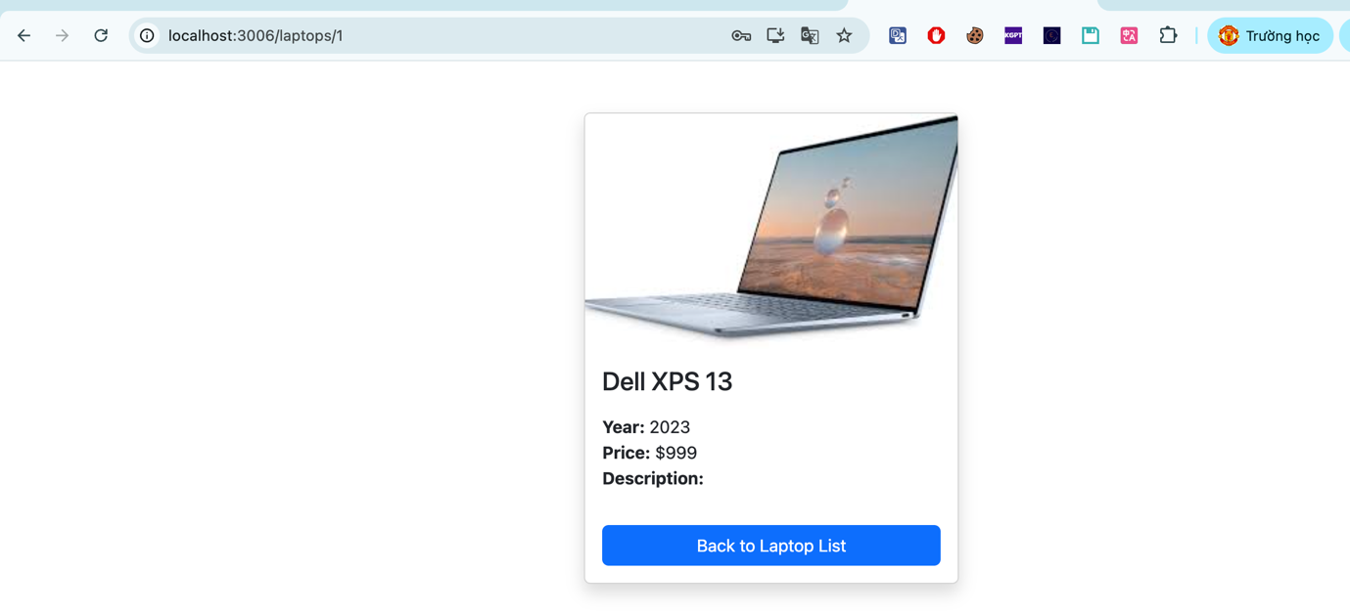

**LotopDetail.js**

import React, { useEffect, useState } from 'react';

import { useParams } from 'react-router-dom';

import axios from 'axios';

import { Card, Container, Button } from 'react-bootstrap';

import { useNavigate } from 'react-router-dom';

function LaptopDetail() {

const { id } = useParams();

const [laptop, setLaptop] = useState(null);

const [notFound, setNotFound] = useState(false);

const navigate = useNavigate();

useEffect(() => {

axios.get(`http://localhost:3002/Laptops/${id}`)

.then(res => {

if (res.data) {

setLaptop(res.data);

} else {

setNotFound(true);

}

})

.catch(() => setNotFound(true));

}, [id]);

if (notFound) {

return <h3 className="text-center text-danger mt-5">404 Not Found: Laptop with id {id} does not exist.</h3>;

}

if (!laptop) {

return null;

}

return (

<Container className="d-flex justify-content-center align-items-center mt-5">

<Card style={{ maxWidth: '350px', width: '100%' }} className="shadow rounded">

<Card.Img

variant="top"

src={laptop.image}

alt={laptop.model}

style={{ objectFit: 'cover', height: '220px', width: '100%' }}

/>

<Card.Body>

<Card.Title className="fs-4 mb-3">{laptop.brand} {laptop.model}</Card.Title>

<Card.Text>

<b>Year:</b> {laptop.year} <br />

<b>Price:</b> {laptop.price} <br />

<b>Description:</b>

</Card.Text>

<Button

variant="primary"

className="mt-3 w-100"

onClick={() => navigate('/laptops')}

>

Back to Laptop List

</Button>

</Card.Body>

</Card>

</Container>

);

}

export default LaptopDetail;

**5. User Interface**

**6. Routing**

**App.js**

import React, { useState } from 'react';

import { BrowserRouter as Router, Routes, Route } from 'react-router-dom';

import { Container } from 'react-bootstrap';

import LoginForm from './components/LoginForm';

import LaptopList from './components/LaptopList.js';

import LaptopDetail from './components/LaptopDetail';

import NotFound from './components/NotFound';

function App() {

const [user, setUser] = useState(null);

return (

<Router>

<Container className="my-4">

<Routes>

<Route path="/" element={<LoginForm setUser={setUser} />} />

<Route path="/laptops" element={<LaptopList user={user} />} />

<Route path="/laptops/:id" element={<LaptopDetail />} />

<Route path="*" element={<NotFound />} />

</Routes>

</Container>

</Router>

);

}

export default App;