Ví Dụ 1:

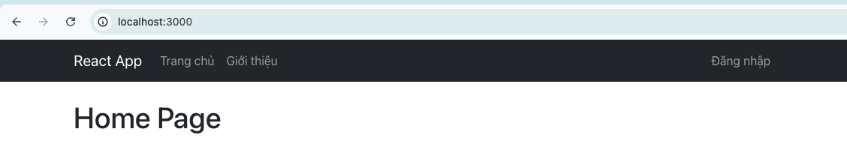

import *React* from 'react';  
  
function *Home*() {  
 return <h1>Home Page</h1>;  
}  
  
export default *Home*;

import *React* from 'react';  
  
function *About*() {  
 return <h1>About Page</h1>;  
}  
  
export default *About*;

Ví Dụ 2:

{  
 "posts": [  
 {  
 "id": 1,  
 "title": "React Router Basics",  
 "content": "This post explains the basics of React Router in a React application.",  
 "author": "Admin"  
 },  
 {  
 "id": 2,  
 "title": "React Bootstrap Introduction",  
 "content": "This post introduces how to use React Bootstrap to create beautiful UIs.",  
 "author": "User"  
 },  
 {  
 "id": 3,  
 "title": "JavaScript ES6 Features",  
 "content": "This post discusses the new features introduced in JavaScript ES6.",  
 "author": "Admin"  
 }  
 ],  
 "users": [  
 {  
 "id": 1,  
 "username": "admin",  
 "password": "123456",  
 "name": "Quản trị viên"  
 },  
 {  
 "id": 2,  
 "username": "THP",  
 "password": "123456",  
 "name": "Người dùng thường"  
 }  
 ]  
}

Ví Dụ 3:

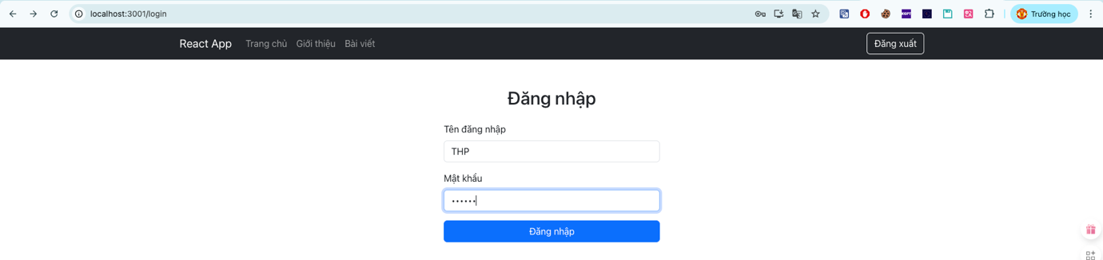

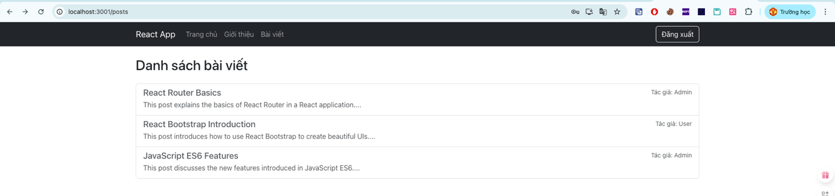

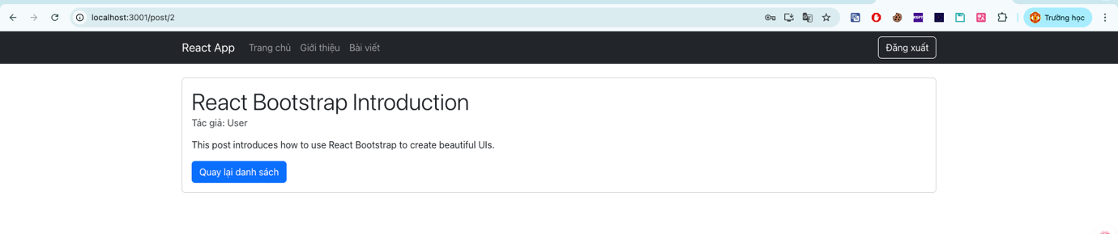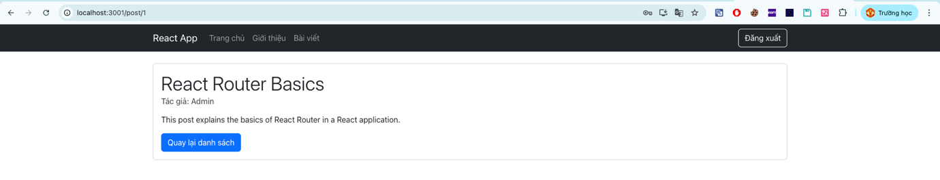

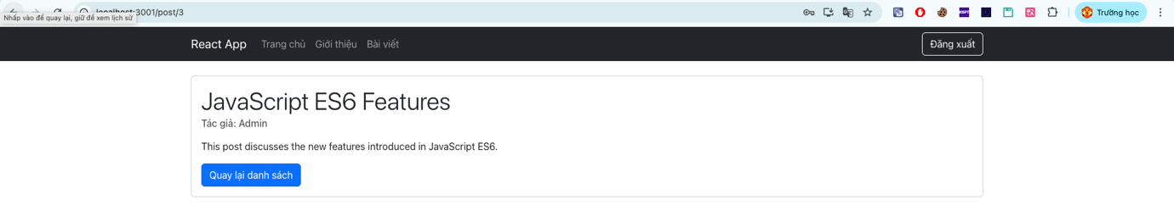

import *React* from 'react';  
import { Navbar, Nav, *Container*, *Button* } from 'react-bootstrap';  
import { *Link*, *useNavigate* } from 'react-router-dom';  
  
function *Navigation*() {  
 const navigate = *useNavigate*();  
 const isAuthenticated = localStorage.getItem('isAuthenticated');  
  
 const handleLogout = () => {  
 localStorage.removeItem('isAuthenticated');  
 navigate('/login');  
 };  
  
 return (  
 <Navbar bg="dark" variant="dark" expand="lg">  
 <Container>  
 <Navbar.Brand as={*Link*} to="/">React App</Navbar.Brand>  
 <Navbar.Toggle aria-controls="basic-navbar-nav" />  
 <Navbar.Collapse id="basic-navbar-nav">  
 <Nav className="me-auto">  
 <Nav.Link as={*Link*} to="/">Trang chủ</Nav.Link>  
 <Nav.Link as={*Link*} to="/about">Giới thiệu</Nav.Link>  
 {isAuthenticated && <Nav.Link as={*Link*} to="/posts">Bài viết</Nav.Link>}  
 </Nav>  
 <Nav>  
 {isAuthenticated ? (  
 <Button variant="outline-light" onClick={handleLogout}>Đăng xuất</Button>  
 ) : (  
 <Nav.Link as={*Link*} to="/login">Đăng nhập</Nav.Link>  
 )}  
 </Nav>  
 </Navbar.Collapse>  
 </Container>  
 </Navbar>  
 );  
}  
  
export default *Navigation*;

import *React*, { *useState*, *useEffect* } from 'react';  
import { *Link* } from 'react-router-dom';  
import { Alert, *Spinner* } from 'react-bootstrap';  
  
function *Post*() {  
 const [posts, setPosts] = *useState*([]);  
 const [loading, setLoading] = *useState*(true);  
 const [error, setError] = *useState*('');  
  
 *useEffect*(() => {  
 const fetchPosts = async () => {  
 try {  
 const response = await *fetch*('http://localhost:3000/posts');  
 if (!response.ok) {  
 throw new *Error*(`Lỗi HTTP! Status: ${response.status} - ${response.statusText}`);  
 }  
 const contentType = response.headers.get('Content-Type');  
 if (!contentType || !contentType.includes('application/json')) {  
 const text = await response.text();  
 console.error('Phản hồi không phải JSON:', text);  
 throw new *Error*('Phản hồi từ server không phải JSON');  
 }  
 const data = await response.json();  
 setPosts(data);  
 } catch (err) {  
 setError(err.message);  
 } finally {  
 setLoading(false);  
 }  
 };  
  
 fetchPosts();  
 }, []);  
  
 if (loading) {  
 return (  
 <div className="text-center mt-5">  
 <Spinner animation="border" role="status">  
 <span className="visually-hidden">Loading...</span>  
 </Spinner>  
 </div>  
 );  
 }  
  
 if (error) {  
 return <Alert variant="danger">{error}</Alert>;  
 }  
  
 return (  
 <div className="mt-4">  
 <h2 className="mb-4">Danh sách bài viết</h2>  
 <div className="list-group">  
 {posts.map(post => (  
 <Link  
 key={post.id}  
 to={`/post/${post.id}`}  
 className="list-group-item list-group-item-action"  
 >  
 <div className="d-flex w-100 justify-content-between">  
 <h5 className="mb-1">{post.title}</h5>  
 <small>Tác giả: {post.author}</small>  
 </div>  
 <p className="mb-1">{post.content.substring(0, 100)}...</p>  
 </Link>  
 ))}  
 </div>  
 </div>  
 );  
}  
  
export default *Post*;

import *React*, { *useState*, *useEffect* } from 'react';  
import { *useParams*, *Link* } from 'react-router-dom';  
import { Alert, Card, *Spinner* } from 'react-bootstrap';  
  
function *PostDetail*() {  
 const { id } = *useParams*();  
 const [post, setPost] = *useState*(null);  
 const [loading, setLoading] = *useState*(true);  
 const [error, setError] = *useState*('');  
  
 *useEffect*(() => {  
 const fetchPost = async () => {  
 try {  
 const response = await *fetch*(`http://localhost:3000/posts/${id}`);  
 if (!response.ok) {  
 throw new *Error*(`Lỗi HTTP! Status: ${response.status}`);  
 }  
 const contentType = response.headers.get('Content-Type');  
 if (!contentType || !contentType.includes('application/json')) {  
 const text = await response.text();  
 console.error('Phản hồi không phải JSON:', text);  
 throw new *Error*('Phản hồi từ server không phải JSON');  
 }  
 const data = await response.json();  
 setPost(data);  
 } catch (err) {  
 setError(err.message);  
 } finally {  
 setLoading(false);  
 }  
 };  
  
 fetchPost();  
 }, [id]);  
  
 if (loading) {  
 return (  
 <div className="text-center mt mc-5">  
 <Spinner animation="border" role="status">  
 <span className="visually-hidden">Loading...</span>  
 </Spinner>  
 </div>  
 );  
 }  
  
 if (error) {  
 return (  
 <Alert variant="danger" className="mt-4">  
 {error}  
 <div className="mt-2">  
 <Link to="/posts" className="btn btn-primary">Quay lại danh sách</Link>  
 </div>  
 </Alert>  
 );  
 }  
  
 return (  
 <div className="mt-4">  
 <Card>  
 <Card.Body>  
 <Card.Title className="display-6">{post?.title}</Card.Title>  
 <Card.Subtitle className="mb-3 text-muted">  
 Tác giả: {post?.author}  
 </Card.Subtitle>  
 <Card.Text>{post?.content}</Card.Text>  
 <Link to="/posts" className="btn btn-primary">Quay lại danh sách</Link>  
 </Card.Body>  
 </Card>  
 </div>  
 );  
}  
  
export default *PostDetail*;

import { *Navigate*, *Outlet* } from 'react-router-dom';  
  
const *ProtectedRoute* = () => {  
 const isAuthenticated = localStorage.getItem('isAuthenticated');  
  
 return isAuthenticated ? <Outlet /> : <Navigate to="/login" />;  
};  
  
export default *ProtectedRoute*;

import *React* from 'react';  
import { *Routes*, *Route* } from 'react-router-dom';  
import *Home* from './components/Home';  
import *About* from './components/About';  
import *Navigation* from './components/Navigation';  
import { *Container* } from 'react-bootstrap';  
import *Post* from './components/Post';  
import *PostDetail* from './components/PostDetail';  
import *Login* from './components/Login';  
import *ProtectedRoute* from './components/ProtectedRoute';  
  
function *App*() {  
 return (  
 <div>  
 <Navigation/>  
 <Container className="mt-4">  
 <Routes>  
 <Route path="/" element={<Home />} />  
 <Route path="/about" element={<About />} />  
 <Route path="/login" element={<Login />} />  
  
 {*/\* Các route được bảo vệ \*/*}  
 <Route element={<ProtectedRoute />}>  
 <Route path="/posts" element={<Post />} />  
 <Route path="/post/:id" element={<PostDetail />} />  
 </Route>  
 </Routes>  
 </Container>  
 </div>  
 );  
}  
  
export default *App*;

Ví dụ 4:

