**Ví dụ 1:**

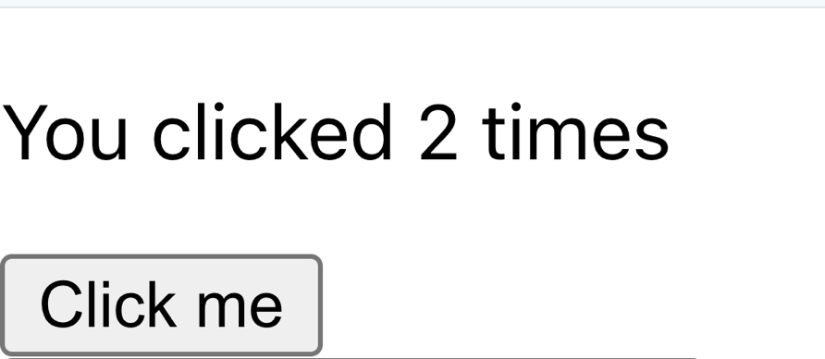

**import *React*, { *useState* } from 'react';  
  
function *Counter*() {  
 const [count, setCount] = *useState*(0);  
  
 return (  
 <div>  
 <p>You clicked {count} times</p>  
 <button onClick={() => setCount(count + 1)}>  
 Click me  
 </button>  
 </div>  
 );  
}  
  
export default *Counter*;**

**Ví dụ 2:**

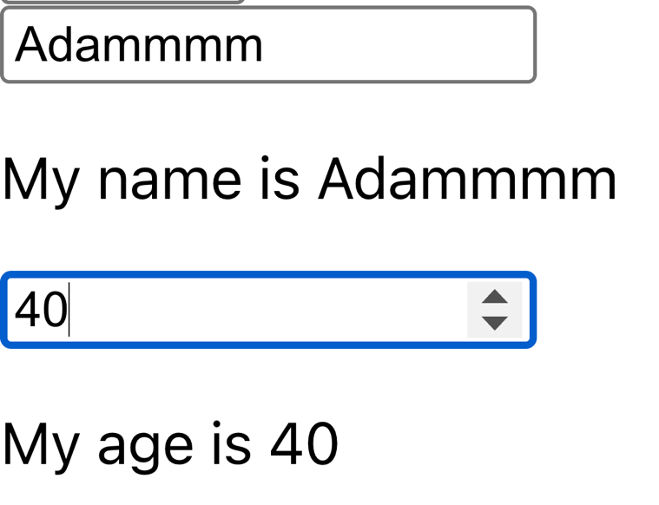

**import { *useState* } from 'react';  
  
function *App*() {  
 const [name, setName] = *useState*('Adam');  
 const [age, setAge] = *useState*(35);  
  
 return (  
 <div>  
 <input  
 type="text"  
 value={name}  
 onChange={(e) => {setName(e.target.value);  
 console.log(e.target.value)  
 }}  
 />  
 <p>My name is {name}</p>  
  
 <input  
 type="number"  
 value={age}  
 onChange={(e) => setAge(*parseInt*(e.target.value, 10))}  
 />  
 <p>My age is {age}</p>  
 </div>  
 );  
}  
  
export default *App*;**

**Ví dụ 3:**



import *React*, { *useState* } from 'react';  
  
function *ProductList*() {  
 const [products, setProducts] = *useState*([  
 { id: 1, name: 'Sản phẩm A' },  
 { id: 2, name: 'Sản phẩm B' },  
 { id: 3, name: 'Sản phẩm C' },  
 ]);  
  
 const [selectedProducts, setSelectedProducts] = *useState*([]);  
  
 const handleCheckboxChange = (event) => {  
 const productId = *parseInt*(event.target.value, 10);  
 if (event.target.checked) {  
 setSelectedProducts([...selectedProducts, productId]);  
 } else {  
 setSelectedProducts(selectedProducts.filter(id => id !== productId));  
 }  
 };  
  
 return (  
 <div>  
 {products.map(product => (  
 <div key={product.id}>  
 <input  
 type="checkbox"  
 id={product.id}  
 value={product.id}  
 checked={selectedProducts.includes(product.id)}  
 onChange={handleCheckboxChange}  
 />  
 <label htmlFor={product.id}>{product.name}</label>  
 </div>  
 ))}  
  
 {selectedProducts.length > 0 && (  
 <p>Bạn đã chọn các sản phẩm: {selectedProducts.map(id => products.find(p => p.id === id).name).join(', ')}</p>  
 )}  
 </div>  
 );  
}  
  
export default *ProductList*;

**Ví Dụ 4**

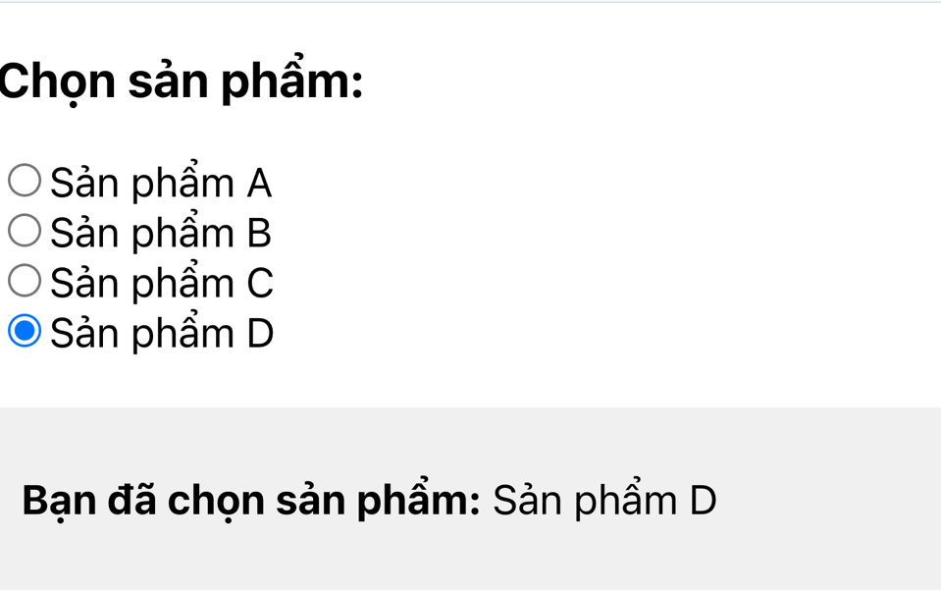

import *React*, { *useState* } from 'react';  
  
function *ProductRadioList*() {  
 const [products, setProducts] = *useState*([  
 { id: 1, name: 'Sản phẩm A' },  
 { id: 2, name: 'Sản phẩm B' },  
 { id: 3, name: 'Sản phẩm C' },  
 { id: 4, name: 'Sản phẩm D' },  
 ]);  
  
 const [selectedProduct, setSelectedProduct] = *useState*(null);  
  
 const handleRadioChange = (event) => {  
 const productId = *parseInt*(event.target.value, 10);  
 setSelectedProduct(productId);  
 };  
  
 return (  
 <div>  
 <h3>Chọn sản phẩm:</h3>  
 {products.map(product => (  
 <div key={product.id}>  
 <input  
 type="radio"  
 id={product.id}  
 name="product"  
 value={product.id}  
 checked={selectedProduct === product.id}  
 onChange={handleRadioChange}  
 />  
 <label htmlFor={product.id}>{product.name}</label>  
 </div>  
 ))}  
  
 {selectedProduct && (  
 <div style={{ marginTop: '20px', padding: '10px', backgroundColor: '#f0f0f0' }}>  
 <p>  
 <strong>Bạn đã chọn sản phẩm:</strong> {' '}  
 {products.find(p => p.id === selectedProduct)?.name}  
 </p>  
 </div>  
 )}  
 </div>  
 );  
}  
  
export default *ProductRadioList*;