Excercise 1:

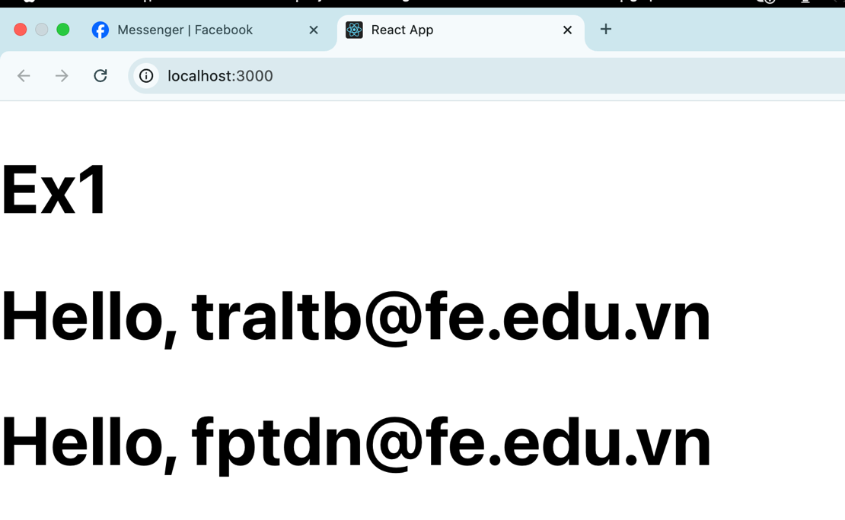

NameList.js

const *NameList* = ({ names }) => {  
 return (  
 <div>  
 <ul>  
 {names.map((name, index) => (  
 <li key={index}>{name}</li>  
 ))}  
 </ul>  
 </div>  
 );  
};  
export default *NameList*;

App.js

import "./App.css";  
import *Welcome* from "./components/Welcome";  
  
function *App*() {  
 return (  
 <div>  
 <h1>Ex1</h1>  
 <>  
 <Welcome name="traltb@fe.edu.vn" />  
 <Welcome name="fptdn@fe.edu.vn" />  
 </>  
 </div>  
 );  
}  
  
export default *App*;

Exercise 2:

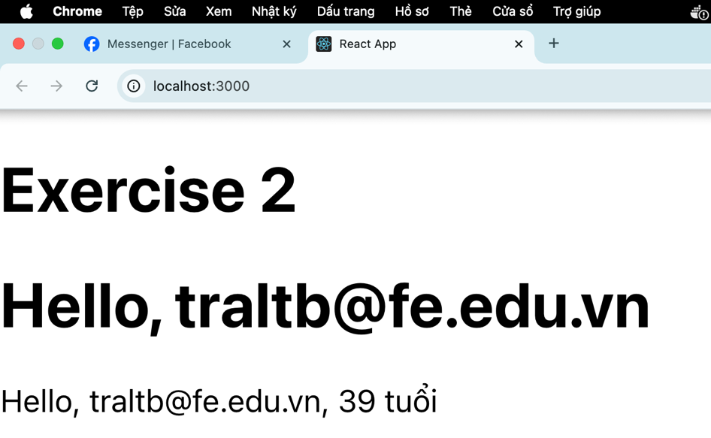

UserProfile.js

const *UserProfile* = ({ user }) => (  
 <div>  
 <p>  
 Hello, {user.name}, {user.age} tuổi  
 </p>  
 </div>  
);  
export default *UserProfile*;

App.js

import *UserProfile* from "./components/UserProfile";  
import *Welcome* from "./components/Welcome";  
  
function *App*() {  
 const userData = { name: "traltb@fe.edu.vn", age: 39 };  
 return (  
 <div>  
 <h1>Exercise 2</h1>  
 <>  
 <Welcome name="traltb@fe.edu.vn" />  
 <UserProfile user={userData} />  
 </>  
 </div>  
 );  
}  
  
export default *App*;

Exercise 3: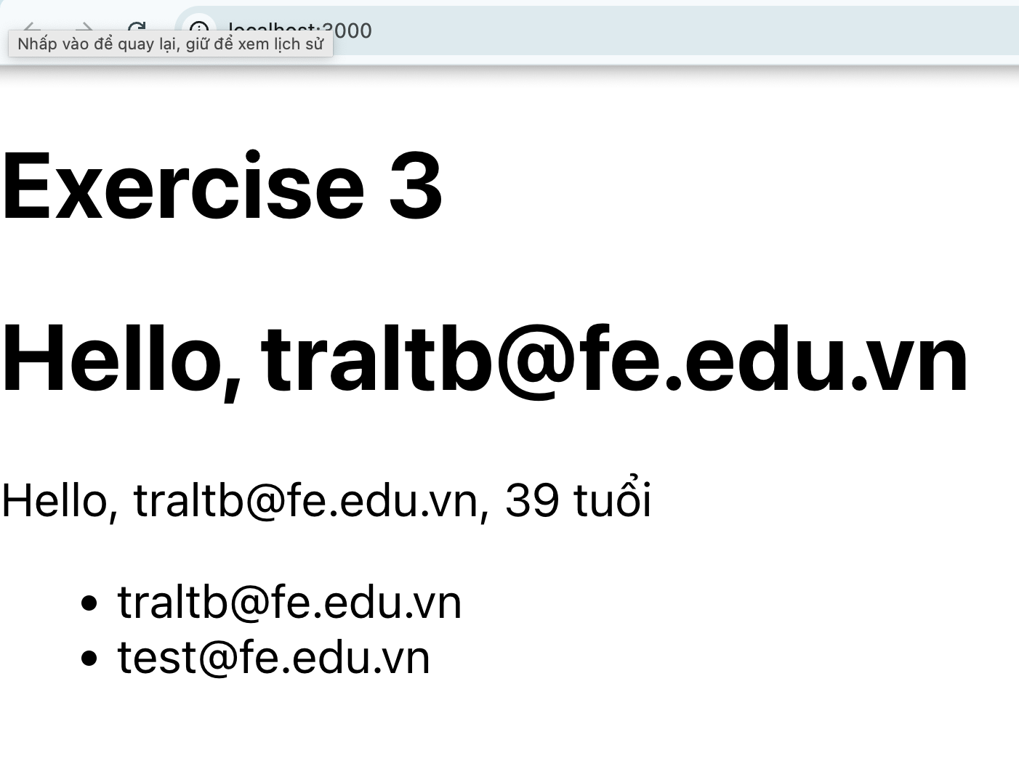

import *NameList* from "./components/NameList";  
import *UserProfile* from "./components/UserProfile";  
import *Welcome* from "./components/Welcome";  
  
function *App*() {  
 const userData = { name: "traltb@fe.edu.vn", age: 39 };  
 const namesList = ["traltb@fe.edu.vn", "test@fe.edu.vn"];  
 return (  
 <div>  
 <h1>Exercise 3</h1>  
 <>  
 <Welcome name="traltb@fe.edu.vn" />  
 <UserProfile user={userData} />  
 <NameList names={namesList} />  
 </>  
 </div>  
 );  
}  
  
export default *App*;

Excercise 4:

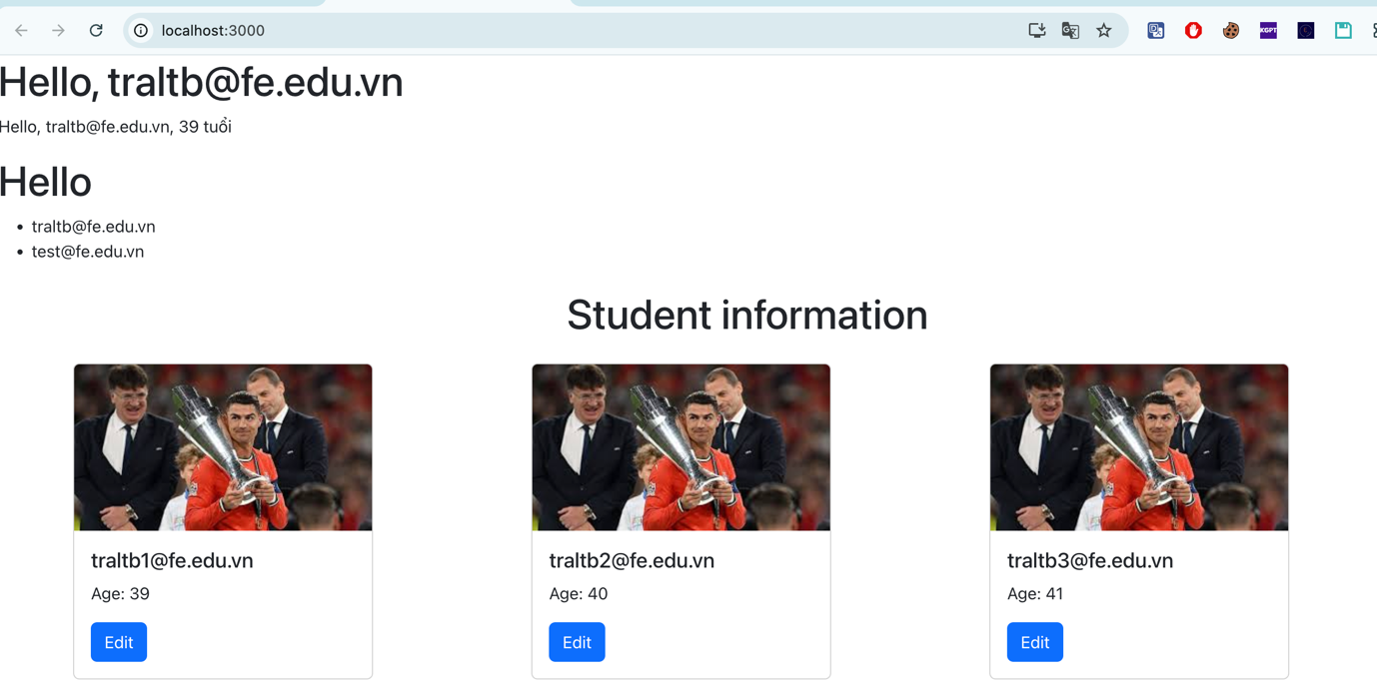

Student Card

import *React* from "react";  
import { Card, *Button* } from "react-bootstrap";  
  
const *StudentCard* = ({ student }) => {  
 return (  
 <Card style={{ width: "18rem" }} className="mb-4">  
 <Card.Img  
 variant="top"  
 src={student.avatar}  
 alt={`${student.name}'s avatar`}  
 />  
 <Card.Body>  
 <Card.Title>{student.name}</Card.Title>  
 <Card.Text>Age: {student.age}</Card.Text>  
 <Button variant="primary">Edit</Button>  
 </Card.Body>  
 </Card>  
 );  
};  
  
export default *StudentCard*;

App.js

import *NameList* from "./components/NameList";  
import *UserProfile* from "./components/UserProfile";  
import *Welcome* from "./components/Welcome";  
import *React* from "react";  
import { *Container*, *Row*, *Col* } from "react-bootstrap";  
// Dùng Container, Row, Col để bố trí các Card  
import *StudentCard* from "./components/StudentCard"; // Import StudentCard component  
  
function *App*() {  
 const userData = { name: "traltb@fe.edu.vn", age: 39 };  
 const namesList = ["traltb@fe.edu.vn", "test@fe.edu.vn"];  
 //Danh sach students  
 const students = [  
 { name: "traltb1@fe.edu.vn", age: 39, avatar: "images/student1.png" },  
 { name: "traltb2@fe.edu.vn", age: 40, avatar: "images/student2.png" },  
 { name: "traltb3@fe.edu.vn", age: 41, avatar: "images/student3.png" },  
 ];  
 return (  
 <>  
 <Welcome name="traltb@fe.edu.vn"/>  
 <UserProfile user={userData}/>  
 <h1>Hello </h1>  
 <NameList names={namesList}/>  
 <Container>  
 <h1 className="my-4 text-center">Student information</h1>  
 <Row>  
 {*/\*Duyệt qua mảng students và truyền từng đối tượng student vào Student Card\*/*}  
 {students.map((student, index) => (  
 <Col key={index} sm={12} md={4}>  
 <StudentCard student={student}/>  
 </Col>  
 ))}  
 </Row>  
 </Container>  
 </>  
 );  
}  
  
export default *App*;