SOFTWARE REQUIREMENTS SPECIFICATION
(Đặc tả yêu cầu phần mềm)
System: GMS — Gym Management System
Version: 1.0-draft (assembled from docs/step0–8 — 11/11/2026)
Group: GroupOfFour – Class: SWR302 (FALL2026)
Members: Văn Xuân Phước (Leader) – DE190430; Nguyễn Anh Tuấn – DE201152; Nguyễn Ngô Tâm Thiên – DE190385; Đặng Nguyễn Huy – DE201171
Instructor: (điền khi nộp)
Date: 11/11/2026
[MISSING / TODO] Mã lớp / tên GV trên trang bìa còn trống. Zip nộp chưa làm lại — chờ AD-01 (Tuấn #30) và SMD PNG.

Revision History
Version | Date | Author | Description
0.1 | 10/11/2026 | Phuoc | Draft cover + §1–2 scaffold
0.2 | 10/11/2026 | Phuoc | English SRS body + UC-05/06
0.9 | 10–11/11/2026 | Team | Merge steps 1–7 drafts into repo
1.0-draft | 11/11/2026 | Phuoc (Leader) | Full assemble from docs/step*; placeholders for unfinished teammate items
1.0 |  | Team | [MISSING] Official freeze after AD-01 + SMD PNG + peer reviews

1. Introduction

1.1 Purpose
This SRS specifies requirements for GMS version 1.0 — a gym management system covering membership registration/activation with QR check-in/out, personal trainer (PT) services, payments, notifications, complaints, and operational reports. Readers: Gym Owner / product owner, SWR302 analysts, developers/testers, and the course instructor. Sources: docs/01_Vision_Scope_GMS.md, docs/step1/*.

1.2 Document Conventions
Font: Times New Roman 12–13; IDs: BO-xx, BR-xx, UC-xx, FR-xx, NFR-<TYPE>-xx, SCR-xx, CD/UCD/AD/SMD/ERD-xx. Priority: High / Medium / Low. Keywords: shall (mandatory), should (recommended), may (optional). End-user UI language: Vietnamese; this SRS body: English (team convention). Canonical Business Rules: Vision BR-01…BR-12 in §2.6 (note: docs/step3/huy_br_glossary.md uses a different BR numbering — do not mix IDs).

1.3 Project Scope
GMS centralizes gym operations: customer & PT accounts, membership packages, counter registration & activation, QR gate events, PT booking lifecycle, payments, SMS/in-app notifications, basic complaints, and Excel operational reports.
Business objectives
ID | Business objective | Success metric
BO-01 | Reduce front-desk register→activate time (Thiên) | ≤ 5 minutes / customer for ≥ 90% paid cases within 1 month
BO-02 | Increase valid check-in compliance (Thiên) | ≥ 95% entries logged; 100% non-ACTIVE QR denied ≤ 2s
BO-03 | Increase PT revenue; reduce hanging bookings (Vision; Tuấn draft empty) | ≥ 80% Pending leave Pending within 24h; PT no-show ≤ 15%
BO-04 | Owner decisions from operational data (Huy) | ≥ 90% monthly Excel exports ≤ 60s; Owner opens reports ≥ 1×/week in ≥ 10/12 weeks

[MISSING / TODO] Tuấn step1/tuan_vision.md vẫn trống — BO-03 lấy từ Vision chung; cần Tuấn xác nhận metric.
In scope / Out of scope (Release 1)
In scope (Release 1) | Out of scope / Later
Register/login/profile for Customer, PT, Owner | Native iOS/Android apps
Membership packages; counter register + activate; QR | Hardware turnstile / biometrics
QR check-in / check-out + manual code extend | Apple/Google Wallet pass
PT approval; PT packages; book/confirm/reject; record session | External PT marketplace
Online payment + cash; SMS/in-app notify | Full accounting ERP
Basic complaints; operational reports + Excel export | AI plans; multi-branch / multi-currency

1.4 References
# | Reference
1 | HuongDan_Assignment.md — SWR302 assignment guide (FPT)
2 | Nghị định 13/2023/NĐ-CP — personal data protection
3 | Wiegers & Beatty, Software Requirements, 3rd ed.
4 | IEEE Std 830-1998
5 | Visual Paradigm Community documentation
6 | Repo drafts: docs/step1–step8, docs/01_Vision_Scope_GMS.md

2. Overall Description

2.1 Product Perspective
GMS is a new standalone product replacing paper logs / disconnected spreadsheets. It integrates Payment Gateway, SMS Service, and QR Service. Periodic jobs use actor Time/Scheduler.
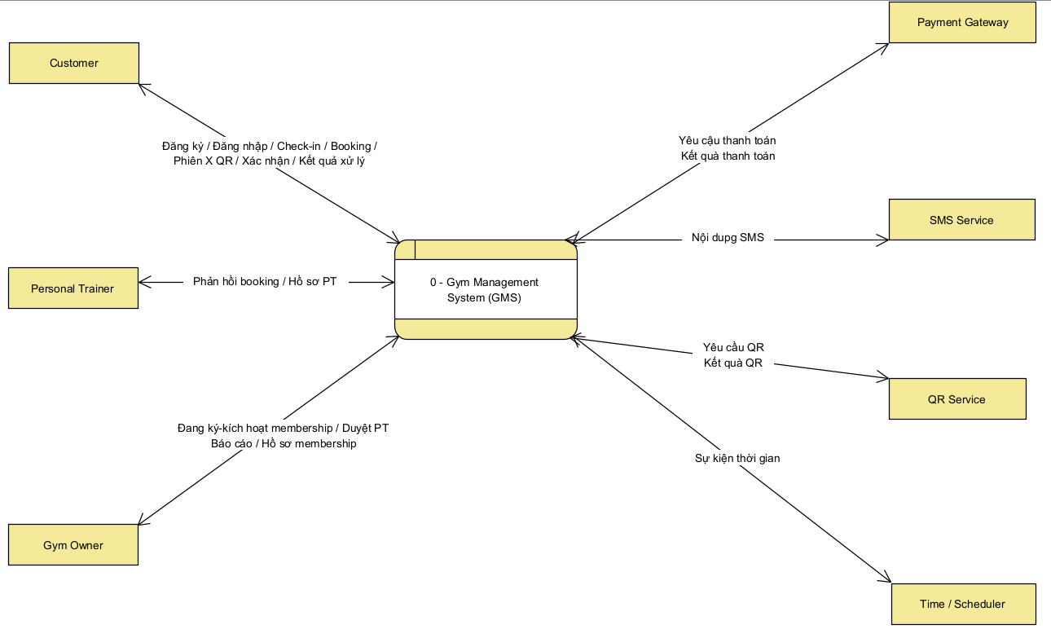
Figure 2.1 — CD-01 Context Diagram of the Gym Management System (GMS)
Source file: 03_Images/CD_ContextDiagram.png · 1 process center; ≥5 external entities; ≥12 noun-named data flows. Owner: Phước #10. Peer note (#42): fix typo labels on VPP re-export. · Export target ≥150 dpi (assignment A.3).
External entities (7) and sample data flows (≥12) — from docs/step2/phuoc_cd.md:
# | Data flow | From | To
1 | Account registration info | Customer | GMS
2 | Login / session | Customer/PT/Owner | GMS
3 | Membership register & activate request | Gym Owner | GMS
4 | Membership profile / QR | GMS | Customer/Owner
5 | Check-in/out event & result | Customer | GMS
6 | Payment request | GMS | Payment Gateway
7 | Payment result | Payment Gateway | GMS
8 | PT booking request & response | Customer/PT | GMS
9 | SMS content | GMS | SMS Service
10 | QR request / validation result | GMS | QR Service
11 | PT approval decision | Gym Owner | GMS
12 | Operational report | GMS | Gym Owner
13 | Time event | Time/Scheduler | GMS
14 | Complaint & handling result | Customer | GMS

[MISSING / TODO] Peer review Thiên (#42): sửa typo nhãn trên ảnh CD (Yêu cầu/Kết quả/Nội dung SMS/Đăng ký) khi mở lại VPP.

2.2 User Classes and Characteristics
User class | Description | Frequency | Skill | Main rights | Favored?
Customer | Gym member (Thiên step1) | High 3–6×/week | Basic smartphone/web | QR, book PT, feedback | Yes
Personal Trainer | Coach managing packages/sessions (Vision; Tuấn step1 empty) | High | Basic–medium | Confirm booking, schedule, record session | Yes
Gym Owner | Owner/manager (Huy step1) | Med–High | Browser + Excel | UC-05/06/17/21/22, packages, complaints | Yes

2.3 Operating Environment
OE-1 Web app on latest Chrome/Edge, responsive. OE-2 Front desk PC/tablet; gate tablet camera for QR. OE-3 Linux cloud HTTPS; shared relational DB. OE-4 REST Payment Gateway, SMS API, QR module. (Huy step1)

2.4 Design and Implementation Constraints
CON-1 Decree 13/2023/NĐ-CP for PII. CON-2 UI Vietnamese; VND; UTC+7; dd/mm/yyyy. CON-3 UML/DFD/ERD in Visual Paradigm (.vpp); wireframes Figma/Stitch/draw.io. CON-4 No card PAN storage — gateway only. CON-5 Release 1 = single gym site.

2.5 Assumptions and Dependencies
ID | Assumption / Dependency | Impact if false
AS-01 | Authorized staff at counter during open hours | Counter membership blocked
AS-02 | One stable QR per ACTIVE membership | Wrong-person check-in
AS-03 | ACTIVE membership required to book PT | Need walk-in exception flow
DE-01 | Payment Gateway sandbox available | Cannot E2E test payments
DE-02 | SMS provider available | Fallback in-app only
DE-03 | QR camera usable; else ManualEntry extend | Higher deny/retry rate

2.6 Business Rules
Canonical BR set (Vision / UC dressed). Do not confuse with Huy step3 BR renumbering.
ID | Business rule | Type
BR-01 | Only logged-in Gym Owner may register/activate membership at counter | Constraint
BR-02 | Membership becomes ACTIVE only after full fee recorded | Constraint
BR-03 | EndDate = activation date + package DurationMonths (end of day UTC+7) | Computation
BR-04 | Exactly one QR while ACTIVE; invalidate when status ≠ ACTIVE | Constraint
BR-05 | Valid check-in only in open hours AND ACTIVE membership | Constraint
BR-06 | Customer books PT only with ACTIVE membership ≥ 1 day left | Constraint
BR-07 | PT operates bookings only when account Approved | Constraint
BR-08 | PT must respond to Pending within 24h; else auto-Cancel + refund | Action enabler
BR-09 | Reject requires reason; paid → initiate refund | Action enabler
BR-10 | Record session only for Confirmed booking with remaining sessions | Constraint
BR-11 | Scheduler: ACTIVE with end_date < today → EXPIRED, kill QR, SMS | Action enabler
BR-12 | Complaint only within 7 days of related session/event | Constraint

3. System Features

3.1 Use Case Overview
Actors
Actor | Type | User class
Customer | Primary | Customer
Personal Trainer | Primary | PT
Gym Owner | Primary | Gym Owner
Payment Gateway | Secondary | —
SMS Service | Secondary | —
QR Service | Secondary | —
Time / Scheduler | Secondary | —
User (abstract) | Generalization parent | Login/profile shared

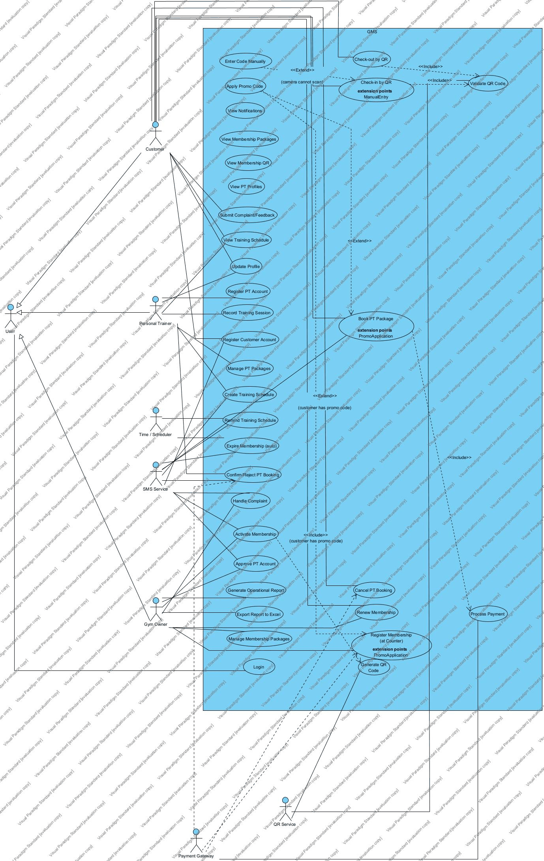
Figure 3.1 — UCD-01 Use Case Overview of GMS
Source file: 03_Images/UCD_Overview.png · Actors + high-priority UCs; generalization User←Customer/PT/Owner. Owner: Phước #15. · Export target ≥150 dpi (assignment A.3).
Package diagrams (Step 3)
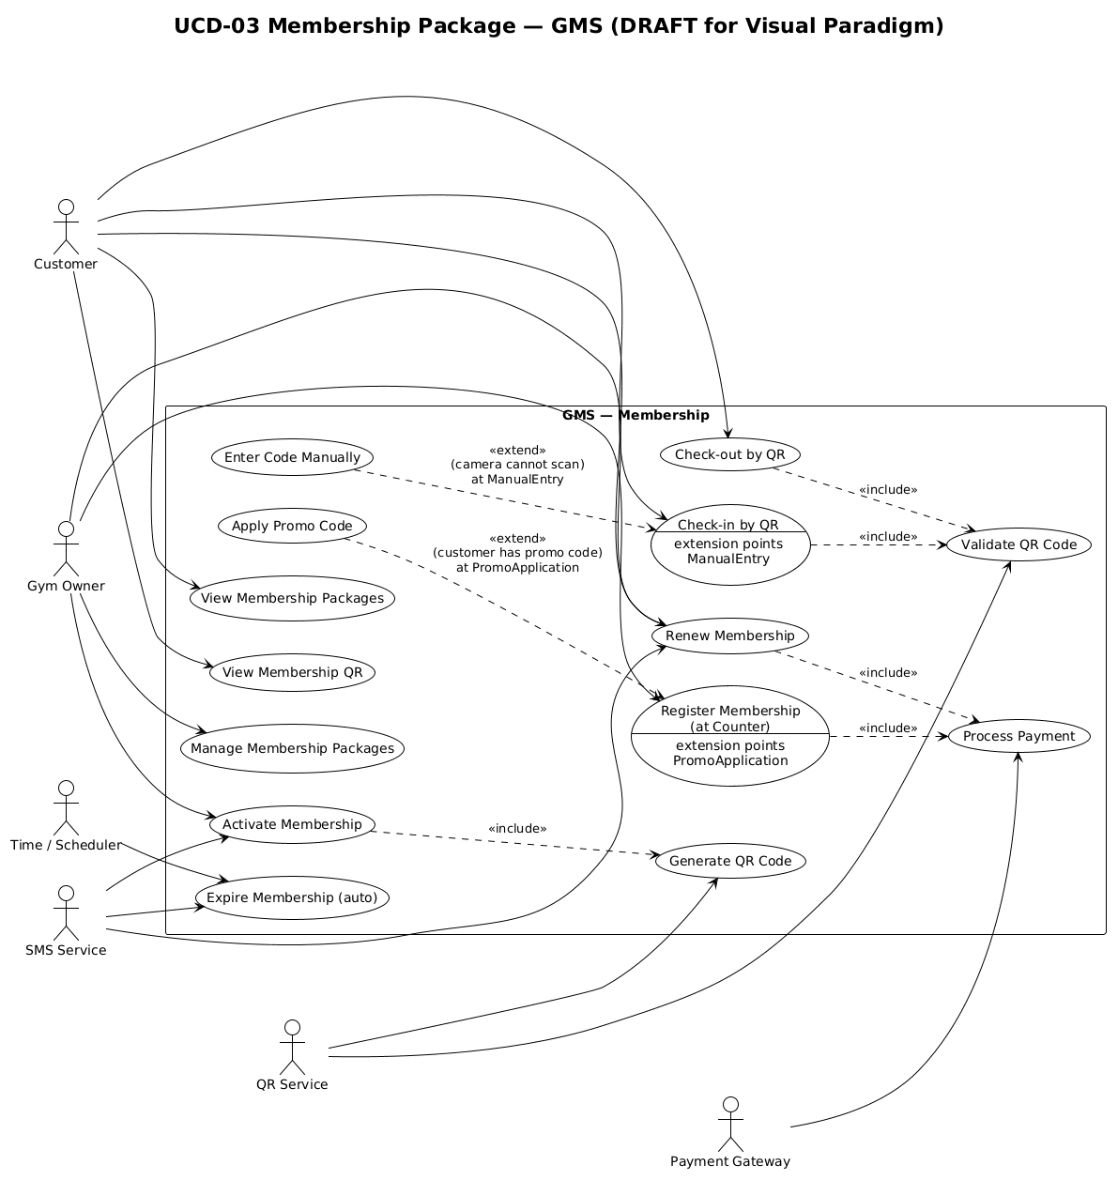
Figure 3.2 — UCD Membership package
Source file: 03_Images/UCD_Membership.png · Package Membership (UC-05…09, activate, QR). Owner: Thiên #16. · Export target ≥150 dpi (assignment A.3).
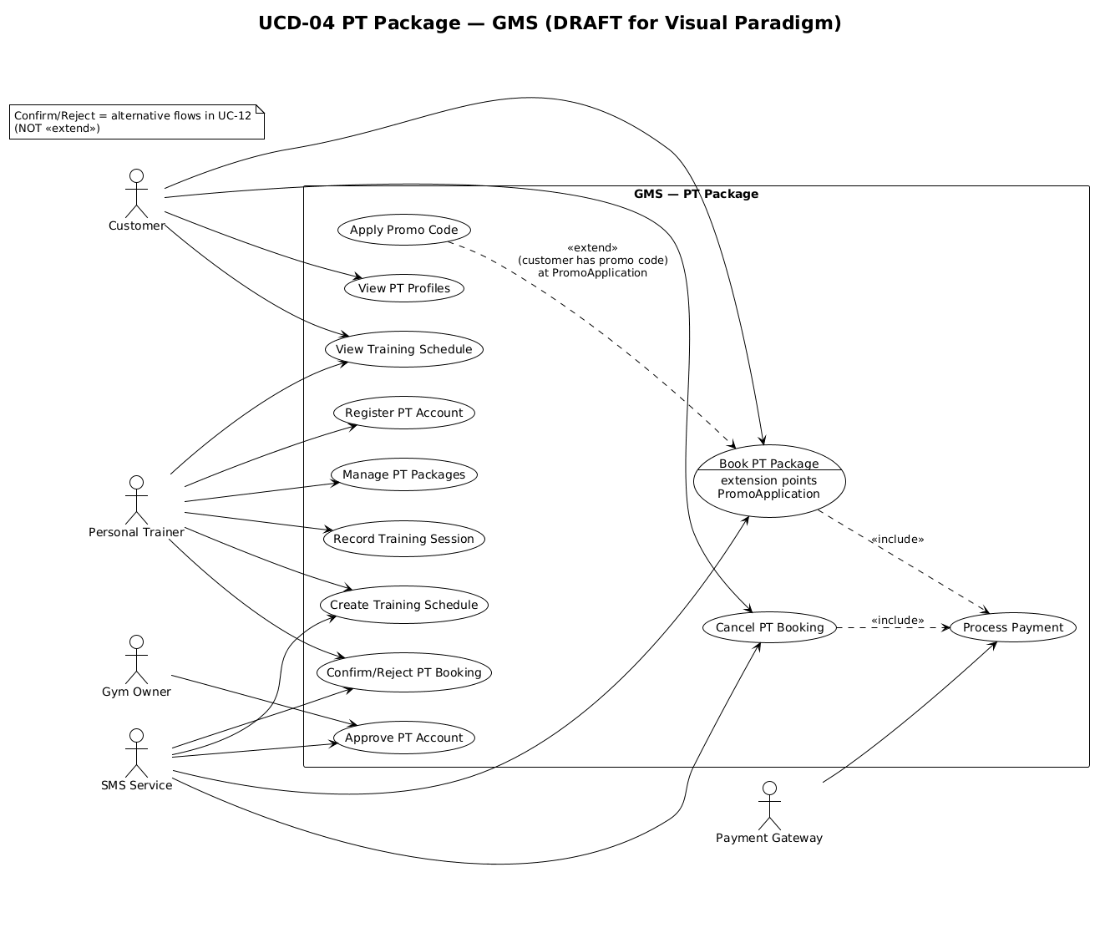
Figure 3.3 — UCD PT package
Source file: 03_Images/UCD_PT.png · Package PT Services (book/confirm/record/register PT). Owner: Tuấn #17. · Export target ≥150 dpi (assignment A.3).
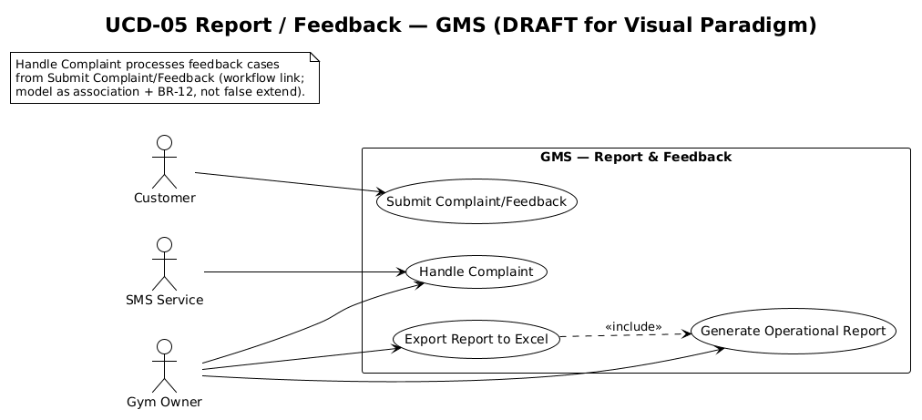
Figure 3.4 — UCD Report / Feedback package
Source file: 03_Images/UCD_Report_Feedback.png · Reports + complaints (UC-21/22/25/26). Owner: Huy #18. · Export target ≥150 dpi (assignment A.3).
Use case catalogue (excerpt High priority — full list docs/02_UC_List_Detailed.md)
UC-ID | Name | Primary | Priority | Package
UC-05 | Register Membership (at Counter) | Gym Owner | H | Membership
UC-06 | Activate Membership | Gym Owner | H | Membership
UC-08 | Check-in by QR | Customer | H | Membership
UC-11 | Book a PT Package | Customer | H | PT
UC-12 | Confirm/Reject PT Booking | PT | H | PT
UC-15 | Record Training Session | PT | H | PT
UC-16 | Register PT Account | PT | H | PT
UC-17 | Approve/Reject PT | Gym Owner | H | PT
UC-27 | Auto-expire Membership (Time) | Time | H | Membership

3.2 Fully Dressed Use Cases (≥8)

3.2.1 UC-05 Register Membership (at Counter)
Field | Content
UC ID and Name | UC-05 — Register Membership (at Counter)
Primary Actor | Gym Owner
Secondary Actors | Payment Gateway (optional online payment); Customer (provides personal data at the counter)
Trigger | A walk-in Customer requests a membership package at the counter, or the Gym Owner selects the function **Register Membership**.
Description | Gym Owner registers a membership for a Customer at the gym counter: identifies the Customer, selects a Membership Package, optionally applies a promo code, records payment (cash or Payment Gateway), and creates a membership with status **INACTIVE** until activation in UC-06.
Preconditions | 1. Gym Owner has successfully logged in (UC-02). 2. At least one Membership Package is available in the catalog. 3. Customer is present at the counter (or reachable) to provide registration data.
Post conditions | 1. A Membership record is created and linked to the Customer and selected package with status **INACTIVE**. 2. Payment information is recorded (paid in full or pending) according to the chosen method. 3. No membership QR is issued in this use case (QR is created only in UC-06). 4. If the use case fails, no **ACTIVE** membership exists for this registration.
Normal Flow | 1. Gym Owner selects **Register Membership**. 2. System displays the registration form and the list of available Membership Packages. 3. Gym Owner identifies the Customer (search by phone/email or enter new details: full name, phone, email). 4. System validates contact data format and shows whether the Customer already exists. 5. Gym Owner selects a Membership Package. 6. System calculates the payable fee and displays duration and total amount. 7. Gym Owner confirms the registration summary. 8. System creates a Membership record with status **INACTIVE**. 9. Gym Owner collects payment (records cash/transfer in GMS, or pays online via Payment Gateway — «include» **Process Payment** when gateway is used). 10. System records the payment result. 11. System displays success with Membership ID and prompts the Owner to continue with **Activate Membership (UC-06)** when the fee is fully paid.
Alternative Flows | 1. **Apply promo code** (extension point *PromoApplication*): At Normal Flow step 6, if the Customer has a promo code, Gym Owner enters the code; System validates it and recalculates the fee; resume at step 7. 2. **Existing Customer**: At step 4, if phone/email already belongs to a Customer, System shows the existing profile; Gym Owner confirms reuse; resume at step 5. 3. **Cash / offline payment only**: At step 9, if payment is cash or bank transfer confirmed offline, Gym Owner marks “Paid in full at counter” with a reference note; System stores payment without calling Payment Gateway; resume at step 11. 4. **Cancel before confirm**: At step 7, if Gym Owner cancels, System discards the uncommitted form and the use case ends with no new membership.
Exceptions | 1. **Payment Gateway failure**: At steps 9–10, if the gateway returns failure or timeout, System displays the error, keeps the membership **INACTIVE**/unpaid, and allows retry or end (BR-02). 2. **Persistence / system error**: At step 8, if System cannot save the membership, System displays an error and does not confirm success; the use case ends; Owner may retry later. 3. **Invalid or expired promo**: During Alternative Flow 1, if the promo code is invalid/expired, System rejects the code, keeps the original fee, and returns to step 6.
Priority | High
Business Rules | BR-01: Only an authenticated Gym Owner may register membership at the counter. BR-02: Membership must not become **ACTIVE** until the full package fee is recorded (activation is UC-06).

Wireframe SCR-05 (Step 5) — Phước #25
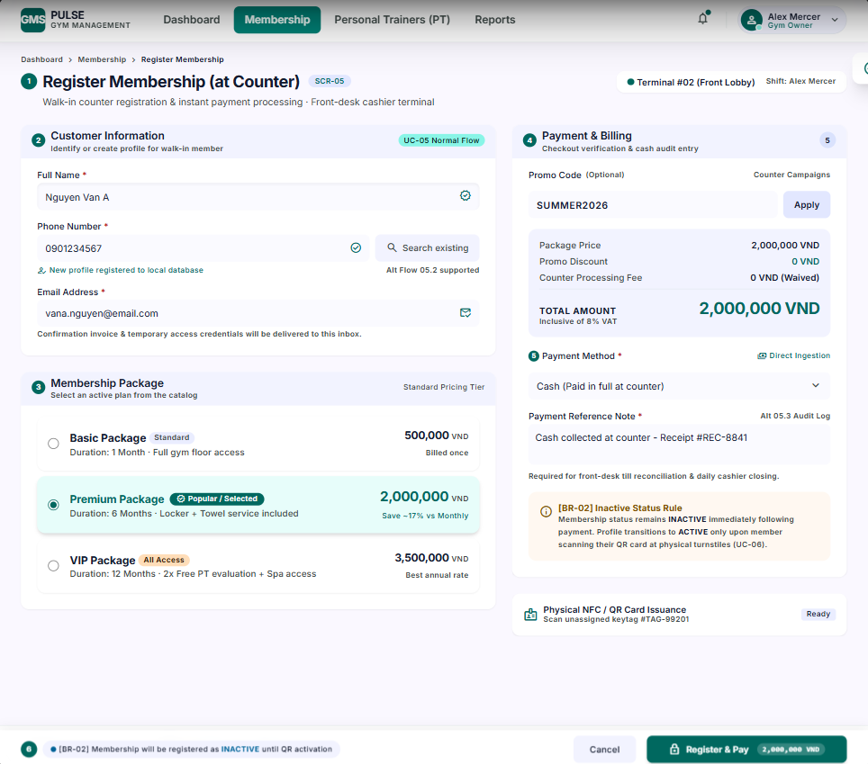
Figure 5.1a — Wireframe SCR-05 (happy path) for UC-05
Source file: 03_Images/UI_UC-05_RegisterMembership.png · Low-fidelity UI · field table in docs/step5 · Phước #25 · Export target ≥150 dpi (assignment A.3).
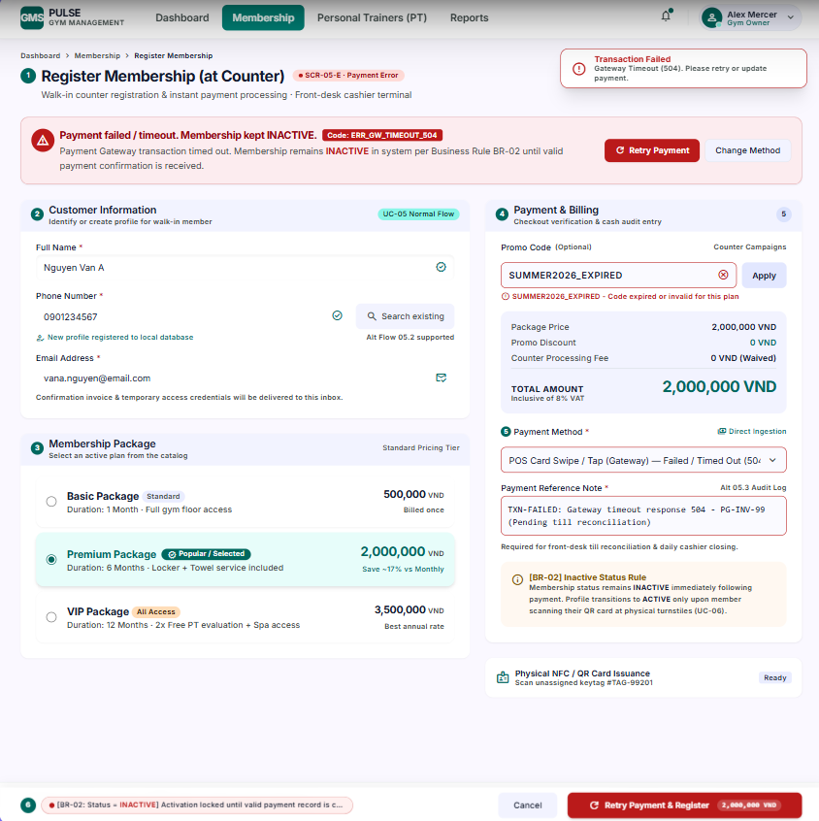
Figure 5.1b — Wireframe SCR-05-E (error / exception state)
Source file: 03_Images/UI_UC-05_RegisterMembership_Error.png · Maps to Exception/Alternative flows in UC-05.md · Phước #25 · Export target ≥150 dpi (assignment A.3).

3.2.2 UC-06 Activate Membership
Field | Content
UC ID and Name | UC-06 — Activate Membership
Primary Actor | Gym Owner
Secondary Actors | QR Service; SMS Service
Trigger | Gym Owner selects a paid **INACTIVE** membership and chooses **Activate**, usually right after completing UC-05.
Description | Gym Owner activates a membership after full payment is recorded. The system sets status to **ACTIVE**, computes the end date, generates a unique membership QR code, and notifies the Customer by SMS.
Preconditions | 1. Gym Owner has successfully logged in (UC-02). 2. The target Membership exists with status **INACTIVE**. 3. The full package fee for that Membership has been recorded as paid (BR-02).
Post conditions | 1. Membership status is **ACTIVE**. 2. `end_date` is set to activation date + package `DurationMonths` (BR-03), end of day UTC+7. 3. Exactly one membership QR is generated and linked (BR-04) via «include» **Generate QR Code**. 4. An activation SMS is sent or queued to the Customer. 5. If the use case fails before success, the membership remains **INACTIVE** and has no usable check-in QR.
Normal Flow | 1. Gym Owner opens the list of memberships pending activation (**INACTIVE** + paid). 2. System displays candidates with Customer name, package, fee status, and created date. 3. Gym Owner selects one Membership and chooses **Activate**. 4. System shows membership details and payment confirmation summary. 5. Gym Owner confirms activation. 6. System verifies that the fee is fully paid (BR-02) and sets membership status to **ACTIVE**. 7. System computes and stores `end_date` = activation date + `DurationMonths` (BR-03). 8. System «include» **Generate QR Code**: requests QR Service to create a unique QR payload for this membership (BR-04). 9. QR Service returns the QR token/image; System stores and links it to the membership. 10. System composes an activation message and sends it to SMS Service with the Customer phone number. 11. SMS Service accepts the message for delivery. 12. System displays activation success (Membership ID, validity period, QR preview/print option).
Alternative Flows | 1. **Fee not fully paid**: At Normal Flow step 6, if payment is incomplete, System blocks activation, shows the outstanding amount (BR-02), and the membership stays **INACTIVE**. 2. **Cancel confirmation**: At step 5, if Gym Owner cancels, System leaves the membership unchanged and the use case ends. 3. **Resend SMS / reprint QR** (optional operations): If the membership is already **ACTIVE**, System allows resend SMS or reprint QR without changing status or end date.
Exceptions | 1. **QR Service failure**: At steps 8–9, if QR Service fails or times out, System rolls back to **INACTIVE** so that no **ACTIVE** membership exists without a QR (BR-04), shows an error, and does not send SMS; Owner may retry. 2. **SMS Service failure**: At steps 10–11, if SMS fails after **ACTIVE** + QR succeeded, System keeps **ACTIVE** and QR, warns that SMS failed, and offers **Resend SMS** (partial success). 3. **Concurrent update**: At step 6, if another session already changed the membership so it is no longer **INACTIVE**, System refreshes status and aborts with a conflict message.
Priority | High
Business Rules | BR-01: Only Gym Owner may activate membership. BR-02: Activation requires full fee recorded. BR-03: End date = activation date + `DurationMonths`. BR-04: Each **ACTIVE** membership has exactly one QR; QR is invalid when status ≠ **ACTIVE**.

Wireframe SCR-06 (Step 5) — Phước #25
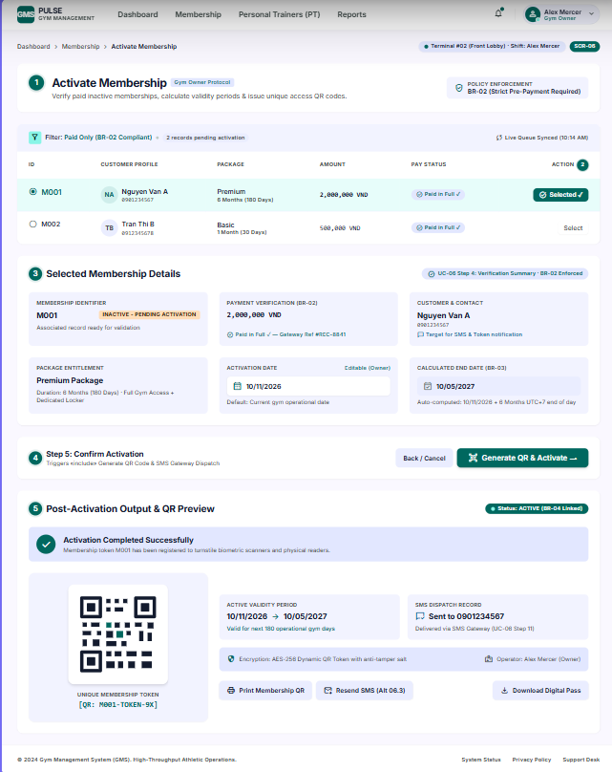
Figure 5.2a — Wireframe SCR-06 (happy path) for UC-06
Source file: 03_Images/UI_UC-06_ActivateMembership.png · Low-fidelity UI · field table in docs/step5 · Phước #25 · Export target ≥150 dpi (assignment A.3).
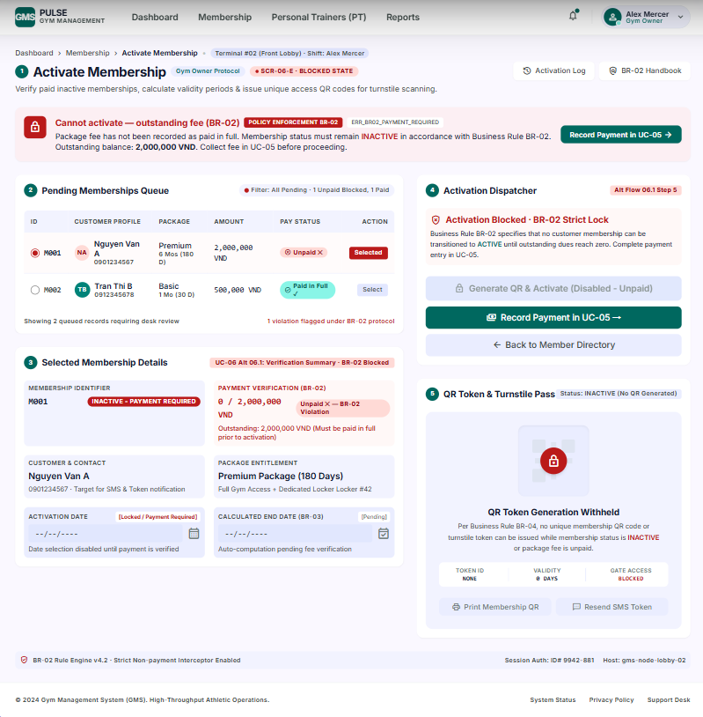
Figure 5.2b — Wireframe SCR-06-E (error / exception state)
Source file: 03_Images/UI_UC-06_ActivateMembership_Error.png · Maps to Exception/Alternative flows in UC-06.md · Phước #25 · Export target ≥150 dpi (assignment A.3).

3.2.3 UC-08 Check-in by QR
Field | Content
UC ID and Name | UC-08 — Check-in by QR
Primary Actor | Customer
Secondary Actors | QR Service
Trigger | Customer arrives at the gym entrance and starts Check-in by QR (scan membership QR at the gate reader / app).
Description | Customer checks in at the gym gate by presenting an ACTIVE membership QR. The system validates the QR, verifies membership status and opening hours, then records a successful check-in.
Preconditions | 1. Customer is authenticated (or presents a valid membership QR linked to an account). 2. Customer has a Membership with status **ACTIVE** and a linked QR token (BR-04). 3. Gate / QR reader (or phone camera) is available.
Post conditions | 1. On success: a CheckInLog entry is created with timestamp and membership ID. 2. Customer is allowed to enter. 3. On failure: no valid check-in is recorded; Customer remains outside / blocked with an error message.
Normal Flow | 1. Customer selects **Check-in by QR** (or presents QR to the gate scanner). 2. System prompts to scan the membership QR. 3. Customer presents the QR code. 4. System «include» **Validate QR Code**: sends payload to QR Service. 5. QR Service returns validation result. 6. System verifies membership is **ACTIVE** and within validity (BR-04). 7. System verifies current time is within gym open hours (BR-05). 8. System creates CheckInLog (membershipId, time, gate/location). 9. System displays check-in success (and opens gate if integrated).
Alternative Flows | 1. **Enter Code Manually** («extend» at extension point `ManualEntry`): At step 3, if the camera cannot scan, Customer/staff enters the membership code manually; System continues from step 4 with the typed code. 2. **Already checked in today (policy optional)**: System warns and asks to confirm duplicate check-in or blocks per gym policy.
Exceptions | 1. **Invalid / expired / inactive QR**: At steps 5–6, System rejects check-in and shows “Membership QR invalid or not ACTIVE” (BR-04). 2. **Outside open hours**: At step 7, System rejects check-in and shows open-hour message (BR-05). 3. **QR Service unavailable**: At step 4–5, System shows service error and does not record check-in; Customer may retry or use ManualEntry if enabled.
Priority | High
Business Rules | BR-04: One valid QR only while membership is ACTIVE. BR-05: Check-in only during open hours and ACTIVE membership.

Wireframe SCR-08 (Step 5) — Thiên #27
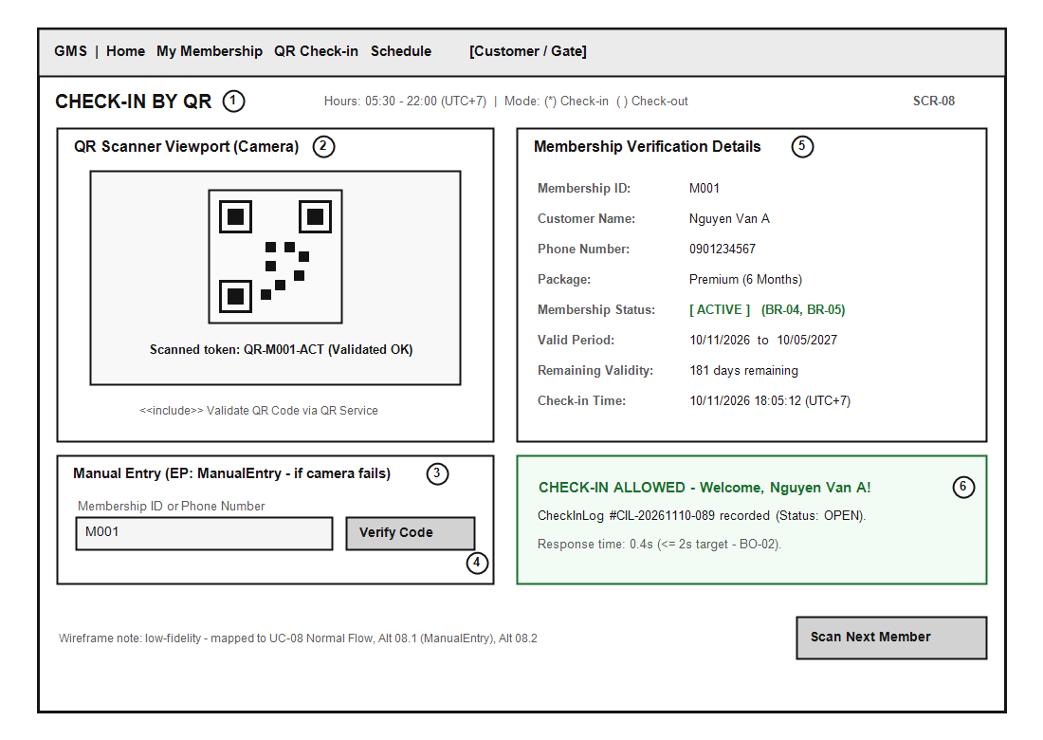
Figure 5.3a — Wireframe SCR-08 (happy path) for UC-08
Source file: 03_Images/UI_UC-08_QRCheckIn.png · Low-fidelity UI · field table in docs/step5 · Thiên #27 · Export target ≥150 dpi (assignment A.3).
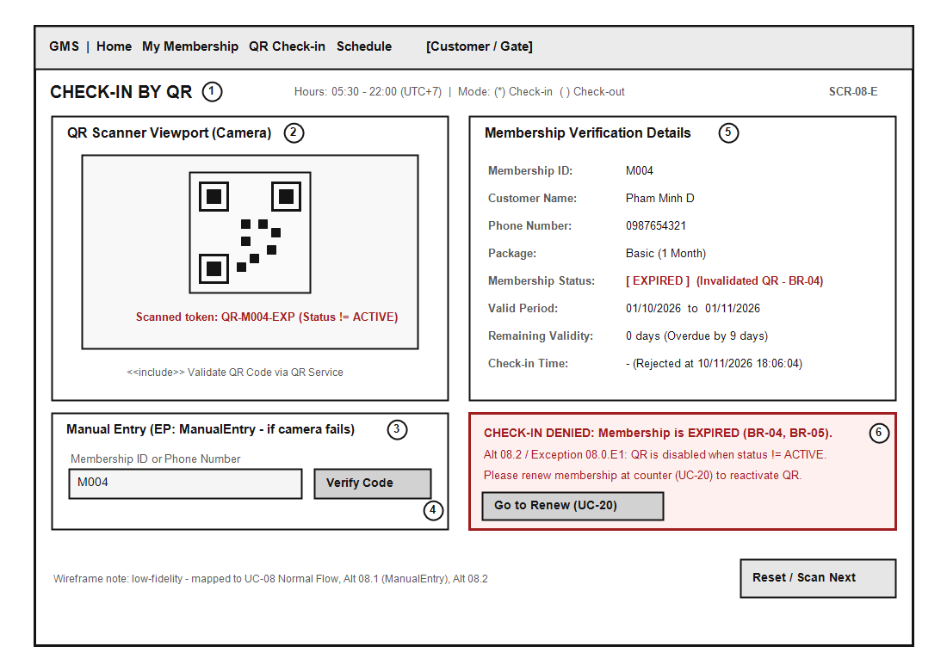
Figure 5.3b — Wireframe SCR-08-E (error / exception state)
Source file: 03_Images/UI_UC-08_QRCheckIn_Error.png · Maps to Exception/Alternative flows in UC-08.md · Thiên #27 · Export target ≥150 dpi (assignment A.3).

3.2.4 UC-11 Book a PT Package
﻿# UC-11 — Book a PT Package
## 1. Use case summary
| Item | Description |
|------|-------------|
| Use case ID | UC-11 |
| Primary actor | Customer |
| Secondary actors | Payment Gateway, SMS Service, Personal Trainer |
| Goal | Allow a Customer to book a PT package and complete the required online payment. |
| Priority | High |
| Related business rules | BR-06, BR-08 |
## 2. Preconditions
1. The Customer is authenticated.
2. The Customer has an ACTIVE membership with at least one valid day remaining.
3. The selected Personal Trainer has an Approved account.
4. The selected PT package is active and available for booking.
## 3. Postconditions
### Success guarantee
- A PT booking is created with status `Pending`.
- The payment result is recorded.
- The booking request is sent to the selected Personal Trainer.
- The Customer receives an in-app/SMS notification containing the booking status.
### Minimal guarantee
- No booking is marked `Confirmed` unless the payment result is successful and the state transition is valid.
- Failed or uncertain payment results are recorded for reconciliation.
## 4. Main success scenario
1. The Customer opens an Approved Personal Trainer's profile.
2. The Customer selects an available PT package.
3. The system displays the package name, number of sessions, price, validity period, and available scheduling information.
4. The Customer selects a preferred date/time and optionally enters a note.
5. The Customer confirms the booking details.
6. The system validates the membership, PT account, package, requested time, and current price.
7. The system creates a pending payment request and sends it to the Payment Gateway.
8. The Payment Gateway returns a successful result.
9. The system records the successful payment and creates the PT booking with status `Pending`.
10. The system sends the booking request to the Personal Trainer.
11. The system sends an in-app/SMS notification to the Customer and displays the booking reference.
## 5. Alternative flows
### A1. Customer enters a valid promotion code
1. At step 4, the Customer enters a promotion code.
2. The system validates the code and recalculates the payable amount.
3. The Customer confirms the updated amount.
4. The use case continues at step 6 of the main scenario.
### A2. Payment is declined
1. At step 8, the Payment Gateway returns `Fail`.
2. The system records the failed payment.
3. The system does not send a booking request to the Personal Trainer.
4. The system informs the Customer and allows the Customer to retry or cancel.
### A3. Customer cancels before payment
1. Before step 8, the Customer cancels the operation.
2. The system cancels the pending payment request, if one exists.
3. The system does not create a valid PT booking.
## 6. Exceptions
### E1. Payment Gateway timeout or uncertain response
1. At step 8, the Payment Gateway does not respond within the configured timeout.
2. The system marks the payment as `Pending` or `Unknown` for reconciliation.
3. The system does not treat the booking as paid or `Confirmed` automatically.
4. The system shows the Customer that the payment is being checked.
### E2. Package or schedule becomes unavailable
1. At step 6, the system detects that the package is inactive, unavailable, or the requested time is no longer valid.
2. The system rejects the request and displays the reason.
3. The Customer must select another package or time.
## 7. Business rules and notes
- BR-06: the Customer must have an ACTIVE membership to book a PT package.
- BR-08: the PT must respond to a Pending booking within 24 hours.
Wireframe SCR-11 (Step 5) — Tuấn #26
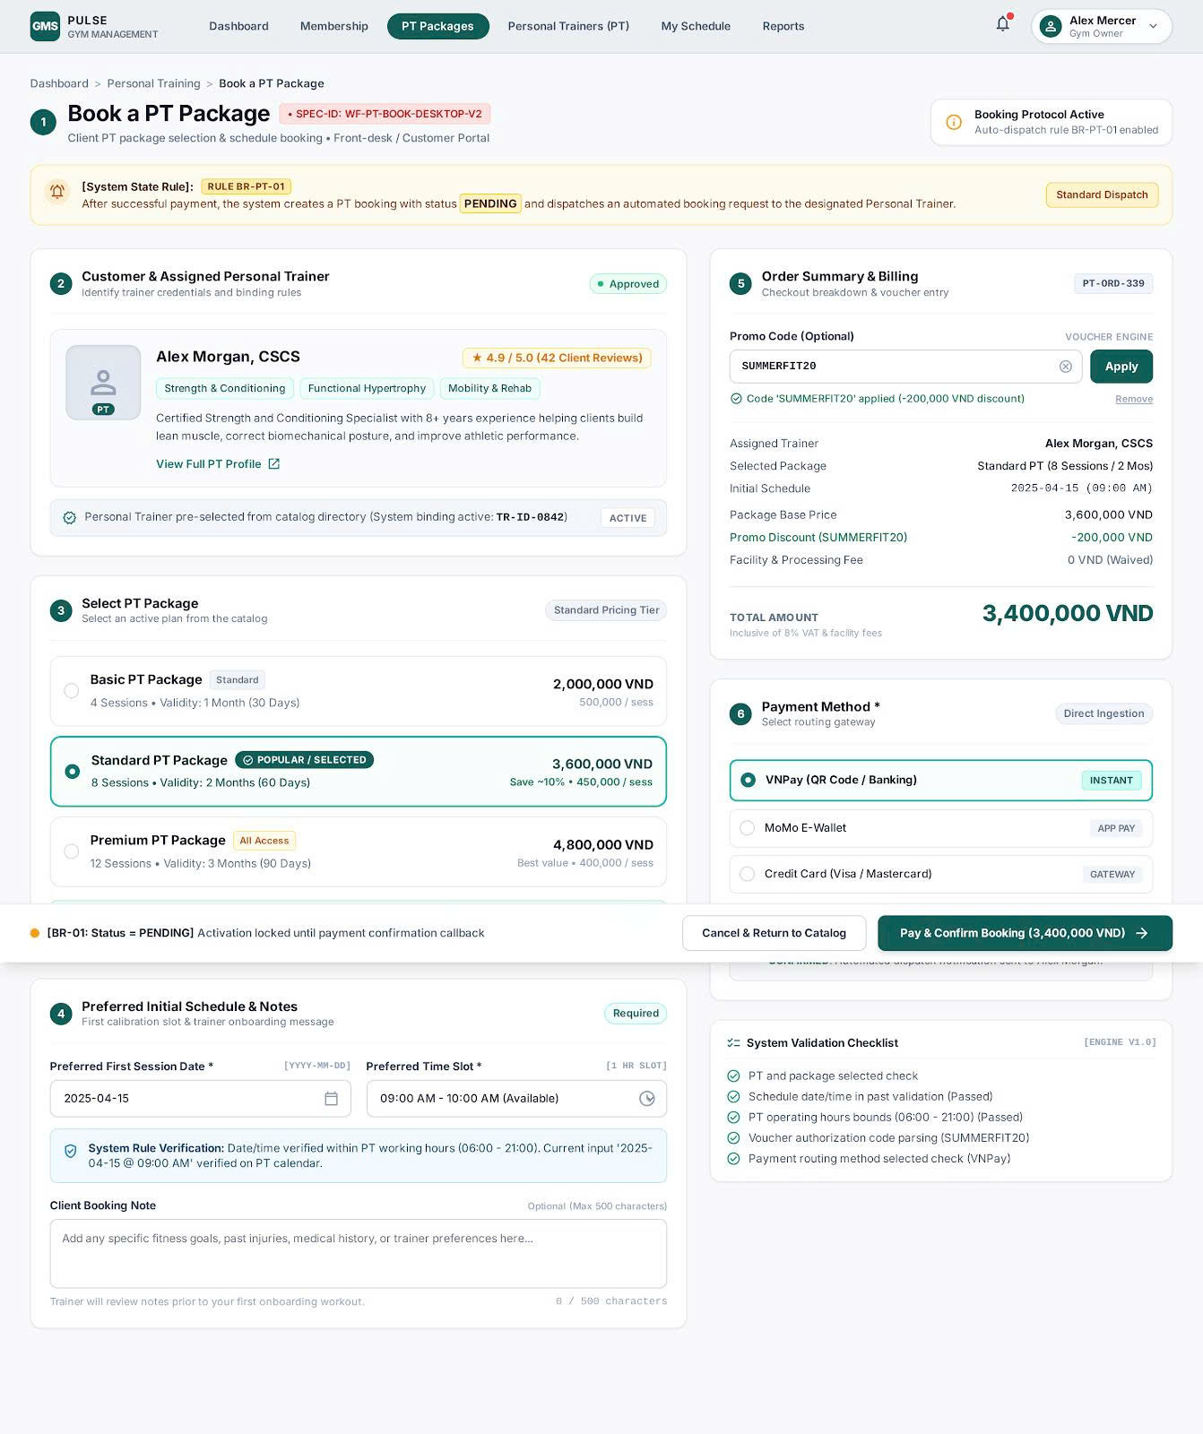
Figure 5.4 — Wireframe SCR-11 (happy path) for UC-11
Source file: 03_Images/UI_UC11_BookPT.png · Low-fidelity UI · field table in docs/step5 · Tuấn #26 · Export target ≥150 dpi (assignment A.3).
[MISSING / TODO] SCR-11: chưa có PNG trạng thái lỗi riêng — validation/error mô tả trong docs/step5 (*_ui.md).

3.2.5 UC-12 Confirm/Reject PT Booking
﻿# UC-12 — Confirm / Reject PT Booking
## 1. Use case summary
| Item | Description |
|------|-------------|
| Use case ID | UC-12 |
| Primary actor | Personal Trainer |
| Secondary actors | SMS Service, Payment Gateway |
| Goal | Allow an Approved Personal Trainer to respond to a Pending PT booking within 24 hours. |
| Priority | High |
| Related business rules | BR-07, BR-08, BR-09 |
## 2. Preconditions
1. The Personal Trainer is authenticated.
2. The Personal Trainer account is in `Approved` status.
3. A `Pending` PT booking belongs to the Personal Trainer.
4. The booking has not expired or been cancelled.
## 3. Postconditions
### Confirm outcome
- The booking status is changed to `Confirmed`.
- The Customer is notified.
- The booking becomes eligible for Training Session scheduling.
### Reject outcome
- The booking status is changed to `Rejected`.
- A rejection reason is stored.
- The Customer is notified.
- A refund request is initiated when a successful payment exists.
## 4. Main success scenario
1. The system notifies the Personal Trainer of a new Pending booking.
2. The Personal Trainer opens the Pending booking list.
3. The Personal Trainer selects a booking.
4. The system displays the Customer, PT package, preferred time, booking time, payment status, and notes.
5. The Personal Trainer chooses `Confirm`.
6. The system verifies that the booking is still Pending, belongs to the current Personal Trainer, and is within the response time limit.
7. The system changes the booking status to `Confirmed`.
8. The system records the response time and sends a confirmation notification to the Customer.
## 5. Alternative flows
### A1. Personal Trainer rejects the booking
1. At step 5, the Personal Trainer chooses `Reject`.
2. The system requires a rejection reason.
3. The Personal Trainer enters the reason and submits the decision.
4. The system verifies that the booking is still Pending.
5. The system changes the booking status to `Rejected`.
6. The system initiates a refund when a successful payment exists.
7. The system sends the rejection reason and status to the Customer.
### A2. Booking has already been processed
1. At step 6, the system detects that the booking is no longer Pending.
2. The system displays the current status.
3. The system does not overwrite the existing decision.
## 6. Exceptions
### E1. Response deadline has passed
1. The system detects that the Pending booking has exceeded 24 hours.
2. The system changes the booking status to `Cancelled` according to the timeout policy.
3. The system initiates a refund when applicable.
4. The system notifies the Customer and the Personal Trainer.
### E2. Rejection reason is missing
1. The Personal Trainer submits `Reject` without a reason.
2. The system displays a validation error.
3. The system does not change the booking status.
### E3. Refund cannot be completed immediately
1. The Payment Gateway rejects or delays the refund request.
2. The system records the refund as `Pending` and creates an operational alert.
3. The booking remains `Rejected`; the refund is processed through reconciliation.
## 7. Business rules and notes
- BR-07: only an Approved Personal Trainer may process the booking.
- BR-08: the Personal Trainer must respond within 24 hours.
Wireframe SCR-12 (Step 5) — Tuấn #26
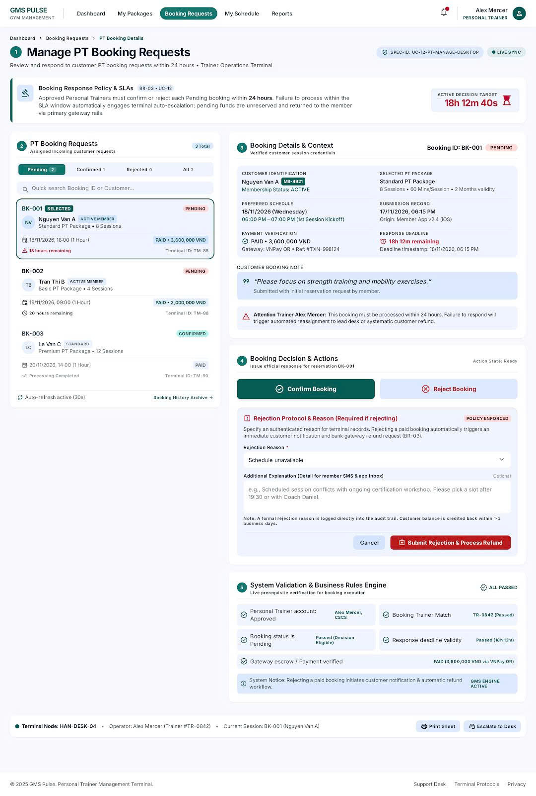
Figure 5.5 — Wireframe SCR-12 (happy path) for UC-12
Source file: 03_Images/UI_UC12_PTBooking.png · Low-fidelity UI · field table in docs/step5 · Tuấn #26 · Export target ≥150 dpi (assignment A.3).
[MISSING / TODO] SCR-12: chưa có PNG trạng thái lỗi riêng — validation/error mô tả trong docs/step5 (*_ui.md).

3.2.6 UC-15 Record Training Session
Field | Content
UC ID and Name | UC-15 — Record Training Session
Primary Actor | Personal Trainer
Secondary Actors | — (optional: SMS Service if customer notification is enabled)
Trigger | After a scheduled training session ends, the PT selects **Record Training Session** for a confirmed booking.
Description | Personal Trainer records that a training session under a Confirmed PT booking has been completed, decreasing remaining sessions and updating booking/session progress.
Preconditions | 1. PT is logged in with an **Approved** account (BR-07). 2. A PT booking exists with status **Confirmed**. 3. The booking still has unused sessions remaining (BR-10). 4. The session to record is on the training schedule (or ad-hoc allowed by policy).
Post conditions | 1. On success: TrainingSession is marked Completed; remaining session count decreases. 2. If remaining sessions become 0, booking may move to Completed (per SMD-02). 3. On failure: session counts unchanged.
Normal Flow | 1. PT opens **Training Schedule** / booking detail. 2. System lists Confirmed bookings and upcoming/past sessions for that PT. 3. PT selects the session (or booking) to record. 4. System shows session details (Customer, package, remaining sessions, scheduled time). 5. PT confirms **Record Session** (optionally adds notes). 6. System verifies booking is Confirmed and remaining sessions > 0 (BR-10). 7. System creates/updates TrainingSession as Completed and decrements remaining sessions. 8. System displays success and updated remaining count.
Alternative Flows | 1. **Customer no-show**: At step 5, PT marks session as No-show (if allowed); System records No-show instead of Completed and applies gym policy to remaining sessions. 2. **Edit notes after record**: PT updates notes only; status unchanged. 3. **Last session**: After step 7, if remaining = 0, System marks booking Completed and notifies Customer (optional SMS).
Exceptions | 1. **Booking not Confirmed / no remaining sessions**: At step 6, System blocks recording and shows BR-10 message. 2. **Unauthorized PT**: If PT is not the assigned trainer, System denies access. 3. **Persistence error**: System shows save failure; session remains unrecorded; PT may retry.
Priority | High
Business Rules | BR-07: Only Approved PT may operate bookings/schedule. BR-10: Record only for Confirmed booking with remaining sessions.

Wireframe SCR-15 (Step 5) — Thiên #27
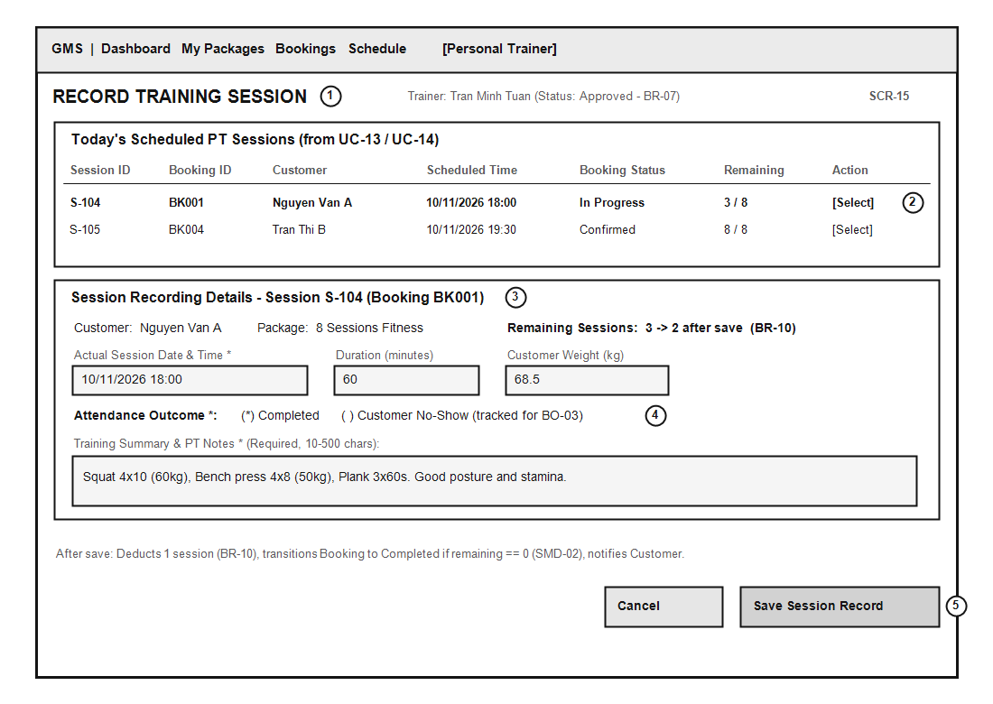
Figure 5.6a — Wireframe SCR-15 (happy path) for UC-15
Source file: 03_Images/UI_UC-15_RecordSession.png · Low-fidelity UI · field table in docs/step5 · Thiên #27 · Export target ≥150 dpi (assignment A.3).
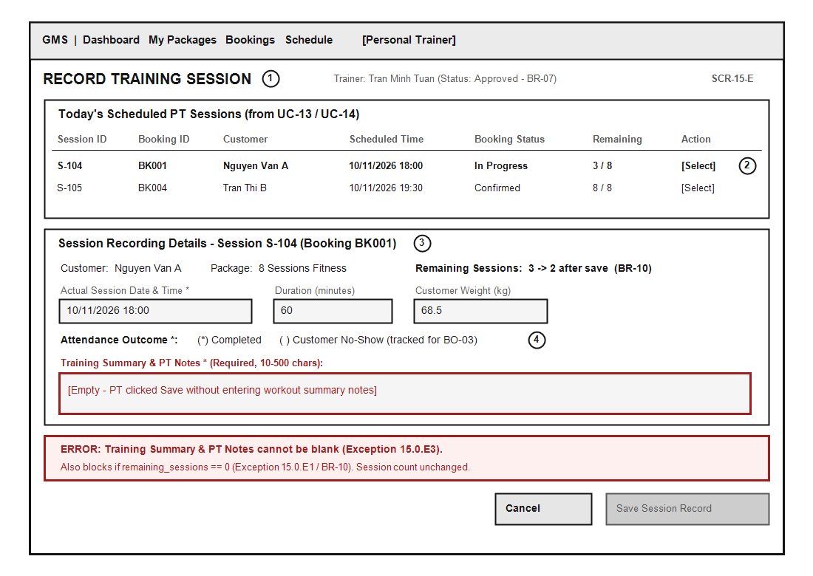
Figure 5.6b — Wireframe SCR-15-E (error / exception state)
Source file: 03_Images/UI_UC-15_RecordSession_Error.png · Maps to Exception/Alternative flows in UC-15.md · Thiên #27 · Export target ≥150 dpi (assignment A.3).

3.2.7 UC-16 Register PT Account
Field | Content
UC ID and Name | UC-16 — Register PT Account
Primary Actor | Personal Trainer (PT)
Secondary Actors | SMS Service
Trigger | The user (PT) accesses the website or application and clicks the "Register as PT" button.
Description | The PT enters personal information, area of expertise, experience, and uploads professional certificates to register a PT account in the system. The profile remains in pending status (`PENDING`) until the Gym Owner reviews it.
Preconditions | 1. The system is operating normally.<br>2. The PT's phone number and email have not been registered in the system before.
Post conditions | 1. The PT account is successfully created with `PENDING` status.<br>2. The PT's certificate information and professional profile are securely stored in the database.<br>3. The system sends a confirmation notification to the PT and a review alert to the Gym Owner.
Normal Flow | 1. The PT selects "Register as PT" on the login screen.<br>2. The system displays a registration form with fields for full name, phone number, email, password, specialization (Gym/Yoga/Boxing), years of experience, self-description, and certificate upload (PDF/PNG/JPG).<br>3. The PT fills in all required information and uploads the certificate file.<br>4. The PT clicks the "Register" button.<br>5. The system validates the data format (valid email, valid phone number, certificate size ≤ 5MB).<br>6. The system checks the uniqueness of the email and phone number in the database.<br>7. The system saves the PT account with `PENDING_APPROVAL` status.<br>8. The system sends an OTP verification code via the SMS Service to the registered phone number.<br>9. The PT enters the correct OTP and clicks "Verify".<br>10. The system displays the message "Registration successful! Your profile is pending Gym Owner approval within 24 hours".
Alternative Flows | **4a. Phone number or email already exists:**<br>1. At step 6, the system detects that the email or phone number is already in use.<br>2. The system displays an error message: "Email or phone number has already been registered".<br>3. The system keeps the entered information and asks the PT to change the phone number or email, or redirects them to Login.<br><br>**9a. Incorrect OTP entered:**<br>1. At step 9, the PT enters the wrong OTP.<br>2. The system displays the error "OTP is incorrect. N attempts remaining".<br>3. The PT can re-enter the code or choose "Resend OTP".
Exceptions | **3a. Invalid certificate file or oversized file (CON-1):**<br>1. The PT uploads a `.exe` file or a file larger than 5MB.<br>2. The system blocks the upload and displays the error "File is invalid or exceeds the 5MB limit".<br><br>**8a. SMS gateway connection error:**<br>1. The system fails to send the OTP via the SMS Service.<br>2. The system displays "The SMS service is temporarily unavailable. Please try again later" and returns to step 4.
Priority | High
Business Rules | BR-03 (Each PT account must be approved by the Gym Owner after certificate verification).<br>CON-1 (Compliance with Decree 13/2023/NĐ-CP on personal data protection).

Wireframe SCR-16 (Step 5) — Huy #28
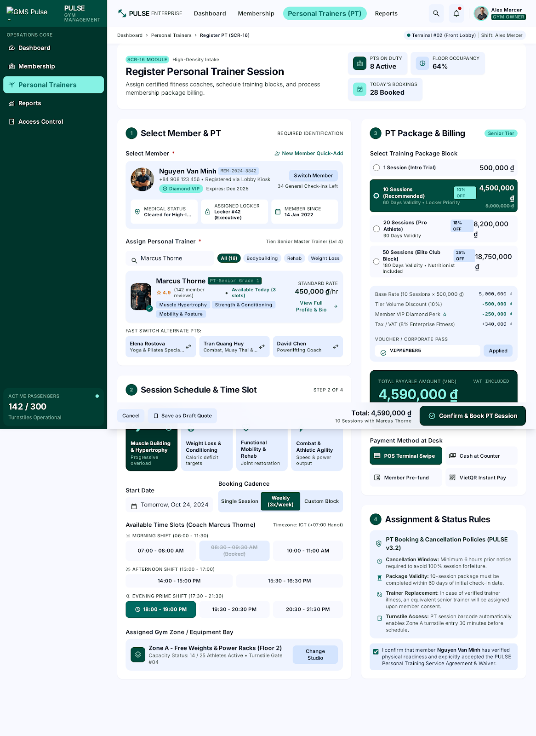
Figure 5.7 — Wireframe SCR-16 (happy path) for UC-16
Source file: 03_Images/UI_UC-16_RegisterPT.png · Low-fidelity UI · field table in docs/step5 · Huy #28 · Export target ≥150 dpi (assignment A.3).
[MISSING / TODO] SCR-16: chưa có PNG trạng thái lỗi riêng — validation/error mô tả trong docs/step5 (*_ui.md).

3.2.8 UC-17 Approve/Reject PT
Field | Content
UC ID and Name | UC-17 — Approve PT Account
Primary Actor | Gym Owner
Secondary Actors | SMS Service
Trigger | The Gym Owner receives a notification of a new PT registration or opens the "PT Management -> Pending List" page.
Description | The Gym Owner reviews the PT's detailed profile, credentials, and certificate while the account is in `PENDING` status and decides whether to approve or reject the application with a reason.
Preconditions | 1. The Gym Owner has successfully logged in to the system with administrator privileges.<br>2. At least one PT account is in `PENDING_APPROVAL` status.
Post conditions | **Approval case:**<br>1. The PT account status changes to `ACTIVE`.<br>2. The system allows the PT to log in and set up PT training packages.<br>3. A success SMS notification is sent to the PT's phone number.<br><br>**Rejection case:**<br>1. The PT account status changes to `REJECTED`.<br>2. The rejection reason is stored, and an SMS notification including the reason is sent to the PT.
Normal Flow | 1. The Gym Owner accesses the "PT Management" menu and selects the "Pending Profiles" tab.<br>2. The system displays the list of PTs awaiting approval (full name, registration date, specialization).<br>3. The Gym Owner selects a PT profile to view details.<br>4. The system displays the full profile: personal information, years of experience, description, and a preview of the certificate file.<br>5. The Gym Owner checks the certificate and clicks the "Approve" button.<br>6. The system displays an approval confirmation dialog.<br>7. The Gym Owner selects "Confirm".<br>8. The system updates the PT account status to `ACTIVE`.<br>9. The system automatically sends a congratulatory SMS and login instructions to the PT via the SMS Service.<br>10. The system displays the message "The PT account was approved successfully".
Alternative Flows | **5a. The Gym Owner rejects the profile:**<br>1. At step 5, the Gym Owner clicks the "Reject" button.<br>2. The system displays a pop-up requiring a rejection reason (required, e.g. "Certificate is invalid", "Insufficient experience").<br>3. The Gym Owner enters the reason and clicks "Confirm rejection".<br>4. The system updates the PT account status to `REJECTED` and saves the reason.<br>5. The system sends an SMS notification to the PT with the rejection result and reason.<br>6. The system displays "The PT profile was rejected".
Exceptions | **4a. Certificate file cannot be loaded:**<br>1. The system cannot display the certificate file because the stored file is corrupted.<br>2. The system shows "Unable to load certificate file" and allows the Gym Owner to request that the PT resend it via email or phone number.<br><br>**8a. Database update error:**<br>1. The database connection is interrupted while changing the status.<br>2. The system shows "Unable to update status. Please try again" and keeps the current status as `PENDING`.
Priority | High
Business Rules | BR-03 (A PT account is only active after approval by the Gym Owner).<br>BO-04 (PT registration files must be processed within 24 hours).

Wireframe SCR-17 (Step 5) — Huy #28
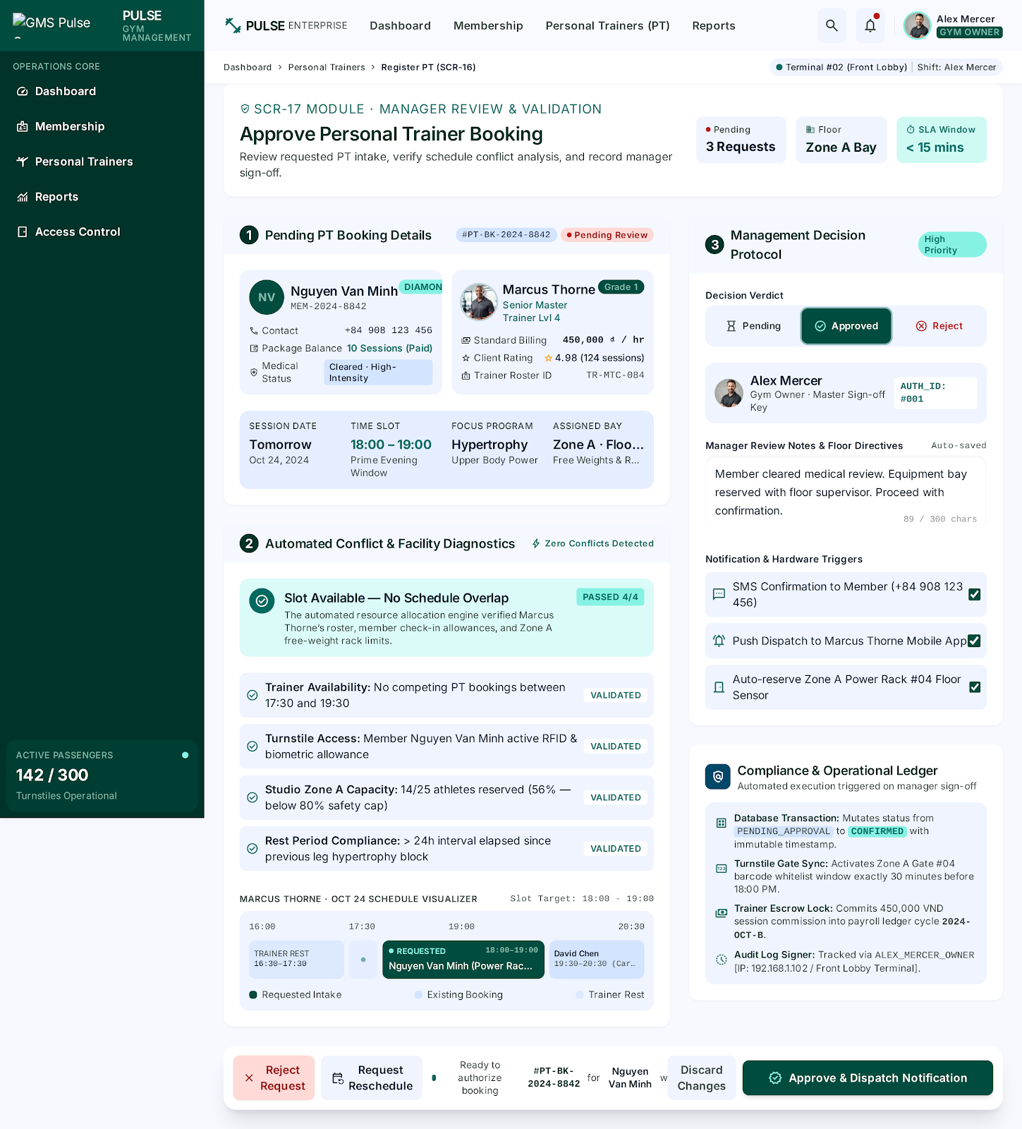
Figure 5.8 — Wireframe SCR-17 (happy path) for UC-17
Source file: 03_Images/UI_UC-17_ApprovePT.png · Low-fidelity UI · field table in docs/step5 · Huy #28 · Export target ≥150 dpi (assignment A.3).
[MISSING / TODO] SCR-17: chưa có PNG trạng thái lỗi riêng — validation/error mô tả trong docs/step5 (*_ui.md).

3.3 Other use cases (brief)
Brief descriptions for remaining catalogue UCs (UC-01…04, 07, 09–10, 13–14, 18–28) are listed in docs/02_UC_List_Detailed.md. Fully dressed elaboration beyond the eight High UCs is out of Release-1 documentation depth unless expanded later.

3.4 Behaviour models — Activity & State
AD-03 Activate Membership at counter (Phước+Thiên #32)
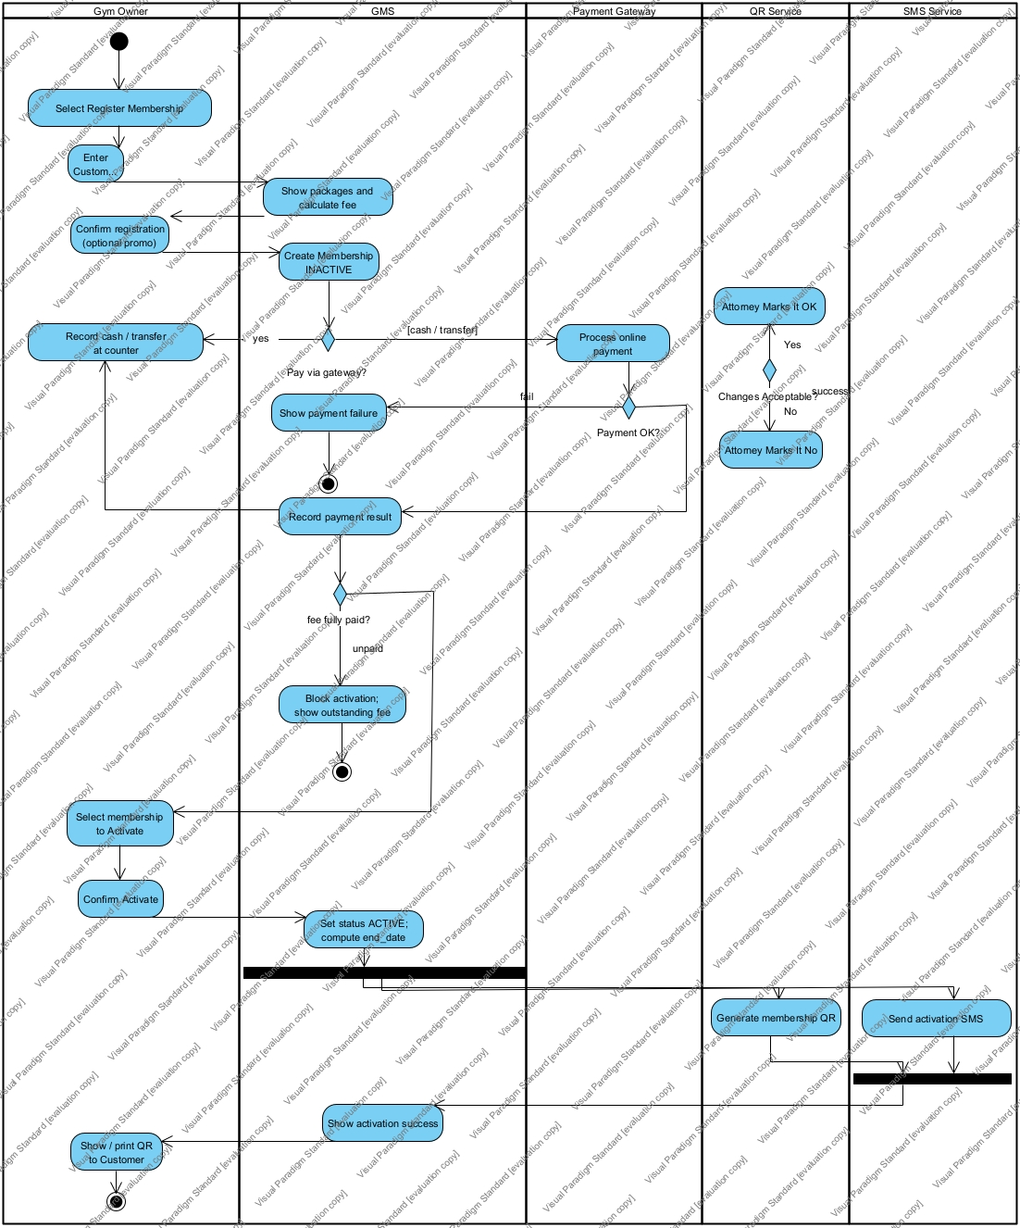
Figure 3.5 — AD-03 Activate Membership at Counter (swimlane)
Source file: 03_Images/AD_ActivateMembership.png · ≥3 lanes (Owner / GMS / Customer|SMS). Related UC-05/06. Owners: Phước+Thiên #32. · Export target ≥150 dpi (assignment A.3).
AD-02 Approve PT (Huy #31)
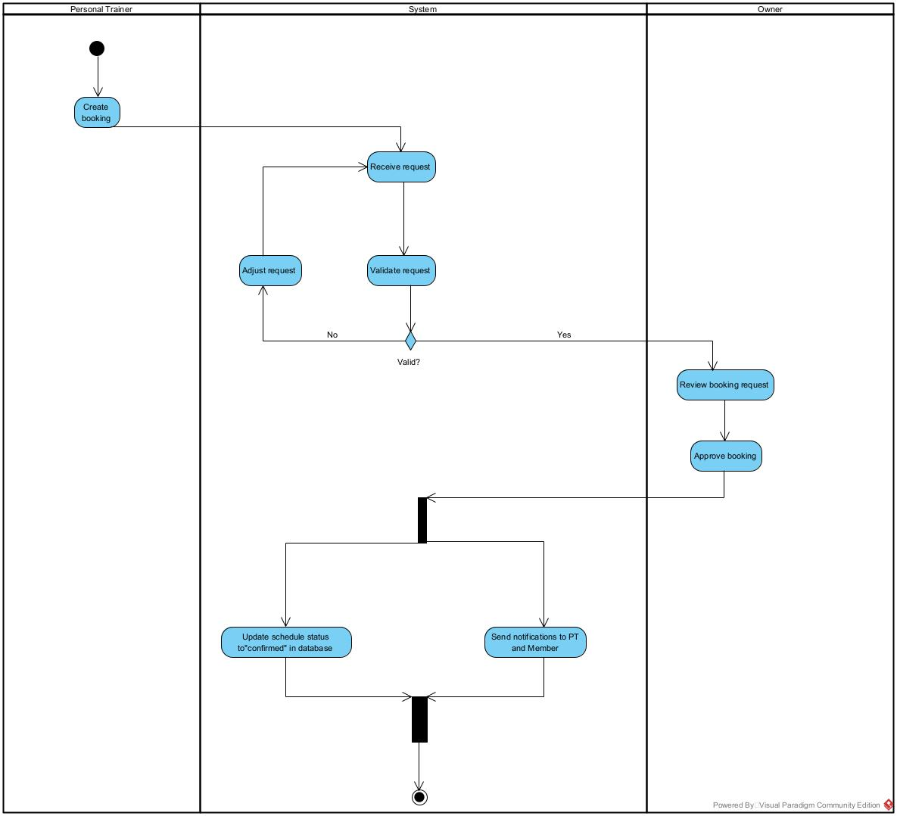
Figure 3.6 — AD-02 Register & Approve Personal Trainer (swimlane)
Source file: 03_Images/AD_ApprovePT.png · Lanes PT / GMS / Owner. Related UC-16/17. Owner: Huy #31. · Export target ≥150 dpi (assignment A.3).
AD-01 Book PT & payment (Tuấn #30)
[MISSING / TODO] Chưa có ảnh — cần file: 03_Images/AD_BookPT.png | Expected file AD_BookPT.png · Related UC-11/12 · Owner: Tuấn #30.
[MISSING / TODO] AD-01 CHƯA CÓ — issue #30 OPEN; docs/step6/tuan_ad01.md trống. Blocker checklist bước 6 #33.
SMD-01 Membership & SMD-02 PT Booking (Thiên #34)
[MISSING / TODO] Chưa có ảnh — cần file: 03_Images/SMD_Membership.png | States Inactive/Active/Suspended/Expired/Cancelled + Time events. Owner: Thiên #34.
[MISSING / TODO] Chưa có ảnh — cần file: 03_Images/SMD_PTBooking.png | States Pending…Cancelled; Time after(24h)=BR-08. Owner: Thiên #34.
[MISSING / TODO] PNG SMD chưa export từ VP — chèn bảng transition bên dưới từ docs/step7/thien_smd.md cho đến khi có hình.
SMD-01 key transitions (UC / Time)
ID | Event | Type | Target | UC/BR
T1 | registerMembership | UC | Inactive | UC-05, BR-01
T2 | activate | UC | Active | UC-06, BR-02/03/04
T5 | when(current_date > end_date) | Time | Expired | UC-27, BR-11
T6 | suspend | Owner | Suspended | BR-04
T10 | renew | UC | Active | UC-20

SMD-02 key transitions (UC / Time)
ID | Event | Type | Target | UC/BR
T1 | bookPTPackage | UC | Pending | UC-11, BR-06/08
T2 | confirmBooking | UC | Confirmed | UC-12
T3 | rejectBooking | UC | Rejected | UC-12, BR-09
T4 | after(24h) | Time | Cancelled | BR-08
T6+ | recordSession | UC | In Progress/Completed | UC-15, BR-10

3.5 Functional Requirements (derived sample)
ID | Requirement | Trace | Priority
FR-05-01 | System shall create Membership INACTIVE after counter registration | UC-05, BR-01/02 | H
FR-06-01 | System shall set ACTIVE and generate QR only when fee fully paid | UC-06, BR-02/04 | H
FR-08-01 | System shall validate QR and open-hours before CheckInLog | UC-08, BR-04/05 | H
FR-11-01 | System shall create Pending booking after successful payment | UC-11, BR-06/08 | H
FR-12-01 | System shall allow Confirm/Reject within 24h with refund rules | UC-12, BR-08/09 | H
FR-15-01 | System shall decrement remaining sessions on record | UC-15, BR-10 | H
FR-16-01 | System shall accept PT registration as Pending approval | UC-16, BR-07 | H
FR-17-01 | Owner shall Approve/Reject PT with reason on reject | UC-17, BR-07 | H
FR-27-01 | Scheduler shall expire memberships past EndDate | UC-27, BR-11 | H

4. Data Requirements

4.1 Logical Data Model
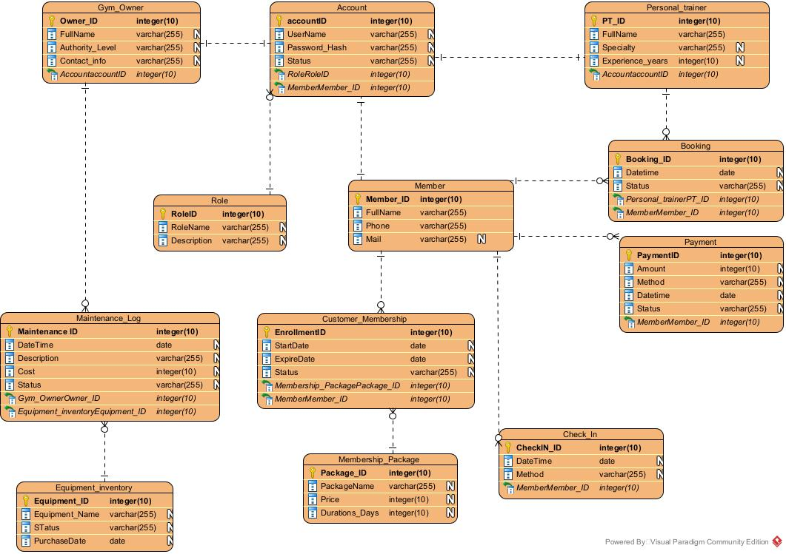
Figure 4.1 — ERD-01 Conceptual Data Model of GMS (≥10 entities)
Source file: 03_Images/ERD_Conceptual.png · Converted/normalized from Entity Relationship Diagram1.jpg · Owner: Huy #35 · Dict: docs/step7/huy_erd.md · Export target ≥150 dpi (assignment A.3).
Vision name | Huy ERD entity
Customer | Member (+ Account)
Gym Owner | Gym_Owner
Personal Trainer | Personal_trainer
Membership | Customer_Membership
MembershipPackage | Membership_Package
PTBooking | Booking
CheckInLog | Check_In
Payment | Payment

[MISSING / TODO] Tuấn #36 tuan_erd_review.md trống — chưa bổ sung TrainingSession / review SMD-02 trên ERD. Booking.Status domain in ERD text may omit IN_PROGRESS/REJECTED vs SMD-02 — cần đồng bộ.

4.2 Data Dictionary
Summary from docs/step7/huy_erd.md (full attribute tables live there).
Entity | Key attributes | Notes
Account | accountID, UserName, Password_Hash, Status, RoleID | NFR-SEC-01 hashing
Role | RoleID, RoleName | Owner/PT/Member
Member | Member_ID, FullName, Phone, Mail | Customer profile
Membership_Package | Package_ID, PackageName, Price, Durations_Days | Catalog
Customer_Membership | EnrollmentID, Start/ExpireDate, Status | Align SMD-01 statuses
Personal_trainer | PT_ID, Specialty, Experience_years, Account | BR-07 Approved
Booking | Booking_ID, DateTime, Status, PT, Member | Align SMD-02
Check_In | CheckIN_ID, DateTime, Method, Member | UC-08
Payment | PaymentID, Amount, Method, Status | Gateway/cash
Equipment_inventory / Maintenance_Log | Equipment + maintenance cost | Extra R1 entities

4.3 Reports
ID | Name | User | Sources
RPT-01 | Revenue summary | Gym Owner | Payment, Customer_Membership, Booking
RPT-02 | Check-in statistics | Gym Owner | Check_In, Customer_Membership
RPT-03 | PT performance | Gym Owner | Booking / sessions

4.4 Collection, Integrity, Retention
Collection via UC-05/06, booking/QR, gateway callbacks, scheduler UC-27/28. Integrity: BR-02/04 and FK Account↔profiles. Retention draft: operational logs ≥ 12 months; archive Cancelled per SMD-01 T11.

5. External Interface Requirements

5.1 User Interfaces
Style: Vietnamese labels on UI; English IDs in SRS. Field/validation tables: docs/step5/*_ui.md. Huy NFR-USAB-01: core reception tasks < 30s for new users. Các wireframe đầy đủ cũng đã chèn cạnh từng UC ở §3.2; mục này là bản đồ + gallery tổng hợp.
Screen map (Step 5 wireframes)
Figure | SCR | UC | PNG | Owner
5.1a/b | SCR-05 | UC-05 | UI_UC-05_RegisterMembership(.png/_Error) | Phước
5.2a/b | SCR-06 | UC-06 | UI_UC-06_ActivateMembership(.png/_Error) | Phước
5.3a/b | SCR-08 | UC-08 | UI_UC-08_QRCheckIn(.png/_Error) | Thiên
5.4 | SCR-11 | UC-11 | UI_UC11_BookPT.png | Tuấn
5.5 | SCR-12 | UC-12 | UI_UC12_PTBooking.png | Tuấn
5.6a/b | SCR-15 | UC-15 | UI_UC-15_RecordSession(.png/_Error) | Thiên
5.7 | SCR-16 | UC-16 | UI_UC-16_RegisterPT.png | Huy
5.8 | SCR-17 | UC-17 | UI_UC-17_ApprovePT.png | Huy

UI gallery (all available wireframes)
Figure 5.1a — SCR-05 Register Membership
Source file: 03_Images/UI_UC-05_RegisterMembership.png · Wireframe · Owner: Phước · Also referenced under the matching UC in §3.2 · Export target ≥150 dpi (assignment A.3).
Figure 5.1b — SCR-05-E Payment/validation error
Source file: 03_Images/UI_UC-05_RegisterMembership_Error.png · Wireframe · Owner: Phước · Also referenced under the matching UC in §3.2 · Export target ≥150 dpi (assignment A.3).
Figure 5.2a — SCR-06 Activate Membership
Source file: 03_Images/UI_UC-06_ActivateMembership.png · Wireframe · Owner: Phước · Also referenced under the matching UC in §3.2 · Export target ≥150 dpi (assignment A.3).
Figure 5.2b — SCR-06-E Unpaid blocked
Source file: 03_Images/UI_UC-06_ActivateMembership_Error.png · Wireframe · Owner: Phước · Also referenced under the matching UC in §3.2 · Export target ≥150 dpi (assignment A.3).
Figure 5.3a — SCR-08 Check-in by QR
Source file: 03_Images/UI_UC-08_QRCheckIn.png · Wireframe · Owner: Thiên · Also referenced under the matching UC in §3.2 · Export target ≥150 dpi (assignment A.3).
Figure 5.3b — SCR-08-E Invalid/expired QR
Source file: 03_Images/UI_UC-08_QRCheckIn_Error.png · Wireframe · Owner: Thiên · Also referenced under the matching UC in §3.2 · Export target ≥150 dpi (assignment A.3).
Figure 5.4 — SCR-11 Book PT Package
Source file: 03_Images/UI_UC11_BookPT.png · Wireframe · Owner: Tuấn · Also referenced under the matching UC in §3.2 · Export target ≥150 dpi (assignment A.3).
Figure 5.5 — SCR-12 Manage PT Booking Requests
Source file: 03_Images/UI_UC12_PTBooking.png · Wireframe · Owner: Tuấn · Also referenced under the matching UC in §3.2 · Export target ≥150 dpi (assignment A.3).
Figure 5.6a — SCR-15 Record Training Session
Source file: 03_Images/UI_UC-15_RecordSession.png · Wireframe · Owner: Thiên · Also referenced under the matching UC in §3.2 · Export target ≥150 dpi (assignment A.3).
Figure 5.6b — SCR-15-E Validation / no sessions
Source file: 03_Images/UI_UC-15_RecordSession_Error.png · Wireframe · Owner: Thiên · Also referenced under the matching UC in §3.2 · Export target ≥150 dpi (assignment A.3).
Figure 5.7 — SCR-16 Register PT Account
Source file: 03_Images/UI_UC-16_RegisterPT.png · Wireframe · Owner: Huy · Also referenced under the matching UC in §3.2 · Export target ≥150 dpi (assignment A.3).
Figure 5.8 — SCR-17 Approve/Reject PT
Source file: 03_Images/UI_UC-17_ApprovePT.png · Wireframe · Owner: Huy · Also referenced under the matching UC in §3.2 · Export target ≥150 dpi (assignment A.3).

5.2 Software Interfaces
Payment Gateway (REST pay/refund callbacks); SMS Service API; QR generation/validation module; relational DBMS. (Huy NFR + Vision OE-4)

5.3 Hardware Interfaces
Không áp dụng thiết bị chuyên dụng — lý do: Release 1 dùng camera điện thoại/tablet tiêu chuẩn để quét QR; không tích hợp turnstile phần cứng.

5.4 Communications Interfaces
HTTPS for clients/APIs; SMS provider channel; payment callbacks over TLS.

6. Quality Attributes
From docs/step8/huy_nfr.md (#39).
NFR-ID | Description | Measurement | Target
NFR-PERF-01 | Lookup/check-in response under load | JMeter / Network @100 concurrent | Avg ≤1.5s; max ≤3s
NFR-SEC-01 | Password hashing | Inspect Account store | BCrypt factor ≥10; no plaintext
NFR-SEC-02 | Session timeout | Idle session test | Logout after 15 minutes
NFR-USAB-01 | Receptionist core task time | UAT 5 new users | 100% <30s
NFR-REL-01 | Daily backup | Verify schedule | Daily end-of-day full backup

[MISSING / TODO] Planguage TAG blocks (≥2) — có thể bổ sung formal TAG: từ mẫu HuongDan nếu GV yêu cầu chặt.

7. Internationalization and Localization Requirements
End-user UI: Vietnamese. Dates dd/mm/yyyy. Currency VND. Time zone UTC+7. SRS/model names: English.

8. Other Requirements
Personal-data compliance (Decree 13/2023). Short front-desk operating guidance. No thick desktop client in R1.

Appendix A – Glossary
Term | Definition
Membership | Customer–package contract with status lifecycle (SMD-01)
QR Membership | Token valid only while membership ACTIVE (BR-04)
PT Booking | Order for PT package sessions (SMD-02)
Training Session | One delivered session under a booking (UC-15)
Pending Booking | Paid/awaiting PT confirm within 24h (BR-08)
Gym Owner | Highest admin role for counter, PT approval, reports
Check-in / Check-out | Gate event logged via QR validation

Appendix B – Analysis Models
ID | Name | Image / location | Status
CD-01 | Context Diagram | CD_ContextDiagram.png | OK (typo polish pending)
UCD-01 | Overview + packages | UCD_*.png | OK
AD-01 | Book PT & payment | AD_BookPT.png | MISSING — Tuấn #30
AD-02 | Approve PT | AD_ApprovePT.png | OK (from step-6)
AD-03 | Activate Membership | AD_ActivateMembership.png | OK
SMD-01 | Membership lifecycle | SMD_Membership.png | MISSING PNG — tables OK
SMD-02 | PT Booking lifecycle | SMD_PTBooking.png | MISSING PNG — tables OK
ERD-01 | Conceptual ERD | ERD_Conceptual.png | OK

Appendix C – Traceability Matrix
Authoritative file: 04_Traceability_Matrix.xlsx (sheets Traceability + NFR). Also docs/step7/phuoc_srs_trace.md. Columns: BO | UC | FR | BR | Diagram | Screen | NFR | Test.

Appendix D – Open Issues / Missing from teammates
ID | Gap | Owner | Blocks
OI-01 | AD-01 Book PT PNG + swimlane write-up | Tuấn #30 | Step 6 checklist #33
OI-02 | SMD_Membership.png & SMD_PTBooking.png VP export | Thiên #34 | SRS figures / zip A.3
OI-03 | tuan_vision.md empty (PT user class / BO-03 confirm) | Tuấn #6 | Formal Vision freeze
OI-04 | tuan_erd_review.md empty (TrainingSession + SMD-02 review) | Tuấn #36 | ERD consistency
OI-05 | tuan_peer_review.md empty | Tuấn #41 | Step 8 checklist #43
OI-06 | Instructor / exact class code on cover | Phước | Cover page
OI-07 | CD typo fixes on VPP export | Phước (+ Thiên review) | Polish
OI-08 | BR ID drift Huy step3 vs Vision | Huy/Phước | Traceability clarity

Appendix E – Source map (docs/step*)
Step | Key files consumed
1 | thien_vision, huy_vision, 01_Vision_Scope_GMS (tuan_vision empty)
2 | phuoc_cd + UC list
3 | UCD PNGs; huy_br_glossary (glossary); thien/tuan UCD notes
4 | UC-05/06/08/11/12/15/16/17.md
5 | *_ui.md + UI_*.png
6 | AD-03 + AD-02; AD-01 missing
7 | huy_erd, thien_smd, phuoc_srs_trace, ERD png
8 | huy_nfr; thien_peer_review; tuan_peer empty

Appendix F – Figure catalogue & image notes
Tất cả hình trong SRS lấy từ thư mục 03_Images/. Mỗi hình trong tài liệu có: (1) tiêu đề Figure, (2) dòng ghi chú Source file + chủ sở hữu + liên kết UC/BR. Yêu cầu nộp: PNG ≥ 150 dpi từ Visual Paradigm (trừ wireframe UI).
Figure | File | Type | SRS § | Status | Note
2.1 | CD_ContextDiagram.png | CD | 2.1 | Embedded | Fix typo labels on re-export (#42)
3.1 | UCD_Overview.png | UCD | 3.1 | Embedded | Overview
3.2 | UCD_Membership.png | UCD | 3.1 | Embedded | Thiên
3.3 | UCD_PT.png | UCD | 3.1 | Embedded | Tuấn
3.4 | UCD_Report_Feedback.png | UCD | 3.1 | Embedded | Huy
3.5 | AD_ActivateMembership.png | AD | 3.4 | Embedded | AD-03 Phước+Thiên
3.6 | AD_ApprovePT.png | AD | 3.4 | Embedded | AD-02 Huy
3.7 | AD_BookPT.png | AD | 3.4 | MISSING | Tuấn #30 — chưa có
3.8 | SMD_Membership.png | SMD | 3.4 | MISSING | Thiên #34 — có bảng transition
3.9 | SMD_PTBooking.png | SMD | 3.4 | MISSING | Thiên #34 — có bảng transition
4.1 | ERD_Conceptual.png | ERD | 4.1 | Embedded | Huy #35
5.1a/b | UI_UC-05_* | UI | 3.2 / 5.1 | Embedded | Phước + error state
5.2a/b | UI_UC-06_* | UI | 3.2 / 5.1 | Embedded | Phước + error state
5.3a/b | UI_UC-08_* | UI | 3.2 / 5.1 | Embedded | Thiên + error state
5.4 | UI_UC11_BookPT.png | UI | 3.2 / 5.1 | Embedded | Tuấn (tên file thiếu '-')
5.5 | UI_UC12_PTBooking.png | UI | 3.2 / 5.1 | Embedded | Tuấn
5.6a/b | UI_UC-15_* | UI | 3.2 / 5.1 | Embedded | Thiên + error state
5.7 | UI_UC-16_RegisterPT.png | UI | 3.2 / 5.1 | Embedded | Huy
5.8 | UI_UC-17_ApprovePT.png | UI | 3.2 / 5.1 | Embedded | Huy

Image notes (quy ước ghi chú dưới mỗi hình)
Mỗi caption gồm: Figure ID + tên sơ đồ/màn hình. Dòng xám bên dưới ghi Source file, owner issue, UC/BR liên quan, và nhắc ≥150 dpi. Hình MISSING vẫn giữ số Figure để đối chiếu khi thành viên bổ sung file vào 03_Images/.
[MISSING / TODO] Không nhúng bản .jpg trùng nếu đã có .png cùng nội dung (tránh phình file). Bản gốc Huy ERD: Entity Relationship Diagram1.jpg — SRS dùng ERD_Conceptual.png.

