PE_FE201M_SU23

SUMMER 23

Subject: FE201M

Duration: 85 minutes

**INSTRUCTIONS**

**Please read the instructions carefully before doing the questions.**

* You are **Not allowed** to use any device to share data with others.
* You must use IDE as **Visual Studio Code,** for your development tools.
* You must use **Material design (MUI)**.

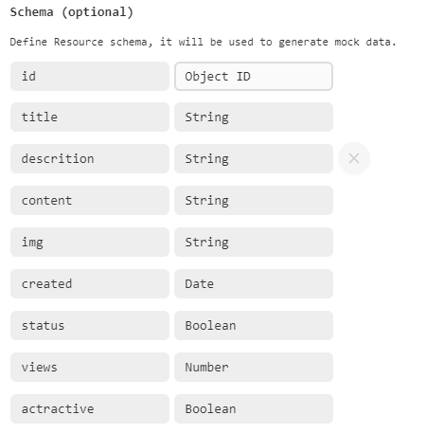 Create a new React application using npx create-react-app your-roll-number.

***Task 1. Create a new resource and supply data for your application.***

1. (0.25 mark) Create a new resource named news in *mockapi.io* and **declare a Schema**.
2. (0.25 mark) Edit/replace data for news resource. Copy the content of **data.json** file.

***Task 2. Implement some actions in public routes.***

1. (1.0 mark) Create a Navbar for navigating all the routes in your application. Including: **Home**, **Top News**, **Contact** and **Sign in**. (*install react-router-dom library*)
2. (2 marks) At **Home** route, display all the news in data which have *attractive* is *true*. Each news must contain some information such as: **Title**, **description**, **img**. When you click the detail button or title link, the view switch to **detail** route.
3. (1.5 marks) At detail route, display all the information of news: title, description, content, img, views (number of views for this news) and attractive. Design and arrange this component as good as possible.

***Task 2. Implement some actions in private routes.***

1. (1.0 mark) At **dashboard** route, it displays the list of news by table. Each row must contain the links or icons for CRUD actions.
2. (1.5 marks) Create a Add route with the requirements:

* Create a form and validate all data.
* All fields are required.
* Control of *description* and *content* are text area.
* *Status* is a checkbox or toggle. Checking means true value.
* Value for *views* is a number. Default value is no. 1.
* *attractive* is a checkbox or toggle. Checking means true value.

1. (1.0 mark) At **Dashboard** route implement the *delete* action.

With *delete* function, you must **confirm** before implementing. After deleting successful, showing a notice (modal, alert, toast…) and the list of news will render the new list.

1. (1.5 marks) Implement the *update* action. With *the update* function, the same validation requirements with the a*dd* function.

***-The end of test-***