

**This is to certify that**

Mr. /Ms: Le Hong Phuong

Do Tat Tuan

Lam Hong Thai

Pham Tien Ha

Has successfully Designed & Developed:Campaign Information Management

Submitted by: Mr. Bui Duy Linh

Date of Issue: Feb 28, 2016

Authorized Signature: Do Tat Tuan

Contents

**Chapter 1: Problem Definition 3**

**1.1 Introduction 3**

**1.2 Existing Scenario 3**

**1.3 Proposed Solution 3**

**1.4 Functional Requirements 3**

**Chapter 2: Customer Requirement Specification (CRS) 5**

**2.1 Client. 5**

**2.2 Business/Project Objective 5**

**2.3 Analysis of each function 5**

**2.4 Hardware Requirements 7**

**2.5 Software Requirements 7**

**2.6 Scope of the Work (in brief) 7**

**Chapter 3: Architecture and Design of the Project 8**

**3.1 Logical view: 8**

**3.2 Physical view: 9**

**Chapter 4: Data Flow Diagram (DFD) &Flowcharts 10**

**4.1 Data Flow Diagram 10**

**4.2 Design Flow Charts 13**

**Chapter 5: Entity Relationship Diagram (ERD) 17**

**Chapter 6: Database Design/Structure 18**

**Chapter 7: Checklist of Validations 22**

# Chapter 1: Problem Definition

## 1.1Introduction and Problems.

FUN ‘N’ FOOD is a big name in the hospitality business (Hotels & Resorts) and has a very successful independent chain of restaurants ***TUNGA*** in the country***.*** *TUNGA restaurants* are known for their wide range of continental cuisine and consummate style.

*TUNGA* provides range fully-equipped, private meeting rooms, and regal banquet halls which offer the perfect combination of efficiency and convenience. They are also popular among school & college students for range of bakery & fast food products.

With increasing popularity and the customer base, organization has decided to go techno savvy to meet customer expectations with respect to its exclusive services in the market.

Organization has decided to reach out to its customers via online services through a web site on the internet.

The web site talks about other business aspects of the firm and has online reservation and home delivery service as one of its premium services.

**However you are essentially required to focus on the online booking and the home delivery aspect only and to design and build a site which deals with the same.**

## 1.2 Existing Scenario

The food and table in the restaurant need to be organized. Information about table booking order and home delivery need to be saved and organized. The web system will collect the order into database to be able to serve the customer as best as possible

## 1.3 Proposed Solution

You have to develop the system, which captures the data related to foods information, tables detail, orders detail, room information.

It will also store the invoice and invoice's tax. There will be only one user of the system. And customer can access to the web TUNGA for the order table and home delivery.

## 1.4 Functional Requirements

Admin of the system: the club manager. There is no other who will be using the system other than the current admin.

Admin will start with the manager page for admin. It also has manager functions

Functions are

* Menu – which will store the information of each menu currently in the restaurant
* Food– which will store the information of each food currently in the restaurant. It also let the user to modify the database which include adding new food to the any menu, modify and delete the food record.
* Table– store the event detail such as the event name, time, date, … This will also let the admin view the event detail and modify/delete event. The admin can add table to room and keep track of the event which the guest attended.
* Room - Which will store the information of each room as the room type, name, ... this will also let the admin view the room detail and modify room. The admin can add the table to the room selected.
* Invoice – The store will save all restaurant’s invoice and invoice’s tax. Admin can’t delete the invoice. Because each invoice is already taxed
* About – Describing information of the website and group that made the website

# Chapter 2: Customer Requirement Specification (CRS)

## 2.1 Business/Project Objective: Guest of the Restaurant.

The guest will start with the Client of website. Index for the guest which has manager function.

Functions are.

* Order room – Restaurant TUNGA has 2 type of room for the guest order. Each room has many tables for the guest choose.
* Online table reservation in the restaurant for specific date and time. This will

1. Provide the list of restaurants in the country so that the user can choose accordingly.
2. Provide the list of tables available for online reservation at different dining rooms in the restaurant.
3. Mention the number of guests that can be accommodated on the particular.
4. Accept the booking for tables.
5. Online table reservations are done 6hrs in advance for the current date.

* Online order for food under restaurant’s exclusive home delivery service.

1. This facility is valid for 24hrs. from the time of order.
2. Accept the customers order so that the nearest restaurant can service the order in stipulated time (60 - 120 Minutes).
3. Record the customer’s name, residence address and contact numbers and other vital details if required.
4. Facilitate with the choice of food keeping Vegetarian and non-vegetarian customers in mind.
5. Provide the menu list with their price tags accordingly and also mention the number of persons that can be served with one unit of order. This will help the customer to decide the quantity to be ordered.
6. Display the list items select from the menu and exact amount (itemized bill) that the customer is supposed to pay (inclusive of all taxes applicable).
7. Give a token number as an acknowledgement to the customer that the order has been noted down by the restaurant.
8. Show the approximate time (in minutes) in which the ordered will be delivered to the customer.

## 2.3 Analysis of each function:

|  |  |  |
| --- | --- | --- |
| **User of system** | **Functions** | **Description of Function** |
| **Admin of system** | Add Food to Menu | * Input information of food * Validate * Add food to menu on database |
| View FoodDetail | * Choose food from list * Search in database * Display detail |
| Edit Food Detail | * Choose food from menu * Search in data base * Edit information * Validate * Update to menu on database |
| Delete Food Detail | * Choose food from list menu * Search in database * Delete food from menu in database |
| Search Food | * Choose option for search * Input text for search * Search information in database * Display detail |
| Add new Menu | * Input information of menu * Validate * Insert into database |
| View MenuDetail | * Choose menu from list * Search in database * Display |
| Edit Menu | * Choose menu from list and edit some information on fields * Validate * Update to database |
| Delete Menu | * Choose Menu from list and delete * Update to database |
| Search Menu | * Choose option for search * Input text * Search and display |

|  |  |  |
| --- | --- | --- |
|  | Delete Table | * Choose table from list room. * Search in database. * Delete table from menu in database. |
| Search Table | * Choose option for search * Input text for search * Search and display |
| Add Table | * Input information of table * Validate * Insert to room on database |
| Edit Table | * Choose table from room and edit any information on fields. * Validate. * Update to database. |
| **Guest** | Book a table or room | * Enter the information you want. * Server will search in store and display all tables are accordance with your requirements. |
| Order food home delivery | * Choose the food you want. * The food will be added to your shopping cart. * Confirm. |
| **About** | Contact | * Displayteam’s information. |

## 2.4 Hardware Requirements:

* A minimum computer system that will help you access the entire tool in the course is a Pentium 166 or a higher capability CPU.
* 128 Megabytes of RAM or Higher.

## 2.5 Software Requirements:

* Any platform you can have (window, Linux…).
* .NET Framework.
* Java Virtual Machine/J2EE server.
* Jdk 1.7 or later.
* Net Bean 8.1
* MS SQL Server 2008 or higher

## 2.6 Scope of the Work (in brief):

* Add new and manage member
* Add new and manage the event
* Add and manage make member attendance to event
* Provide a user friendly interface to the user to work with application.

# Chapter 3: Architecture and Design of the Project

Since the application will have client server rchitecture, it will have three-tier architecture.

## 3.1 Logical view:

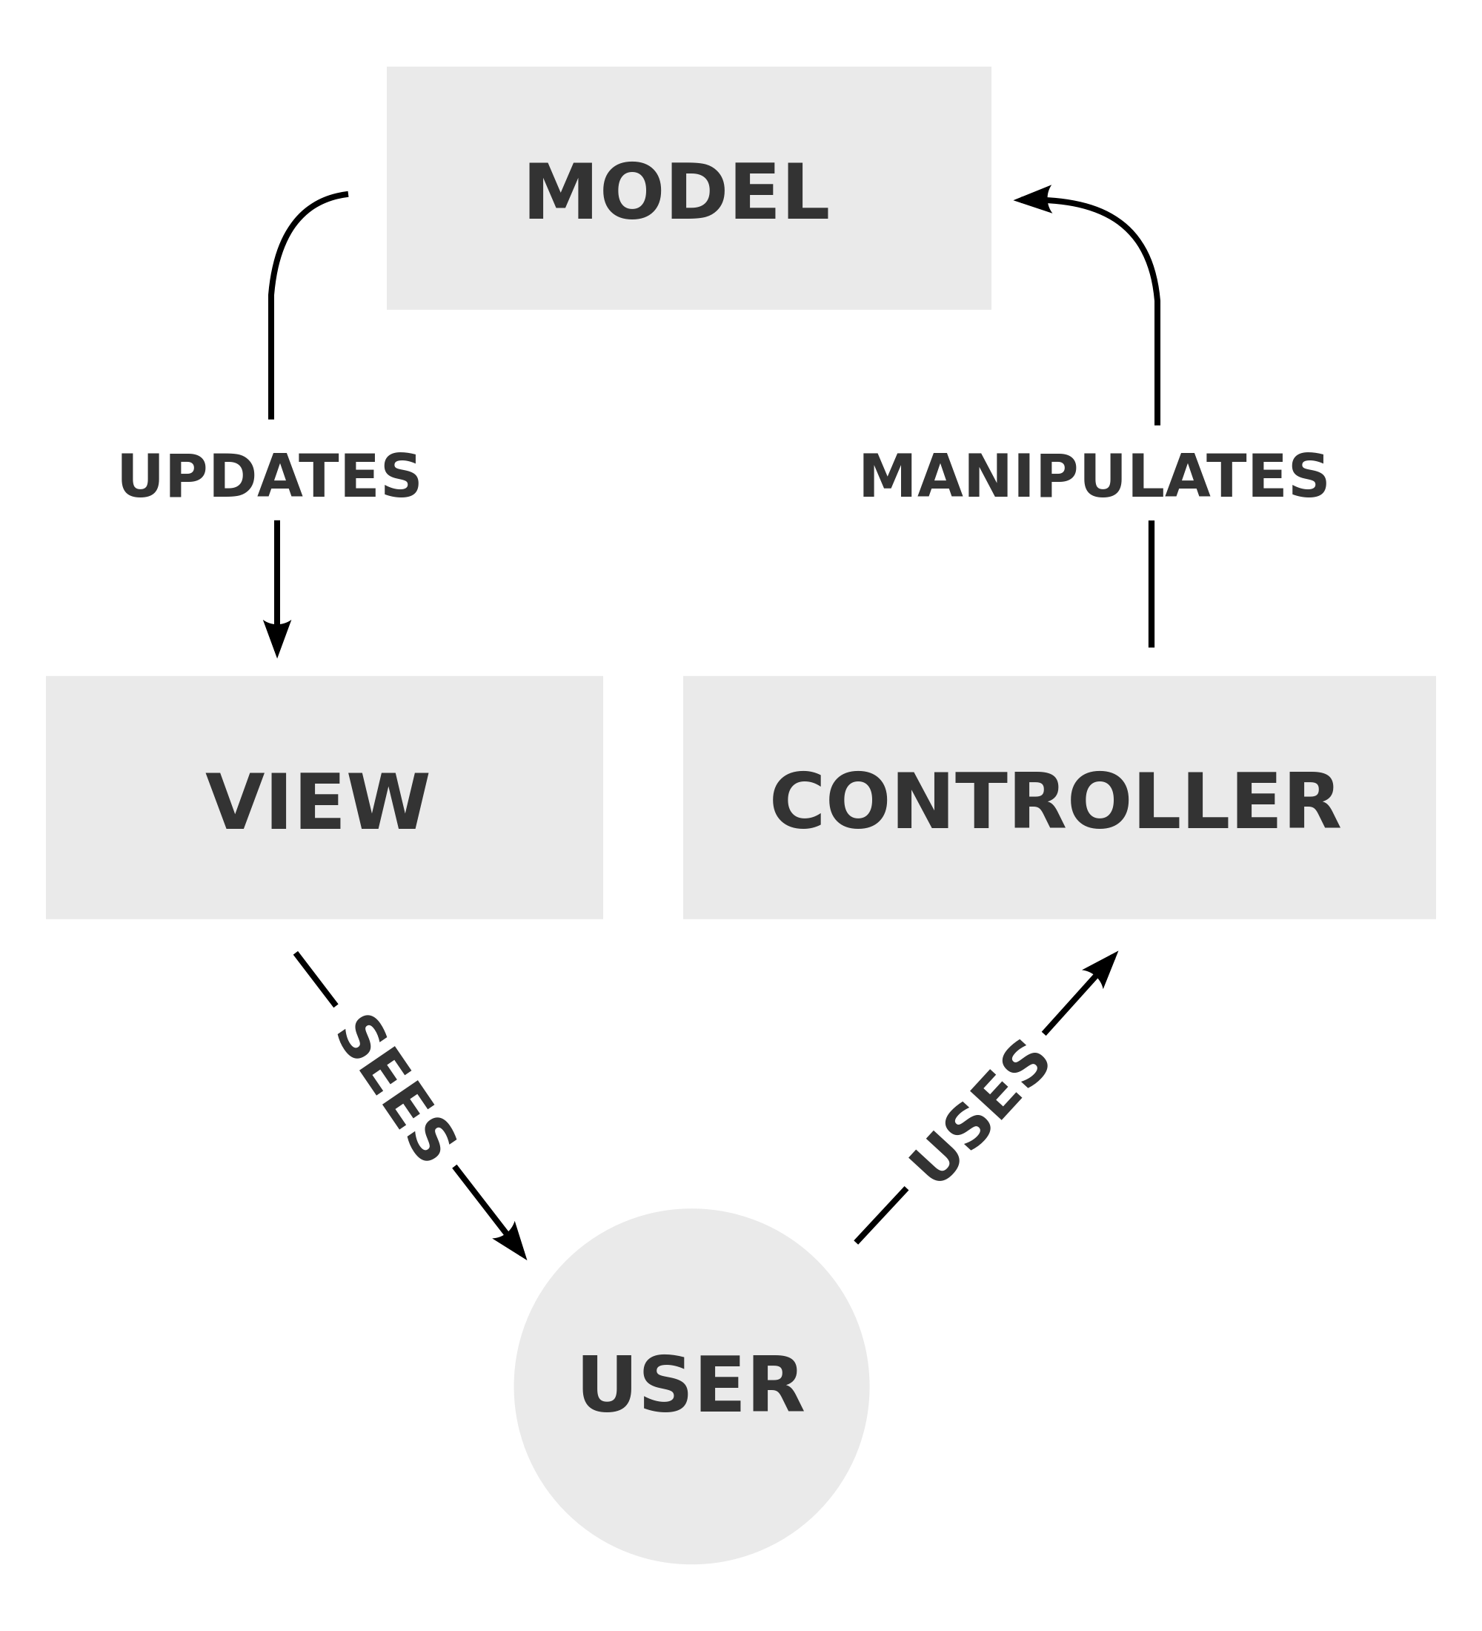

## 3.2 Physical view:

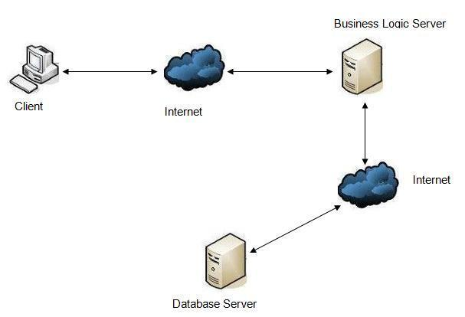

* Client sends the request operations such as adding, deleting, and updating via Internet to Business Logic Server.
* Server to receive and process those requests and then sent via Internet to Database Server.
* Database Server receives service requests and manipulates the database and return relevant results for Business Logic Server.
* Business Logic Server receives the result from Database Server and return to the Client.

**Chapter 4: Data Flow Diagram (DFD) &Flowcharts**

## 4.1 Data Flow Diagram

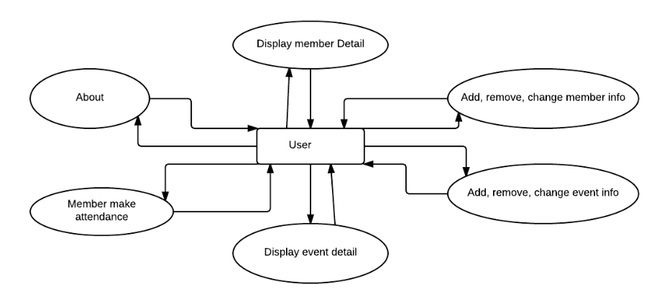

***DFD: Application Process: User***

## 4.2 Design Flow Charts

**4.2.1 Add**

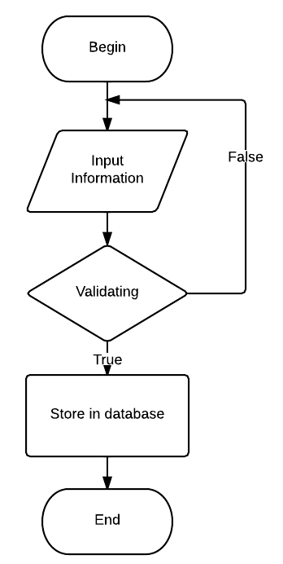

**4.2.2 Delete**

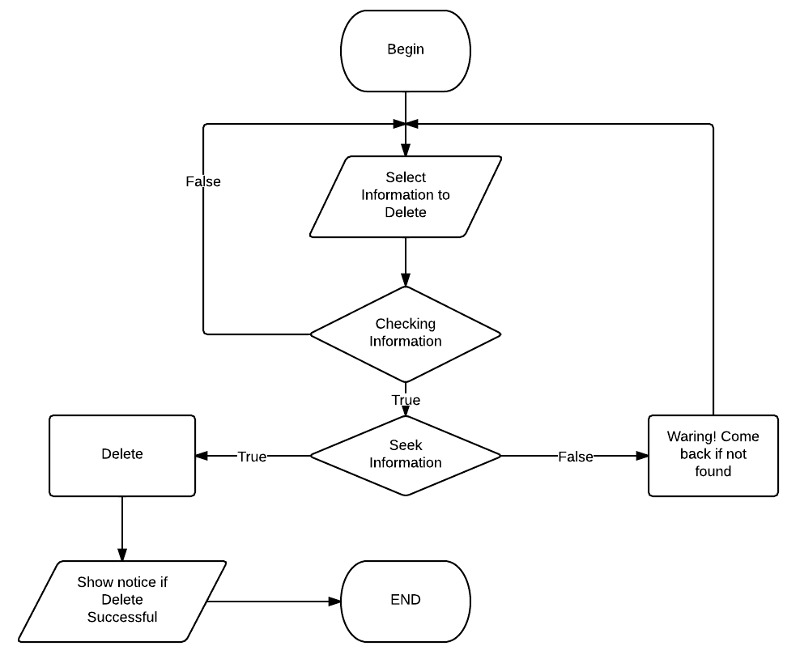

**4.2.3 Search**

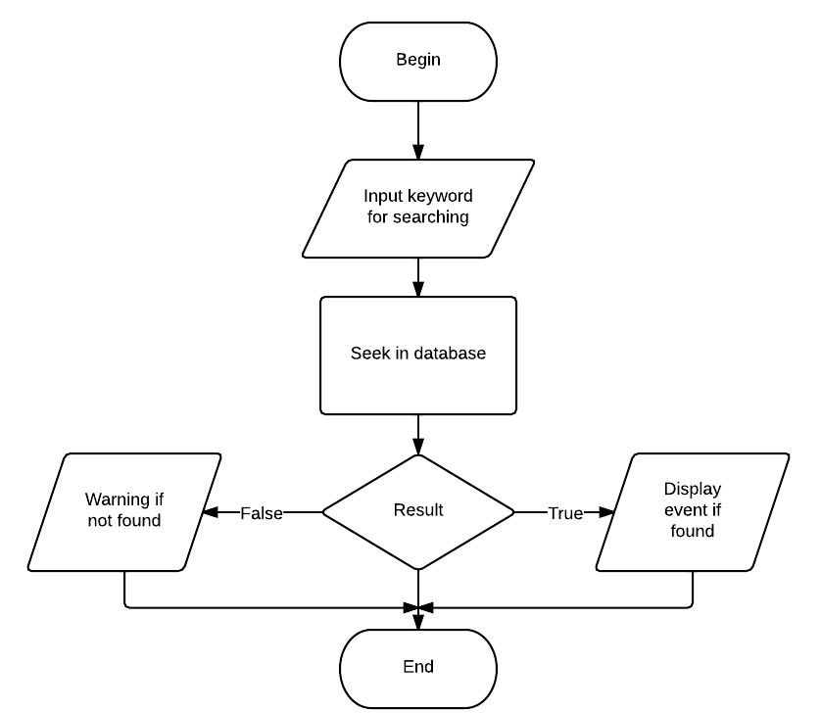

**4.2.4 Update**

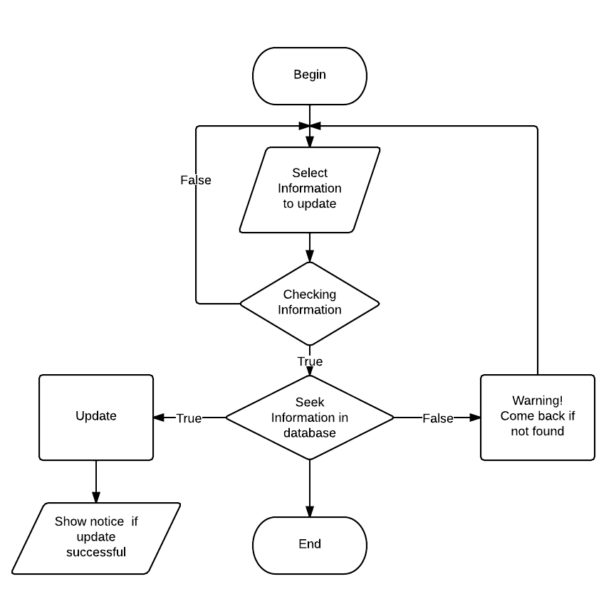

# Chapter 5: Entity Relationship Diagram (ERD)

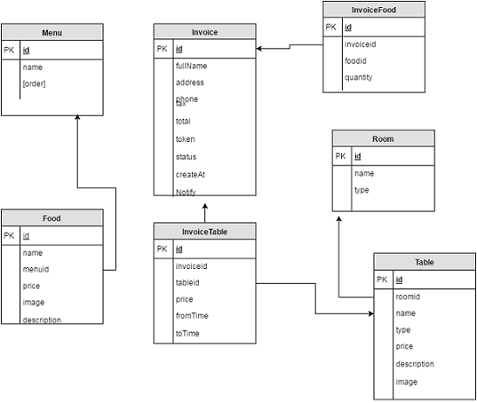

**Chapter 6: Database Design/Structure**

**Database Design:**

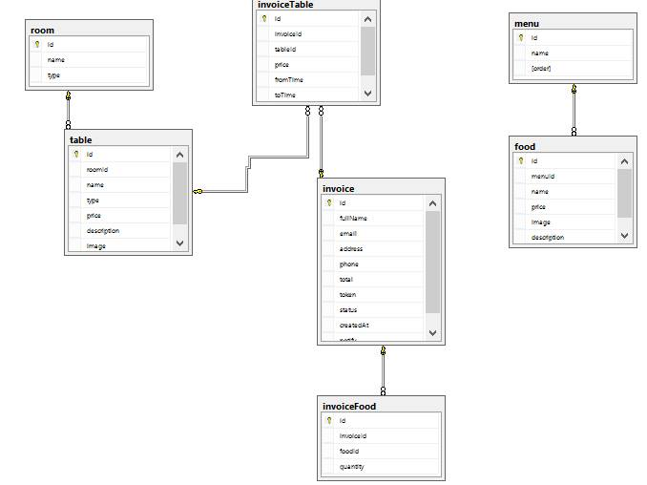

# Chapter 7: Task sheet

|  |  |  |  |  |  |  |  |
| --- | --- | --- | --- | --- | --- | --- | --- |
| **Project Ref.No** | | **Project title** | **Date of Preparation of Activity plan** | | | | |
| **Sr.No** | **Task** | **StartDate** | **CompleteDate** | **TeamMemberNames** | **Status** |
| 1 | Problem Definition | **Campaign Information Management** | 12/9/ 2014 | 12/9/ 2014 | Do Tat Tuan  Lam Hong Thai  Le Hong Phuong  Pham Tien Ha | Completed |
| 2 | Customer Requirements Specification | 13/9/ 2014 | 13/9/ 2014 | Lam Hong Thai | Completed |
| 3 | Project Plan | 14/9/ 2014 | 14/9 2014 | Le Hong Phuong | Completed |
| 4 | Data Flow Diagram | 15/9 2014 | 15/9 2014 | Do Tat Tuan | Completed |
| 5 | Design Flow Charts | 16/9/ 2014 | 16/9/2014 | Pham Tien Ha | Completed |
| 6 | Architecture & Design of Project | 17/9/ 2014 | 17/9/ 2014 | Le Hong Phuong | Completed |
| 7 | Coding System functions | 18/9/ 2014 | 3/10/ 2014 | Do Tat Tuan  Lam Hong Thai  Le Hong Phuong  Pham Tien Ha | Completed |
| 8 | Coding Management System | 18/9/ 2014 | 3/10/ 2014 | Do Tat Tuan  Lam Hong Thai  Le Hong Phuong  Pham Tien Ha | Completed |
| 9 | Fix error | 4/10/ 2014 | 7/10/2014 | Trinh Minh Duc  Giang Minh Trung | Completed |
| 10 | Final Check | 7/10/ 2014 | 7/10/ 2014 | Do Tat Tuan  Lam Hong Thai  Le Hong Phuong  Pham Tien Ha | Completed |
| 11 | Report | 7/10/ 2014 | 7/10/ 2014 | Le Hong Phuong | Completed |
| 12 | User & Installation Guide | 7/10/ 2014 | 7/10/ 2014 | Do Tat Tuan | Completed |