1. Configure 1

BATCH_SIZE = 64

BUFFER_SIZE = 1000

embedding_dim = 256

units = 512

num_steps = len(img_name_train) // BATCH_SIZE

# Shape of the vector extracted from InceptionV3 is (64, 2048)

# These two variables represent that vector shape

features_shape = 2048

attention_features_shape = 64

CNN_encoder: relu

RNN_decoder: BahdanauAttention

Optimizer: adam

loss: SparseCategoricalCrossentropy

20 epochs đầu:

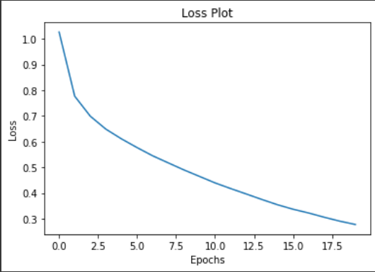

20 epochs làm lại:

