Requirement Analysis

Group 10

* Tran Manh Hung
* Le Huy Van
* Nguyen Trung Hau
* Nguyen Hong Phuong

# Use case diagram

## General use case diagram

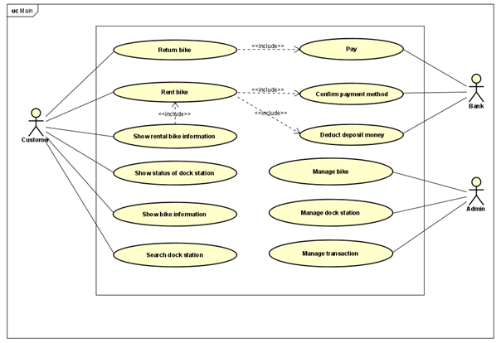

4 part:

+ rent bike , show rented bike information, show bike information

+ Pay , confirm payment method, deduct deposit money

+ Manage transaction, manage data information

+ Return bike, show status of dock

## Use case diagram for “Manage Station”

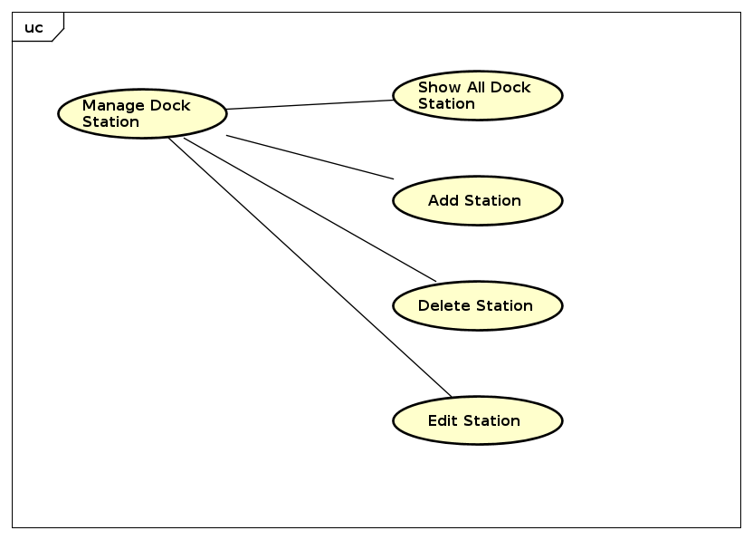

# Use case specification

## Use case “Renter bike”

|  |  |  |  |
| --- | --- | --- | --- |
| **UC Code** | UC001 | **Use case name** | Renter bike |
| **Actor** | Customer | | |
| **Precondition** | * Payment card enough to pay deposit * Customer has payment card | | |
| **Main flow of event (success)** | |  |  |  | | --- | --- | --- | | **#** | **Doer** | **Action** | | 1. 11 | Customer | Choose dock station | |  | System | Show bike list in dock station | |  | Customer | Choose bike | |  | Customer | Show payment method | |  | Customer | Enter payment information and confirm transaction | |  | System | Deduct the deposit | |  | System | Change the rental bike state | |  | System | Show successful renting message | | | |
| **Alternative flow of event** | |  |  |  | | --- | --- | --- | | **#** | **Doer** | **Action** | | 2a. | System | Notifies” The bike is busy” if the bike has trouble | | 5a. | System | Notifies “The payment information is invalid” if the payment information is invalid | | 6a. | System | Notifies “The account balance is not enough to make the transaction” if the balance do not exceed deposit money | |  |  |  | | | |
| **Post condition** | Show information of bike and rental period | | |

## 

## Use case “Return bike”

|  |  |  |  |
| --- | --- | --- | --- |
| **UC Code** | UC003 | **Use case name** | Return bike |
| **Actor** | Customer | | |
| **Precondition** | * Customer must rent bike | | |
| **Main flow of event (success)** | |  |  |  | | --- | --- | --- | | **#** | **Doer** | **Action** | | 1. | Customer | Choose return bike | | 2. | System | Show bill of transaction | | 3. | Customer | Confirm pay | | 4. | System | Pay and change information(status, position) of bike | | 5. | System | Show successful return dialog | | | |
| **Alternative flow of event** | |  |  |  | | --- | --- | --- | | **#** | **Doer** | **Action** | |  |  |  | | | |
| **Post condition** | None | | |

## UC “Manage Dock Station”

|  |  |  |  |
| --- | --- | --- | --- |
| **UC Code** | UC003 | **Use case name** | Manage Dock |
| **Actor** | Admin, system | | |
| **Precondition** | * Admin account was existed * Admin account was authenticated | | |
| **Main flow of event (success)** | |  |  |  | | --- | --- | --- | | **#** | **Doer** | **Action** | | 1 | Admin | Get Dock Station Management Page | |  | System | Get click and collect data from database | |  | System | Render Dock Station Management Page (aslo List Docks) | | | |
| **Alternative flow of event** | None | | |
| **Post condition** | None | | |

|  |  |  |  |
| --- | --- | --- | --- |
| **UC Code** | UC003_2 | **Use case name** | Add Dock |
| **Actor** | Admin,System | | |
| **Precondition** | * Admin account was existed * Admin account was authenticated * Dock station was existed | | |
| **Main flow of event (success)** | |  |  |  | | --- | --- | --- | | **#** | **Doer** | **Action** | | 1 | Admin | Click Add button | | 2 | System | Create a form to get data of new bike | | 3 | System | Display page form | | 4 | Admin | Enter Data | | 5 | Admin | Click submit button | | 6 | System | Check Data and Update Database | | 7 | System | Update Dock Management Page | | | |
| **Alternative flow of event** | |  |  |  | | --- | --- | --- | | **#** | **Doer** | **Action** | | 6 | System | Update errors | | | |
| **Post condition** | None | | |

|  |  |  |  |
| --- | --- | --- | --- |
| **UC Code** | UC003_3 | **Use case name** | Edit Dock |
| **Actor** | Admin,System | | |
| **Precondition** | * Admin account was existed * Admin search or Clicked detail a Dock Sation | | |
| **Main flow of event (success)** | |  |  |  | | --- | --- | --- | | **#** | **Doer** | **Action** | | 1 | Admin | Click Edit button | | 2 | System | Create a edit form | | 3 | System | Display edit form with old data | | 4 | Admin | Enter input data | | 5 | Admin | Click submit button | | 6 | System | Update Dock data in database | | 7 | System | Update Dock Managment Page | | | |
| **Alternative flow of event** | None | | |
| **Post condition** | None | | |

|  |  |  |  |
| --- | --- | --- | --- |
| **UC Code** | UC004_3 | **Use case name** | Delete Dock |
| **Actor** | Admin,System | | |
| **Precondition** | * Admin Clicked or Searched a Dock Station on detail | | |
| **Main flow of event (success)** | |  |  |  | | --- | --- | --- | | **#** | **Doer** | **Action** | | 1 | Admin | Click Delete button | | 2 | System | Show prompt pane | | 3 | Admin | Confirm prompt | | 4 | System | Update database | | 5 | System | Update dock management page | | | |
| **Alternative flow of event** | 3.a Refuse Prompt  4.a Return Dock Management Page | | |
| **Post condition** | **None** | | |

# Glossary

Introduction to Glossary…

## Course

…

## Credit

…

# Supplementary specification

## Functionality

Cxxx

## Performance

Xxxx

## Reliability

…