fie = -

(5)"' (‘

E - 2JL- ln(ln 7

2/7

(3.8)

then, for every x E [0,11)

If u*1* satisfies the conditions 3.2.1

sup ||ui(x, •)Ihp(r) := suP ( / (1+ f2)p |ul(x,

1/2

P L" (x,f)|2df) < Ei, p> 0.

(3.9)

x€(Q,Y) xG(Q,Y) \JR

Put q = min <( , 1 \ then

D^(x) < (In E

(1-2p)q

2

2

*lai * h

1 1 tt\ h r <

**rn\** \1 + **k\** Eh 7 h +

**Yl** (MV V“v V 2p - 1

2 2p-1

(21q)— Ei

If u1 satisfies the conditions 3.2.2

1/2

e2x|?K2 |U1(x,f)|2 df ) < E2 with p> -, (3.10)

sup

ce(Q,Y) \ 9r\es

Then

D^(x) <

2

2

E27-1



1 + kJ— ) +

Yl (h) \ V —2) y (x + p)Y

*If* u1 *satisfies the conditions 3.2.3*

1/2

hx 1_ |x / E\

E £o 7 £o I In — 1

(1-2p)£Y

Yh0

sup

cg(q,y) \ J**r\e**s

e2(x+p)|?|7/2 |U1(x,f )|2 df < E3 with p

1

> 2,

(3.11)

Then

D^(x) < Proof.

2

2

Yl (I1)

( x + p ) Y

E37-1

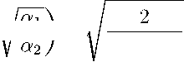

1 + kj— ) +

Yx 1— hx ( E\ E10 7 10 I In — I

(1-2p)hx

Yh0

Ltc(R)

Ltc(R)

D^(x) = ||u 1,(x, ■) - U1(x, D^(x) < ^ (M, - uy (x,

Ltc(R)

+ ll(u1,- u1)(x, ■)|

Ti (x)

T2(x)

u1, - u1,

01(x,f) (fis(f) - <Kf)) + 02(x,

7iV(i+VS)E 16i-1 **i**ln **i**

**<**2W **yi**V(**1+**VS)(/3 **■**) 2—1 e

T(x) = f | [0,(x,o (gs(?) -g(?)) -e2(x,o (/(?) - /(?))] iEj(?)

<

'Ep

0i(x*0(g(0 - g(0)*

de +

'Ep

02(x, 1/2

de

d£

<

2^**V**+**VS** 0 >/2'Wde) 4

2V2 (l+ k

1/2

d e2?/2(x) 6

V VoV^o ^(x)^

2 —y

< 2^2 1 + k./^ e<«’/2<w6

“2 -,l (li)



*Ti(x) <* 2i

**A-**lx II

1 '° ln ?

(1—2_p)|x  
Y&0

(3.12)

To reach the conclusion, it is necessary to estimate T2- Again, in view of

HA^lder nequality and the parameter choice (3.8)

72(x) = |uis(x,e) - «i(x,e)| de

R\Ep

= |ui(x,e)| C

R\Ep

If ui satisfies the conditions (3.9)

72(x) = 1 + V) -^ V + £[1])p^ |ui(x,e)|de

R\Ep

<

' R\Ep

i/2

2 -P

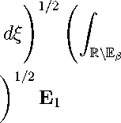

< V2 e-2pd(e)

s,

2P

|ui(x,e)|2 de

E = E + 6 (ee4(2p—1)/Y + e2^A(0,,Y/2) that is E > 6ee

ln E > ln (ln E) , that ls- ^ ^ (2I0 (ln E) )

4(2p—1)/7

2/Y

•Ta

dZ~l

sa

Cl

ui ^a

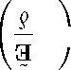

**L(d** + **x)** A _

>

'^j>ea

xi od L

xd dz-i

L(d **+** x) _

**Ud + x**) A / N

V J *11* > (x)H.

^/z

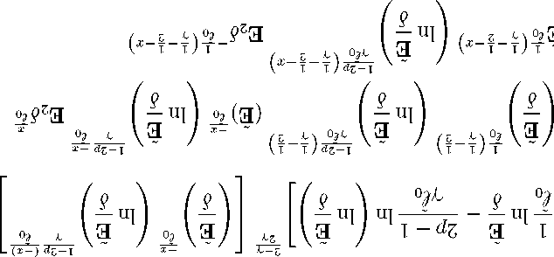

*> (x)%*

5a

L-z z

**L(d** + **x)** A _

>

"a

s/t

.e/^-9)p

/Lz-

z/i

Z,/^-\J OO

f/iVa/

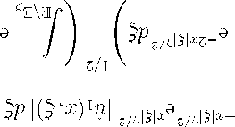

>

f'aVi/*

*J = (x)lL*

**(Ol’g)** suopipuoa at[^ sagsi^BS **ln jj**

. . I - dz A A \ (T?) lL

Ta —~r + x_T?xa ( — rn +1

l-dZ Z

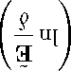

l - dz

X-, I X-,

*lvl*

*xd(dz-i)*

*0*dL



*ZTO*

^-ui ] o, c>o,a i — / V‘Y +1

l *x2 ~ \l/U*

}uim = 6 ina (T?)^ ,vs > (^)°°a

Ta ( ~ui) -L-{°dz)

i - dz A _

*L*

dZ~l

a / i-dz

> *(XH*

n9IIX

_?

**l** V a

dZ~l

|ui) ^j°dz) >

*i-dz*

*m*

*L*

l-dZ

(3.12) then

D^(x) <

2

2

1 + k - +

2

*Y (l* 1) a *(x +* p)7

**If** u1 **satisfies the conditions (3.11)**

72(x) = e-(x+p)|?|7/2e(x+p)|?|Y/2 |«i(x,0| d£

E2d-1

(1-2p)£x

i & e Yd°

E d° d d° ln

**'** M\E^

<

' M\E^

1/2 /. \ 1/2 e-2(x+p)|?|7/2d£ e2(x+p)|?|7/2 |u1(x,C)|2 d£

**f** M\E^

< V2

*crx* £ *1 — y/2*

-(x + p)y

d (e—2(X+p)?Y/2 j

1/2

e.3

2-Y

2

X

|  |  |  |
| --- | --- | --- |
|  | (x + p)y ^ | |
| where £ | = (* f ( | Jn IT |
| 72(x) < 4 | / 2 | E ln  f)o |
| (x + p)Y |

&

2

£

&

3

**2/y**

2-Y

ln lnE

2y

E

I

-(x+p)

d°

1-2p (-(x+p))

E \ Y d°

ln I

E3

72(x) <

2

E

i (1-1)

£ ° ( Y 2 )

1-2p -(x+p)

(x + p) y d

ln d

1-2p (1 — 1 )

E y£ ° Y Y **2** „ -(x+p) ee \ y £ ° (x+p)

(13) d° ln -J

E3d do

**<**

2 1(1-1

13 £°( y

(x + p) y

A (Y—1—(*+P)Yln E' ‘Y-d(Y—2—(x+p))

—A (Y—Y—(x+p))

<

1-2p £x

**2** e Y d° .

(x +PYE *° ln ?' E3 d <o ■

(3.12) then D^(x) <

2

2

1 + k — +

2

-E3d

1

(I1) «2 (x + p) Y

which is the desired conclusion. The theorem is proved.

£x 1

E£ ° d £ ° ln

(1-2p)£x

E Yd°

**4 Numerical experiment**

In general, for an ill-posed problem, we can only obtain the worst-case error for regularized methods but in practical computation, the errors in numerical

ecause of a computation of the priori condition on the exact solution E. Moreover, in practice the test of an inversion process avoiding the “inverse crime” can be done using a model for the numerically simulated data and a different one to invert the data. To overcome this difficultly, we recall a result in [2] calculating continuous Fourier transform by using the discrete Fast

Fourier Transform (FFTt=nd inverse discrete Fast Fourier Transform according

computation of regularization methods are far less than the worst-case errors. This phenomenon has been observed in many literatures, e.g. [3]. It is difficult to compute the formula 3.5

to the formulas () and () in the above section. Based on the theoretical analysis derived in the above section, we construct in the following numerical example to verify the convergence of the proposed method. Errors between the exact and its regularized solutions are estimated by the relative error estimation defined by

E (x)

(ENP-iix-tj >IS),,!

1/2

where tj = jAt, At = Nt-, j = 0,Nt. In our numerical experiment, for simplicity, we always fix T = 5. The following numerical implementation is performed by using Matlab and the computations are done on a c puter equipped with 17- Core CPU 2.5 GHz and having 8.0 GB total RAM. More detail, we solve the following problem

• On the first layer Di := {x|0 < x < 1}

dt1/2«i (x, t) = a1d'Xu1 (x, t) + S (x, t), x eD1,t > 0,

Ui (1,t) = U2 (1,t) ,

t > 0, t > 0,

K1dxU1 (1,t) = K2&xU2 (1,t)

• On the second layer D2 := {x|1 < x < 2}

dt1/2u2 (x, t) = a2dXu2 (x, t), x eD2,t > 0,

U2 (2, t) = g (t), t> 0,

dxU2 (2,t) = f (t), t> 0.

The numerical experiments are composed of four steps:

Step 1. First, In the numerical test, we take a1 = 2,a2 = 3, k1 = 9, k2 = 6 and choose Nx, Nt to generate spatial and temporal discretizations as follows

xk

t*j*

kAx, j At,

Ax

At

1

**nx** ,

T

Nt,

k = 0, Nx, j = 0, Nt.

In this experiment, we choose Nx = Nt = 100.

Step 2. We consider the exact data and the source function as follows

exp(-t2) cos 2, g (t) = exp(-12) sin 2,

f (t)

S (x, t)

exp(-t'2) cos (xs) + ?in<X>.

t2 + 5

Suppose that vector

[F,G]

|  |  |
| --- | --- |
| f (t1) | g (t1) |
| f (t2) | g (t2) |
| f (tN) | g (tNt) |

represents the discrete form of functions f and g. As in practical problems, the data (f, g) is obtained by measurement and thus inevitably is contaminated by measurement errors, some uniformly distributed random noises 8 are added to [F, G] in our test example, i.e.,

[F5, G5] = [F, G] + fmax * 8 [rand (size (F)), rand (size (G))].

Observation data **f**

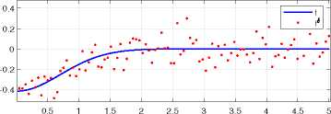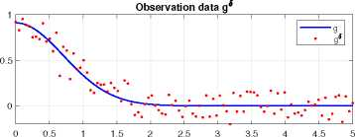

Figure 1: Graphs of Cauchy data in the case of deterministic and random noise.

Then we use the discrete Fast Fourier Transform (FFT) technique to obtain the Fourier Transform f ,9^ , f5, g5) , S of the exact data, the measured data and the source function, respectively.

Step 3 By applying the formulas () and (), we construct the Fourier transform of the exact solution and the regularized solutions at the certain point x = x0 in

various cases of the noise level 8 = {0.1,0.05, 0.01} in which the integral terms

sinh ki (f) (xo - y)

S (y,f) dy,

*i*

S (y,f)

x/Mf) sinh Jki(f) (1 - y)

x/kTTf)

cosh ki (f) (1 - xo) dy

are approximated by the Simpson’s rule. Moreover, because of a difficult compu­tation of the priori condition on the exact solution E, the regularized parameter [5 is chosen as follows

[ 5

1 1012

n T

8ln

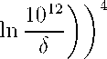

(4.1)

Then, we apply the inverse Fast Fourier transform (IFFT) to recover the discrete exact solution and the discrete regularized solutions by constructing the following matrices of size RNx+i x RNt+i

ui (xo, to) ui (x0, ti)

ui (x0, tNt)

ui (xi ,tNt)

ui *(xNx ,tNt*)

ui (xi, to) ui (xi, ti) ui (xNx ,t0) ui (xNx ,ti)

and

U5i

*Ui*.8

ui. 8i (xo,to) ui,fti (xo,ti)

ui ». (xi,to) ui ». (xi,ti)

ui, 8i (xo, tNt) ui, 8- (xi,tNt)

ui, 8i (xNx ,to) ui ,8i (xNx ,ti)

uii8i (xNx ,tNt)

in which 8i

0.1,82

0.05, 83 = 0.01 and [j is defined as (4.1) corresponding to

8i

**Step 4** For r

computed by

0,Nx,the relative error estimation at certain point xr is

E (xr)

^^^j=1|u1^ (Xr ,tj ) Ul{xr ,tj j| ^

(E'=,i«.<x, .«j )is)‘,!

1/2

Then the result is shown in Table 4. From this computation, we observe the following important facts: The regularization method given in this paper works well for even acceptable error levels. The regularized solution converges to the exact solution with different values of 8. However, the numerical accuracy

becomes worse as x tends to 0.

|  |  |  |  |
| --- | --- | --- | --- |
|  | E (xr) | | |
| z | 4i = 0.1 | 42 = 0.05 | 4s = 0.01 |
| 0 | 1.2927 | 0.6492 | 0.1324 |
| 0.1 | 1.1223 | 0.5636 | 0.1149 |
| 0.2 | 0.9537 | 0.4789 | 0.0977 |
| 0.3 | 0.7868 | 0.3951 | 0.0807 |
| 0.4 | 0.6214 | 0.3122 | 0.0640 |
| 0.5 | 0.4578 | 0.2303 | 0.0476 |
| 0.6 | 0.2967 | 0.1500 | 0.0317 |
| 0.7 | 0.1446 | 0.0751 | 0.0176 |
| 0.8 | 0.0872 | 0.0485 | 0.0128 |
| 0.9 | 0.2191 | 0.1122 | 0.0238 |

Table 4: The relative errors between u1 and u^. with 4i = 0.1,42 = 0.05,4s = 0.01. ’*

Next, Figure 2 - Figure 5 help us to show the comparisions between the exact solution and its computed approximations corresponding to different noise level 4j, i = 1.3. Then, we get Figure 6 which consider the solutions at the fixed point

x = 0.1

**6**

**0.5**

**4**

1.4

1.2

1

0.8

0.6

0.4

0.2

0

**2**

1,4

1,2

1

0,8

0,6

0,4

0,2

0

■0,2

Figure 3: The regularized solu­tion u1a .

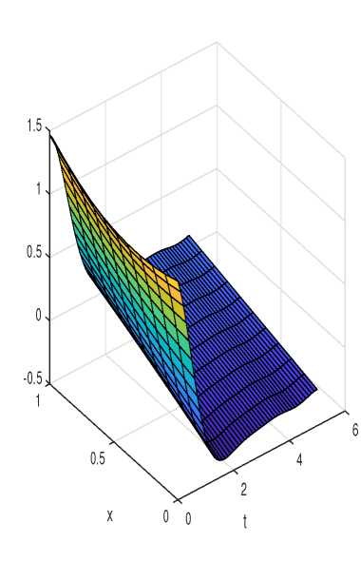

Figure 2: The exact solution u1.

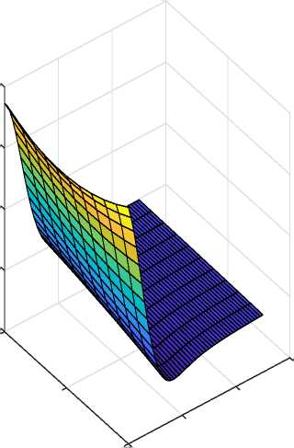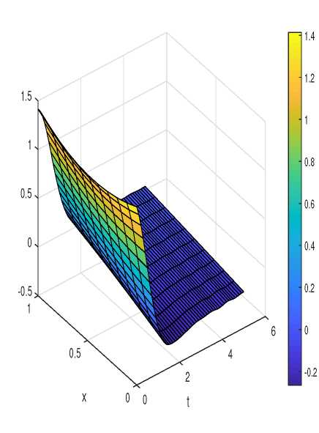

Figure 4: The regularized solu- Figure 5: The regularized solu­tion uf2^. tion uf3^.

**6**

**0.5**

**2**

**4**

1.4

1.2

1

0.8

0.6

0.4

0.2

0

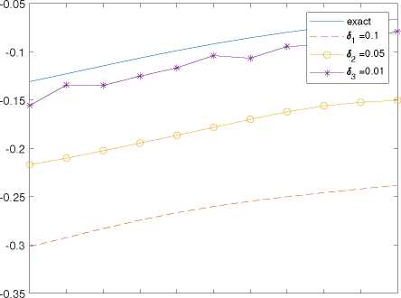

2 2.1 2.2 2.3 2.4 2.5 2.6 2.7 2.8 2.9 3

t

Figure 6: The exact solution ui and the regularized solution u, respectively in the case x = 0.1.

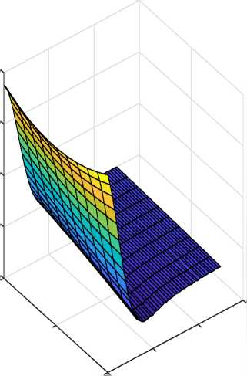

5 Conclusions

Although there are several regularization methods for stabilizing the inverse heat conduction problem in a single-layer body by using an a priori information on the exact solution, the regularization error estimates for the fractional inverse heat conduction problem with the nonhomogenuous source in a multi-layer body are still very rare. This is due to the complexity of the forward operators as shown in (2.23) and (2.24). Therefore, the direct extension of the existing methods for solving the FIHCP in single-layer domain is unavailable. However, the idea for stabilizing the FIHCP in single-layer domain can be used. In this paper, we found that the Fourier truncation is efficient in solving the FIHCP in two layer domain. Furthermore, we obtain the error estimates for our method for solving the FIHCP in two-layer domain. In theoretical aspect, the order of the error estimates is Holder type. The constructed numerical examples also verify that the proposed regularization method is effective for solving the FIHCP in the two-layer domain.

Acknowledgement

References

1. Khieu T. T., Luan N. T., Hong B. Q. N., Khanh Q. T., Recovery of the tem­perature distribution in a multilayer fractional diffusion equation, Cambridge University Press. Feb 20, 2019.
2. Bailey D. H., Swarztrauber P. N., A fast method for the numerical evaluation of continuous Fourier and Laplace transforms, SIAM J. Sci. Comput. 15 (1994), no. 5, 1105-1110.
3. Berntsson F., A spectral method for solving the sideways heat equation*,* In­verse Prob. 15 (1999) 891-906.
4. Garra R., Giusti A., Mainardi F., Pagnini G., Fractional relaxation with time-varying coefficient, Fractional Calc Appl Anal. 172 (2014), pp. 424-439.
5. Giona M., Cerbelli S., Roman H. E., Fractional diffusion equation and re­laxation in complex viscoelastic materials, Phys Stat Mech Appl. 191 (1992), pp. 449-453.
6. Kutner R., Coherent spatio-temporal coupling in fractional wanderings. Re­newed approach to continuous-time Levy flights. Anomalous Diffusion From Basics to Applications*,* Berlin, Heidelberg, Springer, (1999), pp. 1-14.
7. Metzler R, Klafter J., The random walks guide to anomalous diffusion: a fractional dynamics approach*,* Phys Rep. 339 (2000), pp. 1-77.
8. Podlubny I., Fractional Differential Equations, San Diego, Academic Press, (1999).

1. 1 —2p

   <*' 2p-r(^ ■) ^ Ei-