**Laboratory 4 – VLSM and static routing**

Student name: Phan Phương Duy…………………………….. Student ID: ITITIU16010…………………………………...

**Topology**

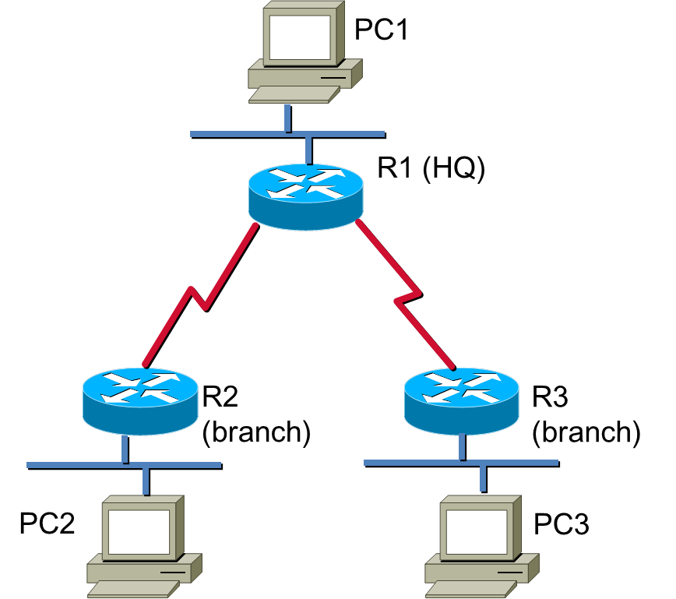

**Learning Objectives**

Upon completion of this lab, you will be able to:

* Design the IP addresses for the network.
* Configure static routes between routers to allow data transfer between routers without the use of dynamic routing protocols.

**Task 1: IP addressing**

**Step 1.** How many subnetworks are there in above topology?

There are 5 subnetworks

**Step 2.** Given the class C address 192.168.1.0/24. Each LAN requires 60 IP addresses. Please assign the IP subnets to the subnetworks in above topology using VLSM?

Subnet 1:

IP range: 192.168.1.1 to 192.168.1.62

Subnet 2:

IP range: 192.168.1.65 to 192.168.1.126

Subnet 3:

IP range: 192.168.1.129 to 192.168.1.190

SC1:

IP range: 192.168.1.193 to 192.168.1.222

SC2:

IP range: 192.168.1.225 to 192.168.1.254

…

**Step 3.** Assign the IP addresses for the interfaces of the devices?

|  |  |  |  |  |
| --- | --- | --- | --- | --- |
| **Device** | **Interface** | **IP Address** | **Subnet Mask** | **Default Gateway** |
| R1 | FE | 192.168.1.1 | 255.255.255.192 |  |
| Serial to R2 | 192.168.1.194 | 255.255.255.224 |  |
| Serial to R3 | 192.168.1.226 | 255.255.255.224 |  |
| R2 | FE | 192.168.1.65 | 255.255.255.192 |  |
| Serial | 192.168.1.193 | 255.255.255.224 |  |
| R3 | FE | 192.168.1.129 | 255.255.255.192 |  |
| Serial | 192.168.1.225 | 255.255.255.224 |  |
| PC1 | NIC | 192.168.1.2 | 255.255.255.192 | 192.168.1.1 |
| PC2 | NIC | 192.168.1.66 | 255.255.255.192 | 192.168.1.65 |
| PC3 | NIC | 192.168.1.130 | 255.255.255.192 | 192.168.1.129 |

**Task 2: Basic router configuration**

**Step 1.** Start the routers. Configure the router names, password of the routers.

**Step 2.** Configure the IP addresses of the interfaces of all the devices in the topology according to the information in step 3, task 1.

(show the status of the interfaces of the routers (show ip interface brief), show all the configuration of the routers.)

***Router 1:***

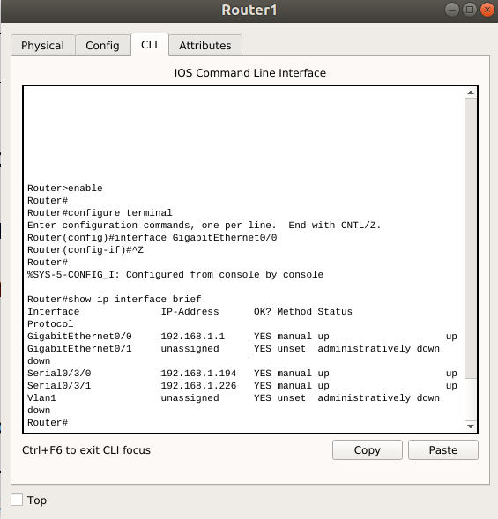

***Router 2:***

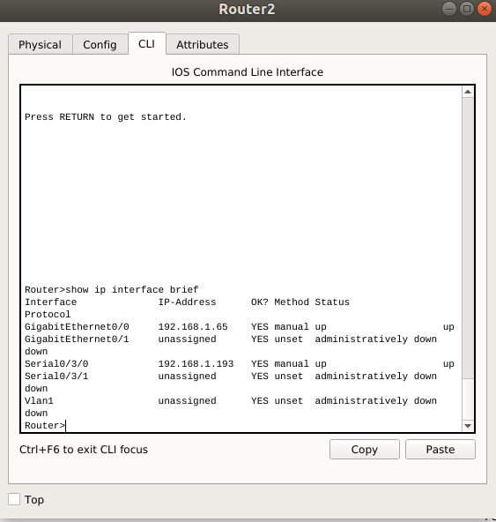

***Router 3:***

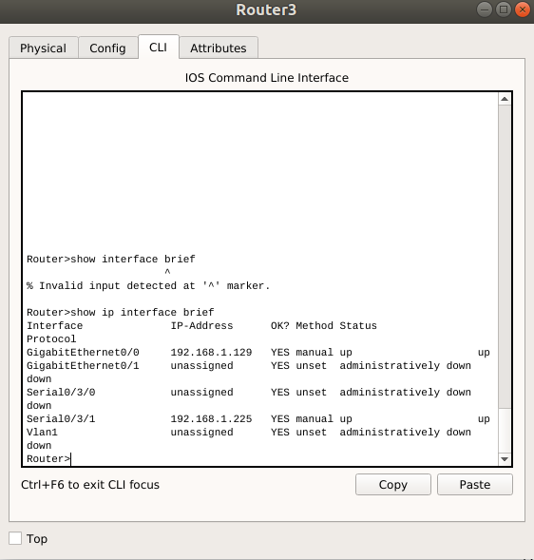

***PC1:***

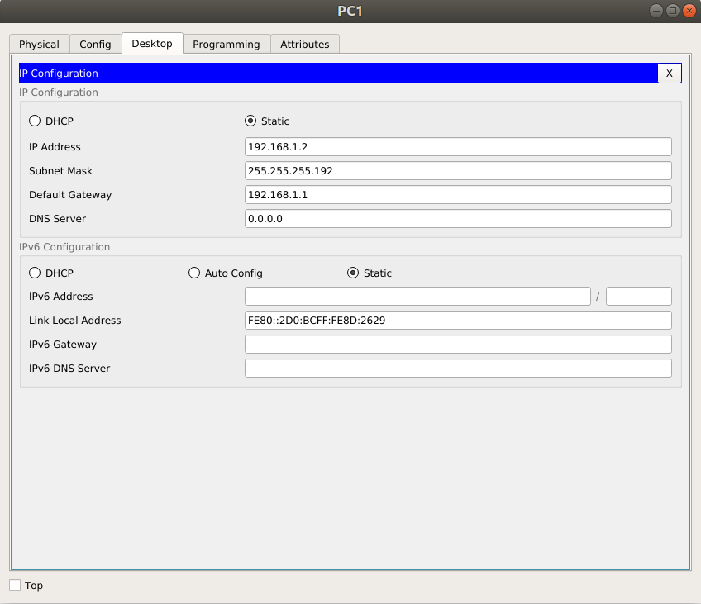

***PC2:***

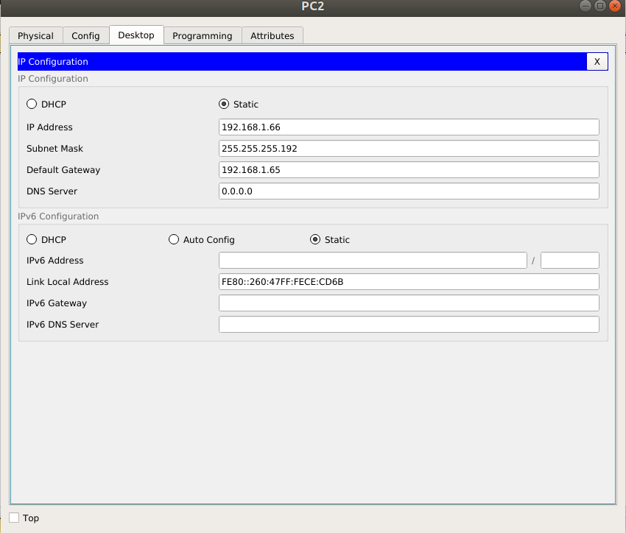

***PC3:***

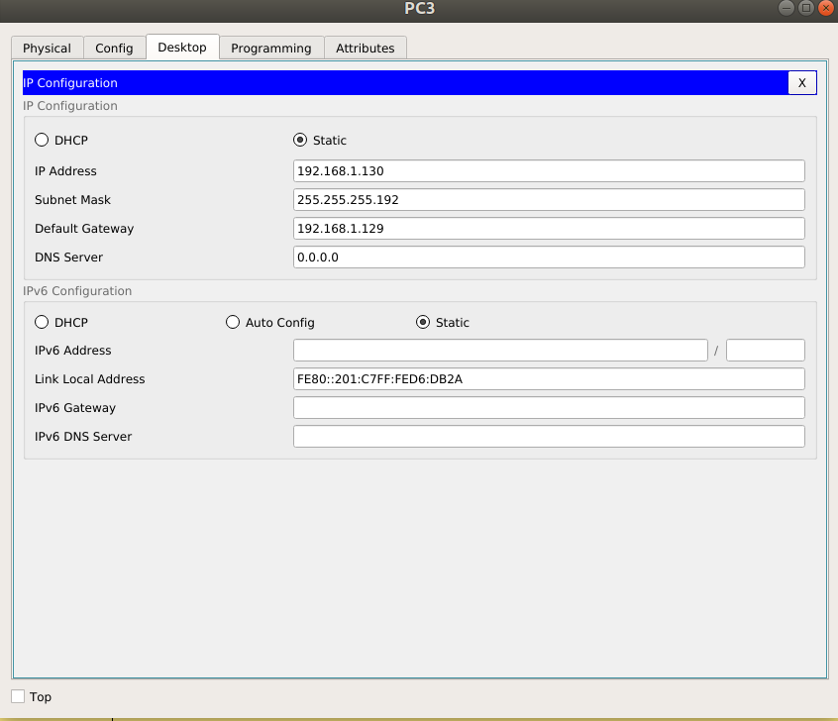

**Step 2.** From Router 1, can you “ping” to the serial interfaces of router 2, router 2, and PC 1?

From router 1, we can ping to PC1 and serial interfaces of router 2. We cannot ping to router 2.

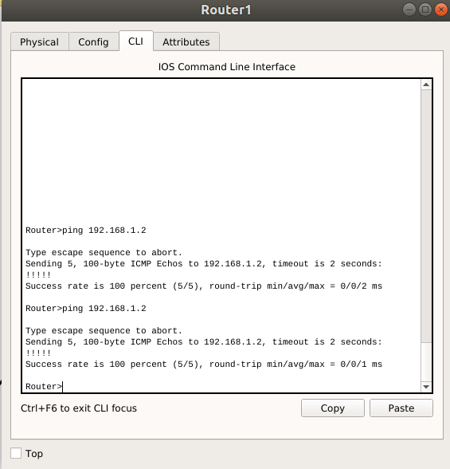

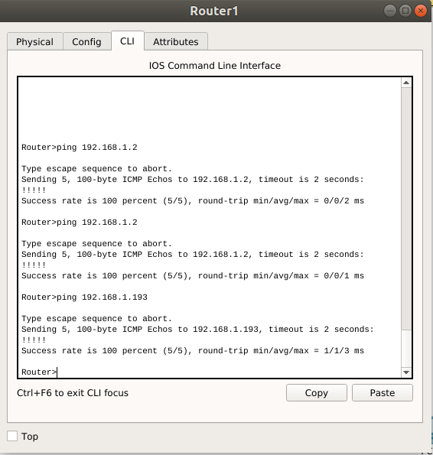

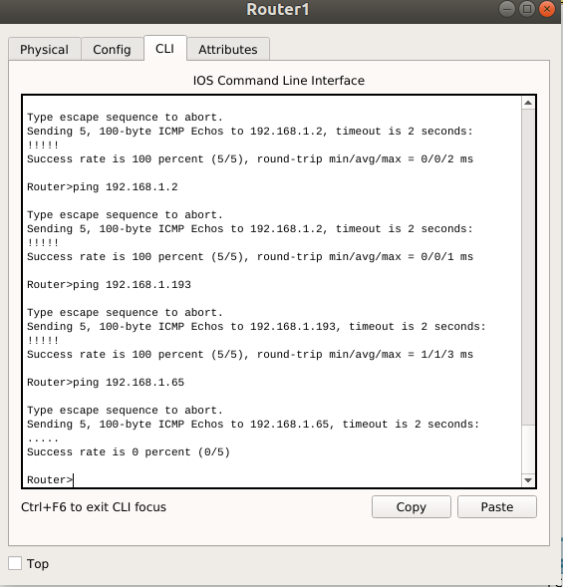

From PC1, can you “ping” to the serial interfaces of router 1, PC2, and PC3?

No, I cannot ping to serial interfaces of router 1, PC2 and PC3

**Task 3: Static IP routing**

**Step 3.** Static IP routing

On router 1, configure the static IP routing to see the LAN 2.

(R1(config)#ip route <LAN2 subnet> <LAN2 mask> <outgoing interface>)

Check the routing table using the command show ip route? Explain the entries in the routing table.

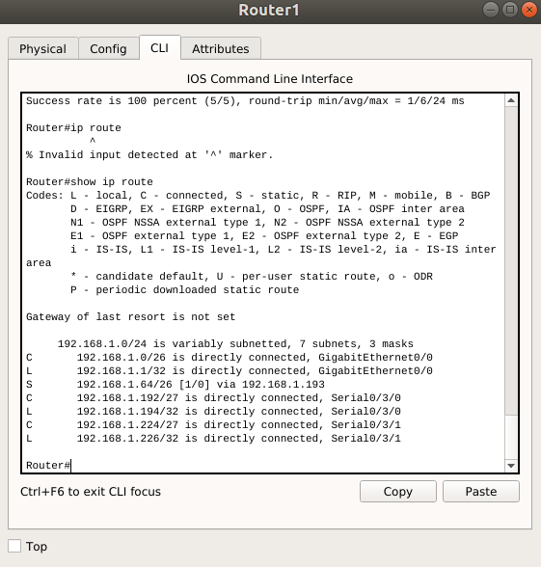

From PC1, can you “ping” to PC2 now?

No I cannot ping PC2

On router 2, configure the static IP routing to see the LAN 1.

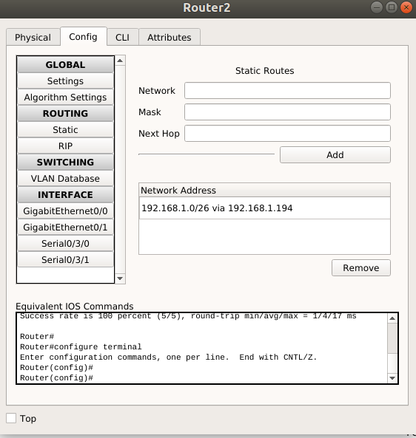

From PC1, can you “ping” to PC2 and vice versa?

Yes, now from PC1, I can ping to PC2

***From PC1 ping to PC2:***

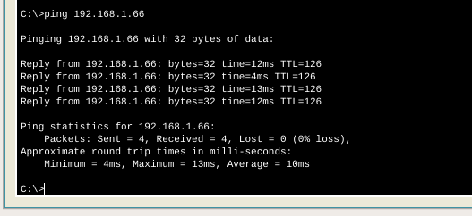

***From PC2 ping to PC1:***

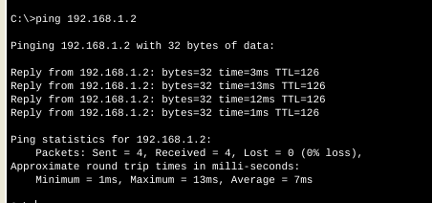

**Step 4.** Configure the static IP routing so that LAN 1 can see LAN 3.

***Router 1:***

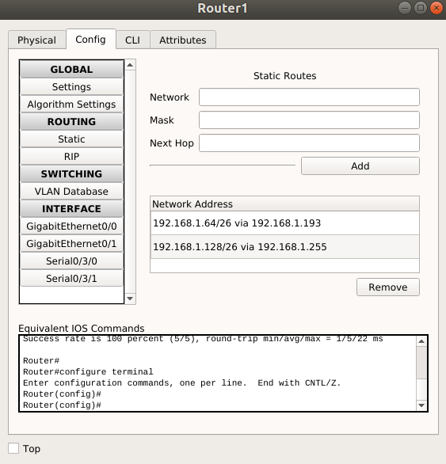

***Router 3:***

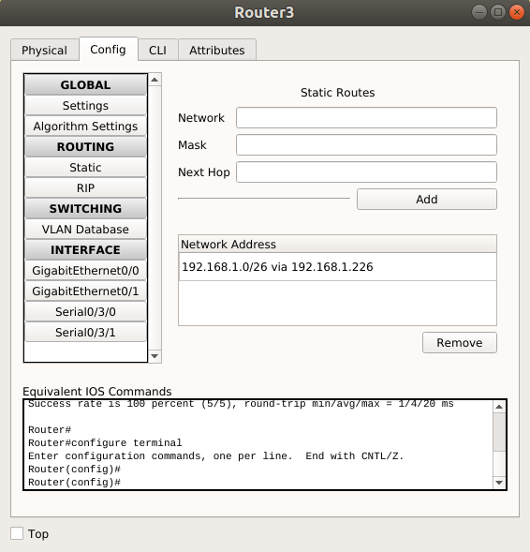

Can PC 2 “ping” to PC3?

No, PC2 cannot ping to PC3

**Step 5.** Routers 2 and 3 are also called the HUB routers. We can use the default route for routers 2 and 3:

* Clear the current IP routing configuration
* Input the command: R1(config)#ip route 0.0.0.0 0.0.0.0 <outgoing interface>

Can the PCs ping to each other?

Yes now the ***PC2 can ping to the PC3***

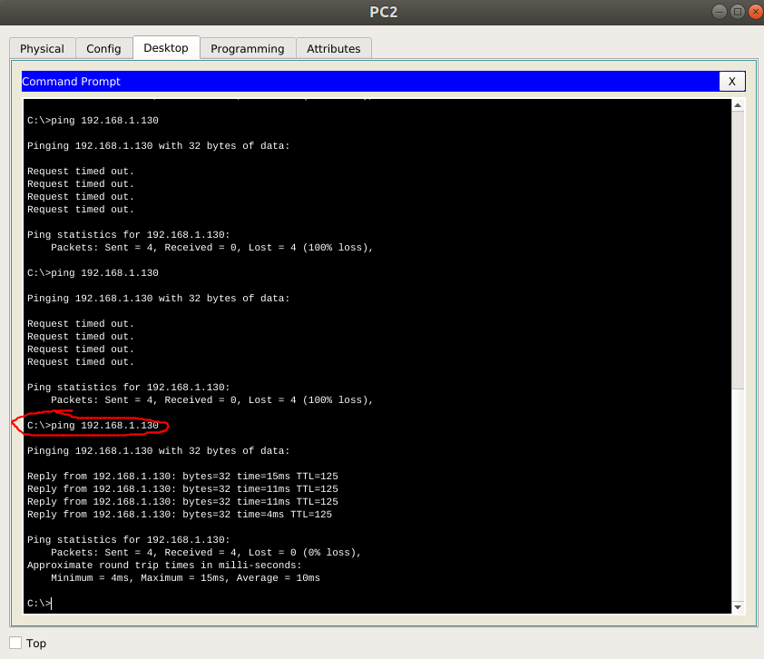

***From PC1 to PC2:***

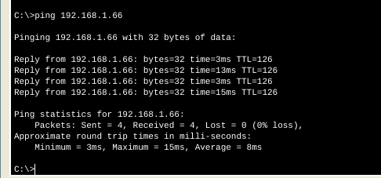

***From PC1 to PC3:***

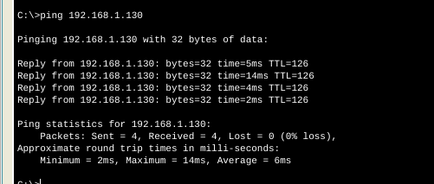

**Step 6.** Show the final configuration of the routers.

***Router 1:***

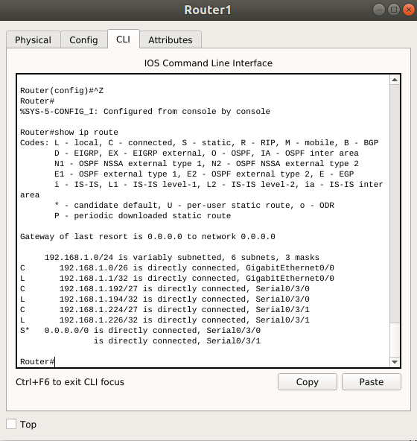

***Route 2:***

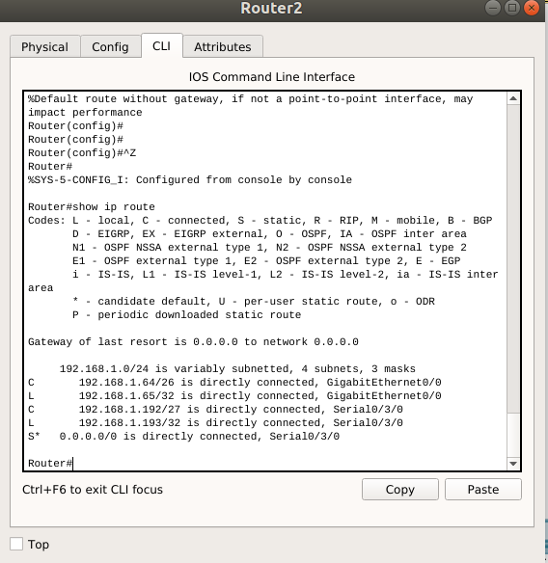

***Route 3:***

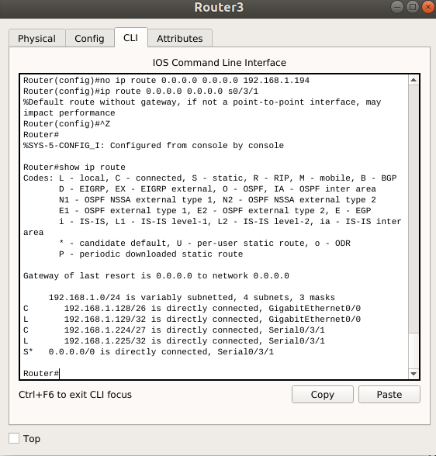

**Task 4: Clean Up**

Save your project, shutdown the computer. Upload your report to Blackboard.

**THE END.**