9.6.1 Kết quả thí nghiệm
Liệt kê những hình vẽ và bảng dữ liệu kết quả.
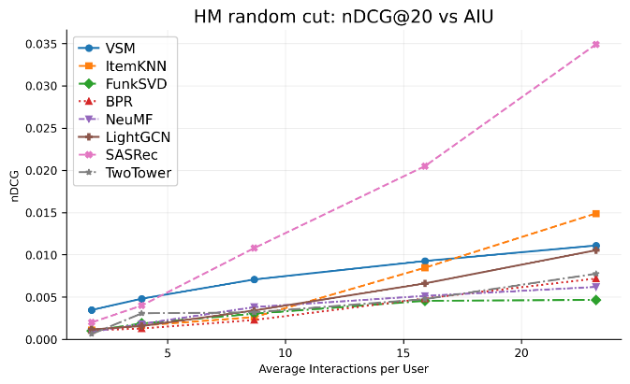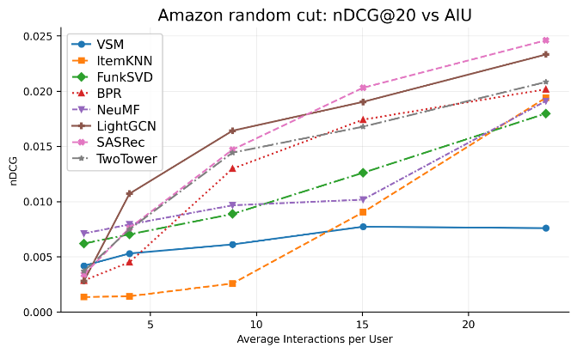
Hình 6.1. nDCG@20 vs AIU
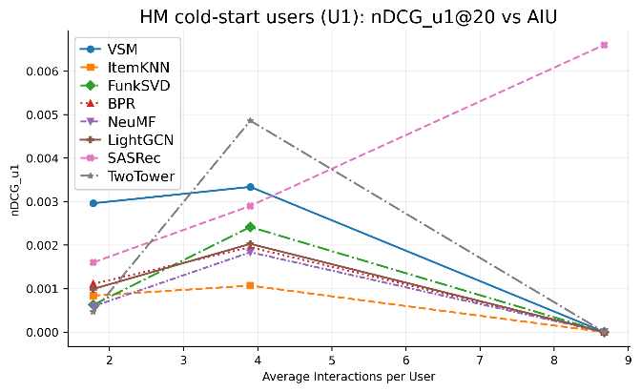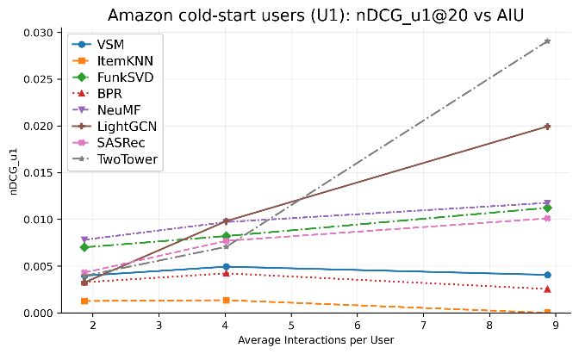
Hình 6.2. nDCG@20 vs AIU – nhóm U1
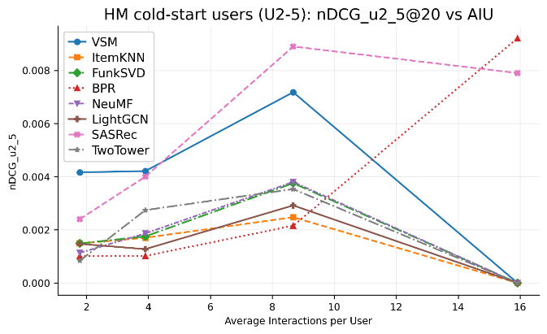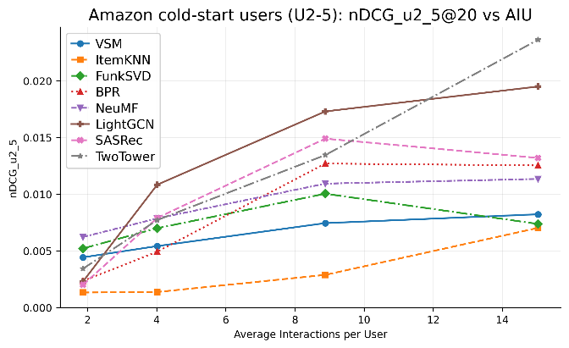
Hình 6.3. nDCG@20 vs AIU – nhóm U2-5
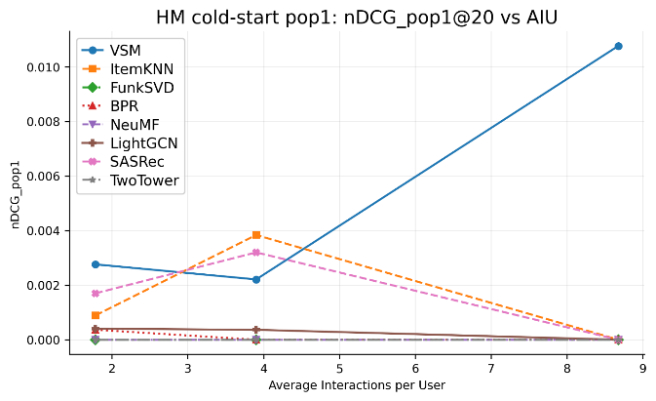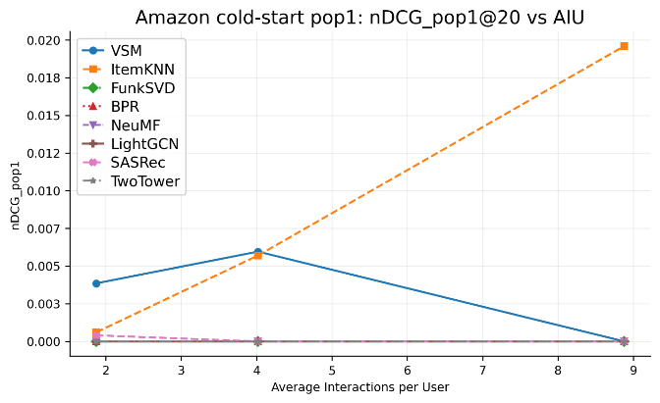
Hình 6.4. nDCG@20 vs AIU – nhóm pop1
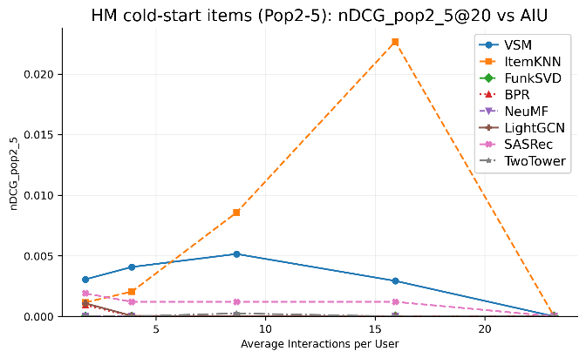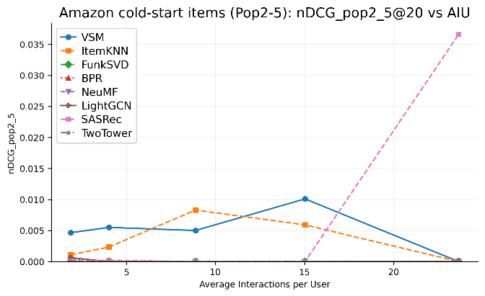
Hình 6.5. nDCG@20 vs AIU – nhóm pop2-5

Bảng 1. nDCG và Recall @20, @50 vs AIU
Thuật Toán | AIU | Amazon |  |  |  | HM
Thuật Toán | AIU | Top-20 |  | Top-50 |  | Top-20 |  | Top-50
Thuật Toán | AIU | nDCG | Recall | nDCG | Recall | nDCG | Recall | nDCG | Recall
VSM | <2 | 0.0042 | 0.0105 | 0.0062 | 0.0208 | 0.0035 | 0.0094 | 0.0050 | 0.0173
VSM | 4 | 0.0053 | 0.0137 | 0.0077 | 0.0259 | 0.0048 | 0.0123 | 0.0068 | 0.0225
VSM | 9 | 0.0061 | 0.0164 | 0.0097 | 0.0346 | 0.0071 | 0.0183 | 0.0102 | 0.0339
VSM | 15 | 0.0077 | 0.0194 | 0.0113 | 0.0376 | 0.0093 | 0.0253 | 0.0142 | 0.0504
VSM | >20 | 0.0076 | 0.0200 | 0.0118 | 0.0410 | 0.0111 | 0.0306 | 0.0175 | 0.0631
ItemKNN | <2 | 0.0038 | 0.0098 | 0.0057 | 0.0192 | 0.0041 | 0.0107 | 0.0060 | 0.0201
ItemKNN | 4 | 0.0068 | 0.0172 | 0.0098 | 0.0324 | 0.0082 | 0.0206 | 0.0117 | 0.0385
ItemKNN | 9 | 0.0119 | 0.0294 | 0.0170 | 0.0547 | 0.0132 | 0.0325 | 0.0186 | 0.0598
ItemKNN | 15 | 0.0152 | 0.0373 | 0.0216 | 0.0693 | 0.0171 | 0.0415 | 0.0241 | 0.0763
ItemKNN | >20 | 0.0177 | 0.0428 | 0.0250 | 0.0795 | 0.0201 | 0.0481 | 0.0282 | 0.0884
FunkSVD | <2 | 0.0029 | 0.0073 | 0.0043 | 0.0146 | 0.0015 | 0.0039 | 0.0022 | 0.0076
FunkSVD | 4 | 0.0053 | 0.0134 | 0.0076 | 0.0251 | 0.0031 | 0.0079 | 0.0045 | 0.0152
FunkSVD | 9 | 0.0098 | 0.0244 | 0.0139 | 0.0449 | 0.0056 | 0.0140 | 0.0081 | 0.0268
FunkSVD | 15 | 0.0132 | 0.0325 | 0.0186 | 0.0591 | 0.0078 | 0.0194 | 0.0112 | 0.0367
FunkSVD | >20 | 0.0158 | 0.0386 | 0.0221 | 0.0695 | 0.0098 | 0.0241 | 0.0139 | 0.0452
BPR | <2 | 0.0029 | 0.0073 | 0.0044 | 0.0153 | 0.0011 | 0.0029 | 0.0017 | 0.0058
BPR | 4 | 0.0045 | 0.0108 | 0.0064 | 0.0203 | 0.0013 | 0.0033 | 0.0024 | 0.0091
BPR | 9 | 0.0130 | 0.0333 | 0.0189 | 0.0631 | 0.0023 | 0.0064 | 0.0036 | 0.0129
BPR | 15 | 0.0174 | 0.0428 | 0.0247 | 0.0801 | 0.0048 | 0.0122 | 0.0073 | 0.0246
BPR | >20 | 0.0202 | 0.0489 | 0.0280 | 0.0887 | 0.0072 | 0.0188 | 0.0107 | 0.0368
NeuMF | <2 | 0.0031 | 0.0077 | 0.0046 | 0.0157 | 0.0009 | 0.0023 | 0.0014 | 0.0049
NeuMF | 4 | 0.0058 | 0.0141 | 0.0082 | 0.0261 | 0.0021 | 0.0052 | 0.0030 | 0.0101
NeuMF | 9 | 0.0105 | 0.0260 | 0.0149 | 0.0477 | 0.0048 | 0.0118 | 0.0069 | 0.0229
NeuMF | 15 | 0.0139 | 0.0339 | 0.0196 | 0.0621 | 0.0077 | 0.0188 | 0.0109 | 0.0356
NeuMF | >20 | 0.0164 | 0.0397 | 0.0230 | 0.0721 | 0.0103 | 0.0245 | 0.0142 | 0.0455
LightGCN | <2 | 0.0035 | 0.0088 | 0.0052 | 0.0176 | 0.0019 | 0.0049 | 0.0028 | 0.0095
LightGCN | 4 | 0.0067 | 0.0166 | 0.0096 | 0.0311 | 0.0042 | 0.0104 | 0.0060 | 0.0199
LightGCN | 9 | 0.0126 | 0.0310 | 0.0179 | 0.0572 | 0.0085 | 0.0207 | 0.0121 | 0.0394
LightGCN | 15 | 0.0170 | 0.0415 | 0.0240 | 0.0757 | 0.0119 | 0.0287 | 0.0167 | 0.0535
LightGCN | >20 | 0.0202 | 0.0488 | 0.0282 | 0.0879 | 0.0151 | 0.0356 | 0.0210 | 0.0657
SASRec | <2 | 0.0027 | 0.0068 | 0.0041 | 0.0141 | 0.0008 | 0.0021 | 0.0013 | 0.0046
SASRec | 4 | 0.0056 | 0.0138 | 0.0080 | 0.0257 | 0.0023 | 0.0057 | 0.0033 | 0.0112
SASRec | 9 | 0.0112 | 0.0276 | 0.0159 | 0.0508 | 0.0062 | 0.0152 | 0.0088 | 0.0288
SASRec | 15 | 0.0155 | 0.0379 | 0.0219 | 0.0693 | 0.0098 | 0.0237 | 0.0139 | 0.0444
SASRec | >20 | 0.0189 | 0.0458 | 0.0265 | 0.0824 | 0.0134 | 0.0320 | 0.0187 | 0.0582
Two-Tower | <2 | 0.0037 | 0.0106 | 0.0063 | 0.0241 | 0.0006 | 0.0015 | 0.0010 | 0.0036
Two-Tower | 4 | 0.0075 | 0.0207 | 0.0122 | 0.0446 | 0.0031 | 0.0076 | 0.0045 | 0.0149
Two-Tower | 9 | 0.0144 | 0.0355 | 0.0215 | 0.0716 | 0.0032 | 0.0088 | 0.0050 | 0.0179
Two-Tower | 15 | 0.0168 | 0.0413 | 0.0239 | 0.0773 | 0.0048 | 0.0133 | 0.0079 | 0.0292
Two-Tower | >20 | 0.0208 | 0.0502 | 0.0295 | 0.0942 | 0.0078 | 0.0209 | 0.0121 | 0.0431

Bảng 2. ndcg@20 vs AIU cho mỗi nhóm u1,..u41+, pop1, ...,pop41+, Amazon
Thuật Toán | AIU | Nhóm người dùng |  |  |  |  |  | Popularity groups
 |  | 1 | 2-5 | 6-10 | 11-20 | 21-40 | 40+ | 1 | 2-5 | 6-10 | 11-20 | 21-40 | 40+
VSM | <2 | 0.0040 | 0.0044 | 0.0059 | 0.0000 | 0.0211 | 0.0000 | 0.0039 | 0.0047 | 0.0027 | 0.0039 | 0.0068 | 0.0028
 | 4 | 0.0049 | 0.0054 | 0.0053 | 0.0038 | 0.0097 | 0.0087 | 0.0060 | 0.0055 | 0.0064 | 0.0040 | 0.0046 | 0.0047
 | 9 | 0.0041 | 0.0074 | 0.0061 | 0.0044 | 0.0053 | 0.0023 | 0.0000 | 0.0050 | 0.0059 | 0.0062 | 0.0069 | 0.0062
 | 15 | — | 0.0082 | 0.0089 | 0.0072 | 0.0061 | 0.0073 | — | 0.0101 | 0.0068 | 0.0074 | 0.0086 | 0.0077
 | >20 | — | — | — | 0.0089 | 0.0056 | 0.0046 | — | 0.0000 | 0.0016 | 0.0069 | 0.0068 | 0.0084
ItemKNN | <2 | 0.0013 | 0.0013 | 0.0044 | 0.0000 | 0.0000 | 0.0000 | 0.0006 | 0.0011 | 0.0008 | 0.0013 | 0.0068 | 0.0322
 | 4 | 0.0014 | 0.0014 | 0.0014 | 0.0029 | 0.0026 | 0.0000 | 0.0057 | 0.0023 | 0.0008 | 0.0004 | 0.0000 | 0.0002
 | 9 | 0.0000 | 0.0029 | 0.0021 | 0.0031 | 0.0032 | 0.0060 | 0.0196 | 0.0083 | 0.0028 | 0.0017 | 0.0011 | 0.0013
 | 15 | — | 0.0070 | 0.0096 | 0.0085 | 0.0091 | 0.0097 | — | 0.0059 | 0.0066 | 0.0053 | 0.0065 | 0.0142
 | >20 | — | — | — | 0.0197 | 0.0191 | 0.0184 | — | 0.0000 | 0.0102 | 0.0056 | 0.0124 | 0.0292
FunkSVD | <2 | 0.0070 | 0.0052 | 0.0026 | 0.0000 | 0.0000 | 0.0000 | 0.0000 | 0.0000 | 0.0001 | 0.0078 | 0.0682 | 0.4763
 | 4 | 0.0082 | 0.0070 | 0.0067 | 0.0037 | 0.0024 | 0.0000 | 0.0000 | 0.0000 | 0.0000 | 0.0000 | 0.0031 | 0.0966
 | 9 | 0.0112 | 0.0100 | 0.0085 | 0.0092 | 0.0051 | 0.0000 | 0.0000 | 0.0000 | 0.0000 | 0.0000 | 0.0000 | 0.0399
 | 15 | — | 0.0074 | 0.0138 | 0.0122 | 0.0126 | 0.0059 | — | 0.0000 | 0.0000 | 0.0000 | 0.0016 | 0.0330
 | >20 | — | — | — | 0.0175 | 0.0184 | 0.0201 | — | 0.0000 | 0.0000 | 0.0002 | 0.0011 | 0.0345
BPR | <2 | 0.0033 | 0.0023 | 0.0008 | 0.0000 | 0.0000 | 0.0000 | 0.0000 | 0.0004 | 0.0035 | 0.0093 | 0.0195 | 0.0905
 | 4 | 0.0042 | 0.0049 | 0.0040 | 0.0013 | 0.0000 | 0.0000 | 0.0000 | 0.0001 | 0.0011 | 0.0019 | 0.0107 | 0.0393
 | 9 | 0.0025 | 0.0127 | 0.0130 | 0.0138 | 0.0146 | 0.0036 | 0.0000 | 0.0000 | 0.0001 | 0.0014 | 0.0083 | 0.0496
 | 15 | — | 0.0125 | 0.0189 | 0.0165 | 0.0186 | 0.0100 | — | 0.0000 | 0.0000 | 0.0000 | 0.0021 | 0.0456
 | >20 | — | — | — | 0.0210 | 0.0184 | 0.0202 | — | 0.0000 | 0.0000 | 0.0015 | 0.0029 | 0.0374
NeuMF | <2 | 0.0078 | 0.0062 | 0.0048 | 0.0000 | 0.0000 | 0.0000 | 0.0000 | 0.0000 | 0.0000 | 0.0000 | 0.0956 | 0.5677
 | 4 | 0.0097 | 0.0079 | 0.0073 | 0.0041 | 0.0000 | 0.0000 | 0.0000 | 0.0000 | 0.0000 | 0.0000 | 0.0000 | 0.1145
 | 9 | 0.0118 | 0.0109 | 0.0089 | 0.0110 | 0.0051 | 0.0000 | 0.0000 | 0.0000 | 0.0000 | 0.0000 | 0.0000 | 0.0434
 | 15 | — | 0.0113 | 0.0112 | 0.0098 | 0.0102 | 0.0023 | — | 0.0000 | 0.0000 | 0.0000 | 0.0000 | 0.0274
 | >20 | — | — | — | 0.0192 | 0.0194 | 0.0176 | — | 0.0000 | 0.0000 | 0.0003 | 0.0014 | 0.0366
LightGCN | <2 | 0.0032 | 0.0023 | 0.0007 | 0.0000 | 0.0000 | 0.0000 | 0.0000 | 0.0006 | 0.0020 | 0.0081 | 0.0255 | 0.0779
 | 4 | 0.0098 | 0.0108 | 0.0121 | 0.0068 | 0.0124 | 0.0000 | 0.0000 | 0.0000 | 0.0004 | 0.0040 | 0.0150 | 0.1194
 | 9 | 0.0199 | 0.0173 | 0.0159 | 0.0167 | 0.0174 | 0.0000 | 0.0000 | 0.0000 | 0.0002 | 0.0016 | 0.0086 | 0.0645
 | 15 | — | 0.0195 | 0.0204 | 0.0180 | 0.0206 | 0.0118 | — | 0.0000 | 0.0001 | 0.0009 | 0.0053 | 0.0474
 | >20 | — | — | — | 0.0233 | 0.0235 | 0.0231 | — | 0.0000 | 0.0014 | 0.0007 | 0.0032 | 0.0437
SASRec | <2 | 0.0043 | 0.0020 | 0.0020 | 0.0000 | 0.0000 | 0.0000 | 0.0004 | 0.0001 | 0.0001 | 0.0024 | 0.0389 | 0.2486
 | 4 | 0.0077 | 0.0079 | 0.0067 | 0.0065 | 0.0049 | 0.0000 | 0.0000 | 0.0002 | 0.0011 | 0.0020 | 0.0110 | 0.0833
 | 9 | 0.0101 | 0.0149 | 0.0146 | 0.0143 | 0.0173 | 0.0133 | 0.0000 | 0.0000 | 0.0000 | 0.0021 | 0.0084 | 0.0567
 | 15 | — | 0.0132 | 0.0212 | 0.0196 | 0.0206 | 0.0218 | — | 0.0000 | 0.0000 | 0.0008 | 0.0073 | 0.0498
 | >20 | — | — | — | 0.0242 | 0.0240 | 0.0289 | — | 0.0366 | 0.0161 | 0.0062 | 0.0115 | 0.0393
Two-Tower | <2 | 0.0039 | 0.0034 | 0.0021 | 0.0000 | 0.0106 | 0.0000 | 0.0000 | 0.0001 | 0.0039 | 0.0144 | 0.0363 | 0.0487
 | 4 | 0.0071 | 0.0077 | 0.0076 | 0.0047 | 0.0093 | 0.0000 | 0.0000 | 0.0000 | 0.0001 | 0.0030 | 0.0263 | 0.0582
 | 9 | 0.0291 | 0.0134 | 0.0144 | 0.0160 | 0.0157 | 0.0019 | 0.0000 | 0.0000 | 0.0004 | 0.0010 | 0.0077 | 0.0568
 | 15 | — | 0.0236 | 0.0165 | 0.0164 | 0.0202 | 0.0089 | — | 0.0000 | 0.0011 | 0.0012 | 0.0062 | 0.0402
 | >20 | — | — | — | 0.0210 | 0.0211 | 0.0182 | — | 0.0000 | 0.0000 | 0.0005 | 0.0019 | 0.0396

Bảng 3. ndcg@20 vs AIU cho mỗi nhóm u1,..u41+, pop1, ...,pop41+, HM
Thuật Toán | AIU |  | Nhóm người dùng |  |  |  |  |  | Popularity groups
 |  |  | 1 | 2-5 | 6-10 | 11-20 | 21-40 | 40+ | 1 | 2-5 | 6-10 | 11-20 | 21-40 | 40+
VSM | <2 | 0.0030 |  | 0.0042 | 0.0041 | 0.0000 | 0.0000 | — | 0.0028 | 0.0031 | 0.0070 | 0.0092 | 0.0078 | 0.0000
 | 4 | 0.0033 |  | 0.0042 | 0.0079 | 0.0078 | 0.0000 | — | 0.0022 | 0.0041 | 0.0051 | 0.0066 | 0.0107 | 0.0108
 | 9 | 0.0000 |  | 0.0072 | 0.0068 | 0.0081 | 0.0040 | 0.0000 | 0.0108 | 0.0051 | 0.0048 | 0.0081 | 0.0107 | 0.0071
 | 15 | — |  | 0.0000 | 0.0101 | 0.0087 | 0.0113 | 0.0039 | — | 0.0029 | 0.0058 | 0.0077 | 0.0095 | 0.0125
 | >20 | — |  | — | 0.0000 | 0.0116 | 0.0111 | 0.0076 | — | 0.0000 | 0.0040 | 0.0066 | 0.0113 | 0.0131
ItemKNN | <2 | 0.0008 |  | 0.0015 | 0.0000 | 0.0000 | 0.0000 | — | 0.0009 | 0.0012 | 0.0006 | 0.0005 | 0.0105 | 0.0000
 | 4 | 0.0011 |  | 0.0017 | 0.0019 | 0.0000 | 0.0000 | — | 0.0038 | 0.0020 | 0.0005 | 0.0005 | 0.0004 | 0.0000
 | 9 | 0.0000 |  | 0.0025 | 0.0022 | 0.0039 | 0.0011 | 0.0000 | 0.0000 | 0.0086 | 0.0017 | 0.0013 | 0.0024 | 0.0003
 | 15 | — |  | 0.0000 | 0.0092 | 0.0087 | 0.0074 | 0.0036 | — | 0.0227 | 0.0060 | 0.0084 | 0.0070 | 0.0106
 | >20 | — |  | — | 0.0057 | 0.0170 | 0.0137 | 0.0073 | — | 0.0000 | 0.0076 | 0.0056 | 0.0104 | 0.0222
FunkSVD | <2 | 0.0006 |  | 0.0015 | 0.0013 | 0.0000 | 0.0000 | — | 0.0000 | 0.0000 | 0.0000 | 0.0033 | 0.0523 | 0.2522
 | 4 | 0.0024 |  | 0.0018 | 0.0020 | 0.0015 | 0.0000 | — | 0.0000 | 0.0000 | 0.0000 | 0.0000 | 0.0071 | 0.0884
 | 9 | 0.0000 |  | 0.0038 | 0.0033 | 0.0014 | 0.0070 | 0.0000 | 0.0000 | 0.0000 | 0.0000 | 0.0000 | 0.0001 | 0.0313
 | 15 | — |  | 0.0000 | 0.0049 | 0.0046 | 0.0043 | 0.0043 | — | 0.0000 | 0.0000 | 0.0000 | 0.0000 | 0.0172
 | >20 | — |  | — | 0.0000 | 0.0044 | 0.0048 | 0.0057 | — | 0.0000 | 0.0000 | 0.0000 | 0.0000 | 0.0101
BPR | <2 | 0.0011 |  | 0.0010 | 0.0016 | 0.0000 | 0.0000 | — | 0.0004 | 0.0009 | 0.0035 | 0.0049 | 0.0080 | 0.0000
 | 4 | 0.0020 |  | 0.0010 | 0.0019 | 0.0000 | 0.0000 | — | 0.0000 | 0.0000 | 0.0004 | 0.0024 | 0.0106 | 0.0220
 | 9 | 0.0000 |  | 0.0022 | 0.0024 | 0.0021 | 0.0034 | 0.0000 | 0.0000 | 0.0000 | 0.0001 | 0.0002 | 0.0026 | 0.0181
 | 15 | — |  | 0.0092 | 0.0053 | 0.0047 | 0.0049 | 0.0036 | — | 0.0000 | 0.0003 | 0.0001 | 0.0004 | 0.0176
 | >20 | — |  | — | 0.0041 | 0.0085 | 0.0060 | 0.0055 | — | 0.0000 | 0.0000 | 0.0000 | 0.0005 | 0.0152
NeuMF | <2 | 0.0006 |  | 0.0011 | 0.0044 | 0.0000 | 0.0000 | — | 0.0000 | 0.0000 | 0.0000 | 0.0000 | 0.0404 | 0.7047
 | 4 | 0.0018 |  | 0.0019 | 0.0016 | 0.0032 | 0.0000 | — | 0.0000 | 0.0000 | 0.0000 | 0.0000 | 0.0000 | 0.1052
 | 9 | 0.0000 |  | 0.0038 | 0.0039 | 0.0035 | 0.0067 | 0.0000 | 0.0000 | 0.0000 | 0.0000 | 0.0000 | 0.0000 | 0.0397
 | 15 | — |  | 0.0000 | 0.0052 | 0.0052 | 0.0044 | 0.0128 | — | 0.0000 | 0.0000 | 0.0000 | 0.0000 | 0.0194
 | >20 | — |  | — | 0.0000 | 0.0062 | 0.0064 | 0.0057 | — | 0.0000 | 0.0000 | 0.0000 | 0.0000 | 0.0134
LightGCN | <2 | 0.0010 |  | 0.0015 | 0.0000 | 0.0000 | 0.0000 | — | 0.0004 | 0.0011 | 0.0018 | 0.0055 | 0.0167 | 0.0000
 | 4 | 0.0020 |  | 0.0013 | 0.0021 | 0.0051 | 0.0000 | — | 0.0004 | 0.0000 | 0.0001 | 0.0009 | 0.0102 | 0.0506
 | 9 | 0.0000 |  | 0.0029 | 0.0041 | 0.0019 | 0.0097 | 0.0000 | 0.0000 | 0.0000 | 0.0001 | 0.0009 | 0.0030 | 0.0270
 | 15 | — |  | 0.0000 | 0.0066 | 0.0070 | 0.0049 | 0.0083 | — | 0.0000 | 0.0003 | 0.0004 | 0.0021 | 0.0219
 | >20 | — |  | — | 0.0118 | 0.0106 | 0.0103 | 0.0116 | — | 0.0000 | 0.0000 | 0.0001 | 0.0013 | 0.0219
SASRec | <2 | 0.0016 |  | 0.0024 | 0.0041 | 0.0000 | 0.0000 | — | 0.0017 | 0.0019 | 0.0019 | 0.0035 | 0.0056 | 0.1635
 | 4 | 0.0029 |  | 0.0040 | 0.0046 | 0.0026 | 0.0000 | — | 0.0032 | 0.0012 | 0.0029 | 0.0059 | 0.0123 | 0.0591
 | 9 | 0.0066 |  | 0.0089 | 0.0101 | 0.0133 | 0.0237 | 0.0000 | 0.0000 | 0.0012 | 0.0046 | 0.0087 | 0.0217 | 0.0315
 | 15 | — |  | 0.0079 | 0.0185 | 0.0202 | 0.0246 | 0.0129 | — | 0.0012 | 0.0019 | 0.0071 | 0.0233 | 0.0396
 | >20 | — |  | — | 0.0655 | 0.0335 | 0.0362 | 0.0329 | — | 0.0000 | 0.0068 | 0.0112 | 0.0311 | 0.0484
Two-Tower | <2 | 0.0005 |  | 0.0008 | 0.0013 | 0.0000 | 0.0000 | — | 0.0000 | 0.0000 | 0.0000 | 0.0023 | 0.0330 | 0.1599
 | 4 | 0.0049 |  | 0.0027 | 0.0028 | 0.0051 | 0.0000 | — | 0.0000 | 0.0000 | 0.0000 | 0.0011 | 0.0219 | 0.1067
 | 9 | 0.0000 |  | 0.0035 | 0.0029 | 0.0035 | 0.0066 | 0.0000 | 0.0000 | 0.0002 | 0.0004 | 0.0015 | 0.0061 | 0.0158
 | 15 | — |  | 0.0000 | 0.0048 | 0.0051 | 0.0037 | 0.0026 | — | 0.0000 | 0.0002 | 0.0004 | 0.0030 | 0.0137
 | >20 | — |  | — | 0.0200 | 0.0078 | 0.0075 | 0.0092 | — | 0.0000 | 0.0000 | 0.0001 | 0.0024 | 0.0150

Bảng 4. Borda count
AIU | VSM | ItemKNN | FunkSVD | BPR | NeuMF | LightGCN | SASRec | Two-Tower
<2 | 6.00 | 2.00 | 4.00 | 2.50 | 4.00 | 3.00 | 4.50 | 2.00
4 | 4.50 | 1.00 | 3.50 | 0.50 | 4.50 | 4.00 | 5.50 | 4.50
9 | 3.50 | 0.50 | 2.00 | 2.00 | 4.00 | 5.50 | 6.50 | 4.00
15 | 3.00 | 3.00 | 1.50 | 3.50 | 2.50 | 5.00 | 7.00 | 2.50
>20 | 2.50 | 4.50 | 0.50 | 3.00 | 1.50 | 5.00 | 7.00 | 4.00

Bảng 5. Borda count u<5
AIU | VSM | ItemKNN | FunkSVD | BPR | NeuMF | LightGCN | SASRec | Two-Tower
<2 | 5.75 | 2.00 | 4.50 | 2.75 | 4.25 | 2.50 | 4.50 | 1.75
4 | 4.25 | 0.50 | 3.75 | 1.00 | 4.00 | 4.50 | 5.25 | 4.75
9 | 3.00 | 1.00 | 3.25 | 2.00 | 4.00 | 4.50 | 5.75 | 4.50
15 | 2.25 | 1.25 | 1.75 | 5.50 | 2.75 | 4.25 | 5.50 | 4.75

Bảng 6. Borda count u5+
AIU | VSM | ItemKNN | FunkSVD | BPR | NeuMF | LightGCN | SASRec | Two-Tower
<2 | 4.63 | 3.06 | 3.19 | 3.15 | 4.27 | 2.44 | 3.60 | 3.67
4 | 5.17 | 1.88 | 2.79 | 1.40 | 2.81 | 5.17 | 4.08 | 4.71
9 | 3.31 | 1.81 | 2.31 | 3.06 | 2.81 | 4.69 | 6.06 | 3.94
15 | 2.88 | 3.00 | 2.00 | 3.50 | 2.38 | 5.00 | 7.00 | 2.25
>20 | 1.88 | 3.88 | 1.42 | 2.54 | 1.92 | 5.38 | 7.00 | 4.00

Bảng 7. Borda count per user group
 | VSM | ItemKNN | FunkSVD | BPR | NeuMF | LightGCN | SASRec | Two-Tower
Coldstart-User | 4.04 | 1.18 | 3.54 | 2.43 | 3.89 | 3.89 | 5.21 | 3.82
Non-coldstart User | 3.62 | 2.76 | 2.30 | 2.70 | 2.82 | 4.54 | 5.59 | 3.67

Bảng 8. Borda count per item popularity
 | VSM | ItemKNN | FunkSVD | BPR | NeuMF | LightGCN |  | SASRec | Two-Tower
Longtail Items | 6.13 | 5.01 | 1.54 | 3.03 | 1.32 | 3.43 |  | 4.57 | 2.97
Head Items | 2.48 | 2.10 | 2.88 | 3.13 | 3.20 | 4.47 |  | 5.50 | 4.25

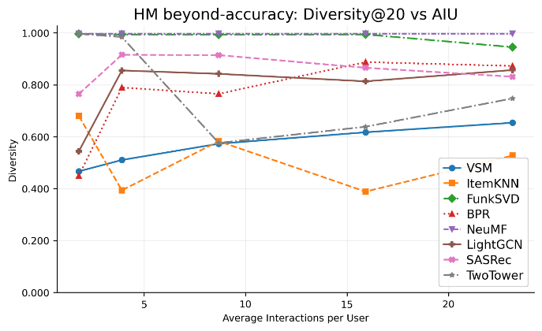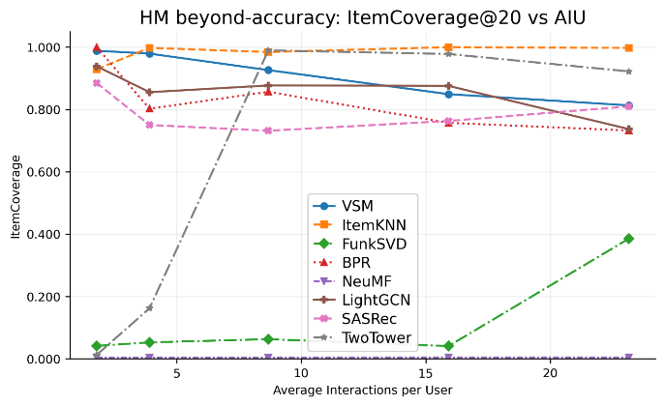
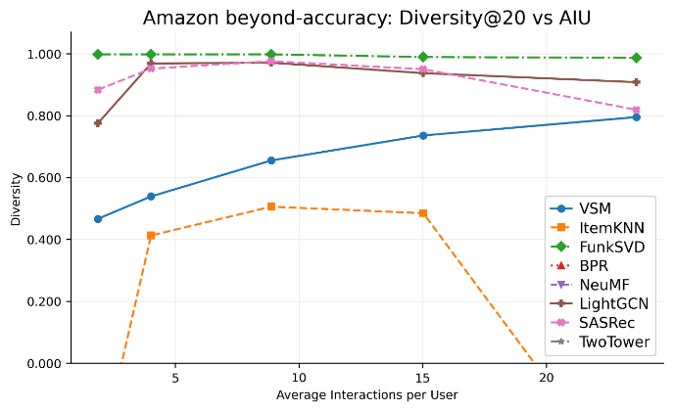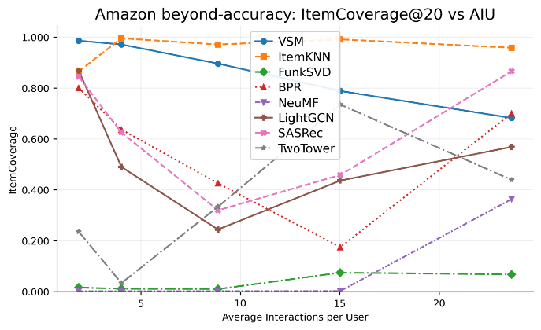
Hình 6.6. Item Coverage, Diversity vs AIU
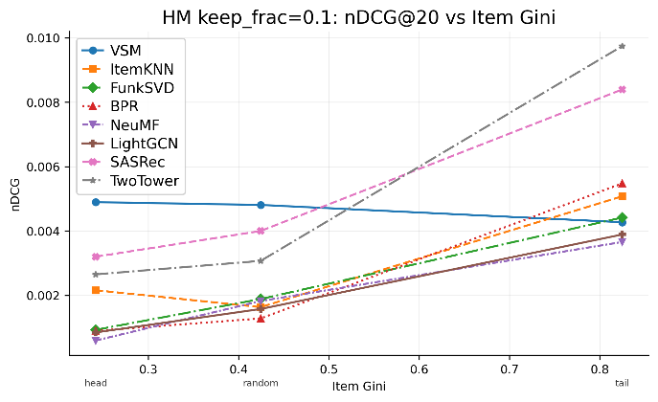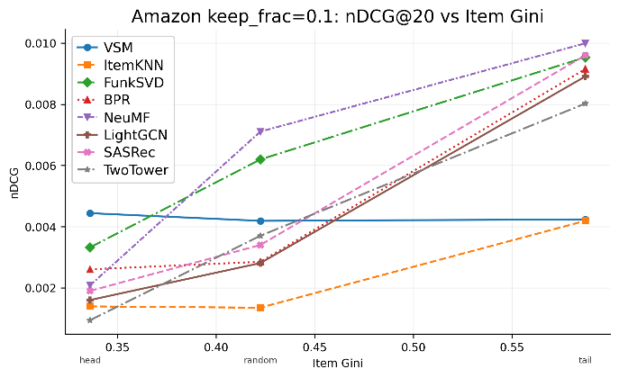
Hình 6.7. nDCG@20 vs Item Gini
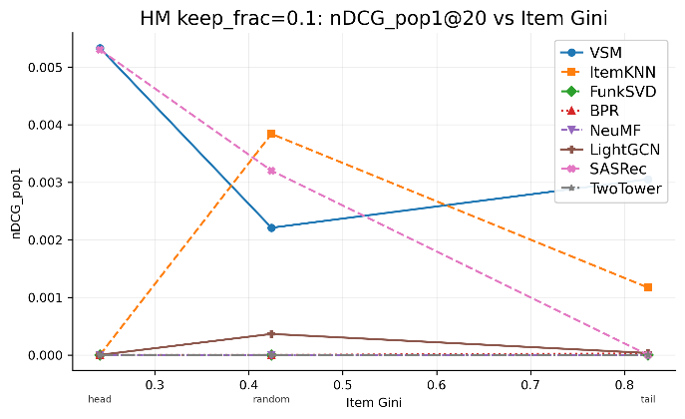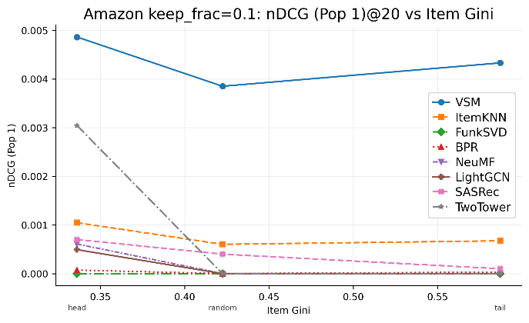
Hình 6.8. nDCG@20 vs Item Gini – nhóm pop1
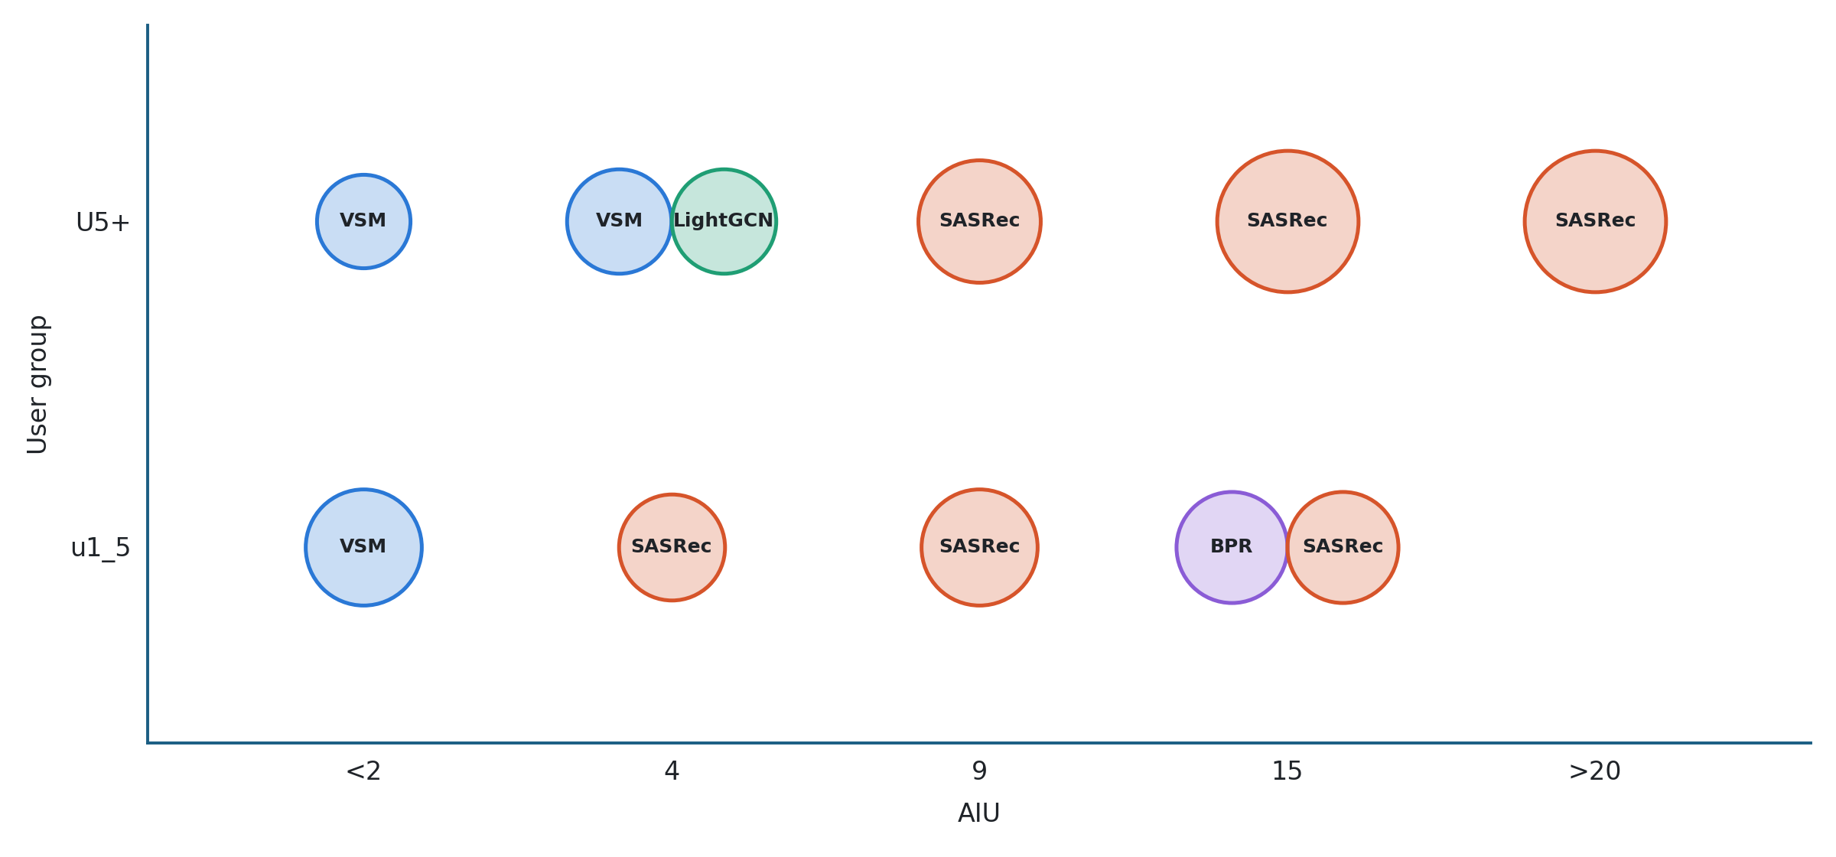
Hình 6.9. Thuật toán có Borda count cao nhất theo độ thưa dữ liệu (AIU) và nhóm người dùng

6.2 Phân tích và thảo luận
a) Hiệu năng của các thuật toán thay đổi như thế nào khi độ thưa dữ liệu tăng/giảm? Những thuật toán nào có độ ổn định cao trong điều kiện dữ liệu thưa?
b) Những thuật toán nào có ưu thế đối với coldstart users?
c) Những thuật toán nào có ưu thế đối với longtail items?
d) Việc mất cân bằng của phân bố tương tác theo sản phẩm ảnh hưởng đến hiệu năng của thuật toán như thế nào?
e) Khuyến nghị: theo hình vẽ borda count rankings per overall sparsity and coldstart/non-coldstart user
f) Các nhận xét khác: bất cứ nhận xét nào khác về kết quả thí nghiệm

