SQL used:

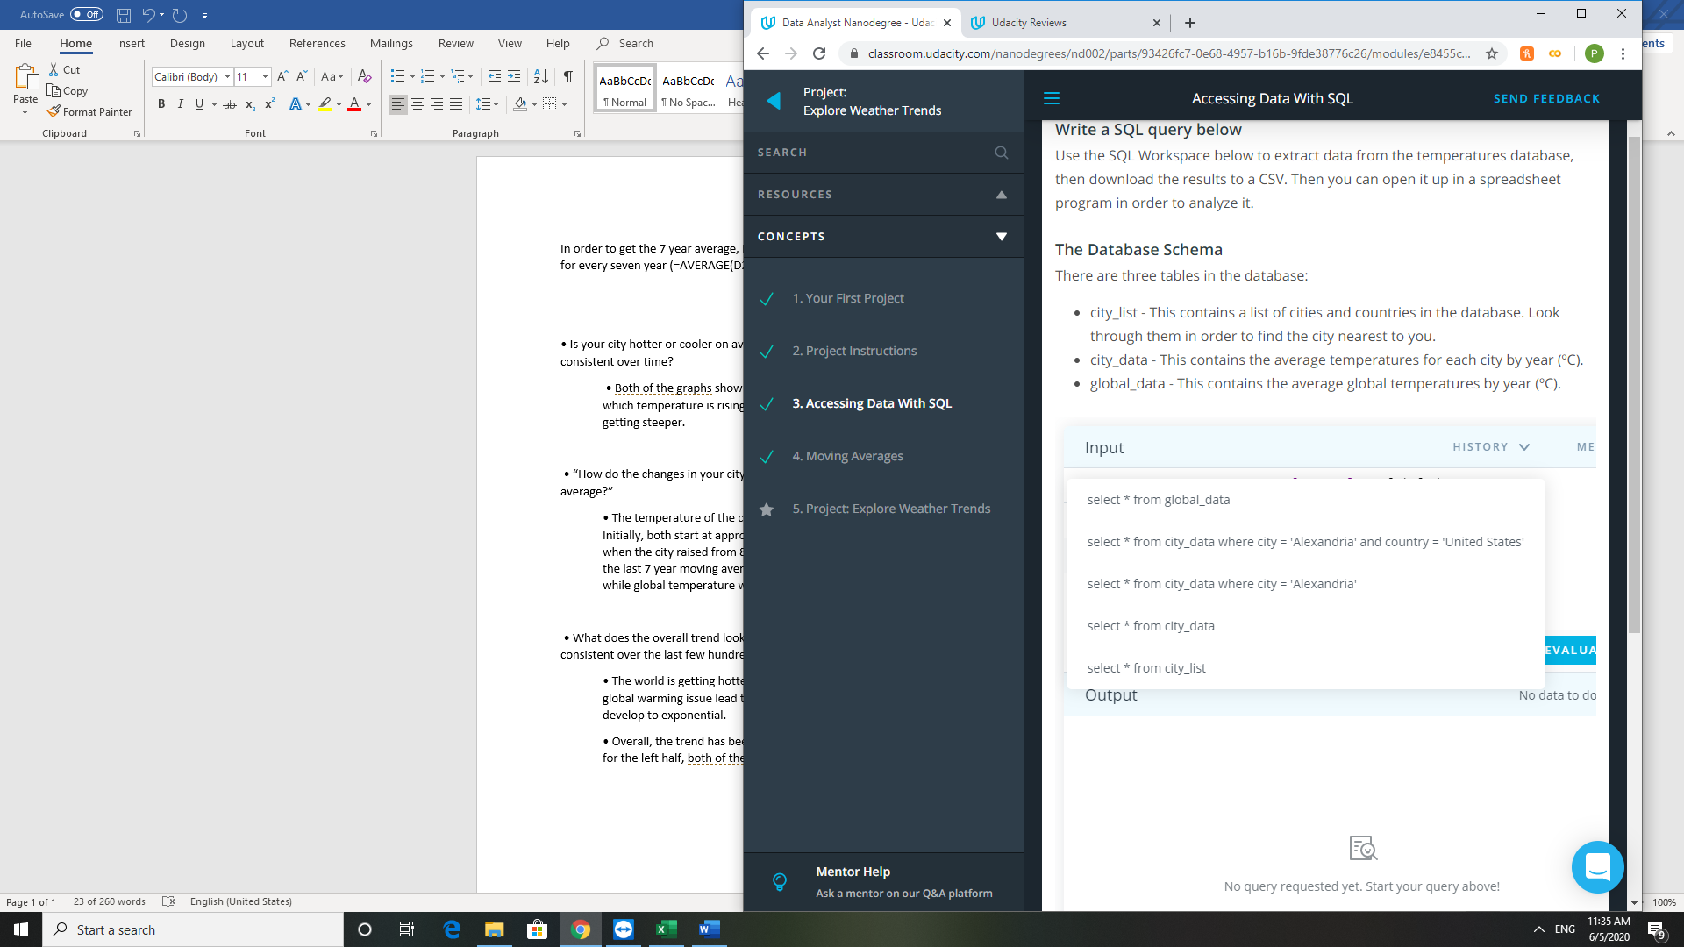

Excel used:

* In order to get the 7 year average, I use excel’s average() formula to calculate the average temperature for every seven year (For instance, =AVERAGE(D2:D8) then drag down until the end of the columns, excel will refractor that formula accordingly)
* For graph, I insert scatter graph base on the calculated data

Graph:

Observation:

• Is your city hotter or cooler on average compared to the global average? Has the difference been consistent over time?

• Both of the graphs show the city and global temperature keep rising. However, the rate of which temperature is rising is getting larger over time as we can see on the graph, the slope is getting steeper.

• “How do the changes in your city’s temperatures over time compare to the changes in the global average?”

• The temperature of the city rises at a faster pace when compare to global temperature. Initially, both start at approximately 8. However, the city temperature overtook the global one when the city raised from 8 to 12, the global was only rise from 8 to 9 at that point of time. As of the last 7 year moving average temperature, city’s 7 years moving average was at nearly 14 while global temperature was at near 10.

• What does the overall trend look like? Is the world getting hotter or cooler? Has the trend been consistent over the last few hundred years?

• The world is getting hotter as the overall trend looks positively linear. However, with the global warming issue lead to ice melting, ozone hole and greenhouse effect, it could potentially develop to exponential.

• Overall, the trend has been consistent for the right half of the graph when it’s slowly rising. As for the left half, both of the graphs are fluctuating.