Hoàng Quang Phương

1150080112

Bài tập buổi 8

Nội dung:

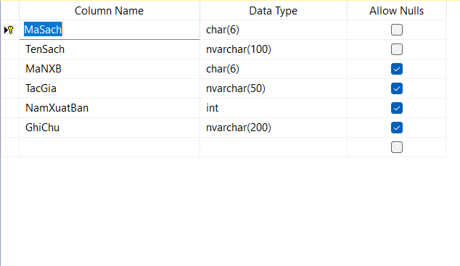

|  |
| --- |
| CREATE TABLE Sach (  MaSach CHAR(6) NOT NULL PRIMARY KEY,  TenSach NVARCHAR(100) NOT NULL,  MaNXB CHAR(6) NULL,  TacGia NVARCHAR(50) NULL,  NamXuatBan INT NULL,  GhiChu NVARCHAR(200) NULL  ); |

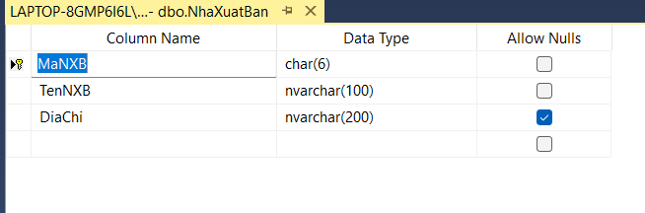

|  |
| --- |
| CREATE TABLE NhaXuatBan (  MaNXB CHAR(6) NOT NULL PRIMARY KEY,  TenNXB NVARCHAR(100) NOT NULL,  DiaChi NVARCHAR(200) NULL  ); |

Thực hành 1:

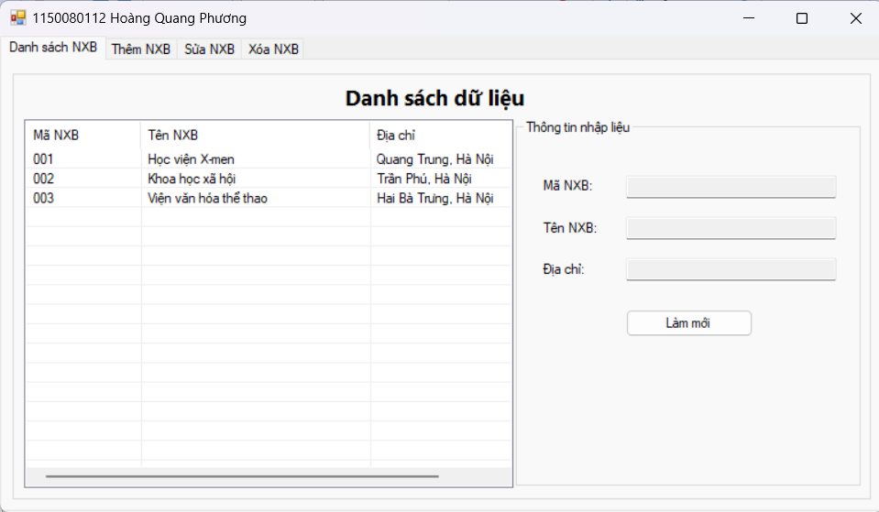

Form1.cs

|  |
| --- |
| private void HienThiDanhSachNXB()  {  try  {  MoKetNoi();  SqlCommand cmd = new SqlCommand("SELECT MaNXB, TenNXB, DiaChi FROM NhaXuatBan", sqlCon);  SqlDataReader reader = cmd.ExecuteReader();  lsvDanhSach.Items.Clear();  while (reader.Read())  {  string ma = reader["MaNXB"].ToString();  string ten = reader["TenNXB"].ToString();  string diachi = reader["DiaChi"].ToString();  ListViewItem item = new ListViewItem(ma);  item.SubItems.Add(ten);  item.SubItems.Add(diachi);  lsvDanhSach.Items.Add(item);  }  reader.Close();  }  catch (Exception ex)  {  MessageBox.Show(" Lỗi tải danh sách: " + ex.Message);  }  finally  {  DongKetNoi();  }  }  // 🔹 Khi form load  private void Form1_Load(object sender, EventArgs e)  {  HienThiDanhSachNXB();  }  // 🔹 Khi chọn dòng trong ListView  private void lsvDanhSach_SelectedIndexChanged(object sender, EventArgs e)  {  if (lsvDanhSach.SelectedItems.Count == 0) return;  ListViewItem item = lsvDanhSach.SelectedItems[0];  txtMaNXB.Text = item.SubItems[0].Text;  txtTenNXB.Text = item.SubItems[1].Text;  txtDiaChi.Text = item.SubItems[2].Text;  }  // 🔹 Nút làm mới danh sách  private void btnLamMoi_Click(object sender, EventArgs e)  {  txtMaNXB.Clear();  txtTenNXB.Clear();  txtDiaChi.Clear();  HienThiDanhSachNXB();  } |

Form1.designer.cs

|  |
| --- |
| // tabMain  //  this.tabMain.Controls.Add(this.tabDanhSach);  this.tabMain.Controls.Add(this.tabThem);  this.tabMain.Controls.Add(this.tabSua);  this.tabMain.Controls.Add(this.tabXoa);  this.tabMain.Dock = System.Windows.Forms.DockStyle.Fill;  this.tabMain.Location = new System.Drawing.Point(0, 0);  this.tabMain.Name = "tabMain";  this.tabMain.SelectedIndex = 0;  this.tabMain.Size = new System.Drawing.Size(900, 480);  this.tabMain.TabIndex = 0;  //  // tabDanhSach  //  this.tabDanhSach.Controls.Add(this.grpMain);  this.tabDanhSach.Location = new System.Drawing.Point(4, 24);  this.tabDanhSach.Name = "tabDanhSach";  this.tabDanhSach.Padding = new System.Windows.Forms.Padding(3);  this.tabDanhSach.Size = new System.Drawing.Size(892, 452);  this.tabDanhSach.TabIndex = 0;  this.tabDanhSach.Text = "Danh sách NXB";  this.tabDanhSach.UseVisualStyleBackColor = true;  //  // grpMain  //  this.grpMain.Controls.Add(this.lblTitle);  this.grpMain.Controls.Add(this.grpNhapLieu);  this.grpMain.Controls.Add(this.lsvDanhSach);  this.grpMain.Location = new System.Drawing.Point(8, 6);  this.grpMain.Name = "grpMain";  this.grpMain.Size = new System.Drawing.Size(876, 440);  this.grpMain.TabIndex = 0;  this.grpMain.TabStop = false;  //  // lblTitle  //  this.lblTitle.Anchor = System.Windows.Forms.AnchorStyles.Top;  this.lblTitle.AutoSize = true;  this.lblTitle.Font = new System.Drawing.Font("Segoe UI", 14.25F, System.Drawing.FontStyle.Bold, System.Drawing.GraphicsUnit.Point);  this.lblTitle.Location = new System.Drawing.Point(334, 16);  this.lblTitle.Name = "lblTitle";  this.lblTitle.Size = new System.Drawing.Size(187, 25);  this.lblTitle.TabIndex = 0;  this.lblTitle.Text = "Danh sách dữ liệu";  //  // grpNhapLieu  //  this.grpNhapLieu.Controls.Add(this.btnLamMoi);  this.grpNhapLieu.Controls.Add(this.txtDiaChi);  this.grpNhapLieu.Controls.Add(this.txtTenNXB);  this.grpNhapLieu.Controls.Add(this.txtMaNXB);  this.grpNhapLieu.Controls.Add(this.lblDiaChi);  this.grpNhapLieu.Controls.Add(this.lblTenNXB);  this.grpNhapLieu.Controls.Add(this.lblMaNXB);  this.grpNhapLieu.Location = new System.Drawing.Point(515, 53);  this.grpNhapLieu.Name = "grpNhapLieu";  this.grpNhapLieu.Size = new System.Drawing.Size(351, 373);  this.grpNhapLieu.TabIndex = 2;  this.grpNhapLieu.TabStop = false;  this.grpNhapLieu.Text = "Thông tin nhập liệu";  //  // btnLamMoi  //  this.btnLamMoi.Location = new System.Drawing.Point(112, 192);  this.btnLamMoi.Name = "btnLamMoi";  this.btnLamMoi.Size = new System.Drawing.Size(130, 28);  this.btnLamMoi.TabIndex = 6;  this.btnLamMoi.Text = "Làm mới";  this.btnLamMoi.UseVisualStyleBackColor = true;  this.btnLamMoi.Click += new System.EventHandler(this.btnLamMoi_Click);  //  // txtDiaChi  //  this.txtDiaChi.Location = new System.Drawing.Point(112, 140);  this.txtDiaChi.Name = "txtDiaChi";  this.txtDiaChi.ReadOnly = true;  this.txtDiaChi.Size = new System.Drawing.Size(214, 23);  this.txtDiaChi.TabIndex = 5;  //  // txtTenNXB  //  this.txtTenNXB.Location = new System.Drawing.Point(112, 98);  this.txtTenNXB.Name = "txtTenNXB";  this.txtTenNXB.ReadOnly = true;  this.txtTenNXB.Size = new System.Drawing.Size(214, 23);  this.txtTenNXB.TabIndex = 4;  //  // txtMaNXB  //  this.txtMaNXB.Location = new System.Drawing.Point(112, 56);  this.txtMaNXB.Name = "txtMaNXB";  this.txtMaNXB.ReadOnly = true;  this.txtMaNXB.Size = new System.Drawing.Size(214, 23);  this.txtMaNXB.TabIndex = 3;  //  // lblDiaChi  //  this.lblDiaChi.AutoSize = true;  this.lblDiaChi.Location = new System.Drawing.Point(24, 143);  this.lblDiaChi.Name = "lblDiaChi";  this.lblDiaChi.Size = new System.Drawing.Size(48, 15);  this.lblDiaChi.TabIndex = 2;  this.lblDiaChi.Text = "Địa chỉ:";  //  // lblTenNXB  //  this.lblTenNXB.AutoSize = true;  this.lblTenNXB.Location = new System.Drawing.Point(24, 101);  this.lblTenNXB.Name = "lblTenNXB";  this.lblTenNXB.Size = new System.Drawing.Size(57, 15);  this.lblTenNXB.TabIndex = 1;  this.lblTenNXB.Text = "Tên NXB:";  //  // lblMaNXB  //  this.lblMaNXB.AutoSize = true;  this.lblMaNXB.Location = new System.Drawing.Point(24, 59);  this.lblMaNXB.Name = "lblMaNXB";  this.lblMaNXB.Size = new System.Drawing.Size(55, 15);  this.lblMaNXB.TabIndex = 0;  this.lblMaNXB.Text = "Mã NXB:";  //  // lsvDanhSach  //  this.lsvDanhSach.Columns.AddRange(new System.Windows.Forms.ColumnHeader[] {  this.colMa,  this.colTen,  this.colDiaChi});  this.lsvDanhSach.FullRowSelect = true;  this.lsvDanhSach.GridLines = true;  this.lsvDanhSach.HideSelection = false;  this.lsvDanhSach.Location = new System.Drawing.Point(12, 53);  this.lsvDanhSach.MultiSelect = false;  this.lsvDanhSach.Name = "lsvDanhSach";  this.lsvDanhSach.Size = new System.Drawing.Size(497, 373);  this.lsvDanhSach.TabIndex = 1;  this.lsvDanhSach.UseCompatibleStateImageBehavior = false;  this.lsvDanhSach.View = System.Windows.Forms.View.Details;  this.lsvDanhSach.SelectedIndexChanged += new System.EventHandler(this.lsvDanhSach_SelectedIndexChanged);  //  // colMa  //  this.colMa.Text = "Mã NXB";  this.colMa.Width = 100;  //  // colTen  //  this.colTen.Text = "Tên NXB";  this.colTen.Width = 200;  //  // colDiaChi  //  this.colDiaChi.Text = "Địa chỉ";  this.colDiaChi.Width = 180;  // |

Thực Hành 2:

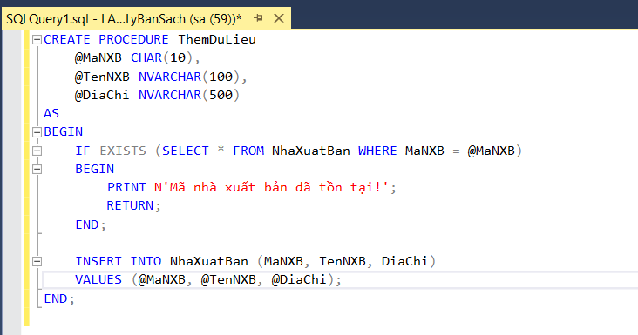

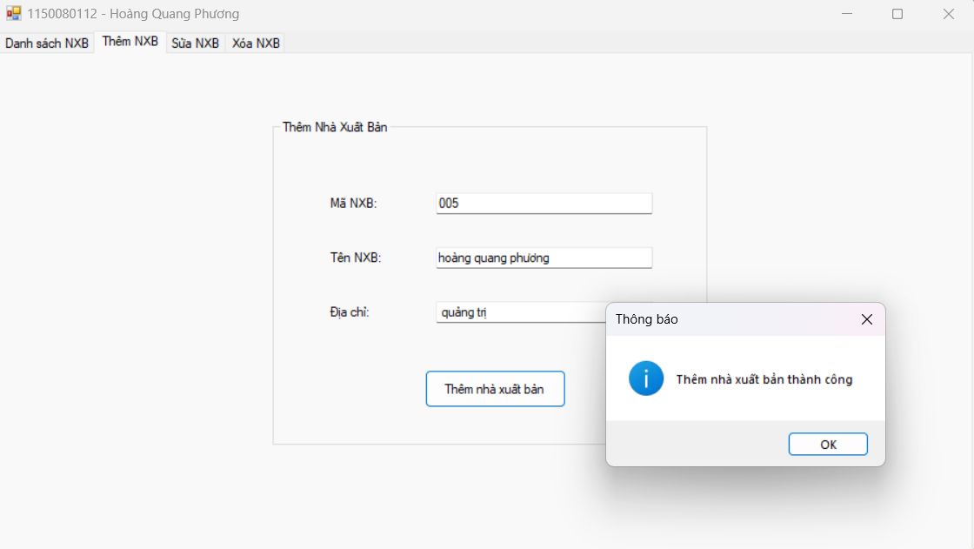

Form1.cs

|  |
| --- |
| private void btnThem_Click(object sender, EventArgs e)  {  string ma = txtThemMa.Text.Trim();  string ten = txtThemTen.Text.Trim();  string diachi = txtThemDiaChi.Text.Trim();  // Kiểm tra dữ liệu nhập  if (string.IsNullOrEmpty(ma) || string.IsNullOrEmpty(ten))  {  MessageBox.Show("Vui lòng nhập đầy đủ Mã NXB và Tên NXB!", "Cảnh báo", MessageBoxButtons.OK, MessageBoxIcon.Warning);  return;  }  try  {  MoKetNoi();  string sql = "INSERT INTO NhaXuatBan (MaNXB, TenNXB, DiaChi) VALUES (@ma, @ten, @diachi)";  SqlCommand cmd = new SqlCommand(sql, sqlCon);  cmd.Parameters.AddWithValue("@ma", ma);  cmd.Parameters.AddWithValue("@ten", ten);  cmd.Parameters.AddWithValue("@diachi", diachi);  int kq = cmd.ExecuteNonQuery();  if (kq > 0)  {  MessageBox.Show(" Thêm nhà xuất bản thành công", "Thông báo", MessageBoxButtons.OK, MessageBoxIcon.Information);  txtThemMa.Clear();  txtThemTen.Clear();  txtThemDiaChi.Clear();  HienThiDanhSachNXB();  tabMain.SelectedTab = tabDanhSach; // Quay lại tab danh sách  }  }  catch (SqlException ex)  {  if (ex.Number == 2627) // Trùng khóa chính  MessageBox.Show(" Mã NXB đã tồn tại. Vui lòng nhập mã khác!", "Lỗi trùng khóa", MessageBoxButtons.OK, MessageBoxIcon.Error);  else  MessageBox.Show(" Lỗi SQL: " + ex.Message);  }  catch (Exception ex)  {  MessageBox.Show(" Lỗi thêm dữ liệu: " + ex.Message);  }  finally  {  DongKetNoi();  } |

Form1.designer.cs

|  |
| --- |
| // tabThem  //  this.tabThem.Controls.Add(this.grpThemNXB);  this.tabThem.Location = new System.Drawing.Point(4, 24);  this.tabThem.Name = "tabThem";  this.tabThem.Padding = new System.Windows.Forms.Padding(3);  this.tabThem.Size = new System.Drawing.Size(892, 452);  this.tabThem.TabIndex = 1;  this.tabThem.Text = "Thêm NXB";  this.tabThem.UseVisualStyleBackColor = true;  //  // grpThemNXB  //  this.grpThemNXB.Controls.Add(this.btnThem);  this.grpThemNXB.Controls.Add(this.txtThemDiaChi);  this.grpThemNXB.Controls.Add(this.txtThemTen);  this.grpThemNXB.Controls.Add(this.txtThemMa);  this.grpThemNXB.Controls.Add(this.lblThemDiaChi);  this.grpThemNXB.Controls.Add(this.lblThemTen);  this.grpThemNXB.Controls.Add(this.lblThemMa);  this.grpThemNXB.Location = new System.Drawing.Point(250, 60);  this.grpThemNXB.Name = "grpThemNXB";  this.grpThemNXB.Size = new System.Drawing.Size(400, 300);  this.grpThemNXB.TabIndex = 0;  this.grpThemNXB.TabStop = false;  this.grpThemNXB.Text = "Thêm Nhà Xuất Bản";  //  // lblThemMa  //  this.lblThemMa.AutoSize = true;  this.lblThemMa.Location = new System.Drawing.Point(50, 70);  this.lblThemMa.Text = "Mã NXB:";  //  // txtThemMa  //  this.txtThemMa.Location = new System.Drawing.Point(150, 67);  this.txtThemMa.Size = new System.Drawing.Size(200, 23);  //  // lblThemTen  //  this.lblThemTen.AutoSize = true;  this.lblThemTen.Location = new System.Drawing.Point(50, 120);  this.lblThemTen.Text = "Tên NXB:";  //  // txtThemTen  //  this.txtThemTen.Location = new System.Drawing.Point(150, 117);  this.txtThemTen.Size = new System.Drawing.Size(200, 23);  //  // lblThemDiaChi  //  this.lblThemDiaChi.AutoSize = true;  this.lblThemDiaChi.Location = new System.Drawing.Point(50, 170);  this.lblThemDiaChi.Text = "Địa chỉ:";  //  // txtThemDiaChi  //  this.txtThemDiaChi.Location = new System.Drawing.Point(150, 167);  this.txtThemDiaChi.Size = new System.Drawing.Size(200, 23);  //  // btnThem  //  this.btnThem.Location = new System.Drawing.Point(140, 230);  this.btnThem.Size = new System.Drawing.Size(130, 35);  this.btnThem.Text = "Thêm nhà xuất bản";  this.btnThem.UseVisualStyleBackColor = true;  this.btnThem.Click += new System.EventHandler(this.btnThem_Click); |