Study

1. A boolean is a value that is either true or false.

Ex:

>>> 5 == (3 + 2)

True

>>> 5 == 6

False

>>> j = "hel"

>>> j + "lo" == "hello"

True

2. A flow chart is a graphical or symbolic representation of a process. Each step in the process is represented by a different symbol and contains a short description of the process step. The flow chart symbols are linked together with arrows showing the process flow direction.

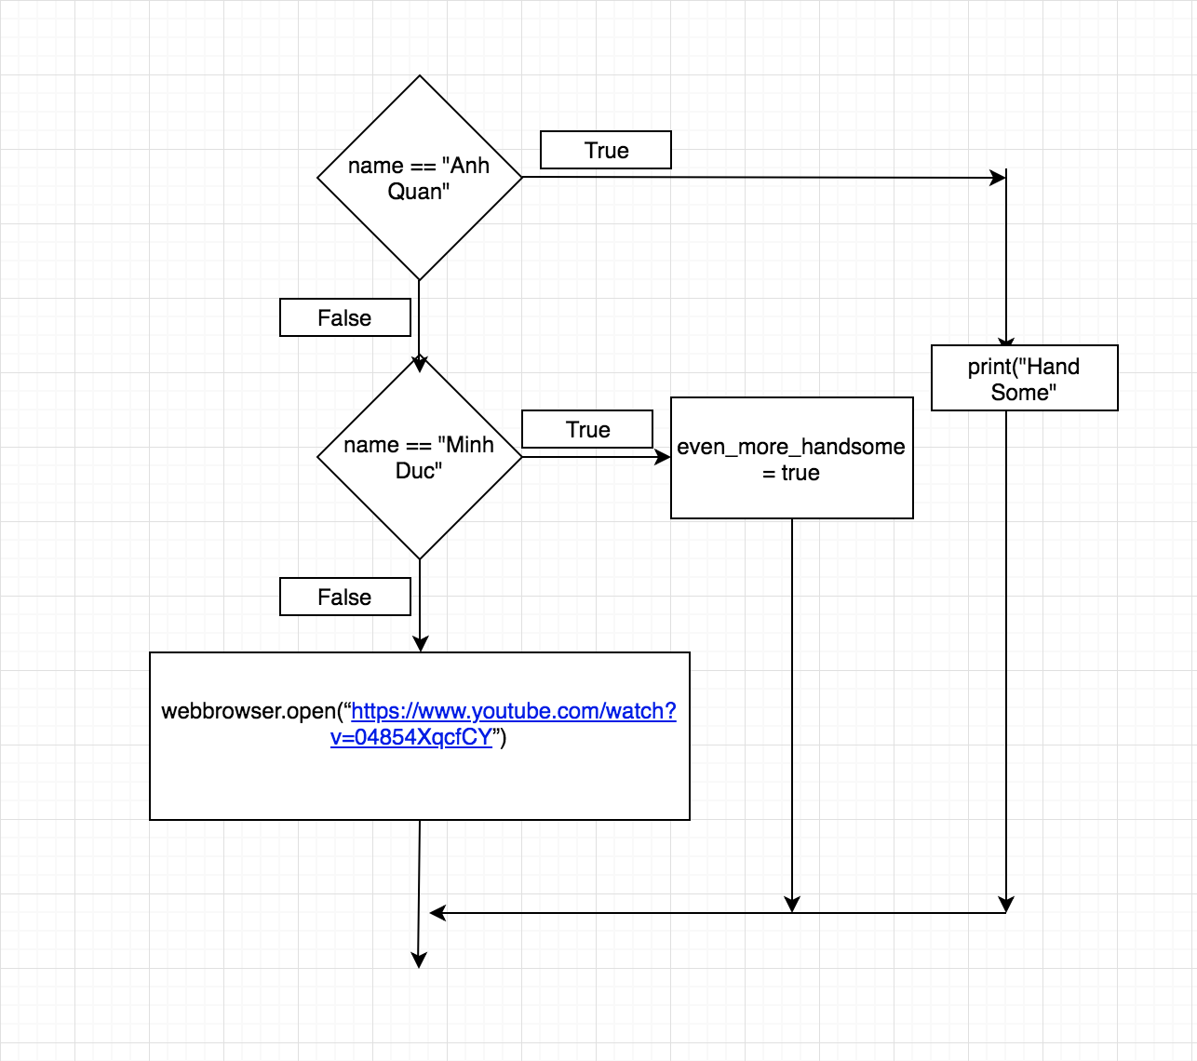

3. “Nesting” conditional statements means that you can use one if or else if statement inside another if or else if statement(s).

num = int(input("enter number"))

if num%2 == 0:

if num%3 == 0:

print ("Divisible by 3 and 2")

else:

print ("divisible by 2 not divisible by 3")

else:

if num%3 == 0:

print ("divisible by 3 not divisible by 2")

else:

print ("not Divisible by 2 not divisible by 3")