# **Capstone Project - The Battle of Neighborhoods**

## **Introduction Problem**

We plan to open a coffee shop in Ho Chi Minh City, Viet Nam. And we already have a list of 40 positions where are available to start the business. The problem is how to choose the best position among them.

In this project, we will get coordinates of these positions, explore venues nearby. Then make a decision based on common venues category. The most suitable position must nearby Stores, Shopping malls, Gym/Fitness center …; and far away from other coffee shop/café.

## **Data**

1. Using [Geopy](https://geopy.readthedocs.io/en/stable/) to locate the coordinates of 40 addresses.

Address data url: <https://raw.githubusercontent.com/phuonglehita/Coursera_Capstone/master/40Address.csv>

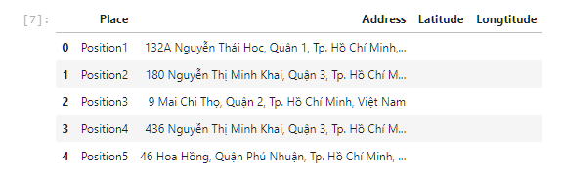 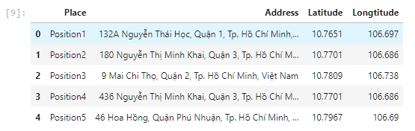

1. Using [FoursquareAPI](https://foursquare.com/) to create data of venues of the addresses.

Based on data of venues to analyze and find most common venue category for each Positions; cluster for Positions.

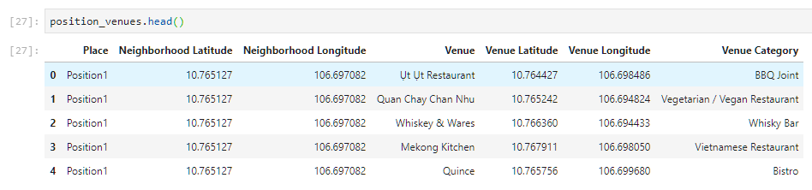

## **Methodology**

1. Prepare data: locate the coordinates for 40 addresses.
2. Explore and Understand Data: explore venues of 40 addresses
3. Analyze each location, Find most common venues
4. Cluster Locations

## **Results**

## **Discussion**

## **Conclusion**