# **Capstone Project - The Battle of Neighborhoods**

## **Introduction Problem**

We plan to open a coffee shop in Ho Chi Minh City, Viet Nam. And we already have a list of 40 positions where are available to start the business. The problem is how to choose the best position among them.

In this project, we will get coordinates of these positions, explore venues nearby. Then make a decision based on common venues category. The most suitable position must nearby Stores, Shopping malls, Gym/Fitness center …; and far away from other coffee shop/café.

## **Data**

1. Using [Geopy](https://geopy.readthedocs.io/en/stable/) to locate the coordinates of 40 addresses.

Address data url: <https://raw.githubusercontent.com/phuonglehita/Coursera_Capstone/master/40Address.csv>

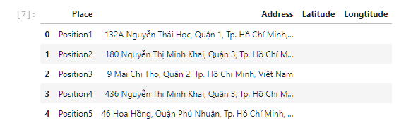 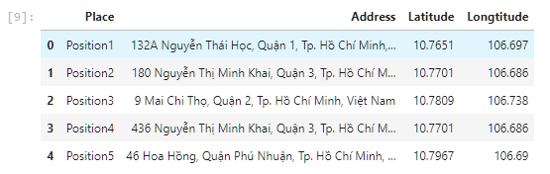

1. Using [FoursquareAPI](https://foursquare.com/) to create data of venues of the addresses.

Based on data of venues to analyze and find most common venue category for each Positions; cluster for Positions.

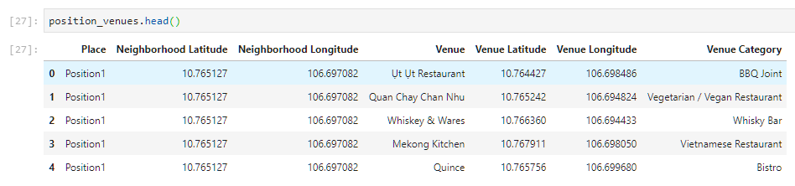

## **Methodology**

1. Prepare data: locate the coordinates for 40 addresses.

Load address list

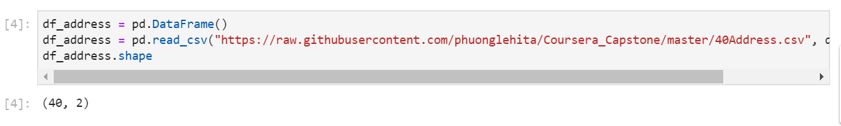

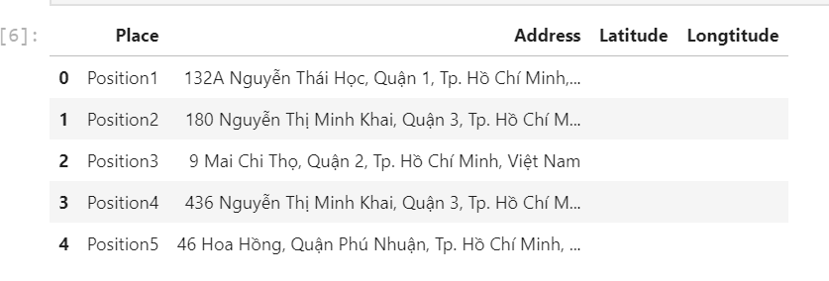

Using Geopy to update coordinates for positions:

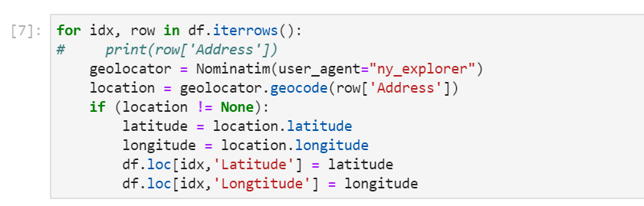

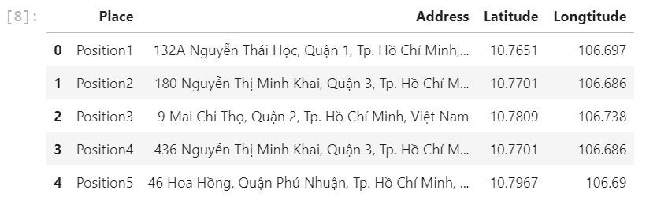

Using Foursquare to explore nearby venues

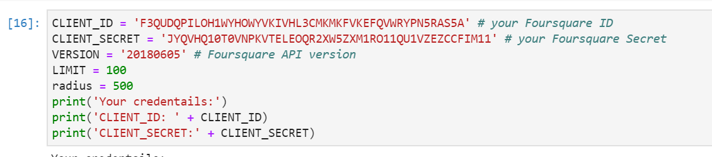

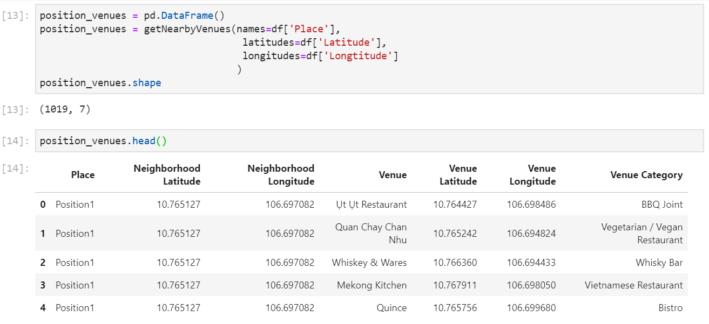

1. Explore and Understand Data: explore venues of 40 addresses

Total nearby venues: 1005

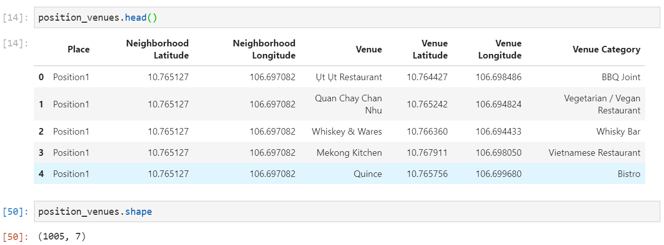

Categories of venues: 124

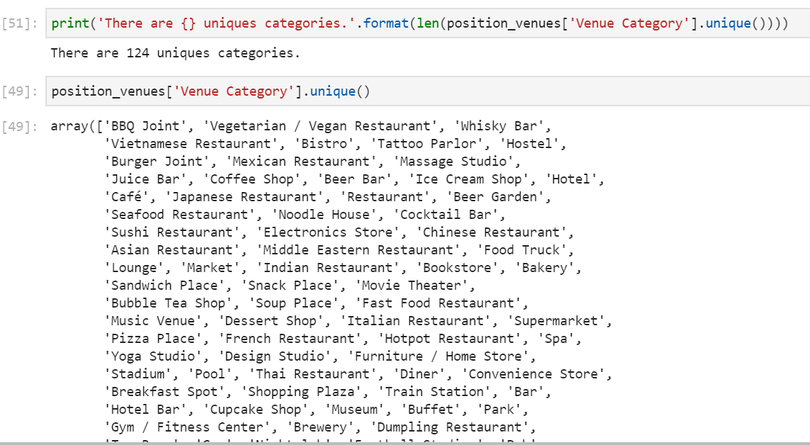

1. Analyze each location, Find most common venues

Take the mean of the frequency of occurrence of each category

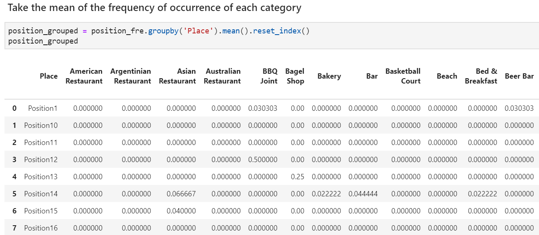

Display top 5 common venue category of each position

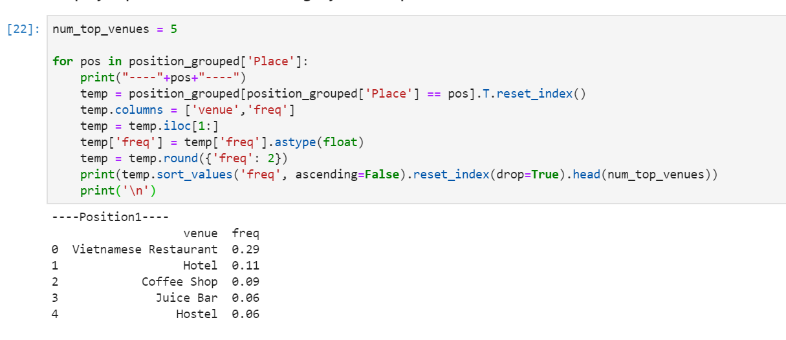

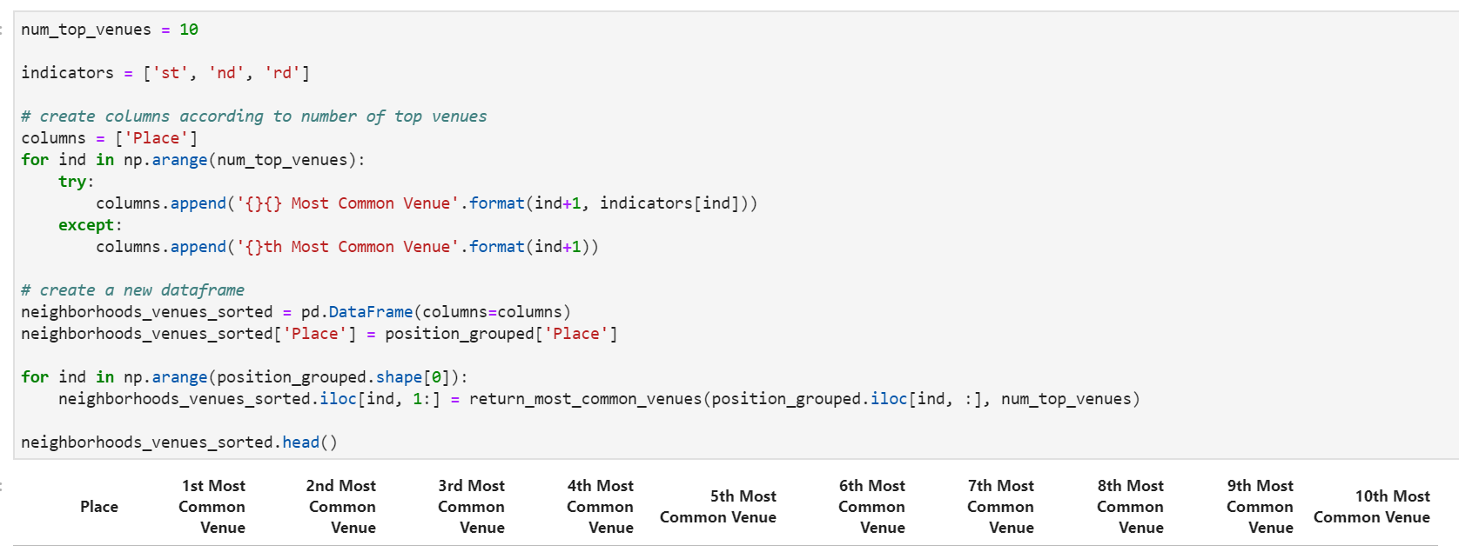

1. Cluster Locations

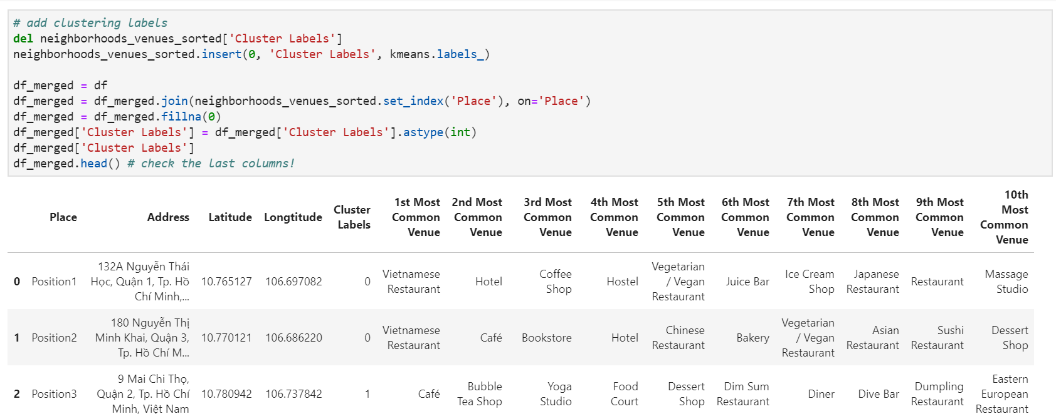

## **Results**

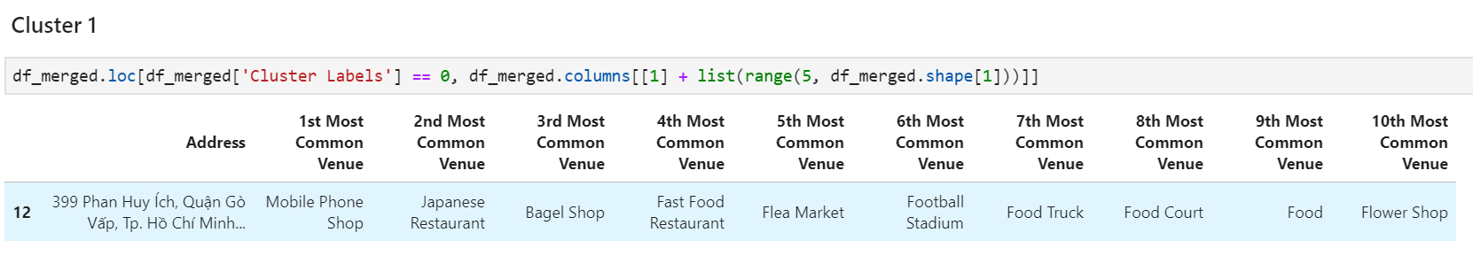

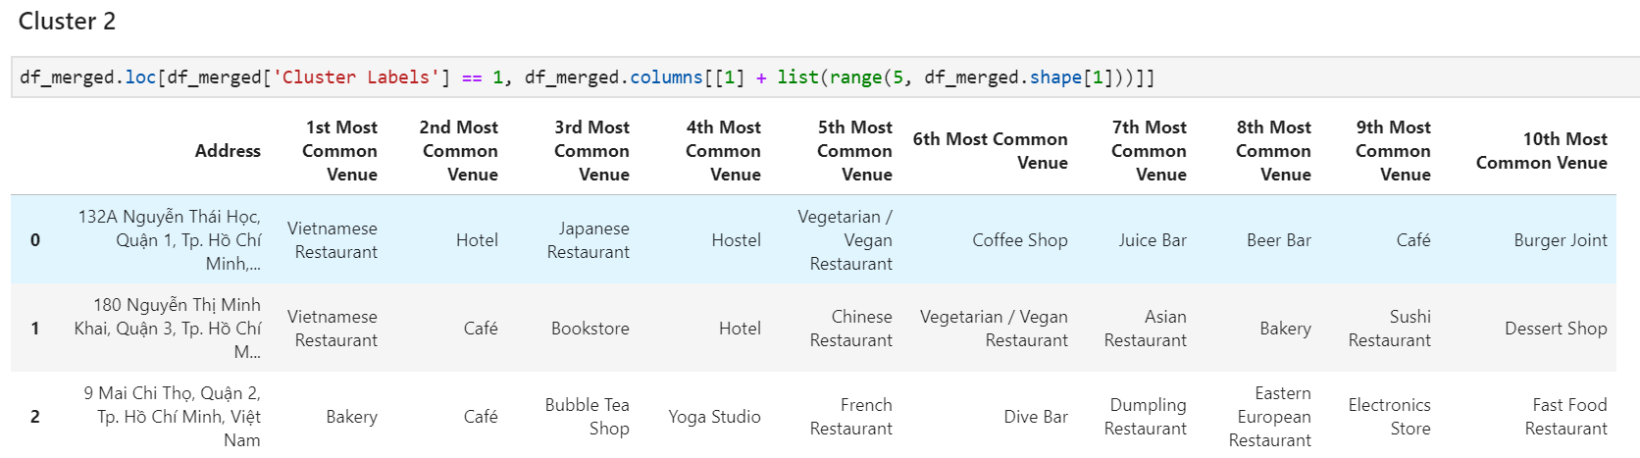

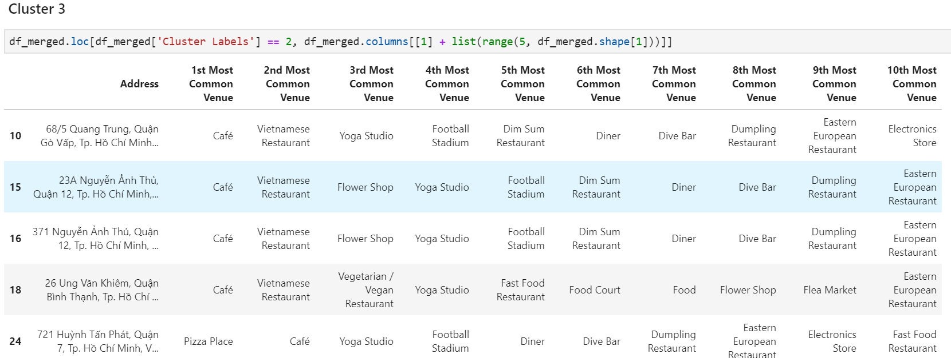

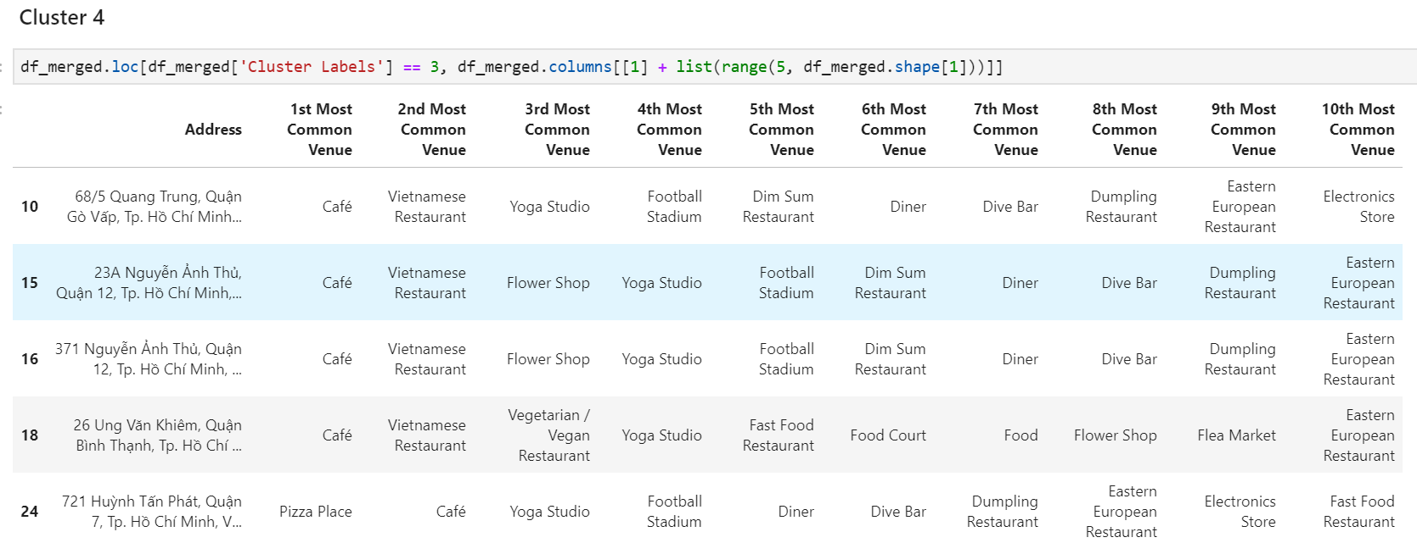

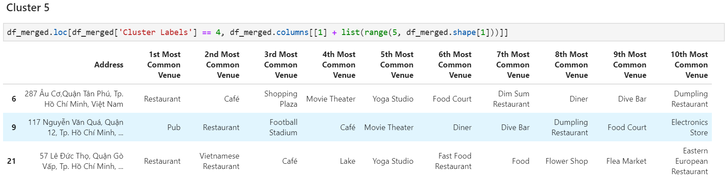

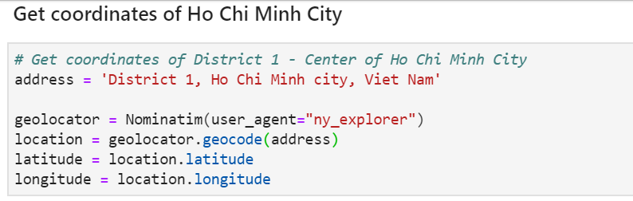

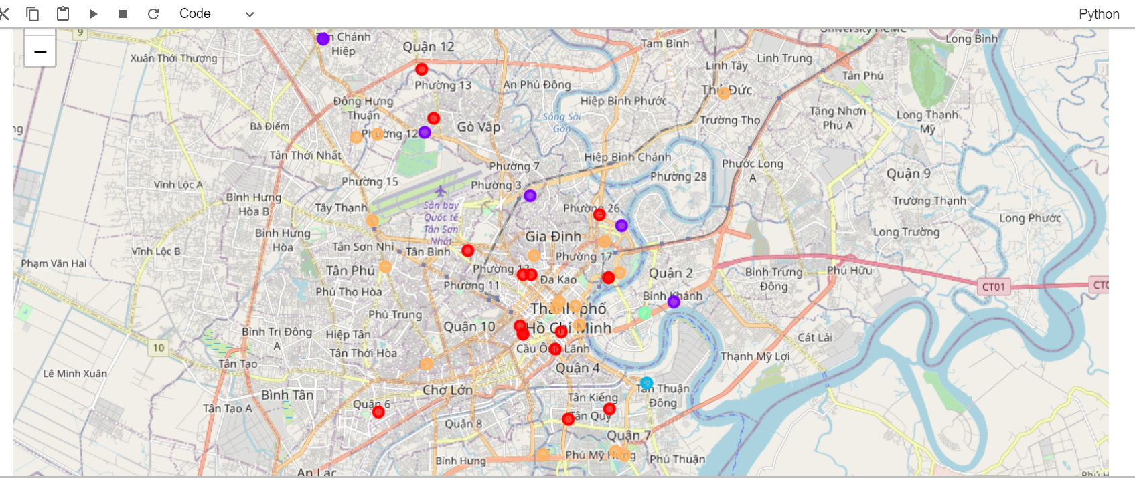

## **Discussion**

Reference to 5 cluster, we found that:

**Cluster 1**: is nearby Mobile Phone Shop, Japanese Restaurant, Bagel Shop, Fast Food, Restaurant, Flea Market, Football Stadium, Food Truck, Food Court, Food, Flower Shop

**Cluster 2,3,4,5**: are nearby Café, Coffee Shop

Which is best cluster for opening a coffee shop?

Based common venue categories, we decide **Cluster 1** is suitable to open the Coffee shop. It is not nearby Café, Coffee. Most common venue category of this Potion is: Shop, Restaurant, Market, Food court.



## **Conclusion**

We make decision in choosing Position based on Most common venue category nearby. It is not good enough. To make decision more accurate, we need traffic density and population density data to analysis. This is an idea for another project in future.