DIGITAL SAFETY MONITORING AND INSPECTION TECHNOLOGY ADOPTION MATURITY ASSESSMENT
- General Information
Expert ID: E01 Date: 2026/08/19 01:52:59 PM
Organizational size: Medium Organizational role: Contractor
- Assessment Records
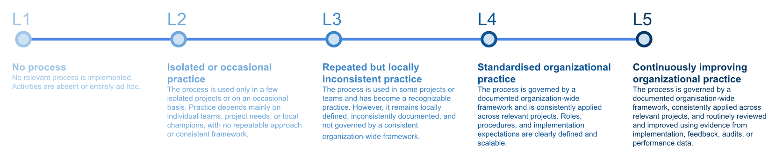
OVERALL CURRENT MATURITY
2.37
Level 2: Isolated or occasional practice
The process is used only in a few isolated projects or on an occasional basis. Practice depends mainly on individual teams, project needs, or local champions, with no repeatable approach or consistent framework.
OVERALL TARGET MATURITY
3.73
Level 3: Repeated but locally inconsistent practice
The process is used in some projects or teams and has become a recognizable practice. However, it remains locally defined, inconsistently documented, and not governed by a consistent organization-wide framework.
 | Current Level | Target Level
Strategy and Commitment | 2.67 Level 2: Isolated or occasional practice | 3.67 Level 3: Repeated but locally inconsistent practice
Operational Process | 2.30 Level 2: Isolated or occasional practice | 3.72 Level 3: Repeated but locally inconsistent practice
People | 2.00 Level 2: Isolated or occasional practice | 3.66 Level 3: Repeated but locally inconsistent practice
Technology Integration | 2.08 Level 2: Isolated or occasional practice | 3.91 Level 3: Repeated but locally inconsistent practice
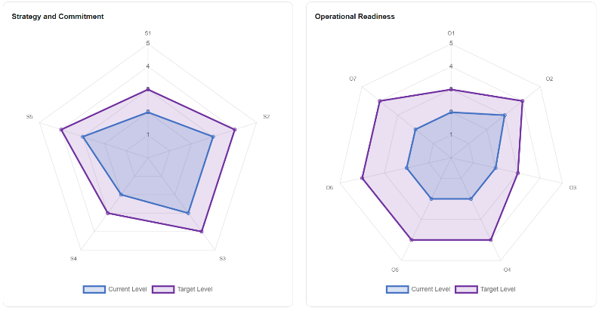
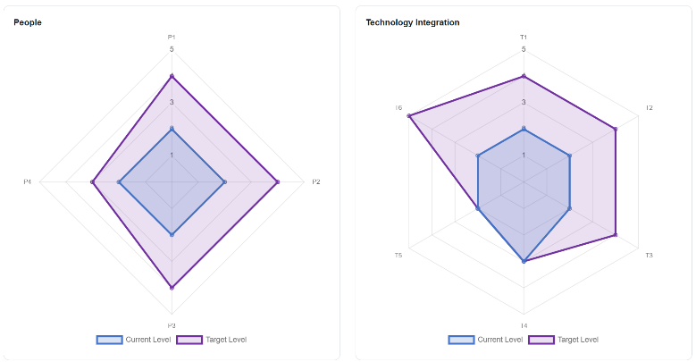
- Summary
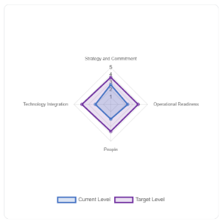
BRIDGING THE GAP BETWEEN CURRENT AND TARGET LEVELS (ongoing development)

L2 Isolated or occasional practice → L3 Repeated but locally inconsistent practice

Establish repeatable practice: Consolidate pilot experience into basic procedures and documentation that can be repeated.

智慧安全工地技術導入成熟度評估報告
- 背景記錄
專家編號：E01 評估日期：2026/08/19 下午 01:52:59
您的公司規模：中性 公司角色：營造厰
- 評估記錄
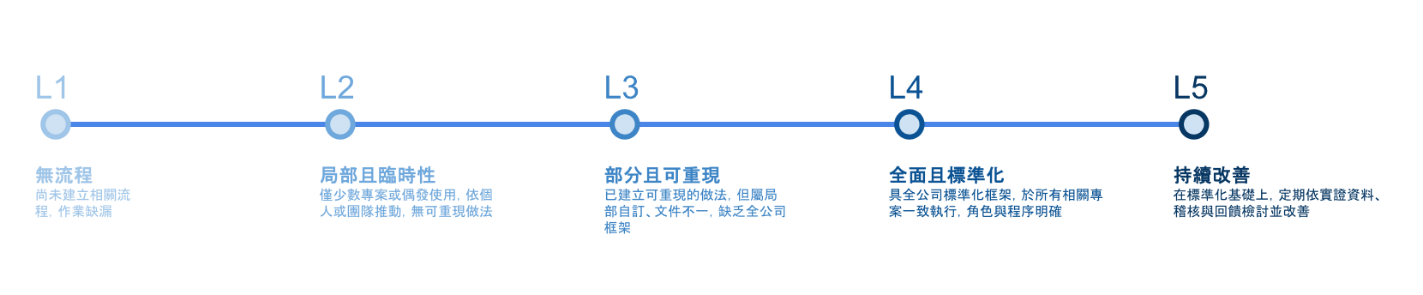
整體現況成熟度
2.37
等級 2：局部且臨時性
僅少數專案或偶發使用，依個人或團隊推動，無可重複做法
整體目標成熟度
3.73
等級 3：部分且可重現
已建立可使用的做法，但屬局部自訂、文件不一，缺乏全公司框架
 | 現況等級 | 目標等級
策略與承諾 | 2.67 等級 2：局部且臨時性 | 3.67 等級 3：部分且可重現
執行流程 | 2.30 等級 2：局部且臨時性 | 3.72 等級 3：部分且可重現
人力 | 2.00 等級 2：局部且臨時性 | 3.66 等級 3：部分且可重現
技術整合 | 2.08 等級 2：局部且臨時性 | 3.91 等級 3：部分且可重現
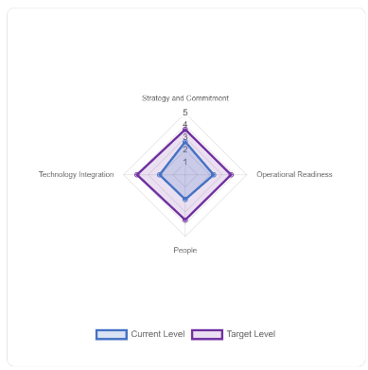


- 總覽
現況等級至目標等級之提升建議（開發中）

等級 2：局部且臨時性 → 等級 3：部分且可重現

建立可重現做法：整理試行經驗，形成基本流程與文件，使做法可穩定重複。

