**Sugar Cane Grading from photo using machine learning**

**2559:39**

Miss Pham Thi Mai Phuong, Phuong, 56070503447, [phuongmaipham@icloud.com](mailto:phuongmaipham@icloud.com)

Advisor: Dr. Sally E. Goldin

January 31, 2017

_________________________________

I have read this report and approve its content.

**Abstract (English)**

This project will work in co-operation with staff from Mitrphol Sugar Company to create a software test bed for improving sugarcane quality control over a large area. The test bed will be able to analyze the sugar cane health from photos of cane fields. The project will use machine learning techniques to train the software to discriminate photos based on cane quality. The test bed will first extract the sugar cane crucial features from mobile phone photos. This test bed will then classify the cane photos into different health categories based on extracted features using supervised machine learning. The results obtained from this project will be useful for developing a real world system to allow individual farmers to send photos of their fields, which can be analyzed and classified to get more detailed information about cane health over a wide area. This project is thus important because it will help sugar companies gain better information with a lower surveying cost.

**Acknowledgements**

This project cannot be completed without help and support from many people. In particular, I am graceful to Dr. Sally E. Goldin - the advisor of this project - for her patient to guide and support me throughout the year; your discussion, feedbacks and helping hand have been absolutely invaluable. I also thank Mr. Rajchawit Sarochawikasit and the Innosoft team for their assistance with the HPC server. Another thank is to KMUTT Network operation center, whose vpn service has allowed me to work with the HPC server remotely. I would also like to thank the people from Mitr Phol Sugar Corporation for their interest in this project and their valuable data which made this project possible. Finally, I want to thank my committee members - Dr. Suthathip Maneewongvatana, Dr. Phond Phunchongharn and Dr. Khajonpong Akkarajitsakul - for their invaluable advice and suggestions. I would especially like to thank and dedicate this thesis to my family and friends, without whom I would not have had the encouragement to complete this work.

Table of Contents

Chapter 1 Introduction 8

1.1 Problem Statement and Approach 8

1.2 Objectives 8

1.3 Scope 8

Deliverables for Term 1 9

Deliverables for Term 2 9

1.4 Tasks and Schedule 9

1.4.1 Task breakdown 9

1.4.2 Draft Schedule 10

Chapter 2 Background, Theory and Related Research 12

2.1 Digital Image Processing Concepts 12

2.1.1 Digital Image Representation 12

2.1.2 Image Processing Operations 13

2.2 Image Convolution 15

2.2.1 Concepts and Mathematics 15

2.2.2 Examples – Sobel, Blurring 16

2.3 Machine learning 17

2.3.1 Core concepts of machine learning 17

2.3.2 Training and testing strategies 17

2.3.3 Model evaluation 17

2.4 Multilayer feed-forward neural networks (MFNN) 19

2.4.1 Overviews 19

2.4.2 Back propagation 20

2.1.1.1 Weight updating 21

2.1.1.2 Bias updating 22

2.4.3.1 Conclusion 23

2.5 Convolutional neural networks (CNN) 23

2.5.3 Overviews 23

2.5.4 Convolutional layer 23

2.5.4.1 Local receptive field 24

2.5.4.2 Filter (Kernel) 24

2.5.4.3 Feature map and stride 24

2.5.4.4 The use of zero-padding 25

2.5.5 Pooling layer 25

2.5.6 ReLU non-linearity 27

2.5.7 Fully connected layer 27

2.5.8 Softmax regression function 27

2.6 Learning in a Convolutional neural networks 27

2.6.3 Back propagation core concepts 27

2.6.4 Back propagation at the Softmax 28

2.6.5 Back propagation in the Fully connected layer (Neural networks) 28

2.6.6 Back propagation in the ReLU layer 28

2.6.7 Back propagation in the pooling layer 28

2.6.8 Back propagation in the convolutional layer 29

2.6.9 What does a CNN learn? 29

2.7 Data Augmentation 29

2.7.3 Concept 29

2.7.4 Methods 30

2.7.4.1 Brightness adjustment 30

2.7.4.2 Contrast adjustment 30

2.7.4.3 Scaling 31

2.7.4.4 Summary 31

2.8 Model combination 31

2.9 GPU Concepts 31

2.10 CNN Software Frameworks 32

2.11 Related research 34

2.11.3 Research using CNN to classify images 34

2.11.4 Variations in algorithms in CNN used for classifying fine-grained objects 34

Chapter 3 Design and Methodology 36

3.1 Experimental set up 37

3.1.1 Gathering data 37

3.1.2 Plan on experimenting different frameworks 37

3.1.2.1 Tensorflow 37

3.1.2.2 Caffe 38

3.1.3 Computer resources 39

3.2 Data preprocessing 39

3.3 Data argumentation 39

3.3.1.1 Brightness and contrast adjustment 41

3.3.1.2 Cropping 41

3.4 Viewpoints extraction 41

3.5 Experimental designs 43

3.5.1.1 Strategy for organizing training and testing set 43

3.5.1.2 Data segregation strategy 44

3.5.1.3 Network architecture 44

3.5.1.4 Results evaluation 45

Chapter 4 Results and Discussion 47

4.1 Frameworks 47

4.1.1 Tensorflow 47

4.1.2 Caffe 47

4.1.3 Torch 47

4.1.4 Some conclusions 48

4.2 Preliminary results 48

4.2.1 The example dataset 48

4.2.2 Training 49

4.3 Experimental results 52

4.3.1 Input images investigation 52

4.3.1.1 Input image organization and the learning rate 55

4.3.1.2 The number of iterations 55

4.3.1.3 The elimination of class “poor” 55

4.3.1.4 Input image size 56

4.3.1.5 Some conclusions 56

4.3.2 Networks configuration 56

4.3.2.1 Convolutional layer 59

4.3.2.2 Pooling layer 60

4.3.2.3 Fully connected layer 60

4.3.2.4 The number of output channels 61

4.3.2.5 Dropout 61

4.3.2.6 Some conclusions 61

Chapter 5 Conclusion 63

5.1 Comments on the project 63

5.2 Our conclusion 63

Reference 65

Appendix A 67

Appendix B 68

Appendix C 69

**List of Figures**

Figure 2.1‑1 What happens as we reduce the resolution of an image while keeping its size the same. [9] 12

Figure 2.1‑2 Level grey scale. [9] 13

Figure 2.1‑3 Color space. [9] 13

Figure 2.1‑4 Color intensity where B stands for blue, R stands for red and G stands for green [11] 13

Figure 2.1‑5 An image histogram[14] 14

Figure 2.1‑6 An illustration of histogram stretching 15

Figure 2.4‑1 Fully connected layers. [8] 20

Figure 2.5‑1 A convolutional neural networks. [16] 23

Figure 2.5‑2 Local receptive fields [7] 24

Figure 2.5‑3 Convolutional process - An input image of size 7x7x3 is filtered by 2 convolutional kernels which create 2 feature maps. [12] 25

Figure 2.5‑4 A max pooling layer [12] 26

Figure 2.6‑1 Feedforward in CNN is identical with convolution operation. [15] 29

Figure 2.7‑1 Brightness adjustment. [14] 30

Figure 2.7‑2 Contrast adjustment. [14] 31

Figure 3‑0‑1 Flowchart with the major stages of the work 36

Figure 3.3‑1 Data argumentation steps 40

Figure 3.4‑1 Viewpoints extraction steps 42

Figure 3.4-2 Flowchart describing the use of viewpoint extraction in constructing a CNN

Figure 4.2‑1 From left to right: Images of poor , medium and good sugarcane from 1-3 months. 49

Figure 4.2‑2 From left to right: Images of poor , medium and good sugarcane from 4-6 months. 49

Figure 4.2‑3 From left to right: Images of poor , medium and good sugarcane from 7-9 months. 49

Figure 4.2‑4 From left to right: Images of poor , medium and good sugarcane from 10-12 months. 49

Figure 4.2‑5 Improvement of the error rate with Torch 50

Figure 4.2‑6 True labels for the images in testing set 51

Figure 4.2‑7 Prediction made to the testing set by the trained model 51

Figure 4.2‑8 Testing accuracies with tensorflow 52

# **Chapter 1**

# **Introduction**

# **Problem Statement and Approach**

Sugarcane is an important crop in Thailand. In order to forecast sugarcane yield, sugar companies need detailed information on the cane conditions in different fields. Features such as color and size of the leaves are some indicators of cane conditions (cane health).

A field’s condition, such as soil properties, seed quality or irrigation system, has some important consequences for those features. However, not every field is identical. Thus, the features and the resulting cane quality vary from one field to another. This will cause a problem in collecting data; there are too many fields and it is too complicated and time consuming for sugar companies to do exhaustive surveys to get the information that they need.

To address to this problem, this project will work in co-operation with staff from Mitrphol Sugar Company to create a software test bed for improving cane quality control over a large area. The test bed will be able to analyze the sugar cane health from photos of the fields taken from ground level. The project will use machine learning to train the software to discriminate photos based on cane quality. The results obtained from this project will be useful for developing a real world system to allow individual farmers to send photos of their fields to Mitrphol which can be analyzed and classified to get more detailed information about cane health over a wide area. This project is thus important because it will help sugar companies gain better information with a lower surveying cost.

## This is a research - real world stakeholder project.

# **Objectives**

The goal of this project is to develop a software test bed for experimenting with images of sugar cane using supervised machine learning technique. The test bed will first extract the sugar cane crucial features from photos. This test bed will then classify the cane photos into different health categories based on extracted features using supervised machine learning.

# **Scope**

This project does not attempt to deliver a final system, but rather a software testbed. The testbed is intended to experiment with images of sugarcane with different machine learning models and conclude which model can achieve the best result.

## Deliverables for Term 1

* Experimental data set
* Experimental design
* Decision on what learning framework(s) to use, with justification
* Some prototype using the selected framework

## Deliverables for Term 2

* Complete experimental design of the test bed
* Software test bed with desired results
* Results and data analysis

# **Tasks and Schedule**

## Task breakdown

1. Analyze and determine the requirements of the project
2. Plan the project schedule
3. Work on introduction chapter of the report (chapter 1)
4. Research emphasizing on the following topics:

Work by other researchers on discriminating between similar images using machine learning

Machine learning methods for image classification and the available libraries

Basic image processing concepts

1. Create the project proposal and get feedback
2. Test prototypes for various learning frameworks and make a decision on which learning framework to use
3. Collect and create dataset
4. Study and understand the dataset
5. Create experimental design
6. Complete progress report for the first semester
7. Work on theory and background chapter of the report (chapter 2)
8. Work on methodology chapter of the report (chapter 3)
9. Prepare for presentation for the first semester
10. Write software to standardize and augment images
11. Write scripts to control the experiments
12. Test the system and fix bugs
13. Train and test the system with different parameters
14. Analyze the results
15. Complete final report for the second semester (Result + conclusions, chapter 4 and 5)
16. Create poster and prepare for presentation for the second semester

## Draft Schedule

|  |  |  |  |  |  |  |  |  |  |  |  |  |  |  |  |  |  |  |  |  |  |  |  |  |  |  |  |  |  |  |  |  |  |  |  |  |  |
| --- | --- | --- | --- | --- | --- | --- | --- | --- | --- | --- | --- | --- | --- | --- | --- | --- | --- | --- | --- | --- | --- | --- | --- | --- | --- | --- | --- | --- | --- | --- | --- | --- | --- | --- | --- | --- | --- |
| Step | Operation | Project Duration | | | | | | | | | | | | | | | | | | | | | | | | | | | | | | | | | | | |
| **2016** | | | | | | | | | | | | | | | | | | | | **2017** | | | | | | | | | | | | | | | |
| **August** | | | | **September** | | | | **October** | | | | **November** | | | | **December** | | | | **January** | | | | **February** | | | | **March** | | | | **April** | | | |
| 1 | 2 | 3 | 4 | 1 | 2 | 3 | 4 | 1 | 2 | 3 | 4 | 1 | 2 | 3 | 4 | 1 | 2 | 3 | 4 | 1 | 2 | 3 | 4 | 1 | 2 | 3 | 4 | 1 | 2 | 3 | 4 | 1 | 2 | 3 | 4 |
| 1 | Analyze and determine the requirements of the project |  |  |  |  |  |  |  |  |  |  |  |  |  |  |  |  |  |  |  |  |  |  |  |  |  |  |  |  |  |  |  |  |  |  |  |  |
| 2 | Plan the project schedule |  |  |  |  |  |  |  |  |  |  |  |  |  |  |  |  |  |  |  |  |  |  |  |  |  |  |  |  |  |  |  |  |  |  |  |  |
| 3 | Work on Introduction chapter of the report |  |  |  |  |  |  |  |  |  |  |  |  |  |  |  |  |  |  |  |  |  |  |  |  |  |  |  |  |  |  |  |  |  |  |  |  |
| 4 | Research emphasizing on the following topics: |  |  |  |  |  |  |  |  |  |  |  |  |  |  |  |  |  |  |  |  |  |  |  |  |  |  |  |  |  |  |  |  |  |  |  |  |
|  | 1) Work by other researchers on discriminating between similar images using machine learning |  |  |  |  |  |  |  |  |  |  |  |  |  |  |  |  |  |  |  |  |  |  |  |  |  |  |  |  |  |  |  |  |  |  |  |  |
|  | 2) ML method for image classification especially CNN and the available libraries |  |  |  |  |  |  |  |  |  |  |  |  |  |  |  |  |  |  |  |  |  |  |  |  |  |  |  |  |  |  |  |  |  |  |  |  |
|  | 3) Basic image processing concept |  |  |  |  |  |  |  |  |  |  |  |  |  |  |  |  |  |  |  |  |  |  |  |  |  |  |  |  |  |  |  |  |  |  |  |  |
| 5 | Create the project proposal and get feedbacks |  |  |  |  |  |  |  |  |  |  |  |  |  |  |  |  |  |  |  |  |  |  |  |  |  |  |  |  |  |  |  |  |  |  |  |  |
| 6 | Test prototypes for various learning frameworks and make a decision on which learning framework to use |  |  |  |  |  |  |  |  |  |  |  |  |  |  |  |  |  |  |  |  |  |  |  |  |  |  |  |  |  |  |  |  |  |  |  |  |
| 7 | Collect and create dataset |  |  |  |  |  |  |  |  |  |  |  |  |  |  |  |  |  |  |  |  |  |  |  |  |  |  |  |  |  |  |  |  |  |  |  |  |
| 8 | Study and understand the dataset |  |  |  |  |  |  |  |  |  |  |  |  |  |  |  |  |  |  |  |  |  |  |  |  |  |  |  |  |  |  |  |  |  |  |  |  |
| 9 | Create experimental design |  |  |  |  |  |  |  |  |  |  |  |  |  |  |  |  |  |  |  |  |  |  |  |  |  |  |  |  |  |  |  |  |  |  |  |  |
| 10 | Complete progress report for the first semester |  |  |  |  |  |  |  |  |  |  |  |  |  |  |  |  |  |  |  |  |  |  |  |  |  |  |  |  |  |  |  |  |  |  |  |  |
| 11 | Prepare for presentation for the first semester |  |  |  |  |  |  |  |  |  |  |  |  |  |  |  |  |  |  |  |  |  |  |  |  |  |  |  |  |  |  |  |  |  |  |  |  |
| 12 | Work on Background and Theory chapter of the report |  |  |  |  |  |  |  |  |  |  |  |  |  |  |  |  |  |  |  |  |  |  |  |  |  |  |  |  |  |  |  |  |  |  |  |  |
| 13 | Work on Methodology chapter of the report |  |  |  |  |  |  |  |  |  |  |  |  |  |  |  |  |  |  |  |  |  |  |  |  |  |  |  |  |  |  |  |  |  |  |  |  |
| 14 | Write pre-processing software to standardize images |  |  |  |  |  |  |  |  |  |  |  |  |  |  |  |  | H | H | H |  |  |  |  |  |  |  |  |  |  |  |  |  |  |  |  |  |
| 15 | Write scripts to control the experiments |  |  |  |  |  |  |  |  |  |  |  |  |  |  |  |  |  |  |  |  |  |  |  |  |  |  |  |  |  |  |  |  |  |  |  |  |
| 16 | Test the system and fix bugs |  |  |  |  |  |  |  |  |  |  |  |  |  |  |  |  |  |  |  |  |  |  |  |  |  |  |  |  |  |  |  |  |  |  |  |  |
| 17 | Train and test the system with different parameters |  |  |  |  |  |  |  |  |  |  |  |  |  |  |  |  |  |  |  |  |  |  |  |  |  |  |  |  |  |  |  |  |  |  |  |  |
| 18 | Analyze the results |  |  |  |  |  |  |  |  |  |  |  |  |  |  |  |  |  |  |  |  |  |  |  |  |  |  |  |  |  |  |  |  |  |  |  |  |
| 19 | Complete final report for the second semester |  |  |  |  |  |  |  |  |  |  |  |  |  |  |  |  |  |  |  |  |  |  |  |  |  |  |  |  |  |  |  |  |  |  |  |  |
| 20 | Create poster and prepare for presentation for the second semester |  |  |  |  |  |  |  |  |  |  |  |  |  |  |  |  |  |  |  |  |  |  |  |  |  |  |  |  |  |  |  |  |  |  |  |  |

** H:holiday

# **Chapter 2**

# **Background, Theory and Related Research**

# **Digital Image Processing Concepts**

## Digital Image Representation

Pixels are basic elements of an image. Each pixel depicts a light intensity value, which is represented as a number. Digital image is a collection of pixels. There are two types of digital image: grey scale image and color image. Grey scale image is defined by a matrix of pixels, whereas color image is usually defined by a cube made of three matrixes of pixels.

The density of pixels in an image is called **resolution**. If we have an image of a particular scene, the level of detail will be controlled by the number of pixels. The more pixels that we keep to describe an image, the more detailed the image.

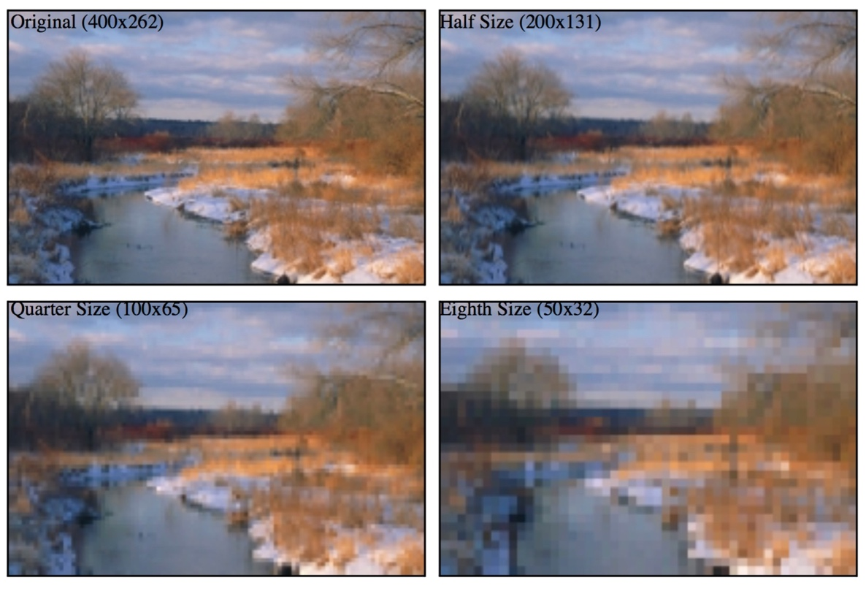

Figure 2.1‑1 What happens as we reduce the resolution of an image while keeping its size the same. [9]

A monochrome image can be described in terms of a two-dimensional light intensity function f(x,y), where the amplitude of f(x,y) is the intensity (brightness) of the image at position (x,y). The intensity of a monochrome image lies in the range

<f(x,y)<

Equation 2.1‑1

where the interval [,] is called the grey scale. There are two common grey scale storage methods: 8-bit storage and 1-bit storage.

The most common storage method is 8-bit storage. It can represent up to colours for each pixel. The grey scale interval is [0,255], with 0 being black and 255 being white.

The less common storage method is 1-bit storage. There are two grey levels, with 0 being black and 1 being white. Images represented by this method are also called binary images.



Figure 2.1‑2 Level grey scale. [9]

A colored image can be represented using multi-channel color models. The most widely used model is the RGB. Colored images are made up of three primary color components: red, green and blue (RGB). These three primary components together create a three-dimensional color space with red defining one axis, green defining the second, and blue defining the third. Every existing color is described as a mixture of red, green, and blue light and located somewhere within the color space.

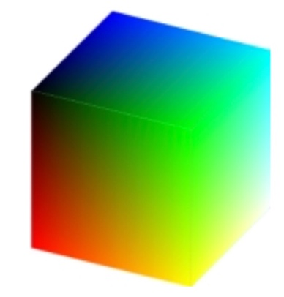

Figure 2.1‑3 Color space. [9]

Using RGB model, a colored image can be described using a three-channel intensity function

Equation 2.1‑2

where is the intensity at position (x,y) in the red channel, is the intensity at position (x,y) in the green channel, and is the intensity at position (x,y) in the blue channel. Each channel usually uses an 8-bit storage, so together the three channels can describe up to colours. Thus, computers commonly use a 24-bit storage to describe the intensity at position (x,y), which can describe up to colours.

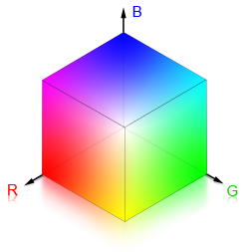

Figure 2.1‑4 Color intensity where B stands for blue, R stands for red and G stands for green [11]

## Image Processing Operations

Image operations are calculations applied to each pixel (x,y) of an input image f to transform the input image f(x,y) into an output image g(x,y). Different operation types are applied to an image depending on what kind of results we want to achieve. In this section, we will focus on discussing three types of image operations: resampling, cropping and histogram modifications.

Resampling is a technique used to generate a new image with a different resolution. Increasing the number of pixels is called **upsampling** and decreasing the number of pixels is called **downsampling**. Upsampling can sharpen the original image whereas downsampling softens or blurs the original image. There are several different resampling techniques. The main concept of those techniques is to interpolate the value of a new pixel from the existing pixels of the original image. Nearest neighbor resampling is the simplest method. The value of each pixel in the output image is the value of its nearest neighbor in the original image.

Cropping refers to the removal of the regions in the image. A new pair of (x,y) coordinates is required to define diagonally opposite corners of the cropped image. The resulting image is a smaller image that contains useful data for further studies.

Histogram is the frequency distribution of pixel values. Histograms are frequently visualized as graphs. For example, the histogram below shows the frequency of pixel values of a grey scale image, where the x axis indicates the range of the pixel values and y axis indicates the frequency with which each value appears in the entire image.

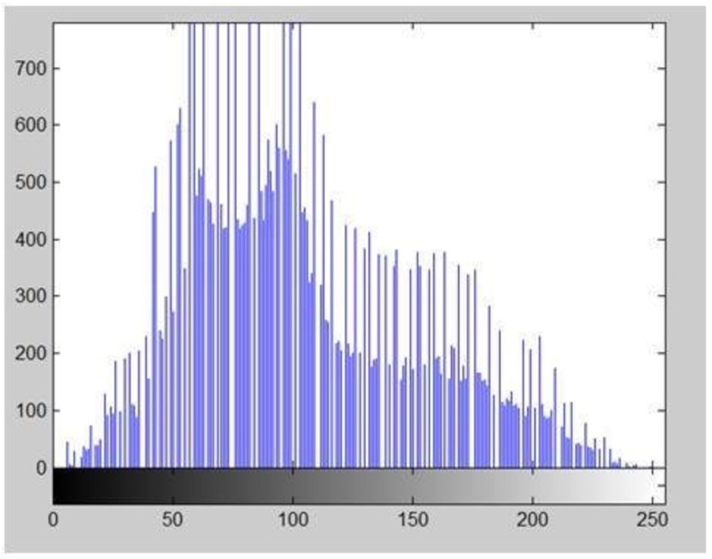

Figure 2.1‑5 An image histogram[14]

There are various operations to modify an image’s histogram. In this section we will focus on discussing about histogram sliding and histogram stretching.

Histogram sliding is a method used to change image brightness. To increase the brightness, we shift an image’s histogram to the right by adding a constant value to every pixel of an image. In contrast, to decrease the brightness, we shift an image’s histogram to the left by subtracting a constant value from every pixel of an image. This does not change the shape of the distribution at all, just the location within the grey scale range.

Histogram stretching is a method used to increase the contrast. Contrast is the difference between the maximum and the minimum intensity values of an image. There are several ways to do histogram stretching. We will illustrate how histogram stretching works by demonstrating one of them through the following formula:

Equation 2.1‑3

where is the pixel intensity of the original image, is the minimum pixel intensity, is the maximum pixel intensity and bpp is the bit per pixel. The purpose of this formula is to ‘spread’ the image’s old intensity values over a larger range. By doing so, we increase the difference between the maximum and the minimum intensity values of an image and hence increase the contrast.

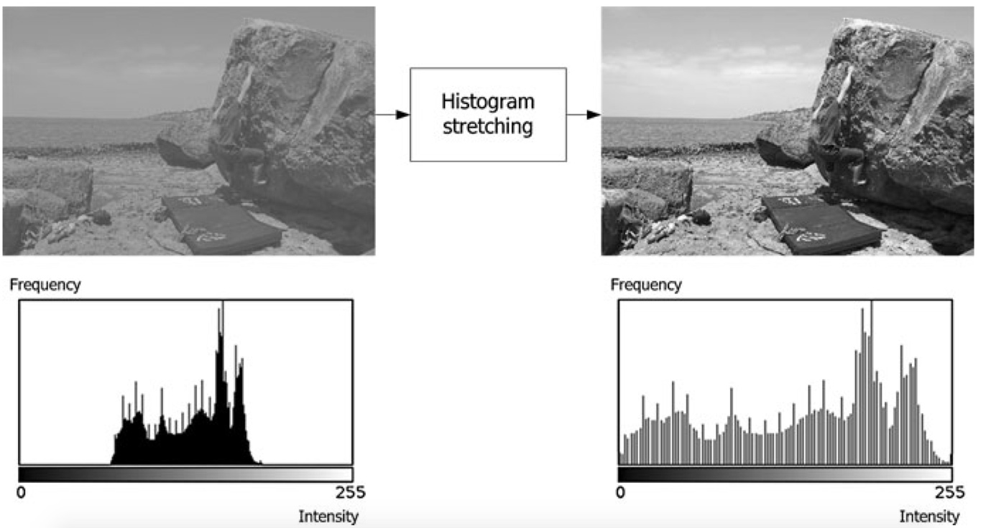

Figure 2.1‑6 An illustration of histogram stretching

Figure 2.1-6 shows an illustration of histogram stretching. The original image and its histogram are on the left. The image whose contrast is increased by histogram stretching and its histogram are on the right.

# **Image Convolution**

## Concepts and Mathematics

Convolution is an image transformation technique using neighborhood (or area-based) operators. The objective of image convolution is to process an input image in order to enhance some important features that are suitable for a specific application. Convolution has two main approaches: spatial-domain approach and frequency-domain approach.

Spatial-domain and frequency-domain approach can both be described in terms of convolutional function:

g(x,y) = h(x,y)*f(x,y)

Equation 2.2‑1

given f(x,y) is the input image, h(x,y) is a small pattern called the **kernel** and g(x,y) is the output image.

In spatial-domain, we look at the value of each pixel varies with respect to scene whereas in frequency-domain, we look at the rate at which the pixel values change in spatial-domain. Thus, in frequency-domain approach, we will have to convert the pixel values into frequency-domain before applying convolution, then convert the result back into spatial-domain. We will mainly discuss about spatial-domain procedure in this section.

The procedure for convolution in spatial-domain is as follows: A **filter** (sometimes can be referred to as a **mask**, a **kernel** or a **window**) is slid around the input image. The filter is a smaller matrix of values called **coefficients**. Each time the filter is placed at a new position, every pixel of the input image contained within the filter is multiplied by the corresponding filter coefficient, and then the resulting products are summed together. The result from each multiplication and summation becomes the value of the next pixel of the output image. The described procedure is repeated this until all values of the output image have been calculated.

## Examples – Sobel, Blurring

Below we will give two simple examples to illustrate the application of convolutional filtering.

The first application is to highlight edges in an image. Some well-known edge enhancement filters are Prewitt operator, Sobel operator, Robinson compass masks, Krisch compass Masks and Laplacian operator. The decision on which filter to use depends on our desired results. Here we will describe the use of Sobel edge detection. A Sobel filter is used to calculate edges in both horizontal and vertical direction.

The vertical mask of Sobel operator is as follows:

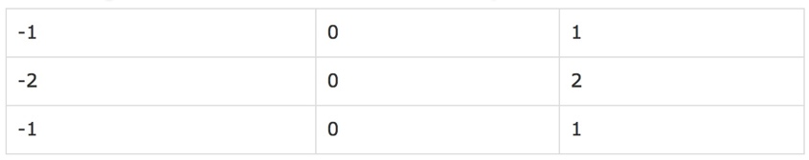

Table 2.2‑1 Vertical Mask of Sobel operator

The pixels at the corresponding position to the area declared by this filter of the input image are respectively multiply by -1,0,1,-2,0,2,-1,0 and 1. The results of these nine multiplications are then summed. The filter is then moved to the next position in the image. This process is repeated until all values of the image has been calculated.

The horizontal Mask of Sobel operator is as follows:

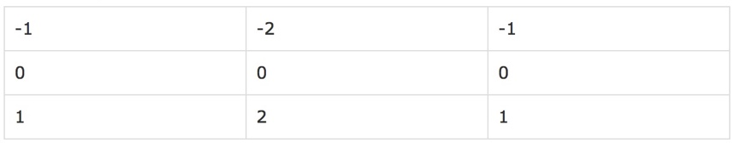

Table 2.2‑2 Horizontal Mask of Sobel operator

Similarly, the pixels at the corresponding position to the area declared by this filter of the input image are respectively multiply by -1,-2,-1,0,0,0,1,2 and 1. The results of these nine multiplications are then summed. The filter is then moved to the next position in the image. The horizontal and vertical output images are kept separately. This process is repeated until all values of the image has been calculated.

This filter gives more weight to the pixel values around the edge region. It thus increases the edge intensities. As a result, the output image edges become enhanced comparatively to the original image.

The second application is to blur an image. There are three common type of filters that are used to perform blurring: mean filter, weighted average filter and Gaussian filter. We are going to discuss about mean filter. In a mean filter, there are an odd number of filter elements, all of which are the same and which sum to one. For example, a 3x3 mean filter can be declared as followed:

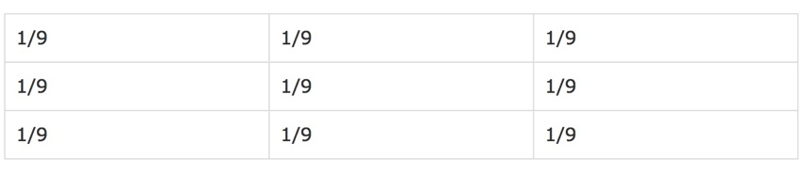

Table 2.2‑3 3x3 Mean filter

The pixels at the corresponding position of the input image to the area covered by this filter are multiplied by 1/9. The results of these nine multiplications are then summed to become the output pixel value at the center position. This process is repeated until all values of the image has been calculated.

This operation can be used to suppress noise data that may be present in a digital image as a result of poor sampling system or transmitting channel such as isolated bright pixels.

# **Machine learning**

## Core concepts of machine learning

**Machine learning** studies computers’ abilities to automatically recognize patterns and generate intelligent conclusions from the given data. It is generally divided into two learning types: supervised and unsupervised.

**Supervised learning (SVM)** is equivalent to data classification. Computers learn patterns from the labeled examples then use them to make intelligent classification on the unknown data.

**Unsupervised learning (USVM)** is equivalent to clustering. Initially, there is no label associated with the data. Computers try to divide the dataset into clusters to discover classes based on pre-existing structure within the data. USVM cannot narrate semantic meaning of the clusters in their learnt models.

**Data classification** consists of a learning step and a classification step. In the learning phrase, computers build a classification model by studying the **training set** made up of pre-labeled tuples. A tuple X describes a set of features. Each tuple is represented by a vector of n-dimension X = (, ,..., ) where is a value for one feature dimension, and categorized with a class label attribute . The class label attribute has a discrete value that indicates to which class tuple X belongs.

In the classification phrase, the learned model is used for predicting the class label for new data. To evaluate this model, a **testing set** is used. Each testing set is also made up of pre-labeled tuples. Testing data sets are usually independent of training sets.

When the resulting model is tailored to fit one specific sample rather than reflecting the overall population, we have an **overfitting** problem. There are various methods to reduce overfitting. One is to put some random noise in the data. Another is to stop training before 100% accuracy is achieved.

## Training and testing strategies

The given dataset must be divided into training and testing sets. There are various strategies for doing this, including the three following methods:

**Hold out:** The given data set is randomly divided into two independent sets: training set and testing set. Usually two-thirds of the data are in the training set and one-third of the data is in the testing set.

**k-fold cross-validation:** The data set is divided into k subsets, and the holdout method is repeated k times. Each time, one of the k subsets is used as the test set and the other k-1 subsets are put together to form a training set. Then the average error across all k trials is computed. The advantage of this method is that it matters less how the data gets divided.

**Bootstrap:** A common bootstrap method is the .632 bootstrap. Given a dataset of d tuples, this dataset will be sampled d times with replacement. Each time a tuple is selected, it is added back into the data pool. Thus it may be selected again. The data that do not make it into the training set will eventually be added into the testing set. The training set and the testing set are not independent because the same tuple can be included in both the training and the testing sets. In .632 bootstrap, 63.2% of the dataset will end up in the bootstrap sample, and the 36.8% that did not make it to the bootstrap sample will together form the test set. Bootstrapping is especially useful when we want to replicate the distributional properties of a random variable in the real world since in the real world, it is not always the case that a tuple only appears once.

## Model evaluation

**Confusion matrix** is often used to measure the performance of a classifier. A confusion matrix is represented by a table of size j x j, where j is the number of output classes. A table entry is in row and column and indicates the number of tuples that are actually in class i but were classified by the classifier to be in class j.

For calculating convention, for every output class j, we will categorize the the tuples classified by the classifier into four groups, as suggested by Jiawei et al. [8]

**True positive (TP):** For each given class j, tuples that are pre-labeled as class j and correctly recognized by the classifier to be in class j are true positive. TP represents the number of true positive tuples.

**True negative (TN):** For each given class j, tuples that are pre-labeled as class i and correctly recognized by the classifier to be in class i are true negative. TN represents the number of true negative tuples.

**False positive (FP):** For each given class j, tuples that are pre-labeled as class i and mistakenly recognized by the classifier to be in class j are false positive. FP represents the number of false positive tuples.

**False negative (FN):** For each given class j, tuples that are pre-labeled as class j and mistakenly recognized by the classifier to be in any class other than j are false negative. FN represents the number of false negative tuples.

Table 2.3-1 and 2.3-2 shows two examples of TP, TN, FP, FN for class 0 and class 1 respectively.

|  |  |  |  |  |  |
| --- | --- | --- | --- | --- | --- |
|  |  |  | Predicted class |  |  |
| Actual class | 0 | 1 | 2 | … | j |
| 0 | **TP** | FN | FN | FN | FN |
| 1 | FP | TN | FN | FN | FN |
| 2 | FP | FN | TN | FN | FN |
| … | FP | FN | FN | TN | FN |
| j | FP | FN | FN | FN | TN |

Table 2.3‑1 Confusion matrix for class 0

|  |  |  |  |  |  |
| --- | --- | --- | --- | --- | --- |
|  |  |  | Predicted class |  |  |
| Actual class | 0 | 1 | 2 | … | j |
| 0 | TN | FP | FN | FN | FN |
| 1 | FN | **TP** | FN | FN | FN |
| 2 | FN | FP | TN | FN | FN |
| … | FN | FP | FN | TN | FN |
| j | FN | FP | FN | FN | TN |

Table 2.3‑2 Confusion matrix for class 1

By dividing classified tuples into these four groups, we can now evaluate our classifiers. The classifier accuracy or recognition rate on the given test set is calculated as follow:

Equation 2.3‑1

where

P = TP+FP

Equation 2.3‑2

and

N = TN+FN

Equation 2.3‑3

Similarly, the classifier error rate or misclassification rate is:

Equation 2.3‑4

# **Multilayer feed-forward neural networks (MFNN)**

## Overviews

MFNN is a classic machine learning algorithm that simulates the way human brain works. MFNN is very useful for studying large datasets due to its ability to tolerate noisy data as well as to learn patterns without prior knowledge. It is especially efficient for real world data, where we do not know much about the relationships between attributes and classes. Generally, MFNN requires a large amount of input data in order to well perform.

Each MFNN consists of an input layer, one more hidden layers and an output layer. Layers are connected in acyclic graph. Each layer is made up of computational elements called **neurons**. Neurons between two adjacent layers are pairwise connected, but neurons within one layer share no connection. No direct connection exists between input and output layer.

Inputs are fed into the neurons making up the input layer. The outputs produced by this layer are weighted and passed simultaneously to the first hidden layer. This hidden layer outputs are again weighted and sent to an another hidden layer and so on. It is arbitrary how many hidden layers there should be. The weighted outputs of the last hidden layer are sent to the output layer, where the prediction for the given tuples will be produced.

Neurons in the input layer are **input units**. Neurons in the hidden layers and the output layers are called **neurodes** or sometimes referred to as **output unit**s. The number of output units are not necessarily equal number of input units. There can be more or less number of hidden units than number of input or output units. Each output unit applies a nonlinear (activation) function to its input. The *activation function* will be described in section 2.5.6.

In a traditional MFNN, all neurons in layer j are connected to each neuron in layer k, for all layers. Thus we say that the NN is fully connected, as shown in figure 2.4-1.

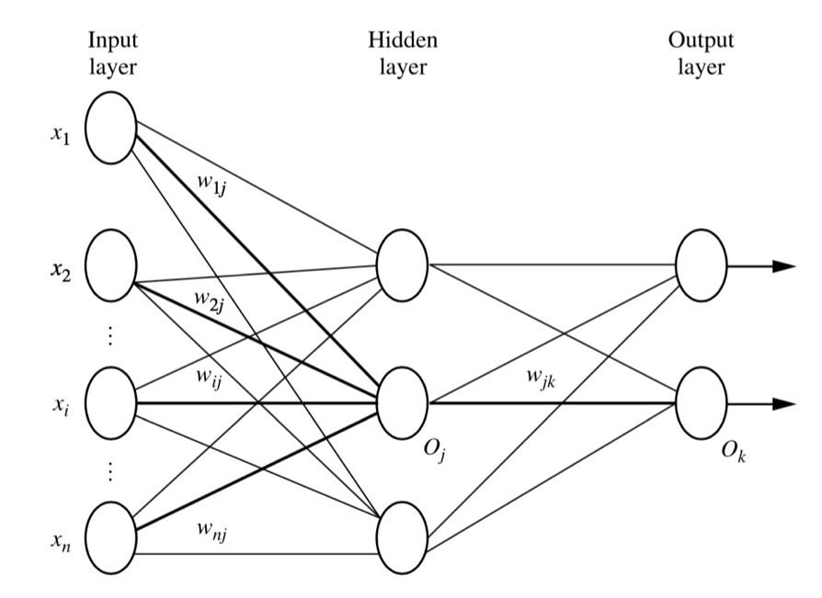

Figure 2.4‑1 Fully connected layers. [8]

## Back propagation

Back propagation is the learning algorithm of neural networks. It propagates the total error at the output layer in the backward direction. During that procedure, it updates the weights on each connection based on calculations using this error so that in the end the error will be reduced.

The true output of any neuron k is calculated as follows. Each connection from neuron j at layer (l-1) to neuron k at layer l is associated with a weight. The output from neuron j is multiplied by the weight between the connection between j and k, summed across all connections entering neuron k. The result is summed with the bias of neuron k layer l. The weight increases the effect of the connection to a neuron whereas bias raises the importance of all connections to one neuron:

Equation 2.4‑1

Where f is the neural activation function, is true output of neuron k at layer l, is true output of neuron j at layer (l-1), is the weight of the connection between node j and k, is the bias of node k.

Total error is the summation of error at each output neuron. The error at each neuron is a function of difference between the actual value of that neuron pre-labeled in the training set and the value predicted by the neural networks. It can be represented in the following equation:

Equation 2.4‑2 [19]

where is the actual label of a tuple, is the label of that tuple predicted by the neural networks and f is any *loss function*. According to many papers and articles [1,2,3,4,5,6,19,20], the loss function used to calculate total error in neural networks is mean squared error, whereas in convolutional neural networks it is cross-entropy error.

### **Weight updating**

First, we want to update the current weight at each connection between neuron i and neuron j in the networks by an amount of in order to reduce this error:

Equation 2.4‑3 [19]

where is the *learning rate*, (old) is the current weight between neuron i and neuron j at layer l, (new) is the updated weight between neuron i and neuron j at layer l and is the amount of weight to be updated at layer l in order to reduce the total error. The larger the learning rate, the faster the networks will learn. Typically, is set to 0.5 to avoid premature convergence.

The amount of weight to be updated at each connection is the rate at which the total error changes with respect to the change of weight of each connection. This rate can be calculated by taking the derivative of the total error with respect to weight. However, we have not yet known the output of this derivative, therefore, we need to take a step further by applying the chain rule in order to calculate the derivative value from something that we can possibly know:

Equation 2.4‑4 [19]

where is the amount of weight to adjust between neuron j and neuron i at layer l, is the *true* *output* of neuron j at layer l, is the *net* *output* of neuron j at layer l, is the current weight between neuron j and neuron i at layer l. The net output of a neuron is the output before applying activation function. The real output a neuron is the output after applying activation function.

We can now calculate the value of by calculating the right hand side of equation 2.4-4 separately in two parts, and as follows:

The value of can be calculated by taking the derivative of the net output of neuron j at layer l with respect to the the current weight between neuron j and neuron i at layer l. Since the net output of neuron j at layer l is

Equation 2.4‑5

which is equation 2.4-1 before applying activation function, the result from this derivative is , which is the sum of true output of all neuron i at layer (l-1) that are connected with neuron j at layer l.

We will denote as . It is in fact which is the rate at which the total error changes with respect to the change of net output of neuron j at layer l. The value of cannot be calculated directly. Further chain rule needs to be applied to this term:

Equation 2.4‑6 [19]

where is the true output of neuron j at layer l, is the net output of neuron j at layer l and is the net output of neuron j at layer (l+1).

To calculate the terms , we will need to understand about the activation function. This will be explained in section 2.5.6. The activation function of each neuron j is a function of net output at neuron j. Therefore, the derivative of true output with respect to net output can be calculated directly.

The term is in fact the summarization of the multiplication between the rate at which the total error changes with respect to the change of net output of each neuron i at layer (l+1) that are connected to neuron j at layer l and the weight between neuron j and neuron i.

Therefore, can be written as:

Equation 2.4‑7

where is the rate at which the total error changes with respect to the change of net output of neuron j at layer l, m is the total number of neurons at layer (l+1) that are connected to neuron j at layer l, is the rate at which the total error changes with respect to the change of net output of neuron i at layer (l+1), is the weight between neuron j and neuron i at layer (l+1), is the true output of neuron j at layer l and is the net output of neuron j at layer l.

The rate at the outer most layer (the output layer) can be calculated directly because the total error is a function of true output of all neurons at output layer.

### **Bias updating**

Next, we want to update the current bias at each neuron j in the networks by an amount of in order to reduce the total error E:

Equation 2.4‑4

Similar to the case of weight updating, the amount of bias to be updated at each connection is the rate at which the total error changes with respect to the change of bias of each neuron j. This rate can be calculated by taking the derivative of the total error with respect to bias. However, we have not yet known the output of this derivative, therefore, we need to take a step further by applying the chain rule in order to calculate the derivative value from something that we can possibly know:

Equation 2.4‑4 [19]

The value of can be calculated by taking the derivative of the net output with respect to the the current bias of neuron j at layer l. According to equation 2.4‑5, the result from this derivative is 1.

We will denote as . Details on how to calculate has been discussed in Section 2.4.3.1.

## Conclusion

The above equations show that the networks can back-propagate the error rate from the outer most layer (output layer) to the inner most layer (input layer). At the same time, it uses that error rate to update weight at each connection in the networks in order to reduce the total error.

# **Convolutional neural networks (CNN)**

## Overviews

CNN is a “state-of-the-art technique for image recognition” [5]. It is a multilayer neural network (as illustrated in figure 2.5-1). It consists of one or more convolutional layers, followed by pooling layers (sometimes called subsampling layers), ReLU layers, and one or more fully connected layers. Convolutional layers are used for extracting important features from the input images. The features learnt by a convolutional layer are often summarized by a pooling layer. A ReLU layer eliminates negative outputs produced by the pooling layer preceding it. The learnt features are eventually passed into fully connected layers, where each input image is mapped with a suitable output class.

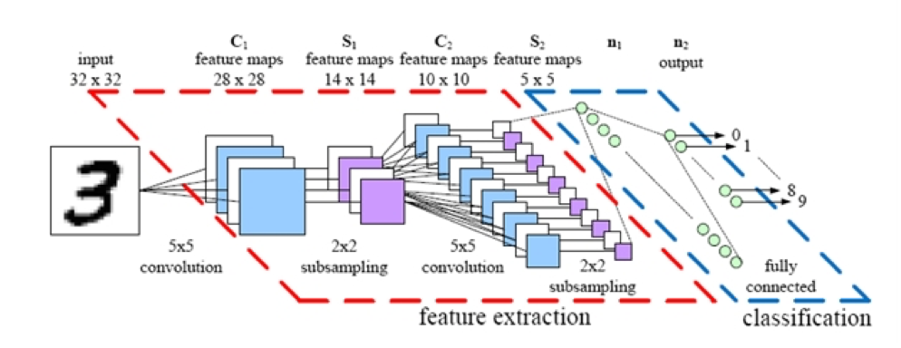

Figure 2.5‑1 A convolutional neural networks. [16]

The networks build a sufficient model for the input dataset by imposing a set of forward and back propagations. At each iteration, the CNN model tries to reduce the number of wrong predictions by updating the weights that are associated with the location of the errors. The updating process iterates until all the weights in the network converge.

## Convolutional layer

Convolutional layer extracts the important features of images via image convolution. Four parameters are required in convolutional layer: the number of filters K, receptive field size F, the stride S and the amount of zero padding P. This layer accepts input of volume size and produces an output of volume size [(.

### **Local receptive field**

Think of the input image as a square of n x n neurons. The value of each neuron is the corresponding pixel intensity of the input image. We will map a localized region of the input neurons to a neuron in the hidden layer. These localized regions of input neuron are called local receptive fields. The size of a local receptive field is equal to the size of a kernel. More about kernel will be discussed in section 2.5.2.2.

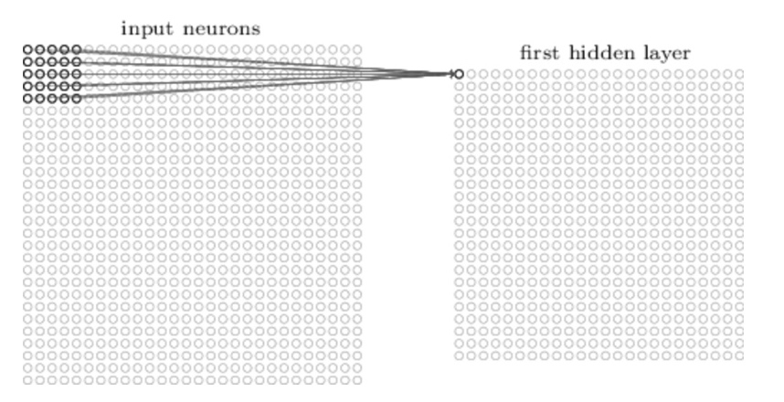

Figure 2.5‑2 Local receptive fields [7]

### **Filter (Kernel)**

Each mapping from input layer to a hidden neuron at the hidden layer next to it learns a weight and each corresponding hidden neuron learns a bias . This weight and bias together make up a kernel (sometimes called a filter). In an FxF filter, each of the F positions holds a weight which is a real value. The bias applies to the filter as a whole. As discussed in section 2.7, the filter is moved around the input image and the output pixel is calculated using the convolution operation. The output at position , is a convolutional function between an input neuron at position ’s value and its weight:

Equation 2.5‑1

where is neural *activation function*,is the true output value at position (x,y) at layer l, is the input pixel value at position (x-a, y-b) at layer (l-1), (a,b) is position of a pixel in the kernel, is the the bias, the weight of the connection at the row and the column of the kernel and k is the size of the kernel. More about the activation function will be described in section 2.5.6.

### **Feature map and stride**

The combination of outputs generated by a hidden layer is called a **feature map**. To calculate the value of the next pixel in the feature map, we will move our kernel k pixels sequentially along width and height. In this case we say a stride length of k is being used. Then we re-apply the convolution function discussed above, until we run out of input neurons.

Figure 2.5-3 shows an example of the convolutional process using two 3 x 3 x 3 convolutional kernels with stride 2. The first pixel of the first output volume is calculated as follows. The first channel of filter is convolved with the first 3 x 3 receptive field of the first input channel. The second channel of filter is convolved with the second 3 x 3 receptive field of the second input channel. The third channel of filter is convolved with the first 3 x 3 receptive field of the third input channel. Corresponding pixel values in the results from these three convolutions are then summed together. Then the bias of filter is added to each output pixel value. The next pixels of first output volume are calculated similarly with one variation: the aforementioned receptive field is slid to the right or down by 2 pixels each time.

Likewise, the pixels of second output volume are calculated with the same fashion but the filter is replaced by filter .

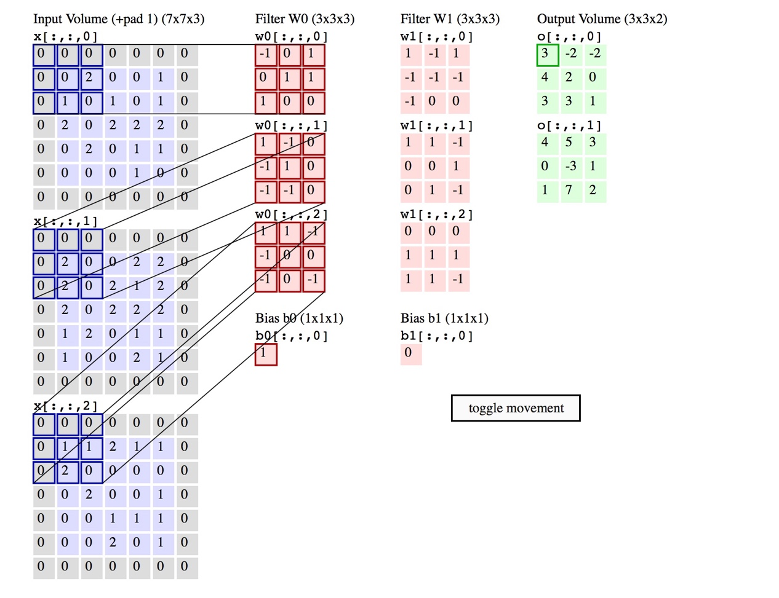

Figure 2.5‑3 Convolutional process - An input image of size 7x7x3 is filtered by 2 convolutional kernels which create 2 feature maps. [12]

Each feature map can detect one feature at different locations of the same input image. To detect many features from one input image, we need several feature maps. To generate several feature maps, we will need several kernels. A complete convolutional layer consists of several different feature maps.

### **The use of zero-padding**

Zero padding is a simple method of padding the borders of the input image in order to control the size of the output image. Padding allows convolution to be performed on pixels at the edges of the input, which otherwise would not have complete receptive fields. Specifically, the relationship among padding size P, input height/length W, output height/length O and filter size K can be described as follow:

Equation 2.5‑2

## Pooling layer

A convolutional layer is usually followed by a pooling layer. The function of the pooling layer is to simplify every feature map in the previous layer at every depth slice. Thus it reduces the amount of parameters and computation in the network. As a result, it will reduce overfitting. Recall that overfitting happens when the model is tailored to fit the random noise in one specific sample. By reducing the amount and improving the quality of the data presented to the networks, overfitting can be reduced. A successful pooling layer should be able to preserve critical information while being “invariant to troublesome deformations” [9].

Pooling layer requires two parameters: filter size F and stride S. It accepts input with volume size and produces an output of volume size [(.

There are several widely used pooling techniques. The most well-known one is **max pooling**. In max pooling, we want to know the max value of the pixels in a particular receptive field. This can be described as:

Equation 2.5‑3

where is the output value of pooling layer l at position (x,y), is the true output value of convolutional layer (l-1) at position () with (i,j) is position of a pixel in the filter.

Figure 2.5-4 shows an example of max pooling operation on three 4 x 4 slices. Each slice is filtered by a 2x2 kernel with stride 2 which results in four pooling feature maps, each of size 2 x 2. The first pixel of an output volume is the maximum value of the pixels in the first 2x2 receptive field of the corresponding input volume. The next pixels of that output volume are calculated similarly with one variation: the aforementioned receptive field is slid to the right or to the bottom by 2 pixels each time.

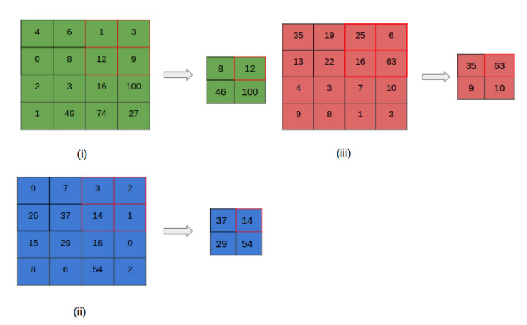

Figure 2.5‑4 A max pooling layer [12]

Other popular pooling techniques are pooling and subsampling. Details about pooling can be found in Bruna et al. paper [21]. Details about subsampling can be found in Dominik et al. paper [18].

A filter size of 2x2 and a stride of length 2 are often applied with these pooling techniques. According to some research [4,9], there is no best pooling technique. We may need to try applying several pooling techniques to our problem to see which one yields the best result.

## ReLU non-linearity

Rectified Linear Unit is a modern way to represent an output f as a function of input x. It computes the function:

f(x) = max(0,x)

Equation 2.5‑4

which means the output is 0 when the input is less than 0.

ReLU has two advantages over *tanh* function which was traditionally used in MFNN as an output function. Deep learning neural networks with ReLU was found to train significantly faster than networks with tanh unit. This is because saturating nonlinearities are generally slower than non-saturating nonlinearities in terms of training time with gradient descent. Secondly, while tanh function involves expensive computational operations, ReLU can be implemented easily by thresholding a matrix of activations at zero. A convolutional layer is often followed by ReLU.

## Fully connected layer

The output from the last pooling layer is flattened into 1-D vectors before it is sent to a set of fully connected layers. Fully connected layers are originated from multi-layers feed forward neural networks. Details on MFNN have been presented in section 2.4.

## Softmax regression function

Softmax regression is a generalized logistic regression model which is used to turn a single neuron into a linear classifier so that the neuron can handle multiple classes. The CNN maps each tuple in the input layer to all neurons in the output layer and assign each output neuron to a probability . The probability is the true output of each neuron k at the output layer given the input tuple , where each output neuron represents a class k. gives the probability that tuple belongs to a class k,

The softmax regression function maps an input to an output in a range between 0 and 1, and all calculated probabilities of different classes must sum to 1. The true output for each neuron k in the output layer can be computed by applying softmax regression function to the net output of every neuron k. Recall that the net output of a neuron is the output before applying softmax function and the real output a neuron is the output after applying softmax function.

For each output neuron, we perform the following calculation:

Equation 2.5‑5

where represents an output neuron j where j K, is net output of neuron j, is net output of each neuron k, where k = 1,…,K and K is the number of classes in output layer.

# **Learning in a Convolutional neural networks**

## Back propagation core concepts

Back propagation is an iterative process to adjust the learnt weight and bias by comparing the network’s prediction with the tuple’s known target value. It takes place after each training example is presented to the network. The aim is to minimize the error between the network’s prediction and the known target value. The target value can either be a known class label or a continuous value. The weight and bias modification process is done in a backward direction, from softmax through fully connected, pooling and ReLU layers to the convolutional layer. The forward and backward process is repeated until a predefined termination condition occurs. The steps are as follows:

1. Initialize all weights and bias in the network with some small random values and choose a learning rate.
2. For each input tuple, propagate the inputs forward the networks using our initialized weights and bias until we reach the output layer.
3. Calculate error rate and consequently update the weight at each layer.
4. Repeat step 2 and 3 until when one of the following conditions is reached:

* All in the previous epoch are below some pre-specified threshold
* A pre-specified number of epochs has reached
* The percentage of misclassified tuples in the previous run is lower than some predefined threshold

## Back propagation at the Softmax

Details about how to calculate are presented in Section 2.4.2.

We will look at how the networks adjust its weight using by looking at effect on each layer.

## Back propagation in the Fully connected layer (Neural networks)

Details about this can be found in Section 2.4.2.

## Back propagation in the ReLU layer

The output for each neuron can be written as

Equation 2.6‑1

where is the real output value of neuron i of ReLU layer (l-1).

Equation 2.6-11 shows that there is no weight associated with this layer. Thus this layer has no effect on the total error and the error rate at this layer is equal to the error rate at the fully connected layer.

## Back propagation in the pooling layer

The output for each neuron can be represented by

as suggested by equation 2.5-5. Similar to ReLU layer, the above equation shows that there is no weight associated with the pooling layer. Therefore, pooling layer has no effect on the total error. The error rate at this layer is also equal to the error rate at fully connected layer.

## Back propagation in the convolutional layer

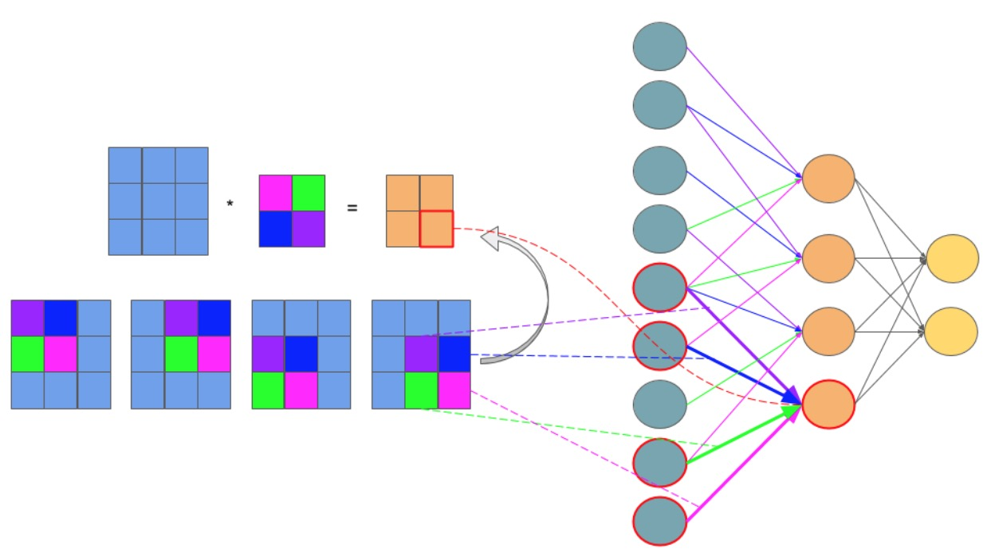

Figure 2.6‑1 Feedforward in CNN is identical with convolution operation. [15]

Figure 2.6-1 illustrates that a feedforward in CNN is equivalent to the convolution operation. If we can somehow ‘open’ every component of a CNN in a 1-D vector, each pixel in the input image of a CNN will become a neuron in the input layer of a MFNN. Each pixel in a kernel of the CNN will become a weight of a connection between a neuron in the input layer and a neuron in the layer ahead of it, which can be a hidden layer or an output layer. Each pixel in the output image produced by convolving the input image and a kernel in CNN will become a neuron in the hidden/output layer of a MFNN. And the bias of a kernel will become the bias of every neuron in the same hidden/output layer. The problem has now become similar to the case of MFNN. The error rate from the outer most layer (output layer) is back-propagated to the inner most layer (input layer). At the same time, the network uses that error rate to update weights at each connection in the networks in order to reduce the total error.

## What does a CNN learn?

This section briefly discusses about the final CNN and how it represents learning. A CNN represents its learning as adapted filters at convolutional layers and weights at fully connected layers. Each filter at convolutional layer can detect a feature at different locations of the same input image. By learning a variety of selective filters, the networks improve its ability to detect robust features. Vice versa, examining learnt kernels can help us understand what kind of features are being extracted. Examining the kernels also helps us debug the problems with our model (for instance: Are the kernels informative enough?) and improve our results accordingly. Learning at fully connected layers on the other hand is represented with adapted weights at each connection. Those weights are the networks’ reference when mapping features representing each object with the output class.

# **Data Augmentation**

## Concept

Artificially enlarging the dataset with label-preserving transformations is the simplest and best known strategy to reduce overfitting on image data. To each randomly chosen sample image, we will apply n *random transformations*. Each of these random transformations is a combination of several elementary forms of transformation, which we will describe shortly. The benefit of using transformations that require little computation is that of we will not have to store the pre-processed image on the disk. Image transformation contains two major approaches: point operators (sometimes called 1-to-1 pixel transforms) and neighborhood (or area-based) operators. In point operators, each output pixel value is strictly a function of the corresponding input pixel value. Brightness and contrast adjustments are two examples of such transformation. Techniques like convolution, which we have discussed in part 2.2, are not 1-to-1 transforms.

## Methods

### **Brightness adjustment**

We add or subtract a constant amount of light to all input pixel in order to change an image brightness, as suggested in the following function:

g(i,j)= f(i,j)+β

Equation 2.7‑1

where f(i,j) is the pixel located in the i-th row and j-th column of the input image, g(i,j) is the pixel located in the i-th row and j-th column of the output image and β is a bias parameter which is used to control the image brightness.

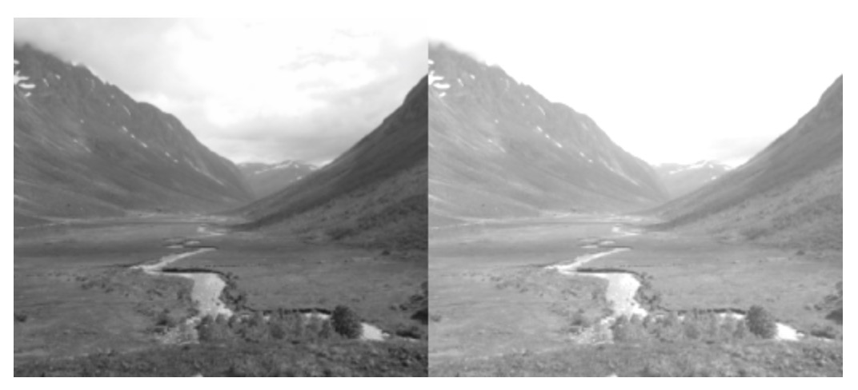

Figure 2.7‑1 Brightness adjustment. [14]

### **Contrast adjustment**

Contrast is the difference between the maximum and the minimum pixel intensity of an image. To change the contrast of an image, we change the range of the luminance value presented in the input pixels. It is mathematically suggested by the following function:

g(i,j)= α f(i,j)

Equation 2.7‑2

where f(i,j) is the pixel located in the i-th row and j-th column of the input image, g(i,j) is the pixel located in the i-th row and j-th column of the output image and α is a weight parameter which is used to control the image contrast. See the discussion of histogram adjustment in Section 2.1.2 for more information.

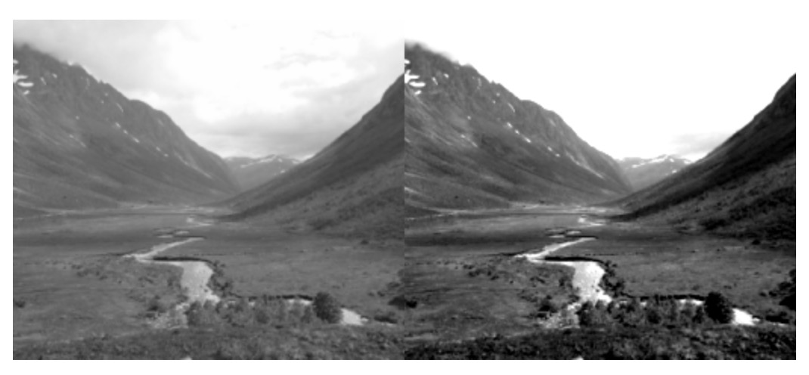

Figure 2.7‑2 Contrast adjustment. [14]

We can combine the brightness and contrast control in a single operation. It is mathematically represented as:

g(i,j)= α f(i,j) + β

Equation 2.7‑3

### **Scaling**

The purpose of scaling is to generate a new image with different resolution. Details can be found in upsampling and downsampling methods in section 2.1.2.

### **Summary**

Artificially enlarging the dataset using the combination of these three forms of image transformation in image pre-processing has two extra benefits. Firstly, it allows the network to “look at” the seed image at different perspectives. Secondly, it allows the CNN model to work properly, because CNN requires a large set of training data. Notice that data augmentation is different from *image* *pre-processing*. Image pre-processing processes the images so that they all meet some pre-defined standards whereas data augmentation artificially enlarges the dataset by applying random transformations to each pre-processed image.

# **Model combination**

Combination of models is a very effective way to reduce testing errors. At the same time, it significantly increases the number of networks parameters and thus computers processing speed. Dropout is a very efficient method for simulating model combination. Dropout sets the output of each hidden layer of a network to zero with the probability of 0.5. Propagation and back propagation processes will not consider the ‘dropout neurons’ into their calculations. The described process is repeated several times. At each time, a different set of outputs from hidden layers are set to zero. The network’s prediction of a tuple is remains the same regarding the change of the dropout neurons. By performing these presented steps, dropout can simulate the combination of several neural networks.

When dropout is used, it will take more time for a neuron to learn more robust features in order to make predictions, since it can no longer rely on the existence of other neurons. Therefore, it will take more time for the network to converge.

# **GPU Concepts**

The enormous amount of input data required by deep learning may considerably increase computation time. This problem can be overcome by spreading and training the networks across processing units. There are two types of processing units: central processing unit (CPU) and graphics processing unit (GPUs).

In comparison to CPU, GPUs are far more powerful and efficient in parallel computing. They can be used to train far larger training sets in considerably less time. Current GPUs support cross-GPU parallelization that allows GPUs to read and write into one another’s memory directly. Even though each GPU has limited memory, which may restrict the size of networks to be trained using one, a GPU can still distribute the network’s size across multiple units.

Recent deep learning toolkits are mostly developed based on CUDA GPU-support library. This library only supports NVIDIA GPU card with *compute capability* >= 3.0. Compute capacity is a number that defines general specifications and available features of a GPU card. Details about general specifications and available features associated with each compute capacity value can be found in CUDA toolkit documentation [24]

# **CNN Software Frameworks**

# Table 2.10-1 [21,22,23] shows a comparison among different currently popular frameworks. All of the frameworks in the table support parallelism through GPU mode using CUDA library. They also have an ability to produce a series of matrix operations (computation graph) on which automatic differentiation can be performed. With automatic differentiation, one does not have to hand-code a new variation of back propagation each time a new arrangement of the CNN is made.

|  |  |  |  |  |  |  |
| --- | --- | --- | --- | --- | --- | --- |
| **Framework** | **Base language** | **API** | **Single GPU execution speed** | **Ready-to-use low-level operators for writing new models** | **GPU memory for training large models** | **Ease to use** |
| **Tensorflow** | Python and C++ | - Python and C/C++ - Mathematical operations are supported with numpy | Slower than other frameworks | Fairly good | Not so good | - Sample code and tutorials available |
| **Caffe** | C++, Python | C++, command line, Python, MATLAB | Slower than other frameworks | Fairly good | Better than Torch | - Sample code and to tutorials are somewhat confusing because different versions are developed by different people  - Code might not need to be written to train models |
| **Theano** | Python | - Python - Mathematical operations are supported with numpy | Faster than Caffe and Tensorflow | Many basic operations | Great | - Sample code and tutorials available  - Error messages are difficult to understand, therefore can be unhelpful |
| **MXNET** | C++, Python, Julia, Matlab, R, Scala | C++, Python, Julia, Matlab, JavaScript, R, Scala | Faster than Caffe and Tensorflow | Very few | Excellent | - Sample code and to tutorials are somewhat confusing because different versions are developed by different people |
| **Torch** | Lua | Lua | Faster than Caffe and Tensorflow | Many basic operations | Fair | - Easy to set up - Error messages are helpful |

Table 0‑1 Comparison among different frameworks

# Each framework, however, has some tradeoffs that we will have to consider before making a decision on which one to use. Theano supports the *numpy* library for mathematical operations, provides considerably fast single GPU speed, great GPU memory support for training large models and many basic operations. However, its error messages are difficult to understand. MXNET is the best in terms of GPU memory. However, it reportedly has confusing tutorials and a poor set of ready-to-use low-level operators. Torch has the best ease of use, many basic operations and compromising GPU speed and memory, but it uses the less well-known Lua programming language as its API. Caffe and Tensorflow are the most widely use frameworks recently. Caffe allows us to train models with little modification to its existing models. Nevertheless, it has supposedly confusing tutorials, slower GPU speed than other frameworks and it does not have *numpy* support for mathematical operations. Tensorflow does not have very good GPU memory and GPU speed but it has a fairly good set of ready-to-use low-level operators and sample tutorials. For this project, we consider experimenting Caffe and Tensorflow as they have a balanced compromise among different aspects and appear to be adopted by most developers.

# **Related research**

## Research using CNN to classify images

CNN has proved to be very efficient in object recognition. A. Krizhesy et al. (2012) successfully modeled a deep CNN “to classify the 1.2 million high-resolution images in the ImageNet […] into the 1000 different classes” with “top-1 and top-5 error rates of 37.5% and 17.0%”. The networks contained five convolutional layers, three max pooling layers, three fully connected layers and a 1000-way softmax. Data argumentation, overlap pooling and dropout were used to reduce data overfitting. To improve the processing speed, the networks were split into different parts, which were trained on multiple GPUs [1].

Hokuto et al. (2014) developed a food detection and recognition deep CNN trained from 20,000 samples of food items. The networks consisted of two convolutional layers, one ReLU layer and was able to detect up to 93.8% and recognize up to 72.39% of testing food items [5].

## Variations in algorithms in CNN used for classifying fine-grained objects

Krizhevsky et al. (2012) has taken a step further to the traditional pooling. Suppose a pooling layer consists of a grid of pooling units, each summarizes a neighborhood of size z x z and stride s. Traditionally, we set z = s, where we obtained non overlap pooling. Now we will set s < z to obtain overlap pooling. A. Krizhevsky et al. has pointed out this is a more effective pooling technique as it reduces the top-1 error rate by 0.4% and top-5 error rate by 0.3% [1].

Jonathan et al. (2014) exploited deep CNN in fine-grained object recognition. The objective was to identify different car models. The networks were built by adapting the model from A. Krizhesy et al. with little variation. A deep CNN model consists of two convolutional layers, three fully connected layers and a softmax loss were used to extract useful features from the seed image. The seed image then is used to retrieved its nearest neighbors (those that has the same pose with it). Only parts with highest energy detected from this seed image and its neighbors are chosen because they are likely to be important when describing the seed image. Learnt features obtained earlier from CNN are then pooled in the regions of each selected part. Those regions are said to describe critical parts for the class where seed image belongs. This networks were able to categorize testing data with accuracy up to 73.9%. However, the described technique is only useful for recognizing pictures with the same pose [4].

Aäron et al (2015) attempted to build a CNN to classify grayscale 30000 images of plankton into one of 121 classes. Input images were preprocessed in by downsampling. 300 CNN models were trained and several of them were combined to improve the final accuracy. A significant variation made when training the model was to exploit the viewpoints in pooling. One example of the models that works well consisted of 10 convolutional layers, 4 pooling layers and 3 fully connected layers. Models were trained on the NVIDA GPUs using various overfitting-reducing techniques: data argumentation, ReLU, dropout and overlap pooling. The best models had an accuracy of 82% on the testing set and top 5% accuracy of 98% [3].

Sander et al. (2015) built a deep CNN to measure approximately 900,000 galaxy morphology by exploiting viewpoints in pooling. After preprocessing and data augmentation, viewpoints are extracted by applying the combination of flipping, rotating, cropping to the input image. Every viewpoint is then presented to the same convolutional architecture in a separated path. The resulting feature maps from each viewpoint are first concatenated in to a single vector, then processed by a set of fully connected layer to obtain predictions. The benefit of exploiting viewpoints in pooling is that it allows the network to “look at” the image at different angles. The model was claimed to “reproduce their consensus with near-perfect accuracy (> 99%) for most questions” in Galaxy Challenge Contest 2015. Techniques discussed in A. Krizhesy et al. were also applied to reduce data overfitting [2].

# **Chapter 3**

# **Design and Methodology**

In this section, we will describe our approach to developing a valid model for sugarcane grading using ground-level images. We will first discuss the experimental set up. We will then discuss the successive processing steps used to obtain a set of predictive probabilities for each input image. The successive steps consist of the following: data preprocessing, data argumentation, viewpoint extraction, convolutional neural network experimental design and model evaluation, as shown in figure 3-1.

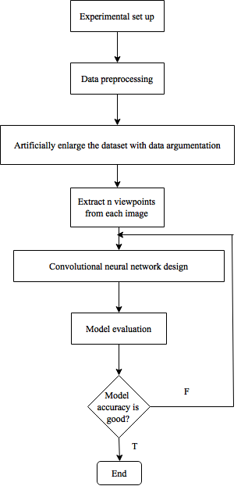

Figure 3‑0‑1 Flowchart with the major stages of the work

# **Experimental set up**

## Gathering data

The dataset consists of sugarcane field images taken from ground level and is provided by Mitrphol company. As suggested by other research, a minimum amount of 1000 pre-labeled samples in the dataset is required in order to train the convolutional neural networks. We have been provided with approximately 1700 pre-labeled image examples, which are divided into 4 growing seasons of sugarcane. We will use them to develop some simple models so as to evaluate the use of different frameworks.

## Plan on experimenting different frameworks

As mentioned in Section 2.10, we consider experimenting Caffe and Tensorflow as they have a balanced compromise among different aspects and appear to be adopted by most developers. In this section, we will discuss our plan to study the use of the two aforementioned frameworks. Then we will evaluate the usability of each framework based on the following criteria:

**The ease of the framework installation:** We can evaluate the ease of installation by answering the following questions. Is the documentation for installing the framework easy to follow? Does the framework require many other toolkits to be installed together with it? And if yes, is the installation of the supporting toolkits are complicated?

**The ease of following the framework documentation:** The documentation must provide instructions that are easy to follow. It must also contain understandable explanations of all operations that the framework provides.

**The ease of constructing the network:** A good framework should provide a good set of ready-to-use low-level operators for writing new models. It should also allow us to modify the networks’ structure easily.

**Performance:** A good framework must support parallelism through GPU mode, which will allow us to train the networks with a reasonable amount of time.

**The availability and accessibility of sample code and tutorials:** Sample code and tutorials are important for us to understand how the framework works. If there are too little sample code and tutorials available, we might have difficulty in learning and modifying code in the framework.

**The ease of understanding error messages from the framework:** Error messages have to be helpful and easy to understand.

### **Tensorflow**

#### **Installation**

Before installing Tensorflow, we will need to set up a few things. First, we will need to install Python. Details on how to install Python can be found in Python documentation [28]. Next, we will need to download and install CUDA toolkit in order to use Tensorflow CUDA version. Details can be found in CUDA installation documentation [29]. Finally, we can install Tensorflow on the machine. Different ways of installing Tensorflow is supported. In our case, we will try to install it via one of the installation pipes called Virtualenv with GPU enabled mode [26], because it allows us to install TensorFlow in its own directory without affecting any existing Python programs on our machine.

#### **Testing plan**

In order to evaluate this framework, we plan to refine the code from Tensorflow documentation on ‘how to recognize hand-written digits from digital images in the MNIST data-set’ to build a simple model that suits our problem. The code refinement are as follows. First, the example code attempted to read images and labels of binary format, which is not our case. We will need to read all images in the dataset and associate each with a label. Details on how we did this will be explained in Section 3.2.

We will reuse the next parts of the example code, with some modifications to fit the refinement we made at the beginning. Each time the system read an image, it will perform on this image a set of random transformations to create *n* new distorted images. The distorted images will inherit their labels from the original image. The original image and the distorted images will then be stored in a batch together with their labels. There is a finite number of batches, each of which stores a finite number of training images. The CNN is initialized with random weights and bias. At each iteration, a new batch is selected.

However, at this point, we want to try extracting a set of viewpoints from each image in the batch and present each view point to the same convolutional architecture in a separate path, as suggested by Sander et al. (2015) [2]. Since the example code did not attempt do this, we need to modify it to fit our case. For each image in the selected batch, we will extract a set of viewpoints and put them in an another, separate batch. We will then present this new batch to the same convolutional architecture, but we will concatenate the results from the last ReLU layers of all convolutional architecture before sending them to the fully connected layers, where each input image is mapped with a suitable output class. Finally, Tensorflow provides a back-propagation method that allows all initial weights and bias in the networks to be updated so as to minimize the error rate within a single call.

We will assess the usability of the framework using the criteria specified earlier in this section based on how much trouble we will encounter during the experiment.

### **Caffe**

#### **Installation**

Before installing Caffe, we will first need to install its dependencies. Caffe has some compulsory dependencies as follows. CUDA library is required to support GPU mode. BLAS library is required to support vector computation. Since Caffe base language is C++, Boost package is also required to support its C++ library. And Python is required to support its interface.

Besides these compulsory dependencies, Caffe has some optional dependencies. Caffe optional dependencies are OpenCV for image processing and cuDNN for GPU acceleration.

We will then install Caffe according to instructions on Caffe documentation [27].

#### **Testing plan**

In order to evaluate this framework, we plan to modify the imagenet tutorial in Caffe documentation to make the model trained on our sugarcane image.

The first step is to split our image dataset into two parts, one of which is the training set, the other is the testing set. There are three splitting strategies as described in Section 2.3.2. We will try the ‘hold out’ strategy because it is the simplest and most widely used.

After having the training and testing data all set, we will then refine the sample code so that it is able to read all images in each dataset and associate them with a label. To do this, we will have to create a text file for each dataset. Each line in the text file is a directory to an image in the dataset and is followed by its label, as described in Section 3.2.

The next step is to inform the *create_imagenet.sh* file about the directory to the new dataset. To do this we will need to modify all arguments in that file that refers to one of the following: the training set directory, the testing set directory, the training set text file or the testing set text file. When we run the *create_imagenet.sh* file, it will generate a training *leveldb* and testing *leveldb* directories. Caffe will work with these *leveldb* directories instead.

We will then need to inform *make_imagenet_mean.sh* about our new *leveldb* directories. The file *make_imagenet_mean.sh* when being compile will create a file name *imagenet_mean.binaryproto*. Caffe uses this file to subtract the image mean value from each image in order to normalize our inputs. This step is probably irrelevant to our problem since we want to mimic the photos taken in different conditions with different mobile phones. Therefore, we may want to find a way to set the image mean value to zero.

The final step is to notify each of these following files: *solver.prototxt, train_val.prototxt* and *deploy.prototxt* on the newly created *leveldb* directories and *imagenet_mean.binaryproto*.

The file *solver.prototxt* keeps information about how we will use our dataset to train and test the CNN. One example is the number of iteration for the propagation and back-propagation cycle. The *train_val.prototxt* is where data argumentation is performed. The file *deploy.prototxt* defines the network structure. This is where the organisation of convolutional, pooling, ReLU and fully connected layers are defined. We plan to play around with this file in order to see how easily can we modify the networks structure using this framework.

We will assess the usability of the framework using the criteria specified earlier in this section based on how much trouble we will encounter during the experiment. Then we will conclude which framework is better for our experiment.

## Computer resources

We need a powerful GPU card that supports CUDA library to train the CNN. CUDA library documentation recommends any NVIDIA GPU card with compute capacity greater than 2, but the most powerful are some models of the NVIDIA Tesla and any model of the NVIDIA Geforce Titan [24]. For our main experiments, we plan to use the KMUTT Innosoft high performance computing service to train our CNN [25]. The Innosoft server hosts a NVIDIA Tesla K10 card. This card has a compute capacity of 3.0 and is thus suitable for the experiment.

Tensorflow provides *tf.device* method and Caffe provides *caffe.set_device(gpu_id)* method. Both of these methods allow us to specify the remote GPU server that we would like to train our networks on.

# **Data preprocessing**

First, we will make sure that every image is associated with a label and all labels can be automatically interpreted by our system. In the example dataset we have, images are stored in the local machine and each of them is labeled by its name. We can handle this example dataset as follows. We will first label each file with a number in the range [0,2] according to its name, with 0 being **poor**, 1 being **medium** and 2 being **good**. We will then keep all information of the images in the dataset in a text file, where each line is a directory to an image followed by its label. Our networks can look at this file in order to locate each image and identify its label. Finally, if we look into the output layer of the CNN, we will see this layer contains three output neurons, each represents a class. Our final step is thus to encode decimal labels into binary labels where each digit of a binary label represents a class value. For the complete dataset, images could be split into different folders and labeled by folder names. In this case we will read each folder name and impose the label to all images contained within each folder. The dataset could be hosted by a remote server, in which case the approach is the same with one variation: all directories are directories of files and images on the server.

Next, we will need to standardize each experimental image before sending them to the input layer of the CNN. Having all images standardized allows us to process them more easily. We will standardize the images by cropping each experimental image into a standardized square shape. Resizing images speeds up the training process with little or no effect on the accuracy [2]. Both Tensorflow and Caffe provide functions to perform these operations easily.

# **Data argumentation**

To expand the training set size, we will need to artificially increase the number of the training samples. Each training sample is randomly distorted into *n* forms. The steps are shown in figure 3.3-1. However, in order to mimic the photos taken in different conditions with different mobile phones, they cannot be extremely distorted.

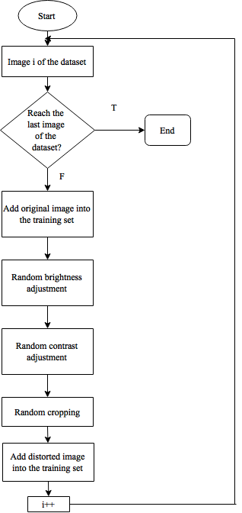

Figure 3.3‑1 Data argumentation steps

Each distortion method is a combination of the several elementary forms of transformations. Details about the mechanics behind each form of transformation were discussed in Section 2.10.

### **Brightness and contrast adjustment**

We plan to test the brightness and contrast adjustment operations with different input value and print out the resulting image. By doing this, we can look for the range in which the resulting image is most appropriate to human eyes. That is, when the brightness and the contrast of an image are neither too high nor too low. We will then able to choose a random value within this range and use it on different input images.

### **Cropping**

We will randomly crop an area in the central region of an image for two reasons. Randomly cropping mimics photos of the same object taken by different people, while cropping an area in the central region retains the important information from an image. We plan to crop out from 20-40% and retain from 60-80% the area in the central region of an image.

Tensorflow provides operations that allow us to transform an image within a single call without writing extra code. The operations that we plan to use are:

* *tf.image.adjust_brightness(image, delta)* for adjusting an image brightness
* *tf.image.adjust_contrast(image, delta*) for adjusting an image contrast
* *tf.image.central_crop(image, central_fraction)* for cropping an image
* Details on how to use these operations can be found on Tensorflow documentations [26].

Caffe provides the *transform_param*, where we can set a value of the *contrast_adjustment*, *brightness__adjustment* and *crop* variables to make it do the same job. However, depending on which Caffe version is used, we may have to add some C++ code to the transform_param function in order to specify the exact job for each operation.

# **Viewpoints extraction**

After artificially enlarge the dataset with data argumentation, we will extract *n* different viewpoints by cropping, adjusting the brightness and contrast of each input image in the new dataset, as shown in in figure 3.4-1.

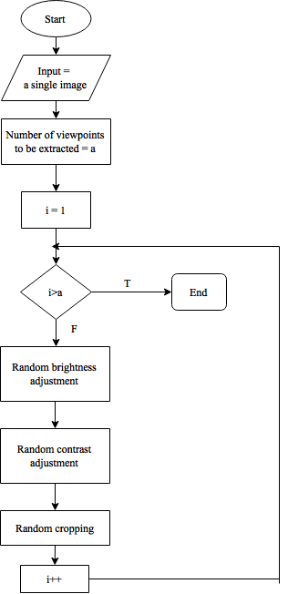

Figure 3.4‑1 Viewpoints extraction steps

Every viewpoint from the same image is then presented to the same convolutional architecture in a separate path. The resulting feature maps from each viewpoint are first concatenated into a single vector, then processed by a set of fully connected layers to obtain predictions. An overview of the aforementioned steps is shown in figure 3.4-2.

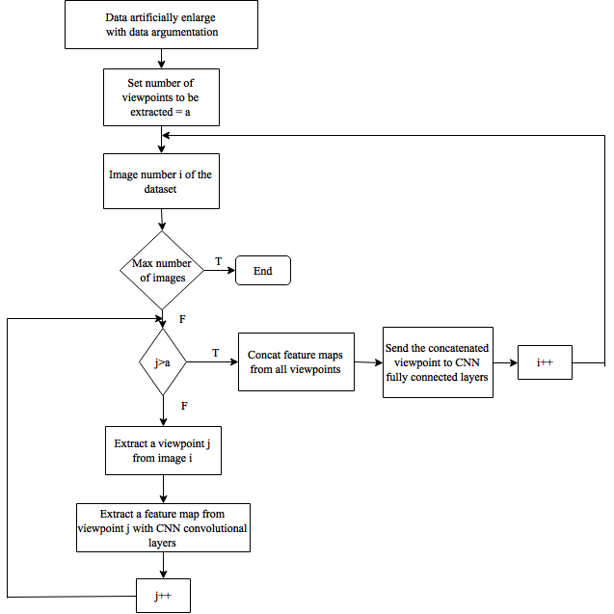

Figure 3.4-2 Flowchart describing the use of viewpoint extraction in constructing a CNN

By theory, viewpoints extraction allows the CNN to ‘look at’ each input image at different perspectives. Thus, exploiting viewpoints extraction in constructing a model should improve its accuracy. To test this theory, we will build our models both with and without viewpoints. We will also try to increase n in order to see whether it will increase the accuracy.

# **Experimental designs**

### **Strategy for organizing training and testing set**

Before building any model, we will need to divide the given dataset into training and testing sets. We will use the ‘hold out’ strategy because it is the most popular and easy to implement. We will follow the traditional 2/3 to 1/3 proportion for training versus testing data.

### **Data segregation strategy**

It is uncertain whether models trained with datasets segregated by different growing seasons will have better accuracy than a single model trained with the entire dataset. We will begin by building one model for the entire dataset. However, if we have a big enough amount of data on each growing seasons and if time allows, we will also try to develop a model for each season.

### **Network architecture**

After choosing an appropriate framework, we will begin to experiment different CNN architectures. We will start with the CNN architecture suggested by the classic article by Krizvevsky et al. (2012). It consists of 8 trainable layers. There are 5 convolutional layers, all of them have square filters with size 11,5,3,3,3 respectively. The first, second and fifth convolutional layers are followed by an overlap 3 by 3 max pooling layer with stride 2. The feature maps from the last max pooling layer are then processed by three fully connected layers. The results from the final fully connected layer are fed to a softmax function, which will produce a prediction over the three classes. [1]

Next, we will modify this architecture by adjusting different levels of independent variables and see whether any of these adjustments will help increase the accuracy.

The simplest adjustment is the size of input images. Krizvevsky et al. (2012) uses square input images of size 224. Larger input images would cost the CNN more training time. In our case, we would like to know the input images size that generates the best accuracy with an optimal amount of time.

The size of the filters and the use of overlap pooling are probably the two least time consuming adjustment because they do not considerably expand the size of a model. However, previous experiments have shown that it is not always the case that they will affect the accuracy. In this experiment, we will first test whether the use of overlap pooling will increase the accuracy. We will then adjust each filter size up to 2 by 2 pixels difference from the original to test whether they have some significant effects to the accuracy.

According to Aaron et al. (2015), viewpoint extraction would increase the accuracy. Nevertheless, viewpoints extraction increases the number of input images and the number of convolutional layers, max pooling layers and ReLU layers by n times, where n is the number of viewpoints extracted [2]. We would like to experiment with viewpoint extraction on our problem to see whether it will improve the prediction capability of a model. We will start by extracting two view points and gradually increase it according to the available time. Because viewpoint extraction is extremely costly to do, we will only continue using it if we see a significant improvement on the accuracy.

Increasing the number of layers of each type would potentially increase the accuracy. However, it will take more time to train a CNN with more layers. We will gradually increase the number of convolutional layers according to the time we have. Since it costs us less time train a network with fewer layers, we would also like to decrease the number of layers of each type and see if it will improve or at least not reduce the accuracy.

Table 3.5‑1 summaries the potential testing values for different factors in our experiment. We will then adjust the experiment in the direction where we see improvement on the accuracy.

|  |  |  |  |
| --- | --- | --- | --- |
| Input image size | Convolutional layer | Max pooling layer | Viewpoints extraction |
| 224 | Number of layers = 5  Sizes = 11,5,3,3,3 | Size = 3 x 3  Stride = 2  Follow the , and convolutional layer | No |
| 224 | Number of layers = 5  Sizes = 11,5,3,3,3 | Size = 2 x 2  Stride = 2  Follow the , and convolutional layer | No |
| 224 | Number of layers = 5  Sizes = 11,5,3,3,3 | Size = 3 x 3  Stride = 2  Follow the , and convolutional layer | Extract 2 viewpoints |
| 224 | Number of layers = 5  Sizes = 11,5,3,3,3 | Size = 3 x 3  Stride = 2  Follow the , and convolutional layer | Extract 3 viewpoints |
| 224 | Number of layers = 4  Sizes = 11,5,3,3 | Size = 3 x 3  Stride = 2  Follow the , and convolutional layer | No |
| 224 | Number of layers = 6  Sizes = 11,5,3,3,3,3 | Size = 3 x 3  Stride = 2  Follow the , and 6 convolutional layer | No |
| 500 | Number of layers = 5  Sizes = 11,5,3,3,3 | Size = 3 x 3  Stride = 2  Follow the , and convolutional layer | No |

Table 3.5‑1 A summary of testing values for different factors

### **Results evaluation**

In order to evaluate the results, we will calculate the accuracy and the error rate of each model. We will compare the predictions made by a model with the original label of each input image. The accuracy is the percentage of correct prediction over the total number of input images. The error rate is the one minus the accuracy.

For debugging purpose, we will print out both the input label and the label predicted by a model for each input images. An input label and a predicted label at any corresponding position will refer to the same input image.

Below is an example of the actual labels for a batch of three images.

[0 0 1

1 0 0

0 1 0]

Each line contains labelling information for one image. Each digit in a line represents one class. The first digit represents class ‘poor’, the second represents class ‘medium’ and the last represents class ‘good’. When the digit is ‘1’, the class that it refers to is *on*, otherwise it is *off*.Hence in the example above, the first image is good quality, the second is poor quality and the third is medium.

The predicted labels are represented in the same fashion with that of the actual labels. Let’s suppose that our model predicts the labels for the same batch of images as follows:

[0 0 1

0 1 0

0 0 1]

We can interpret from the data in the above example the following. The actual label for the first image in the batch is ‘good’ and it is also correctly classified by the model as ‘good’. The actual label for the second image in the batch is ‘poor’ but it is misclassified by the model as ‘medium’. And the actual label for the last image in the batch is ‘medium’ but it is misclassified by the model as ‘good’.

# **Chapter 4**

# **Results and Discussion**

## Frameworks

### **Tensorflow**

We were able to install CPU mode Tensorflow with the commands shown in figure 4.1-1:

sudo chown -R $USER /usr/local/lib/python2.7/

pip uninstall protobuf

pip uninstall tensorflow

brew uninstall protobuf

export TF_BINARY_URL=https://storage.googleapis.com/tensorflow/mac/tensorflow-0.9.0-py2-none-any.whl

pip install --upgrade $TF_BINARY_URL

Figure 0‑1

Figure 4.1‑1 Commands for installing Tensorflow in MacOS

Tensorflow, in general, has a good documentation that is well organized and easy to understand. The installation steps are neat. Tutorial and sample codes are widely available on the Internet. Data argumentation can be performed very easily with Tensorflow. The biggest disadvantage of Tensorflow would be its compute time. When computing with one CPU, it took many hours longer for Tensorflow to process the same size training data set with the same number of iterations as Torch.

### **Caffe**

Caffe has many dependency packages, including *CUDA, Blas, Boost, OpenCV, cuDNN, snappy, leveldb, gflags, glog, szip, lmdb*. There was no single command to install Caffe. We had to install each package individually. Because the packages were installed separately, some were located at unexpected places in the computer. This led to the failure of the Caffe *make* command since it could not locate some of the required libraries that existed somewhere in the code.

The versions of some packages were not compatible with that of another. In our case, CUDA 8.0 was not supported by Xcode 8 so we had to downgrade it to Xcode 7. Caffe documentation did not provide these information, we had to look for it in CUDA documentation.

The installation pipe was broken. We had to modify some codes according to the instructions in their documentation in order to be able to execute it.

The documentation was not very useful and hard to understand. We followed what it said but we could not find out how to install Caffe.

### **Torch**

Since we could not install Caffe, we decided to try an another framework which is also popular – Torch. We decided to try Torch because it is used by the Facebook people. We were able to install CPU mode Torch with the commands shown in figure 4.1-2:

Figure 4.1‑2 Commands for installing Torch in MacOS

git clone https://github.com/torch/distro.git ~/torch --recursive

cd ~/torch; bash install-deps;

/install.sh

echo ". /Users/phuongpham/torch/install/bin/torch-activate" > ~/.profile

source ~/.profile

The installation of Torch is very simple. The compute time is very fast compared to Tensorflow and the error messages are overall useful. It is also very easy to change the values of different parameters in a Torch model. Torch requires us to write less code to achieve the same thing we want to do in comparison with Tensorflow.

The biggest weakness of Torch is that it uses Lua as an API language. This is a not very popular programming language. Therefore, the learning curve is low as it is very hard to find example codes and tutorials from the Internet. However, this framework is still worth considering because we are not required to write a lot of lua code.

## Some conclusions

With Tensorflow, we got the accuracies varied a lot with different runs (from 0.25 to 70%). We suspect is because the number of images we currently have are too little for deep learning algorithms, since the model we tried was claimed to perform well on the Galaxy dataset [2].

We have not made a decision on which framework to use. Torch is probably a good framework since it is very easy to install and use. The only problem with Torch is we have not figured out how to perform data augmentation with it. Tensorflow is also easy to install but less easy to modify the parameters. Plus, it takes Tensorflow longer to process our images. Finally, Caffe theoretically is an ideal choose because it is a specialized framework for CNN. However, we had a lot of trouble when we tried to install it on MacOS. Since the HPC server is Linux-based, we plan to give Caffe another try. If we still cannot install Caffe on the server, we will consider using Torch.

# **Preliminary results**

We did not have the authorization to access to the KMUTT Innosoft high performance computing service until October 27th 2016. In the meantime, we had done some experiments with some frameworks on CPU mode on MacOS in order to evaluate their usability.

## The example dataset

We did not receive the full dataset until November 9th 2016. Therefore, all of the experiments for evaluating the frameworks were conducted with the example dataset which we had got earlier. It consists of 31 ground level images of types png and jpg. They are segregated by the sugarcane age into four categories: 1-3 months, 4-6 months, 7-9 months and 10-12 months. Each category contains sample sugarcane images of different qualities: poor, medium and good. Each image is labeled according to the quality of the field which it shows.

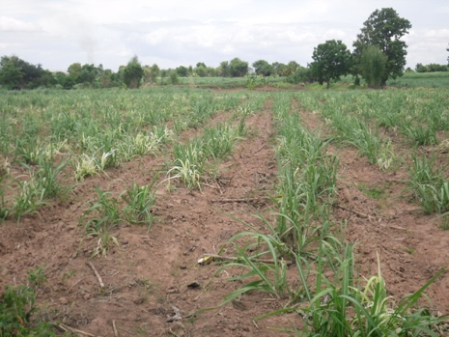 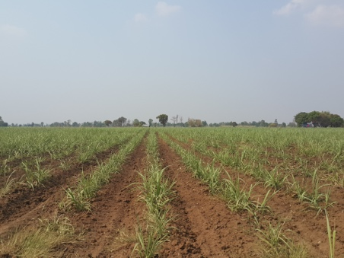 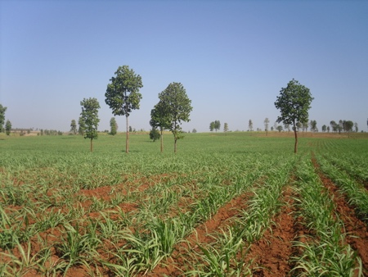

Figure 4.2‑1 From left to right: Images of poor , medium and good sugarcane from 1-3 months.

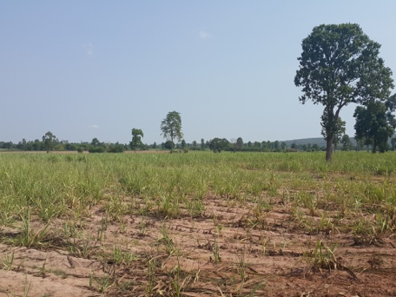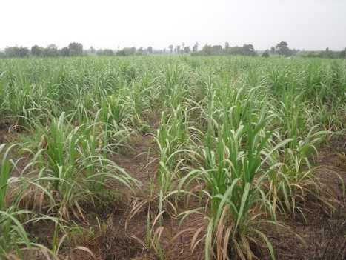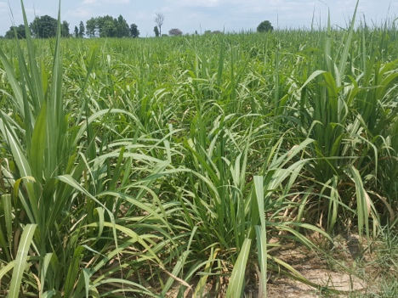

Figure 4.2‑2 From left to right: Images of poor , medium and good sugarcane from 4-6 months.

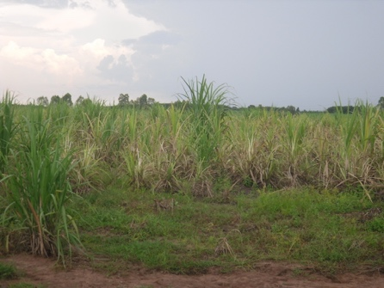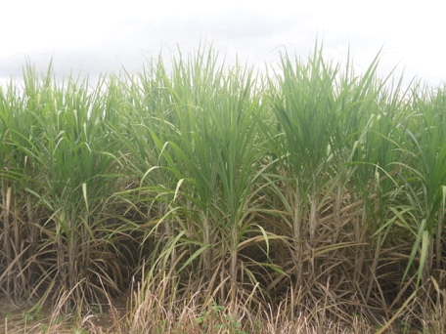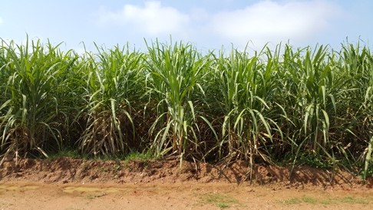

Figure 4.2‑3 From left to right: Images of poor , medium and good sugarcane from 7-9 months.

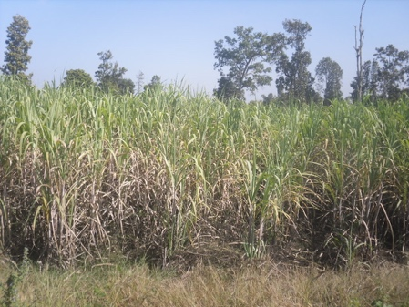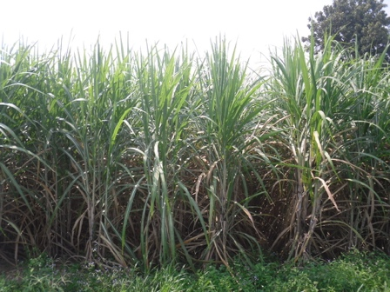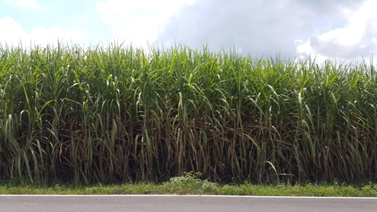

Figure 4.2‑4 From left to right: Images of poor , medium and good sugarcane from 10-12 months.

## Training

We have tried to rebuild the model proposed by S. Dieleman et al. [2] for our example dataset using each framework. The summary of this model is as shown in table 4.1-1:

|  |  |  |  |  |
| --- | --- | --- | --- | --- |
| Type | # features | filter size | Non-linearity | Max pooling |
| Convolutional | 32 | 6 x 6 | ReLU | Yes |
| Convolutional | 64 | 5 x 5 | ReLU | No |
| Convolutional | 128 | 3 x 3 | ReLU | Yes |
| Convolutional | 128 | 3 x 3 | ReLU | Yes |
| Fully connected | 2048 |  | Maxout |  |
| Fully connected | 2048 |  | Maxout |  |
| Fully connected | 3 |  | Maxout |  |

Table 4.2‑1 The summary of the model we are going to use to test the frameworks

A network for each framework was built as follows. First, a batch of *n* images was randomly picked from the training set. Next, we set the network to iterate 5 times on each batch. Each iteration consisted of n cycles of propagation and back-propagation operating on n images in the batch. At every cycle, the weights were adapted in order to reduce the error rate of the networks. Below are the screenshots of the results for the experiment with Torch and Tensorflow.

For the experiment with Torch, we tried to print out the improvement of the training error, as shown in figure 4.1-5. The training error is the summation of error at each output neuron. The error at each neuron is a function of difference between the actual value of that neuron pre-labeled in the training set and the value predicted by the neural networks. Thus the larger the error, the poorer the model performs. Details about training error can be found in Section 2.4.2.

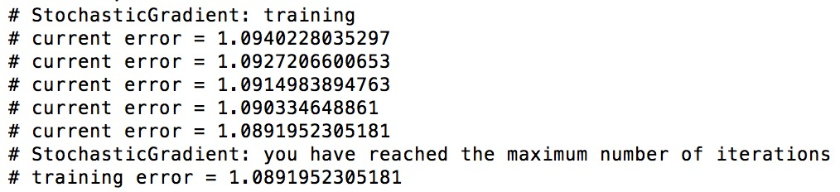

Figure 4.2‑5 Improvement of the error rate with Torch

Next, we tried to observe how the model uses the trained model to make predictions on the testing dataset. The real labels of the testing dataset are shown in figure 4.1-6. Label 1 represents good quality, label 2 represents medium quality and label 3 represent poor quality.

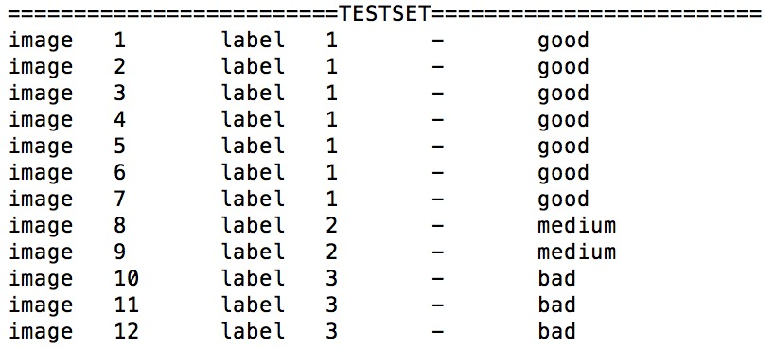

Figure 4.2‑6 True labels for the images in testing set

The prediction made by the model is shown in figure 4.1-7. There are 12 images in the testing set. For each image, we printed out the prediction made by the model for each class. The image belonged to the class which raised the highest value. It took about 40 seconds to train a model with 24 images using Torch.

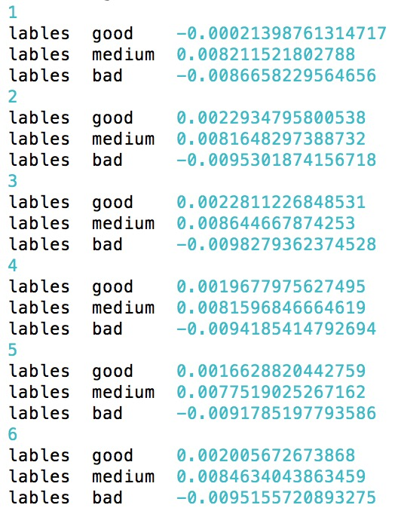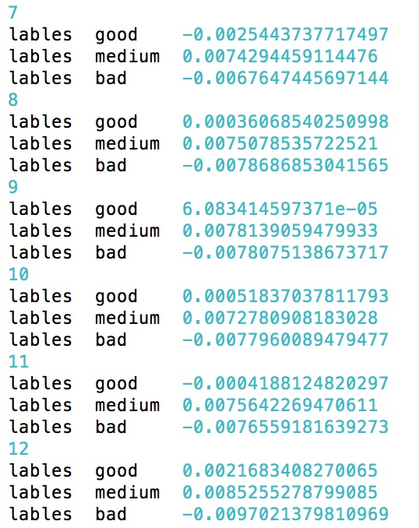

Figure 4.2‑7 Prediction made to the testing set by the trained model

It is obvious that the predictions are not at all adequate. However, the training used only a handful of images.

For the experiment with Tensorflow, we tried to print out the *training accuracy* for each iteration, as shown in figure 4.1-8. The training accuracy is the percentage of the number of correctly classified images over the total number of images in each training batch. It took Tensorflow 7 minutes to train a model with 24 images.

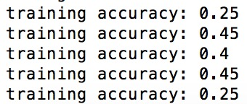

Figure 4.2‑8 Testing accuracies with tensorflow

We got some errors when trying to use the trained model on the test dataset and have not yet been able to fix it.

# **Experimental results**

## Input images investigation

To understand the effect image processing may have on the accuracy, we train the same convolutional neural networks with different sets of input images. Table 4.3‑1shows the configuration of the CNN (the Lenet 1) we used for investigating a variation of input images .

|  |  |  |
| --- | --- | --- |
| Type | Patch size/ Stride | #Output channels |
| Convolution (1) | 5x5/1 | 16 |
| ReLU (1) | Used | 16 |
| Max pool (1) | 2x2/2 | 16 |
| Convolution (2) | 5x5/1 | 20 |
| ReLU (2) | Used | 20 |
| Max pool (2) | 2x2/2 | 20 |
| FC (1) | 120 neurons | Flatten |
| FC (2) | 84 neurons | Flatten |
| FC (3) | 3 output classes | Flatten |

Table 4.3‑1 Lenet 1

Table 4.3‑2 summaries the variations of image preprocessing techniques we used to create different sets of input images and their corresponding accuracies. The changed values are highlighted in red.

|  |  |  |  |  |  |  |  |  |  |  |
| --- | --- | --- | --- | --- | --- | --- | --- | --- | --- | --- |
| Model no. | Input size | Trainset | Testset | i | Learning rate | %TP Good | %TP Avg | %TP Poor | Train time (min) | Accuracy |
|  | **Class Good//Medium//Poor** | **Class Good//Medium//Poor** |  |  |  |  |  |  |  |
| 1 | 32x32 | Original//Original//Original | Original//Original//Original | 5 | 0.001 | 38 | 13.1 | 0 | 0.2 | 51.11 |
| 2a | 32x32 | Original//Original//Original & 200x200 pixels center crop & 200x200 pixels bottom left crop & 200x200 pixels bottom right crop | Original//Original//Original & 200x200 pixels center crop & 200x200 pixels bottom left crop & 200x200 pixels bottom right crop | 10 | 0.001 | 34.44 | 2.05 | 17.17 | 0.33 | 53.67 |
| 2b | 32x32 | Original//Original/Original & 200x200 pixels center crop & 200x200 pixels bottom left crop & 200x200 pixels bottom right crop | Original//Original//Original & 200x200 pixels center crop & 200x200 pixels bottom left crop & 200x200 pixels bottom right crop | 10 | 0.005 | 9.61 | 28.61 | 16.63 | 0.46 | 54.85 |
| 2c | 32x32 | Original//Original//Original & 200x200 pixels center crop & 200x200 pixels bottom left crop & 200x200 pixels bottom right crop (3 batches) | Original//Original//Original & 200x200 pixels center crop & 200x200 pixels bottom left crop & 200x200 pixels bottom right crop | 10 | 0.005 | 2.80 | 26.67 | 16.84 | 2.33 | 46.32 |
| 2d | 32x32 | Original//Original/Original & 128x128 pixels center crop & 128x128 pixels bottom left crop & 128x128 pixels bottom right crop | Original//Original//Original & 128x128 pixels center crop & 128x128 pixels bottom left crop & 128x128 pixels bottom right crop | 10 | 0.005 | 21.16 | 11.77 | 20.62 | 0.48 | 53.56 |
| 3 | 32x32 | 200x200 pixels center crop//200x200 pixels center crop//Original & 200x200 pixels center crop & 200x200 pixels bottom left crop & 200x200 pixels bottom right crop | 200x200 pixels center crop//200x200 pixels center crop//Original & 200x200 pixels center crop & 200x200 pixels bottom left crop & 200x200 pixels bottom right crop | 10 | 0.005 | 35.74 | 6.8 | 7.12 | 0.46 | 49.67 |
| 4a | 32x32 | Original//200x200 pixels center crop//Original & 200x200 pixels center crop & 200x200 pixels bottom left crop & 200x200 pixels bottom right crop | Original// Original 35%, 200x200 pixels center crop 65%//Original & 200x200 pixels center crop & 200x200 pixels bottom left crop & 200x200 pixels bottom right crop | 20 | 0.005 | 36.60 | 20.84 | 12.63 | 0.46 | 70.08 |
| 4b | 32x32 | Original//200x200 pixels center crop//Original & 200x200 pixels center crop & 200x200 pixels bottom left crop & 200x200 pixels bottom right crop | Original//Original 35% & 200x200 pixels center crop 65%//Original & 200x200 pixels center crop & 200x200 pixels bottom left crop & 200x200 pixels bottom right crop | 1000 | 0.0015 | 37.25 | 19.33 | 13.39 | 32 | 69.97 |
| 5a | 32x32 | Original//Original//N.A | Original//Original//N.A | 10 | 0.005 | 37.51 | 20.31 | N/A | 0.68 | 57.82 |
| 5b | 32x32 | Original & 200x200 pixels bottom left crop & 200x200 pixels bottom right crop // Original & 200x200 pixels bottom left crop & 200x200 pixels bottom right crop //N.A | Original//Original//N.A | 15 | 0.005 | 36.67 | 23.83 | N/A | 1.03 | 60.50 |
| 5c | 32x32 | Original & 200x200 pixels center crop & 200x200 pixels bottom left crop & 200x200 pixels bottom right crop // Original & 200x200 pixels center crop & 200x200 pixels bottom left crop & 200x200 pixels bottom right crop //N.A | Original//Original//N.A | 15 | 0.005 | 36.38 | 22.99 | N/A | 1.68 | 59.37 |
| 5c | 32x32 | Original & 200x200 pixels center crop & 200x200 pixels bottom left crop & 200x200 pixels bottom right crop // Original & 200x200 pixels center crop & 200x200 pixels bottom left crop & 200x200 pixels bottom right crop //N.A | Original & 200x200 pixels center crop & 200x200 pixels bottom left crop & 200x200 pixels bottom right crop // Original & 200x200 pixels center crop & 200x200 pixels bottom left crop & 200x200 pixels bottom right crop // N.A | 15 | 0.005 |  |  |  |  |  |
| 5c | 32x32 | Original & 200x200 pixels center crop & 200x200 pixels bottom left crop & 200x200 pixels bottom right crop // Original & 200x200 pixels center crop & 200x200 pixels bottom left crop & 200x200 pixels bottom right crop //N.A | 200x200 pixels center crop & 200x200 pixels bottom left crop & 200x200 pixels bottom right crop // 200x200 pixels center crop & 200x200 pixels bottom left crop & 200x200 pixels bottom right crop //N.A | 15 | 0.005 |  |  |  |  |  |
| 5c | 128x128 | Original & 200x200 pixels center crop & 200x200 pixels bottom left crop & 200x200 pixels bottom right crop // Original & 200x200 pixels center crop & 200x200 pixels bottom left crop & 200x200 pixels bottom right crop //N.A | Original//Original//N.A | 15 | 0.005 |  |  |  |  |  |
| 5c | 128x128 | Original & 200x200 pixels center crop & 200x200 pixels bottom left crop & 200x200 pixels bottom right crop // Original & 200x200 pixels center crop & 200x200 pixels bottom left crop & 200x200 pixels bottom right crop //N.A | 200x200 pixels center crop & 200x200 pixels bottom left crop & 200x200 pixels bottom right crop // 200x200 pixels center crop & 200x200 pixels bottom left crop & 200x200 pixels bottom right crop //N.A | 15 | 0.005 |  |  |  |  |  |
| 5c | 128x128 | Original & 200x200 pixels center crop & 200x200 pixels bottom left crop & 200x200 pixels bottom right crop // Original & 200x200 pixels center crop & 200x200 pixels bottom left crop & 200x200 pixels bottom right crop //N.A | Original & 200x200 pixels center crop & 200x200 pixels bottom left crop & 200x200 pixels bottom right crop // Original & 200x200 pixels center crop & 200x200 pixels bottom left crop & 200x200 pixels bottom right crop // N.A | 15 | 0.005 |  |  |  |  |  |
| 6a | 32x32 | Original & 200x200 pixels center crop & 200x200 pixels bottom left crop & 200x200 pixels bottom right crop // Original & 200x200 pixels center crop & 200x200 pixels bottom left crop & 200x200 pixels bottom right crop // Original & 200x200 pixels center crop & 200x200 pixels bottom left crop & 200x200 pixels bottom right crop | Original//Original//Original | 15 | 0.005 |  |  |  |  |  |
| 6b | 32x32 | Original & 200x200 pixels center crop & 200x200 pixels bottom left crop & 200x200 pixels bottom right crop // Original & 200x200 pixels center crop & 200x200 pixels bottom left crop & 200x200 pixels bottom right crop // Original & 200x200 pixels center crop & 200x200 pixels bottom left crop & 200x200 pixels bottom right crop | 200x200 pixels center crop & 200x200 pixels bottom left crop & 200x200 pixels bottom right crop // 200x200 pixels center crop & 200x200 pixels bottom left crop & 200x200 pixels bottom right crop //200x200 pixels center crop & 200x200 pixels bottom left crop & 200x200 pixels bottom right crop | 15 | 0.005 |  |  |  |  |  |
| 6c | 32x32 | 200x200 pixels center crop & 200x200 pixels bottom left crop & 200x200 pixels bottom right crop // 200x200 pixels center crop & 200x200 pixels bottom left crop & 200x200 pixels bottom right crop // Original & 200x200 pixels center crop & 200x200 pixels bottom left crop & 200x200 pixels bottom right crop | Original & 200x200 pixels center crop & 200x200 pixels bottom left crop & 200x200 pixels bottom right crop // Original & 200x200 pixels center crop & 200x200 pixels bottom left crop & 200x200 pixels bottom right crop // Original & 200x200 pixels center crop & 200x200 pixels bottom left crop & 200x200 pixels bottom right crop | 15 | 0.005 |  |  |  |  |  |
| 6e | 128x128 | Original & 200x200 pixels center crop & 200x200 pixels bottom left crop & 200x200 pixels bottom right crop // Original & 200x200 pixels center crop & 200x200 pixels bottom left crop & 200x200 pixels bottom right crop // Original & 200x200 pixels center crop & 200x200 pixels bottom left crop & 200x200 pixels bottom right crop | Original//Original//Original | 15 | 0.005 |  |  |  |  |  |
| 6f | 128x128 | Original & 200x200 pixels center crop & 200x200 pixels bottom left crop & 200x200 pixels bottom right crop // Original & 200x200 pixels center crop & 200x200 pixels bottom left crop & 200x200 pixels bottom right crop // Original & 200x200 pixels center crop & 200x200 pixels bottom left crop & 200x200 pixels bottom right crop | 200x200 pixels center crop & 200x200 pixels bottom left crop & 200x200 pixels bottom right crop // 200x200 pixels center crop & 200x200 pixels bottom left crop & 200x200 pixels bottom right crop //200x200 pixels center crop & 200x200 pixels bottom left crop & 200x200 pixels bottom right crop | 15 | 0.005 |  |  |  |  |  |
| 6g | 128x128 | 200x200 pixels center crop & 200x200 pixels bottom left crop & 200x200 pixels bottom right crop // 200x200 pixels center crop & 200x200 pixels bottom left crop & 200x200 pixels bottom right crop // Original & 200x200 pixels center crop & 200x200 pixels bottom left crop & 200x200 pixels bottom right crop | Original & 200x200 pixels center crop & 200x200 pixels bottom left crop & 200x200 pixels bottom right crop // Original & 200x200 pixels center crop & 200x200 pixels bottom left crop & 200x200 pixels bottom right crop // Original & 200x200 pixels center crop & 200x200 pixels bottom left crop & 200x200 pixels bottom right crop | 15 | 0.005 |  |  |  |  |  |
| 7 | 128x128 | Original//128x128 pixels center crop//Original & 128x128 pixels center crop & 128x128 pixels bottom left crop & 128x128 pixels bottom right crop | Original//Original 35% & 128x128 pixels center crop 65%//Original & 128x128 pixels center crop & 128x128 pixels bottom left crop & 128x128 pixels bottom right crop | 10 | 0.005 | 33.90 | 18.14 | 10.47 | 2.5 | 62.52 |

Table 4.3‑2 The summary of the image preprocessing variations

### **Input image organization and the learning rate**

We started by training the CNN with the raw images resized into 32x32 with learning rate equals to 0.001 using both the CPU and the GPU (experiment 1a and 1b). It took the CPU 20 minutes to finish the execution, while it took the GPU only roughly 2.5 seconds to complete the same task. The resulting accuracy was 51.11% with 38.00% of the true positives resides in class “good”, 13.10% in class “medium” and 0% in class “poor”. The result indicated that the networks were able to tell the difference between the first two classes, but it was not able to distinguish the third one from the rest. This suggested that the amount of images from class ‘bad’ was probably too small and not proportionally equal to the other two, and therefore should be increased somehow.

We then artificially increased the number of images in the class “poor” by cropping 3 extra pieces out of each original image in this category (experiment 2a). The cropped positions of these pieces are respectively the center, the bottom left and the bottom right of the original image, each of size 200x200. We trained the networks with this new data set using the same specifications from experiment 1. The resulting accuracy was 53.67% with 34.44% of the true positives resides in class “good”, 2.05% in class “medium” and 17.17% in class “poor”.

In experiment 2b, we tried to increase the learning rate to 0.005. The resulting accuracy slightly increased to 54.85% with 9.61% of the true positives resides in class “good”, 28.61% in class “medium” and 16.63% in class “poor”. This suggested that the higher the learning rate, the less number of iterations the CNN takes to learn.

In the next experiment, we tried to split the training set into 3 batches, each consists of 600 images. We trained the networks 20 times on each batch. However, it was not a good approach to this problem as it made the accuracy went down to 46.32% with 2.80% in class “good”, 26.67% in class “medium” and 16.84% in class “poor”.

We also tried to decrease the cropping size from 200x200 to 128x128 (experiment 2d). The reason we chose to do this was because we wanted to scale down the cropped image to 32x32 pixels. Therefore, we wanted a cropping size which was a multiple of 3. We in fact began with a bigger cropping size which is 224x224. However, since some images in the dataset were smaller than this size, we had to use a smaller one. The resulting accuracy for this experiment was 53.56% with 21.16% in class “good”, 11.77% in class “medium” and 20.62% in class “poor”.

In experiment 3, we tried to improve the result by improving the quality of the input images. Specifically, we cropped 200x200 pixels at the center of each image in these category and used them as the input images to train the lenet 1. Unfortunately, this made the resulting accuracy went down to 49.67% with 35.74% of the true positives resides in class “good”, 6.80% in class “medium” and 7.12% in class “poor”.

We observed from experiment 3 that the %TP of class “medium” was low. Therefore, in experiment 4a, we tried to emphasize the learning of the networks on the class “medium”: we slightly modify the input sets from experiment 3 by replacing the cropped images in class “good” by the raw image. The resulting accuracy went up to 70.08% with 36.60 % of the true positives resides in class “good”, 20.84% in class “medium” and 12.63% in class “poor”.

### **The number of iterations**

In experiment 4b, we decreased the learning rate to 0.0015 and increased the number of iterations to 1000 (the lower the learning rate, the more iterations the CNN takes to learn). The resulting accuracy increased to 69.97% with 37.25% of the true positives resides in class “good”, 19.33% in class “medium” and 13.39% in class “poor”.

### **The elimination of class “poor”**

We also conducted three extra experiments where we removed class “poor” from the input dataset. In the first experiment (experiment 5a), we trained the networks using the raw images from both class “good” and class “medium”, all of which were resized to 32x32. The resulting accuracy for this experiment was 57.82% with 37.51% of the true positives resides in class “good” and 20.31% in class “medium”. In the second experiment (experiment 5b), we trained the networks using both orginal and data augmented images from class “good” and class “medium” as specified in table 4.3-3, all of which were resized to 32x32. The slightly increased to 60.50% with 36.67% of the true positives resides in class “good” and 23.83% in class “medium”. In the third experiment (experiment 5c), we added more data to the training set using data augmentation. However, this made accuracy decreased to 59.37% with 36.38% in class “good” and 22.99% in class “medium”.

### **Input image size**

In experiment 6, we increased the size of the input images to 128x128. The resulting accuracy decreases to 62.52 % with 33.90 % of the true positives resides in class in class “good”, 18.14% in class “medium” and 10.47% in class “poor”.

### **Some conclusions**

The experiments show that the image preprocessing and data augmentation can have a direct effect to the accuracy. The best network performance in classifying sugarcane images into the three classes was 70.08% with Lenet 1 (described in table 4.3‑2)applying on a size 32x32 input set. This set composes of raw images in class “good”, images cropped at the center into 200x200 pixels in class “medium” and artificially enlarged set of images in class “poor” (as described in Section 4.3.1.1). Even though the accuracy is relatively high, it is not an ideal result because the network is only able to perform well on a testing set containing a mixed proportion of original and cropped images in class “medium” and class “poor”. In reality, sometimes the same shoot is taken by different people at different perspectives. However, considering that the aforementioned scenario is not always true and that the model still does not perform well on classifying original images, we think this model is still not optimal.

The best network performance in classifying sugarcane images into the two classes “good” and “medium” was 60.5% with Lenet 1 applying on a size 32x32 input set. This set composes of orginal and data augmented images from class “good” and “medium”. Though this model has a lower accuracy, it is better because it can classify original images.

The experiments also show that choosing the correct learning rate is important. A networks with low learning rate takes longer time to train than one with high learning rate. However, a too high learning rate can prevent the networks from learning, as demonstrated by experiment 1a and 1b.

In experiment 5a, 5b and 5c, we omitted the images from class “poor”. However, the predicting result was still not very good. In experiment 5c, we added more images to the training set by cropping 200 x 200 pixels at the center of the original images, but this did not make the accuracy improve. We think this is because the images from these two classes do not contain enough distinguish information for the networks to classify.

Next, the experiment suggests that increasing the number of iterations actually made the accuracy decrease. From experiment 4a to 4b, we increased the the number of iterations further by 980, and it decreased the accuracy. We suspect this is a problem of over fitting: the model was trained 1000 times on the same data, thus it adapted itself to fit only that particular data.

Finally, as illustrated by experiment 4b and 6, it is actually better to use an input image with a smaller size. An extra benefit when using smaller input images is that they take less training time.

## Networks configuration

To understand the effect that networks configuration can have on the accuracy, we experimented some of the preprocessed datasets with some more models which were modifications of the Lenet 1. Models 7a to 13b were trained using data from experiment 2a and model 13c were trained using data from experiment 4b. The models were training using the learning rate equals to 0.005. The modifications of the networks were obtained by varying the convolutional layers, the pooling layers, the fully connected layers and the use of dropout as shown in table 4.4-1. Details of the modifications will be discussed in Section 4.4.1, 4.4.2, 4.4.3, 4.4.4, 4.4.5 and 4.4.6.

|  |  |  |  |  |  |  |  |  |  |  |  |
| --- | --- | --- | --- | --- | --- | --- | --- | --- | --- | --- | --- |
| No | Image size | Trainset | Testset | Network component | New value | New %TP Good | New %TP Avg | New %TP Poor | i | Time (min) | New accuracy |
|  |  | **Class Good//Medium//Poor** | **Class Good//Medium//Poor** |  |  |  |  |  |  |  |  |
| 7a | 32x32 | Original//Original//Original & 200x200 pixels center crop & 200x200 pixels bottom left crop & 200x200 pixels bottom right crop | Original//Original//Original & 200x200 pixels center crop & 200x200 pixels bottom left crop & 200x200 pixels bottom right crop | #Conv layers | 4 | 23.32 | 17.92 | 16.73 | 15 | 0.53 | 57.99 |
| 7b | 32x32 | (as above) | (as above) | #Conv layers | 6 | 7.45 | 28.61 | 16.52 | 15 | 0.58 | 52.59 |
| 8a | 32x32 | (as above) | (as above) | Kernel size of conv layer | 7x7 | 34.23 | 8.85 | 16.73 | 15 | 0.56 | 59.82 |
| 8b | 32x32 | (as above) | (as above) | Kernel size of conv layer | 3x3 | 23.86 | 16.41 | 16.95 | 15 | 0.46 | 57.23 |
| 9a | 32x32 | (as above) | (as above) | Pooling technique | N/A | 23.65 | 19.00 | 16.73 | 15 | 0.43 | 59.39 |
| 9b | 32x32 | (as above) | (as above) | Pooling technique | Overlap max pooling | 32.28 | 11.87 | 15.98 | 15 | 0.5 | 60.15 |
| 10 | 32x32 | (as above) | (as above) | Kernel size of pool layer | Max pooling//kernel size = 3x3 | 25.48 | 16.95 | 16.41 | 15 | 0.5 | 58.85 |
| 11a | 32x32 | (as above) | (as above) | #of FC layers | 5 | 38.76 | 3.45 | 15.44 | 15 | 0.88 | 57.66 |
| 11b | 32x32 | (as above) | (as above) | #of FC layers | 1 | 23.43 | 21.38 | 11.55 | 15 | 0.4 | 56.37 |
| 11c | 32x32 | (as above) | (as above) | #neuron at FC layers | FC1 = 2084; FC2 = 2084; FC3 = 3 | 29.26 | 15.65 | 16.30 | 15 | 0.62 | 61.23 |
| 12 | 32x32 | (as above) | (as above) | #Output channels; #FC layer | Conv1:16🡪20  Conv2: 20🡪50  #FC: 3🡪2 | 28.40 | 20.51 | 15.55 | 15 | 0.46 | 64.47 |
| 13a | 32x32 | (as above) | (as above) | Dropout | Drop out prob. = 0.05 | 33.80 | 9.17 | 16.63 | 15 | 0.5 | 59.82 |
| 13b | 32x32 | (as above) | (as above) | #Output channels; #FC layer; Dropout | Conv1:16🡪20  Conv2: 20🡪50  #FC: 3🡪2; Drop out prob. = 0.05 | 30.12 | 15.01 | 16.63 | 15 | 0.6 | 61.66 |
| 13c | 32x32 | Original//200x200 pixels center crop//Original & 200x200 pixels center crop & 200x200 pixels bottom left crop & 200x200 pixels bottom right crop | Original//65% 200x200 pixels center crop & 35% Original//Original & 200x200 pixels center crop & 200x200 pixels bottom left crop & 200x200 pixels bottom right crop | Dropout | Drop out prob. = 0.05 | 39.09 | 21.27 | 8.96 | 20 | 0.46 | 69.43 |

Table 4.3‑3 Modifications of network configuration

### **Convolutional layer**

#### **The number of convolutional layers**

In experiment 7a, we added 2 more convolutional layers to the lenet 1, as shown in table 4.4-2. The resulting accuracy went up (in compare to experiment 2b) to 57.99% with 23.32% of the true positives resides in class “good”, 17.92% in class “medium” and 16.73% in class “poor”.

|  |  |  |
| --- | --- | --- |
| Type | Patch size/ Stride | #Output channels |
| Convolution (1) | 5x5/1 | 16 |
| Tanh | Used | 16 |
| Max pool | 2x2/2 | 16 |
| Convolution (2) | 5x5/1 | 20 |
| Convolution (3) | 3x3/1 | 32 |
| ReLU | Used | 32 |
| Convolution (4) | 3x3/1 | 64 |
| Tanh | Used | 64 |
| Max pool | 2x2/2 | 64 |
| FC (1) | 120 neurons | Flatten |
| FC (2) | 84 neurons | Flatten |
| FC (3) | 3 output classes | Flatten |

Table 4.3‑4 Lenet 1-7a

In experiment 7b, we added 2 more convolutional layers to the lenet 1-7a, as shown in table 4.4-2. The resulting accuracy went down to 52.59% with 7.45% of the true positives resides in class “good”, 28.61% in class “medium” and 16.52% in class “poor”.

|  |  |  |
| --- | --- | --- |
| Type | Patch size/ Stride | #Output channels |
| Convolution (1) | 5x5/1 | 16 |
| Tanh | Used | 16 |
| Max pool | 2x2/2 | 16 |
| Convolution (2) | 5x5/1 | 20 |
| Convolution (3) | 3x3/1 | 32 |
| ReLU | Used | 32 |
| Convolution (4) | 3x3/1 | 50 |
| Convolution (5) | 3x3/1 | 64 |
| Convolution (6) | 2x2/1 | 64 |
| Tanh | Used | 64 |
| Max pool | 2x2/2 | 64 |
| FC (1) | 120 neurons | Flatten |
| FC (2) | 84 neurons | Flatten |
| FC (3) | 3 output classes | Flatten |

Table 4.3‑5 Lenet 1-7b

#### **Kernel size**

In experiment 8a, we increased the kernel size at the convolutional layers to 7x7. The resulting accuracy slightly increase to 59.82% with 34.23% of the true positives resides in class “good”, 8.85% in class “medium” and 16.73% in class “poor”.

In experiment 8b, we decreased the kernel size at the convolutional layers to 3x3. The resulting accuracy decreases to 57.23% with 23.86% of the true positives resides in class “good”, 16.41% in class “medium” and 16.95% in class “poor”.

### **Pooling layer**

#### **The use of max pooling**

Next, we tried to remove the pooling layers from the CNN (experiment 9a). The resulting accuracy increased to 59.39% with 23.65% of the true positives resides in class “good”, 19.00% in class “medium” and 16.73% in class “poor”. Then, we replaced max pooling with overlap max pooling (experiment 9b). The accuracy in this experiment increased a bit further to 60.15% with 32.28% of the true positives resides in class “good”, 11.87% in class “medium” and 15.98% in class “poor”.

#### **Kernel size**

In experiment 10, we modified the kernel size at each pooling layer to 3x3. The increment of the kernel size at pooling layers actually made the resulting accuracy decreased to 58.85% with 25.48% of the true positives resides in class “good”, 16.95% in class “medium” and 16.41% in class “poor”.

### **Fully connected layer**

#### **The number of fully connected layer**

Next, we increased the number of fully connected layers to 5. Details of the new CNN is shown in table 4.4-3. With this configuration, the decreases to 57.66% with 38.76% of the true positives resides in class “good”, 3.45% in class “medium” and 15.44% in class “poor”.

|  |  |  |
| --- | --- | --- |
| Type | Patch size/ Stride | #Output channels |
| Convolution (1) | 5x5/1 | 16 |
| ReLU | Used | 16 |
| Max pool | 2x2/2 | 16 |
| Convolution (2) | 5x5/1 | 20 |
| ReLU | Used | 32 |
| Max pool | 2x2/2 | 64 |
| FC (1) | 2048 neurons | Flatten |
| FC (2) | 2048 neurons | Flatten |
| FC (3) | 120 neurons | Flatten |
| FC (4) | 84 neurons | Flatten |
| FC (5) | 3 output classes | Flatten |

Table 4.3‑6 Lenet 1-11a

Then we decreased the the number of fully connected layers to 1. Details of the new CNN is shown in table 4.4-4. Unfortunately, this configuration made the accuracy decrease further to 56.37% with 23.43% of the true positives resides in class “good”, 21.38% in class “medium” and 11.55% in class “poor”.

|  |  |  |
| --- | --- | --- |
| Type | Patch size/ Stride | #Output channels |
| Convolution (1) | 5x5/1 | 16 |
| ReLU | Used | 16 |
| Max pool | 2x2/2 | 16 |
| Convolution (2) | 5x5/1 | 20 |
| ReLU | Used | 32 |
| Max pool | 2x2/2 | 64 |
| FC (1) | 3 neurons | Flatten |

Table 4.3‑7 Lenet 1-11b

#### **The number of neurons**

We also tried to increase the number of neurons in each fully connected layer of the letnet 1 to 2048. The accuracy increased to 61.23% with 29.26% of the true positives resides in class “good”, 15.65% in class “medium” and 16.30% in class “poor.

### **The number of output channels**

In experiment 12, we tried to increase the number of output channels at each convolutional layer, as shown in table 4.4‑5. This configuration made the accuracy increase to 64.47% with 28.40% of the true positives resides in class “good”, 20.51% in class “medium” and 15.55% in class “poor.

|  |  |  |
| --- | --- | --- |
| Type | Patch size/ Stride | #Output channels |
| Convolution (1) | 5x5/1 | 20 |
| Max pool | 2x2/2 | 20 |
| Convolution (2) | 5x5/1 | 50 |
| Max pool | 2x2/2 | 50 |
| FC (1) | 500 neurons | Flatten |
| ReLU | Used | Flatten |
| FC (2) | 3 neurons | Flatten |

Table 4.3‑8 Lenet 1-12

### **Dropout**

In experiment 13a, we added a dropout in layer 2 with probability equals to 5% to the lenet 1. The accuracy we obtained from this set up was 59.82% with 33.80% of the true positive in class “good”, 9.17% in class “medium” and 16.63% in class “poor”.

In experiment 13b, we added a dropout in layer 2 with probability equals to 5% to the lenet 1-12. The accuracy we obtained from this set up was 61.66% with 30.12% of the true positive in class “good”, 15.01% in class “medium” and 16.63% in class “poor”.

In the last experiment, we trained the lenet 1 with dropout in layer 2 with probability equals to 5% using the data from experiment 4b. At its peak performance, the accuracy reached 69.43% with 39.09 % of the true positives resides in class “good”, 21.27% in class “medium” and 8.96 % in class “poor”.

### **Some conclusions**

Our experiments show the impacts of different network components to the accuracy. From experiments 7a and 7b, we can conclude that increasing the number of convolutional layers does not always improve the predicting capability of the networks; and from experiments 8a and 8b, we can conclude that increasing the kernel size at convolutional layers can improve the predicting accuracy. Experiment 9a, 9b and 10 showed that among all configuration types of pooling layer, the use of overlap pooling will significantly improve the accuracy. Experiment 11a, 11b and 11c suggested that increasing the number of neurons at fully connected layer will also improve the networks. Experiment 12 showed that increasing the number of output channels can significantly increase the accuracy as well. Finally, from experiment 13a, 13b and 13c, we found that implementing our networks with dropout does not improve the accuracy.

# **Chapter 5**

# **Conclusion**

# **Comments on the project**

We had two responses from our advisor and committee during the proposal defense as follows. First, it was recommended we should “consider the effects of age or stage of sugar cane and quality of picture taken at different time and with different devices” (Aj. Suthathip). The matter of the quality of picture taken at different time and with different devices has been targeted at with data argumentation and viewpoints extraction, as discussed in Section 2.7, 3.3. and 3.4. For the matter of the effects of age or stage of sugar cane, it was uncertain whether this would affect the predicting quality of the CNN. Since one of the key success factors of the CNN is the amount of data and since we only have 1700 samples for all growing seasons, we would like to try training the networks with the whole dataset without segregating by seasons first. If the predicting quality is low, we will then try training the networks with the sugarcane images at the most mature stage to see whether there are some improvements. The reason we want use the sugarcane images at the most mature stage is because we think they have gained enough distinguish shape and color to support the feature extraction step. Second was a comment from Aj. Sally: “Overall a really excellent job. I think you really impressed the committee with your knowledge. Your slides had some problems with readability, maybe because you were using a different OS than the one you used to create them. Also, your voice was very loud. Maybe you were nervous!”. We will notice about the issue of the readability of our slides and the loudness of the voice in our next presentation.

We had a response from Aj. Sally in the term 1 proposal defense as follow:

“Good presentation. I thought the animations highlighting different steps in order to clarify the calculations for the convolutional and fully connected layers were very effective.

Some suggestions for you:

1. Do not read your slides. Look at the audience.
2. Spend a bit of time linking specific slides back to the problem. When you are buried deep in the explanation of how CNN works, it is sometimes hard to remember the higher level goals. This is something you can do as you present. It is not needed on the slides.
3. Slow down your speaking a bit. You were speaking very fast, maybe because you were nervous. You should practice your presentation several times so that you feel more relaxed and confident.”

We would like to thank Aj. Sally for the comments. In response to comment 1 and 3, we will do more practices on our presentation in order to make it more professional and comprehensible. In response to comment 2, we will do as suggested for our next presentation slides.

# **Our conclusion**

Our results show that convolutional neural networks is a promising technique for sugarcane health classification. Our best network performance in classifying sugarcane images into the three classes was 70.08%.

The main problem with our result is that our best models are only capable of classifying dataset that consists a mixed proportion of original and cropped images. The biggest challenge for this project are the small and imbalanced dataset, and the high level of similarities among images from different classes. We have only 2281 images in the dataset, where the number of images in class “poor” were only 160. The images between two adjacent classes are quite similar.

The reason we cannot further improve the accuracy is the network is often confused between class “good” and class “medium”. The experiments in this research show that the percentage of true positive in class “good” is often high when the percentage of true positive in class “medium” is low and vice versa. Ultimately, we would like to solve this problem. For the future works on this issue, we suggest that more images, ideally about 10 000 per class, should be obtained in order to build a good CNN model for this problem, since each image contains very little representative information for a class. We also suggest that extra features for each image, such as soil quality and weather condition, should be obtained and used as training data together with the image. These features could then be concatenated with the extracted features from each input image at FC layer for better prediction quality. Finally, we suggest that a server capable of storing updated images from farmers and classifying them automatically being created, for better data manipulation.

# **Reference**

[1] *ImageNet classification with deep convolutional neural networks*. A. Krizhevsky, I. Sutskever, G.E. Hinton. In Advances in Neural Information Processing Systems 25 (NIPS’2012), 2012

[2] *Rotation-invariant convolutional neural networks for galaxy morphology prediction*. S. Dieleman, Kyle W. Willett and Joni Dambre. Mon. Not. R. Astron. Soc. 000, 1–20 (2014).

[3] *Classifying plankton with deep neural networks.* A. van den Oord, Ira Korshunova, Jeroen Burms, Jonas Degrave, Lionel Pigou, Pieter Buteneers. First prize of The National Data Science Bowl competition, March 2015.

[4] *Learning Features and Parts for Fine-Grained Recognition.* Jonathan Krause, Timnit Gebru, Jia Deng, Li-Jia Li, Li Fei-Fei. ICPR, 2014, supported by an ONR MURI grant and the Yahoo! FREP program.

[5] *Food Detection and Recognition Using Convolutional Neural Network.* Hokuto Kagaya, Kiyoharu Aizawa, Makoto Ogawa. MM’14, November 3–7, 2014.

[6] *Comparison of Regularization Methods for ImageNet Classification with Deep Convolutional Neural Networks.* Evgeny A. Smirnov*, Denis M. Timoshenko, Serge N. Andrianov. 2013 2nd AASRI Conference on Computational Intelligence and Bioinformatics

[7] *Draft book in preparation. Deep learning, Jan 2016*. Yoshua Bengio, Ian Goodfellow, and Aaron Courville.

[8] *Data Mining Concepts and Techniques, 3rd edition, 2012.* Jiawei Han & Micheline Kamber.

[9] *Digital Light & Color.* Jonathan Sachs. 1996-1999.

[10] *Digital Image Processing, 2nd edition, 1987.* Rafael C. Gonzalez, Paul Wintz.

[11] *RGB color model.* Wikipedia. <https://en.wikipedia.org/wiki/RGB_color_model>. Accessed 16 Oct 2016.

[12] *Convolutional neural networks for visual recognition.* Stanford University. <http://cs231n.stanford.edu>. Accessed 16 Oct 2016.

[13] *Convolutional neural networks documentation.* Mathworks. <https://www.mathworks.com/help/nnet/convolutional-neural-networks.html>. Accessed 16 Oct 2016.

[14] *Pippin online tutorial.* <http://pippin.gimp.org/image_processing/image_processing.html>.Accessed 16 Oct 2016.

[15] Convolutional Neural Networks. Grzegorzgwardys. <https://grzegorzgwardys.wordpress.com/2016/04/22/8/>. Accessed 16 Oct 2016.

[16] *Convolutional Neural Networks.* Eindhoven University of Technology – PARsE. <http://parse.ele.tue.nl/education/cluster2>. Accessed 16 Oct 2016.

[17] *Visualizing and Understanding Convolutional Networks.* Matthew D. Zeiler, Rob Fergus. Nov 2013.

[18] *Evaluation of Pooling Operations in Convolutional Architectures for Object Recognition.* Dominik Scherer, Andreas Mu ̈ller, and Sven Behnke. 20th International Conference on Artificial Neural Networks (ICANN), Thessaloniki, Greece, September 2010.

[19] *A Step by Step Backpropagation Example.* Matt Mazur. <https://mattmazur.com/2015/03/17/a-step-by-step-backpropagation-example/>. Accessed 7 Oct 2016.

[20] *Signal recovery from Pooling Representations.* Bruna J., A. Szlam and LeCun Y. 27 Feb 2014.

[21] *Deep Learning Part 1: Comparison of Symbolic Deep Learning Frameworks.* Trivedi A., Microsoft Data Scientist. <http://blog.revolutionanalytics.com/2016/08/deep-learning-part-1.html>. Accessed 7 Oct 2016.

[22] *DL4J vs. Torch vs. Theano vs. Caffe vs. TensorFlow.* <http://deeplearning4j.org/compare-dl4j-torch7-pylearn.html#caffe>. Accessed 7 Oct 2016.

[23] *Deep Learning Frameworks: A Survey of TensorFlow, Torch, Theano, Caffe, Neon, and the IBM Machine Learning Stack.* Murphy J. <https://www.microway.com/hpc-tech-tips/deep-learning-frameworks-survey-tensorflow-torch-theano-caffe-neon-ibm-machine-learning-stack/>. Accessed 7 Oct 2016.

[24] *CUDA toolkit documentation.* <http://docs.nvidia.com/cuda/cuda-c-programming-guide/index.html#compute-capability-6-x>. Accessed 12 Oct 2016.

[25] *KMUTT innosoft high performance computing service.* <http://hcp.innosoft.kmutt.ac.th/site>. Accessed 16 Oct 2016.

[26] *Tensorflow documentation.* <https://www.tensorflow.org>. Accessed 16 Oct 2016.

[27] *Caffe documentation.* <http://caffe.berkeleyvision.org>.Accessed 16 Oct 2016.

[28] *Python documentation.* <https://www.python.org>. Accessed 16 Oct 2016.

[29] *CUDA installation documentation.* <https://developer.nvidia.com/cuda-zone>. Accessed 16 Oct 2016.

# **Appendix A**

**An example of how raw files are read**

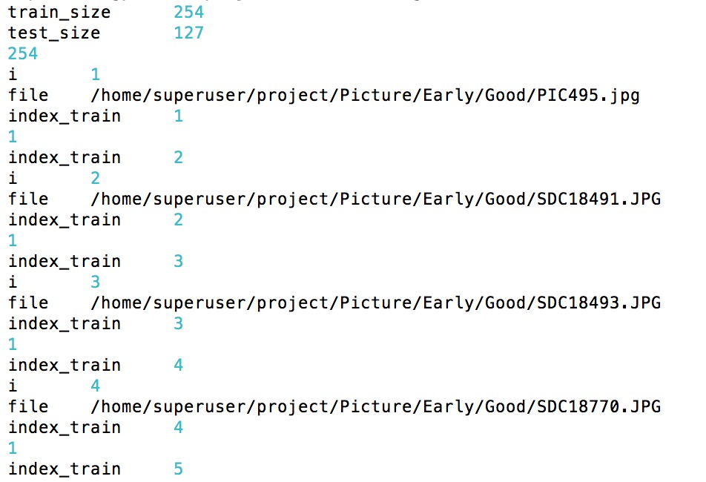

# **Appendix B**

**An example of the training error at each iteration**

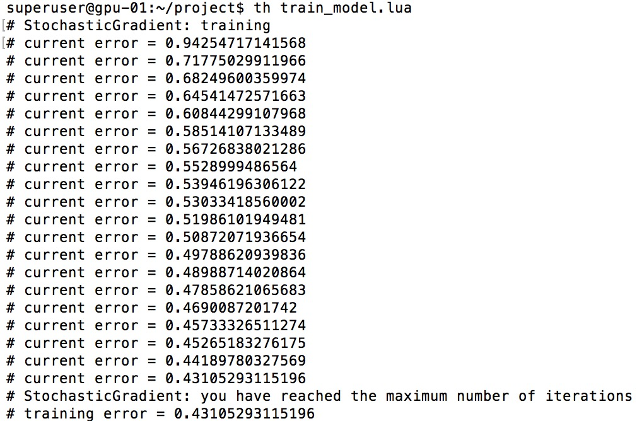

# **Appendix C**

**An example of how the result is saved (extracted from file results.txt)**

