Automation Test  
User Manual

**Document History**

|  |  |  |  |
| --- | --- | --- | --- |
| Date | Version | Author | Change |
| 18/06/2020 | 0 | Nam | First release |

**General Note**

The aim of this document is to support the application and engineering efforts of STYL customers that use STYL’s products. This document is intended for testing, evaluation, integration, and information purposes.

STYL makes every effort to ensure that the quality of the information is available. The content of this documentation is provided on an “as is” basis and may contain deficiencies or inadequacies.

STYL disclaims any warranty and all responsibility for the application of the device(s) that is made in relation to the accuracy, reliability or contents of this document. STYL is not liable for any injury, loss or damage of any kind incurred for the use of or reliance upon information.

STYL reserves the right to make any modifications, additions and deletions to this document due to typographical errors, inaccurate information, or improvements to products at any time and without notice.

**Contents**

Automation Test User Manual 1

1 Introduction 5

2 Terminology, Abbreviations and Notations 5

3 Installation 5

4 Uninstallation 8

5 Software overview 8

5.1 Main menu 9

5.2 Function Test 9

6 Usage 10

6.1 Open port 10

6.2 Test functions 10

6.3 Read Sensor Real Time 12

6.4 Update Firmware 14

6.5 Close Port 15

# Introduction

This document aims to describe how to install PID Test Tool and it’s all features of the PID Test Tool. This tool is used by the developer to test the serial command interface to PID device and its peripheral functionalities in integrated mode. In this version, some functions are not completed, because of firmware of PID is being developed.

# Terminology, Abbreviations and Notations

|  |  |
| --- | --- |
| PTT | PID Test Tool |

**Table 1. Terminology, abbreviations, notations**

# Installation

Click icon “PIDTestToolSetup.exe” to install application.

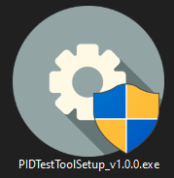

**Figure 1. Application Overview**

Click **Next** on Welcome Page Setup.

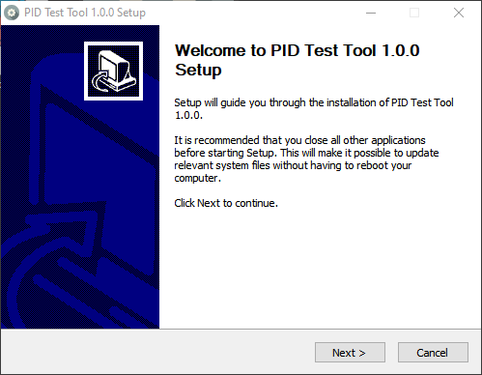

**Figure 2. Welcome Page Setup**

Choose **I Agree** to agree the License Agreement.

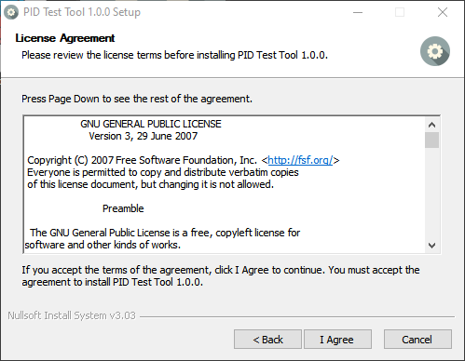

**Figure 3. License Agreement**

Click **Install** to install application and let the “Destination Folder” default.

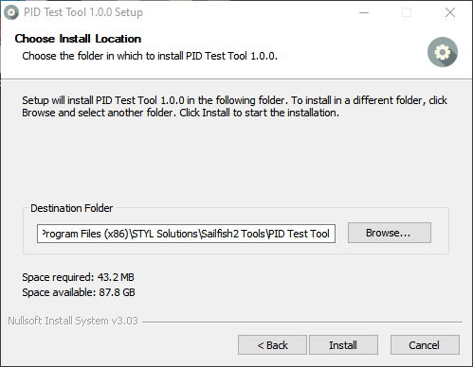

**Figure 4. Choose Location**

When finish installing, choose **Finish** to complete the installation process.

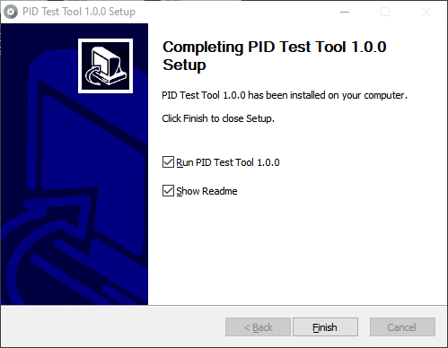

**Figure 5. Finish Setup**

# Uninstallation

Uninstall “PID Test Tool” by go to “Programs and Features” in Control Panel.

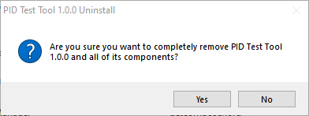

**Figure 6. Uninstall program in Control Panel**

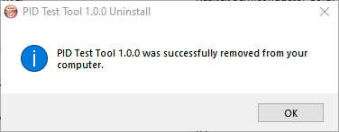

**Figure 7. Finish uninstalling program**

# Software overview

Click “PID Test Tool” to open application.

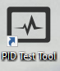

**Figure 8. Application Icon**

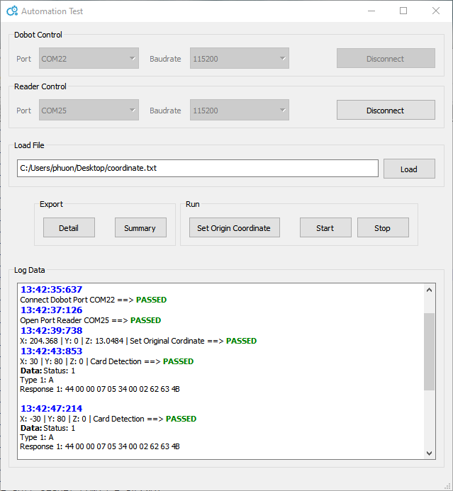

**Figure 9. Application Overview**

## Main menu

|  |  |  |
| --- | --- | --- |
| Communication | Open Port | Open serial COM port to communicate with device, the baud rate is set default 115200. |
| Close Port | Close serial COM port. |
| Exit | Close program. |
| Sensor | Read RealTime | Read data of sensor in real time. |
| Help | About | Inform the application including version, build number. |

**Table 2. Main Menu Contents**

## Function Test

|  |  |  |
| --- | --- | --- |
| MODULE | FUNCTION | DESCRIPTION |
| PWM | PWM Set Duty Cycle | Set duty cycle for PWM |
| PWM Get Duty Cycle | Get duty cycle for PWM |
| PWM Self-Test | Test PWM |
| PWM Set Frequency | Set frequency for PWM |
| PWM Get Frequency | Get frequency for PWM |
| SENSOR | Sensor Read Value | Read value of sensor proximity |
| Sensor Calibration | Calibrate the sensor |
| Sensor Self-Test | Test sensor |
| BRIGHTNESS  CONTROL | Brightness Control | Turn on/off the PID backlight brightness screen |

**Table 3. Describe Function**

# Usage

Demo clip: <https://drive.google.com/file/d/1jkYeBWvg2Ox6P9e1G2SVtYrR92DSML4Y/view>

# Input File Description

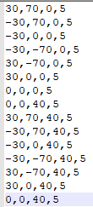

**Figure 9. Application Overview**

Format: x,y,z,loop

# Export File Description

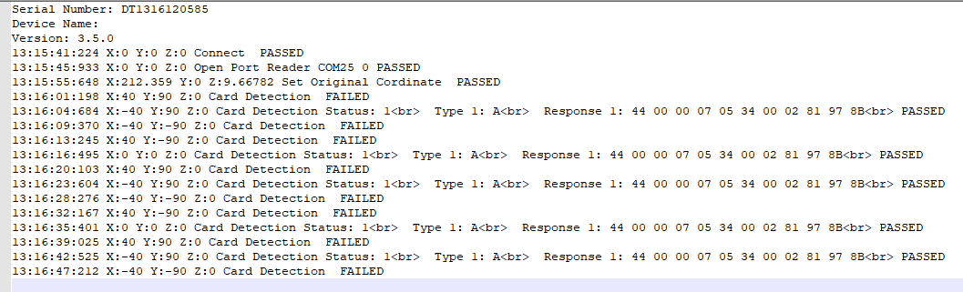

**Contact information**

STYL Solutions Pte. Ltd.

81 Ubi Avenue 4, UB.One, #05-07

Singapore 408830

Phone: +65 66948058

Fax: +65 66948060

Email: sales@styl.com.sg

STYL Solutions owns the proprietary rights to the information contained herein this document. It may not be edited, copied or circulated without prior written agreement by STYL Solutions Pte., Ltd © 2019.