Question 1: What is Boolean? Write down 3 different expression that results a Boolean type?

* Boolean values are the two constant objects False and True. They are used to represent truth values. Python also has the Boolean-able concept for every object,which is used when the function bool() is called
* Ex: 3>5

“a”<”b”

( “1”>”2”) and (1>2)

Question 2: What is a flow chart? Draw flow chart for the following code snippet

* Flow chart is a diagram of the sequence of movements or actions of people or thing involved in a complex system or activity

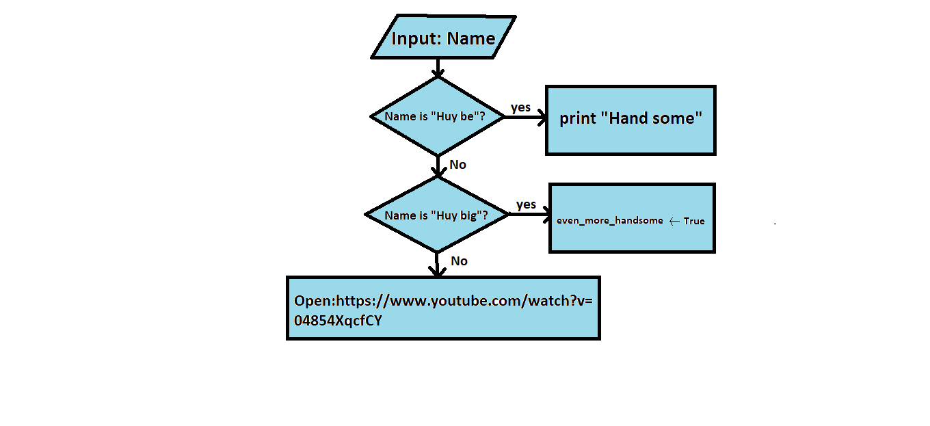

Question 3: What is nested conditionals? Write a piece of code that uses nested conditionals

* When you have one or more **if…(elif)…else** statementinside another **if…(elif)…else** statement, this is called nested conditionals
* Ex:

n = int ( input (“enter a number:” )

if n >= 0:

if n=0:

print( “n = 0” )

else:

print( “n >0” )

else:

print(“n < 0” )