SUMMARY

- Printf function:

Format Specifiers :
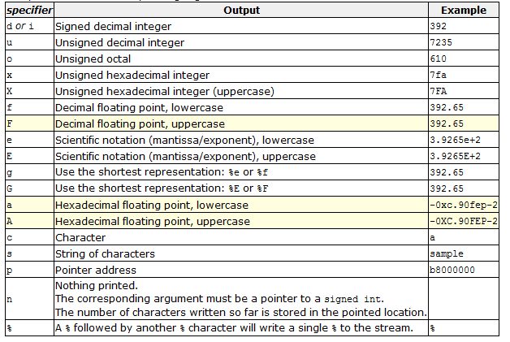

Note: %f stands for float, but C language has also a thing called “default argument promotions”.
Default argument promotions happen in variadic functions. Variadic functions are functions (e.g. printf) which take a variable number of arguments. When a variadic function is called, after lvalue-to-rvalue, array-to-pointer, and function-to-pointer conversions, each argument that is a part of the variable argument list undergoes additional conversions known as default argument promotions:

float arguments are converted to double as in floating-point promotion
bool, char, short, and unscoped enumerations are converted to int or wider integer types as in integer promotion

- Data type:

Signed and Usigned Variable:

Signed Range Unsigned Range
char -128 to 127 unsigned char 0 to 255
int -32768 to 32,767 unsigned int 0 to 65,535
long -2,147,483,648 unsigned long 0 to 4,294,967,295 to 2,147,483,647

- Used for integers in different CPUs

The value of an item with an integral type is the mathematical integer that it corresponds to. Integral types may be unsigned (capable of representing only non-negative integers) or signed (capable of representing negative integers as well).[1]

An integer value is typically specified in the source code of a program as a sequence of digits optionally prefixed with + or −. Some programming languages allow other notations, such as hexadecimal (base 16) or octal (base 8). Some programming languages also permit digit group separators.

The internal representation of this datum is the way the value is stored in the computer's memory. Unlike mathematical integers, a typical datum in a computer has some minimal and maximum possible value.

There are four well-known ways to represent signed numbers in a binary computing system. The most common is two's complement, which allows a signed integral type with n bits to represent numbers from −2(n−1) through 2(n−1)−1. Two's complement arithmetic is convenient because there is a perfect one-to-one correspondence between representations and values (in particular, no separate +0 and −0), and because addition, subtraction and multiplication do not need to distinguish between signed and unsigned types. Other possibilities include offset binary, sign-magnitude, and ones' complement.

