Use PDE in Image Processing

1. Gaussian filter without noise

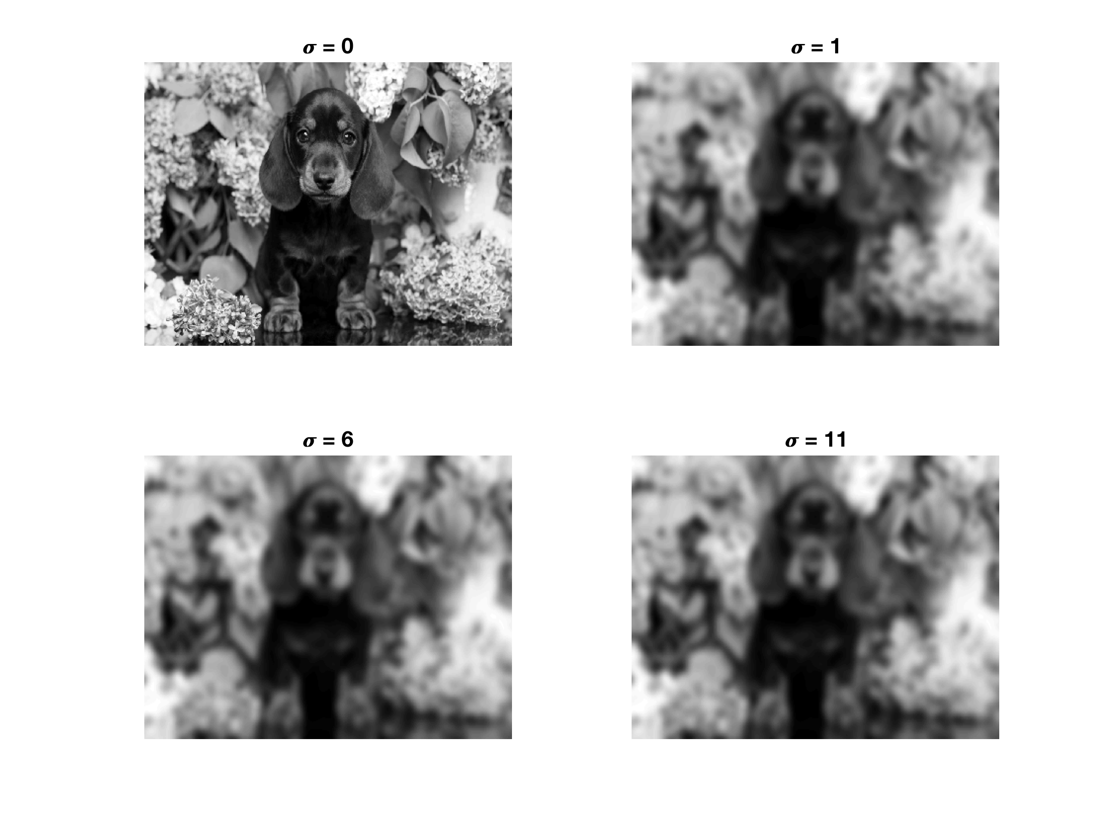

Figure 1

1. Gaussian filter with noise: normal distribution with mean 0, variance = 0.025



Figure 2

1. Gaussian filtering with Heat Equation

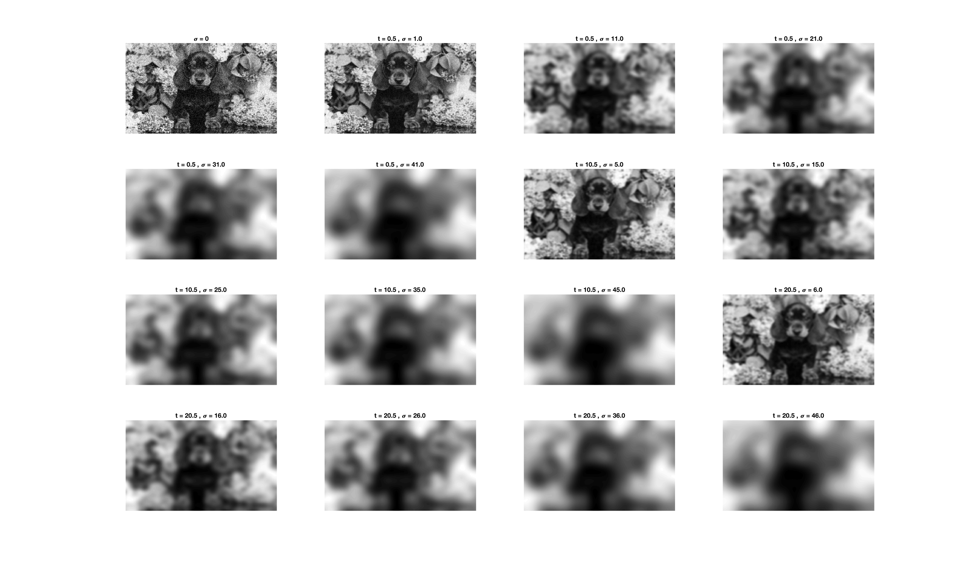

Figure 3