**Hotel Reservation System (HRS)**

A group of 2 or 3 members. Free to make your own team.

You are required to make a system which helps the hotel manage the booking. The system must provide the needed operations to track the status of room and booking and money that guest has to pay for booking. As normal the process is:

1. A Guest/Customer come to hotel and makes his/her booking.
2. The staff records the information of booking to the system, calculate the money that customer has to pay.
3. The administrator will register the information of new room, roomtype, hotel and update the price of room.

|  |  |  |
| --- | --- | --- |
| **Operation** | **Performed by** | **Description** |
| Create a booking | Staff | Perform registering information of booking. |
| Register customer | Staff | Perform registering information of customer |
| Update information of Staff | Staff |  |
| Print summary report | Staff | Display the information of booking |
| Register Hotel/room/roomtype/Staff | Administrator | Perform registering information of hotel/room/roomtype/staff. |
| Print summary report | Administrator | Display the revenue of each room |
| Update room price | Administrator |  |

**1. Functions for an administrator**

1.1 Login

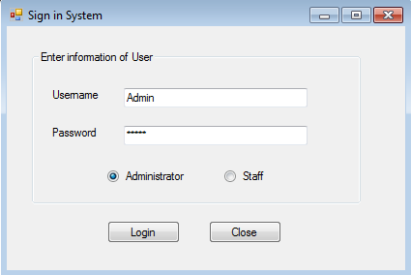

1.2 Add a new room type

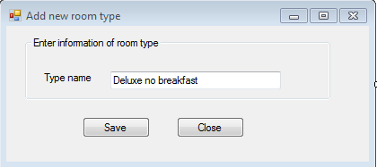

1.3 Add a new Hotel

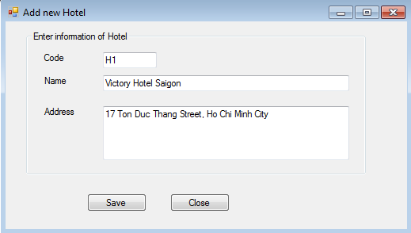

1.4 Add a new Staff

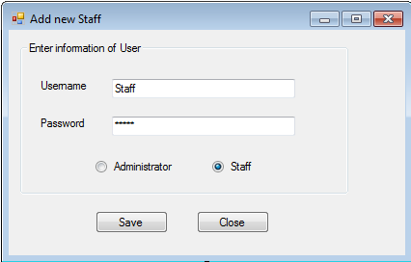

1.5 Add a new Room

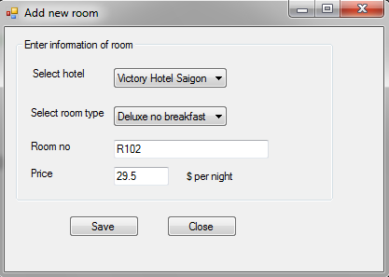

1.6 Update room price

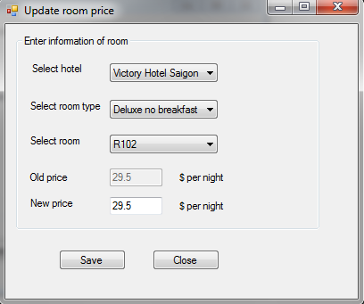

1.4 Print summary

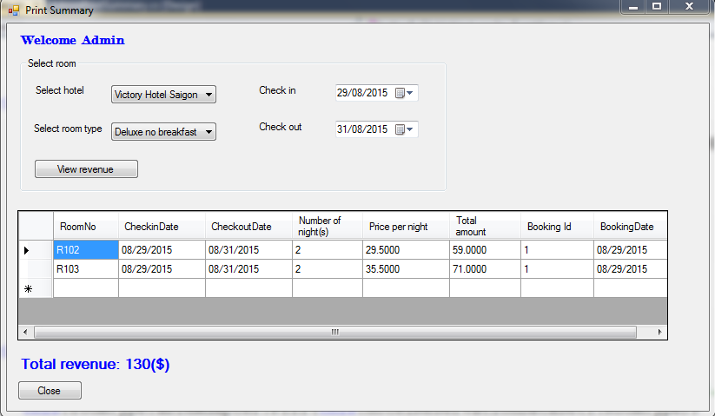

**2. Functions for a staff**

2.1 Login

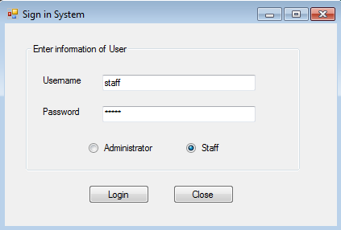

2.2 Add new customer

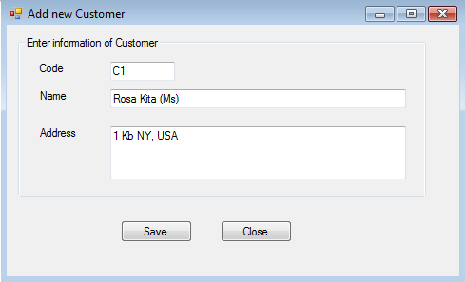

2.3 Update information of staff. The value of username is saved there automatically (depend on logged users), to change the password, user must enter the old password and if its correct/value then update the new password for user otherwise show an error message.

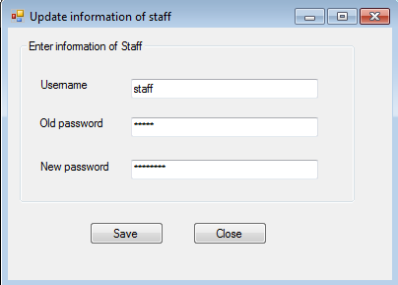

2.4 Create a booking. Firstly select the customer code or make a new customer (if needed). Select a room to book by select the hotel and room type, select the check in/out date and view all available rooms, now when users select a room from listbox and click book, bring the selected room from list box to data grid view and finally when users click save, save all selected information to database.

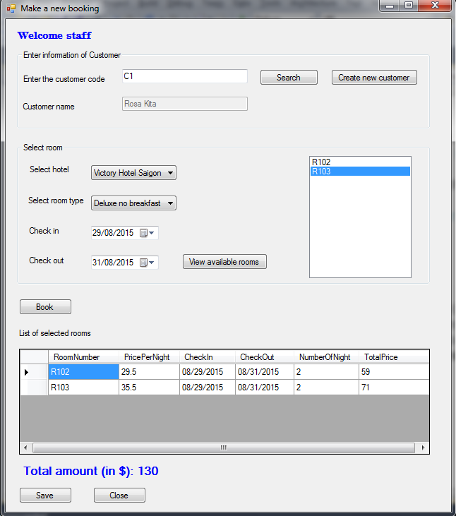

2.5 Print summary

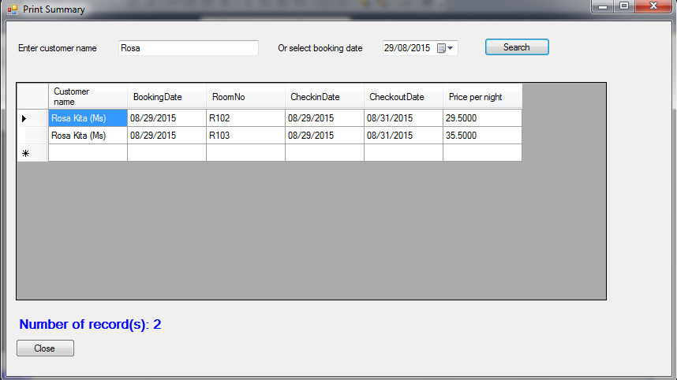

Here is Database diagram of our system

