PFC - Workshop 02

Q1 (8 marks). Write a program that performs the following tasks:
- Input an integer number n, where n > 5 (If n≤ 5 then prompt a user to re-enter). Then calculate
- S1 = 1 + 2 + 3 + ... + n.
- S2 = n!
- S3 =1+++...+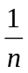.
- Re-input n. Check whether n is a prime number or not.

Sample input and output:
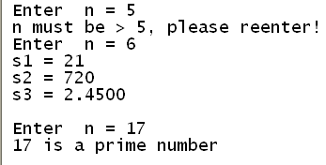 | 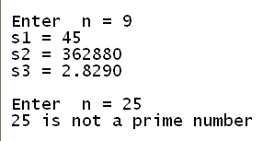

Additional questions ((2 marks):
Q2. Write a program to accept 2 integer numbers m and n, then:
- Display all common prime dividers of them.
- Find the greatest common divider (GCD) of them.
- Find the least common multiple (LCM) of them.

Sample input & output

Enter m, n: 15 30
1.
Common prime dividers: 3, 5
2.
GCD = 15
3.
LCM = 30

