PFC - Workshop 03

Q1 (8 marks). Write a program that performs the following tasks:
- Input an integer number n (check input validation), then
- Display n in binary number format.
- Re-input n (not check input validation). Calculate sum of all digits of n.
- Find the number m, which is the reverse of n.

Sample input and output:
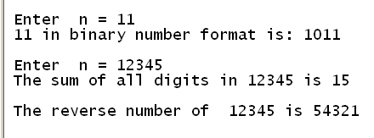

Additional questions (2 marks):
Q2. Write a program to accept 3 real numbers a, b and c, then
Solve the quadratic equation ax² + bx + c = 0.
Delta = 25 – 4 *2 * 3 = 1
X = (5 +- 1) / 4 = 1, 1.5

Enter a, b, c: 2 -5 3
Root 1: 1.5
Root 2: 1

Enter a, b,c: 1 -2 3
No real root
(delta = 4 – 4 * 3 *1 = -8 = 8i^2
X1,2 = (2 +-2sqrt(2)i) / 2 = 1 +- sqrt2 i = 1 +- 1.41i

Q3. Write a program to accept 2 integer numbers m and n, where m < n then
Display all palindrom numbers in the interval [m.n]. (A palindromic number or numeral palindrome is a number that remains the same when its digits are reversed, e.g. 16461)

Enter m, n: 121, 131
Palindrome numbers are: 121, 131

