PFC - Workshop 04B

1. Fraction Simplifier
In this question you should write 3 functions with prototypes as follows:
void input(int *num, int *den); // input numerator (num) and denominator of a fraction (den)
void display(int num, int den); // display the fraction
void simplify(int *num, int *den); // simplify the fraction
Include negative as well as zero values in your test cases.
The output from your program looks something like
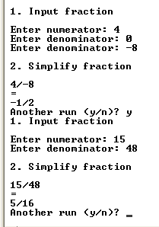
2. roots Function
Design and code a C function named roots that calculates the roots of a quadratic equation. Your function receives three doubles that hold the coefficients of the quadratic equation and returns through two other double parameters the real roots of the equation. The function returns the number of real roots as the return value of the function itself. The header for your function looks something like
int roots(double a, double b, double c, double *x1, double *x2)

Consider the quadratic equation:
f(x) = a * x² + b * x + c

where a, b and c are constant coefficients. This equation may have up to 2 real roots. The roots are the values of x for which
a * x² + b * x + c = 0
The roots are given by the equations
x₁ = ( - b + sqrt( D ) ) / ( 2 * a )
x₂ = ( - b - sqrt( D ) ) / ( 2 * a )
where D is the discriminant
D = b² - 4 * a * c
If D is positive-valued, there are 2 real roots. If D is zero-valued, there is one real root. If D is negative-valued, there are no real roots.
If there is one real root, set x₁ to its value and leave x₂ unchanged. If there are no real roots, leave x₁ and x₂ unchanged.
The output from your program looks something like
