PFC - Workshop 06

Array of real numbers
Write a menu driven program with the options below:
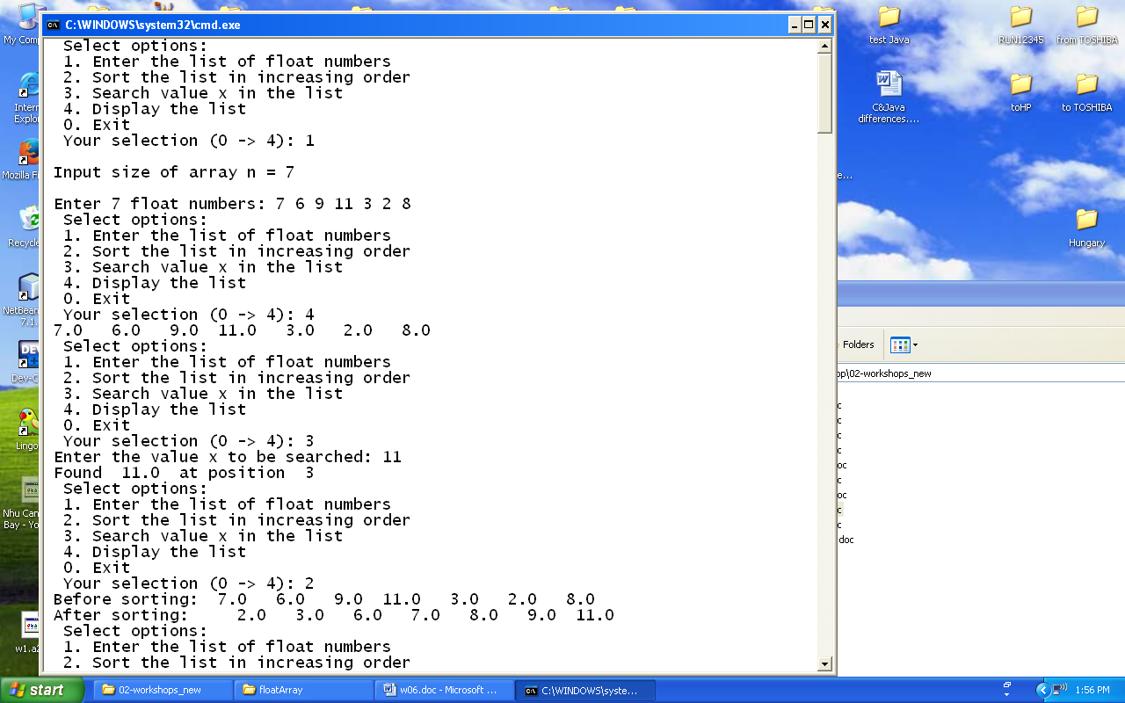

Sample input and output:

