Swing

PRJ311 – workshop3A:
Create Jframe form with the following components:
Name (text field, cannot be blank, do not contain digit )
Age (number, between 18 and 60)
Sex (radio button, male or female)
Preferable fruits (check boxes)
Check (button, display the message about data validation

PRJ311 – workshop3B:
Design the form might look something like figure below, named the java file is AEdit.java.
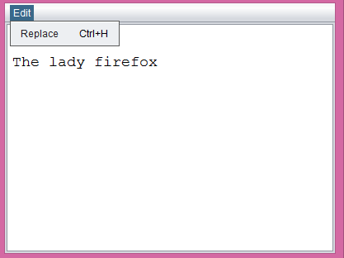
The Frame includes a menu bar with a menuitem (Replace, shortcut key included) and a textarea, “the lady firefox” is default value of textarea.
If users select Replace, show a Replace dialog form which might look something like figure below (0.5 Point)
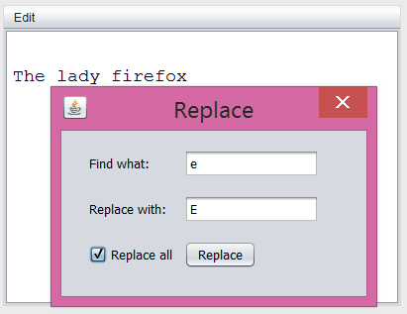
txt1
txt2

When users enter values for txt1, txt2 and click on Replace button, find the characters in textarea which is equals to txt1 and replace by txt2. Replace the first occurrence if checkbox Replace all is unchecked (1.0 Point) otherwise replace all occurrences (1.0 Point).
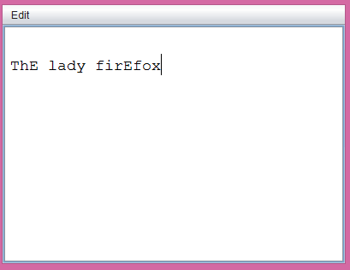

PRJ311 – workshop4A:

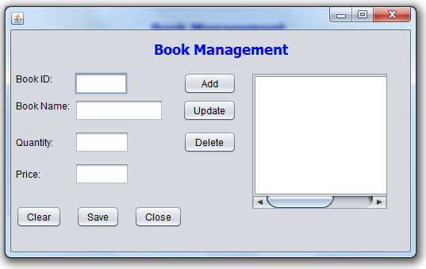

PRJ311 – workshop4B:
Design and implement a class named Employee with the following information:
Code,name,sex,salary,bonus,income
Design and implement a class named EmployeeList, which contain an ArrayList of type Employee, which has add,search, delete, sort methods.

Create Jframe form with the following components:
Code (text field)
Name (text field, cannot be blank, do not contain digit )
Sex (radio button, male or female)
Salary (text field)
Bonus (text field)
Income(non-editable field, = Salary + Bonus)

Buttons:
Load&Display, which load data from a given file and display on the screen,
Add, Search, Delete, Sort buttons.

A table to display the list of emplyees.

