Java 2D Graphics

PRJ311 – workshop 7:

Draw a table with different colors.

PRJ311 – workshop 8:
Write an Java application with the following requirements:
- Use JDBC to store data.
- Implement functions related to buttons

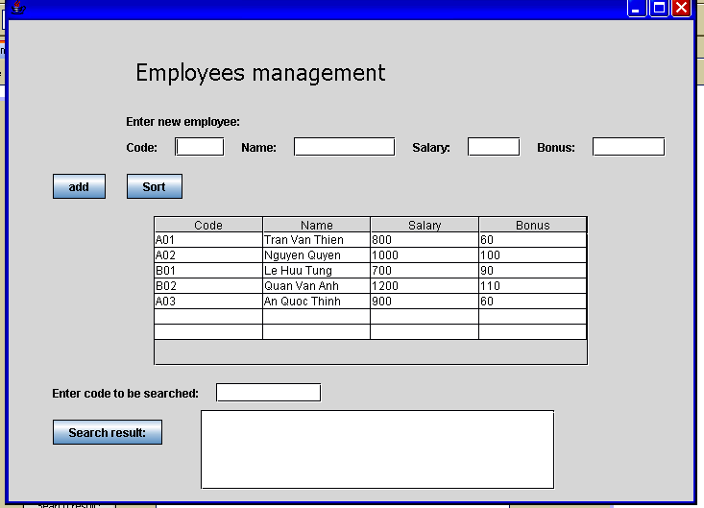

PRJ311 – workshop 9:
Create a button named “En/Vn” such that by clicking on this button we can change the language to display components on the form in workshop 8 between English and Vietnamese.

