**ASSIGNMENT 2 FRONT SHEET**

|  |  |  |  |
| --- | --- | --- | --- |
| **Qualification** | **BTEC Level 5 HND Diploma in Computing** | | |
| **Unit number and title** | Unit 30: Application Development | | |
| **Submission date** | 10/04/2024 | **Date Received 1st submission** |  |
| **Re-submission Date** |  | **Date Received 2nd submission** |  |
| **Student Name** | Le Phuong Thao | **Student ID** | BH00228 |
| **Class** | IT0502 | **Assessor name** | Nguyen Thanh Trieu |
| **Student declaration**  I certify that the assignment submission is entirely my own work and I fully understand the consequences of plagiarism. I understand that making a false declaration is a form of malpractice. | | | |
|  |  | **Student’s signature** | Thao |

**Grading grid**

|  |  |  |  |  |  |  |  |
| --- | --- | --- | --- | --- | --- | --- | --- |
| P4 | P5 | P6 | M3 | M4 | M5 | D2 | D3 |
|  |  |  |  |  |  |  |  |

|  |  |  |
| --- | --- | --- |
| **❒ Summative Feedback: ❒ Resubmission Feedback:** | | |
| **Grade:** | **Assessor Signature:** | **Date:** |
| **Lecturer Signature:** | | |

# **I. CREATE A FORMAL QUESTIONNAIRE THAT EFFECTIVELY REVIEWS YOUR BUSINESS APPLICATION, PROBLEM DEFINITION STATEMENT, PROPOSED SOLUTION, AND DEVELOPMENT STRATEGY. USE THIS QUESTIONNAIRE AS PART OF A PEER-REVIEW AND DOCUMENT ANY FEEDBACK GIVEN (P4)**

## **1. Formal questionnaire**

The survey to collect data from users of the FPT HR training system will be conducted by a group of interviewers mainly composed of members of the development team who are responsible for implementing and maintaining the system. These interviewers will include software developers, project managers, and user experience designers. This ensures that interviewers have a comprehensive understanding of the system's functions and goals. Additionally, the survey will also invite subject matter experts such as administrators, training staff, and trainers, who are actively involved in the system on a daily basis, to participate in the interview process. The participation of these experts will provide valuable insight into practical experiences in using the FPT HR training system. The survey will be conducted carefully and in detail, in order to ppppppppcollect accurate information about the effectiveness and efficiency of the training system. The results from the survey will provide important information to evaluate and improve the system, thereby ensuring that it meets the goals and needs of users.

### **Administrator**

The purpose of an administrator survey is to focus on gathering information and evaluating the performance, efficiency, and user experience of administrators in their role. This survey aims to evaluate administrators' response to user requirements and expectations, and identify areas for improvement to enhance performance and user experience. During the survey, we will evaluate the ability to manage users, assign access rights, technical support, maintain and update systems, data security and other tasks related to the role. of administrator. We will find out the satisfaction level and evaluate the administrator's work performance, to identify difficulties, problems or weaknesses that need improvement.

**Question 1 :** How satisfied do you feel with the Administrator's performance and work efficiency in the FPT HR training system?

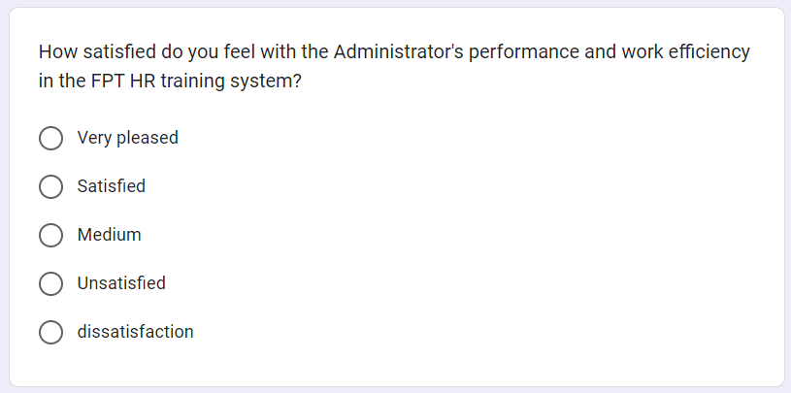

**Question 2 :** During the process of using the system, did you receive support from the Administrator quickly and effectively?

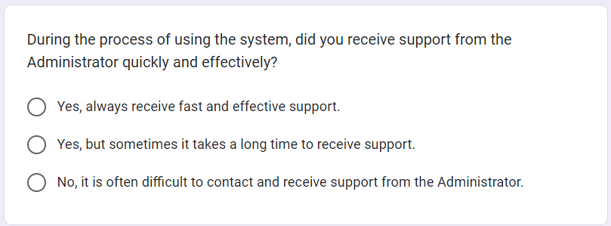

**Question 3 :** How do you evaluate the Administrator's ability to manage users and assign access rights in the system?

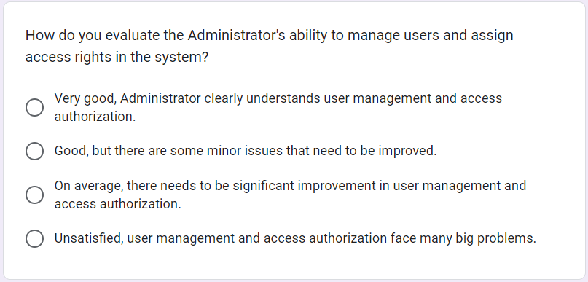

**Question 4 :** Do you feel that your personal information and data are properly secured and protected in the FPT HR training system?

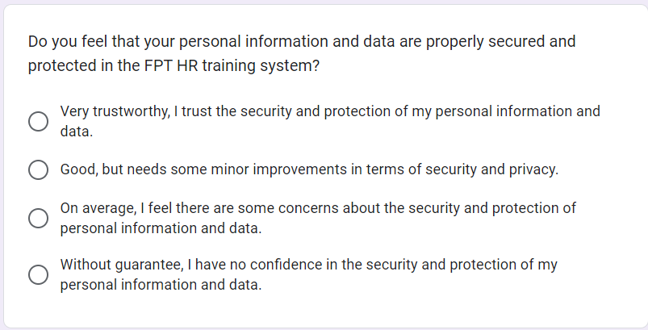

**Question 5 :** During the process of encountering technical problems, did you receive reliable support and resolution from the Administrator?

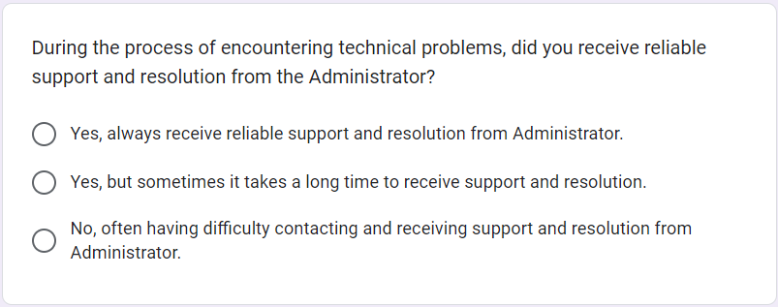

**Question 6 :** How do you evaluate the Administrator's ability to maintain and update the FPT HR training system?

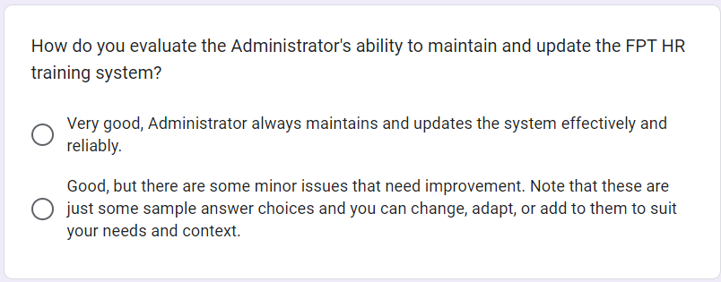

**Question 7 :** Do you have any suggestions for improving performance and user experience in the Administrator role?

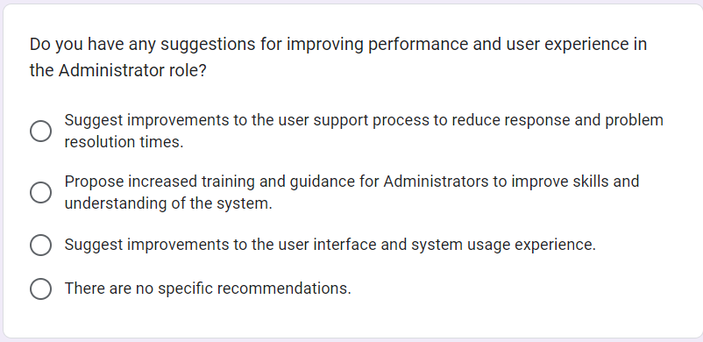

**Question 8 :** In your opinion, does the Administrator's role in the FPT HR training system meet users' requirements and expectations?

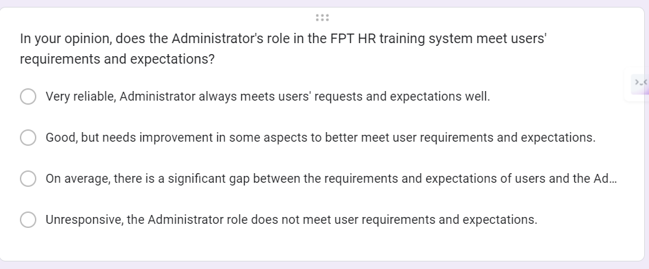

### **Training Staff**

The training staff survey serves as a valuable tool to gather feedback and insights from training staff on their use of and engagement with FPT's HR training system. Its main objective is to collect information about any issues, difficulties or suggestions for improvement related to various aspects of the system, including student accounts, catalog and course management, adding subjects topics and assign lecturers according to topics. Furthermore, the survey aimed to evaluate the effectiveness and efficiency of the system's features from the perspective of the training team. By gaining a deeper understanding of their experiences and perspectives, the survey enabled the identification of areas for possible improvement to better support the roles and responsibilities of training staff within the training programme.

**Question 1 :** Have you had experience working with our training staff? If so, please share your opinion on the quality and effectiveness of training activities undertaken by our training staff.

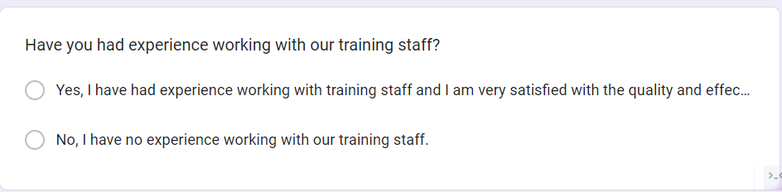

**Question 2 :** Evaluate the ability of training staff to convey information and knowledge to learners. Do you feel the trainer has a deep understanding of the training content and is able to communicate clearly and effectively?

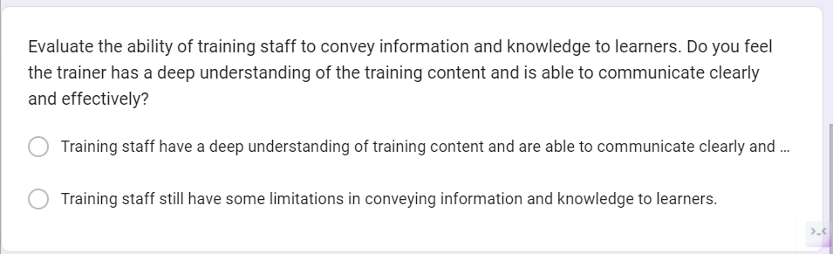

**Question 3 :** During the training process, did the training staff create a positive and motivating learning environment for you? Please share your experiences and rate the level of support and encouragement from the training staff.

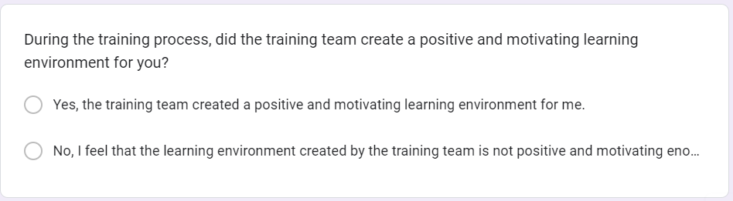

**Question 4 :** Did the training staff use appropriate training methods and tools? Evaluate the effectiveness of training methods used by training staff.

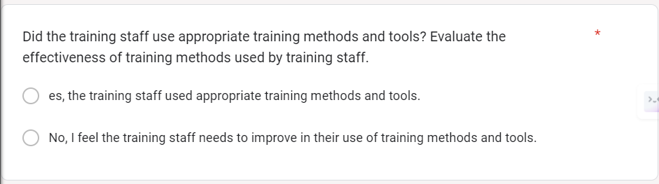

**Question 5 :** Did the training staff demonstrate the ability to listen and interact well with learners? Did you feel the training staff created a comfortable environment for you to ask questions and discuss?

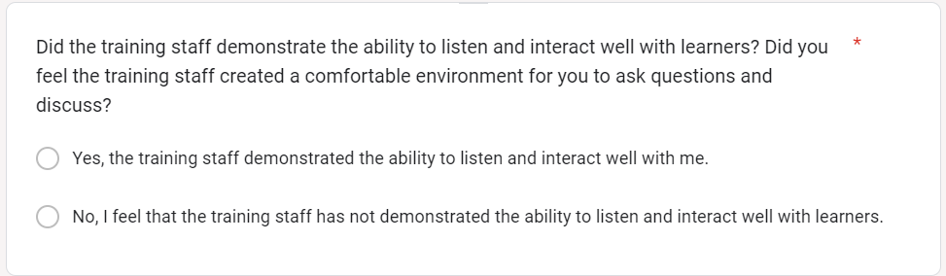

**Question 6 :** In your opinion, did the training staff meet our organization's training requirements and goals?

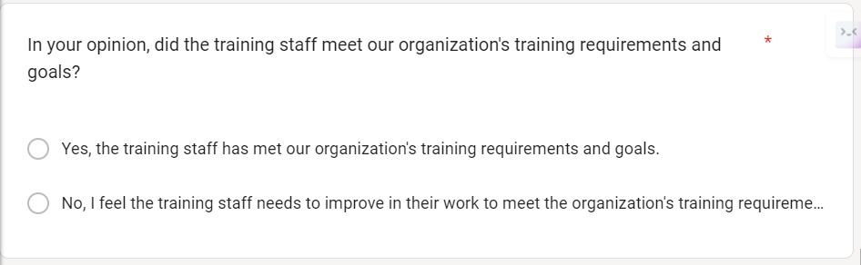

### **Trainer**

The purpose of the survey for instructors is to collect information and opinions from instructors about their experiences with the FPT HR training system. This survey aimed to evaluate the usability, functionality and effectiveness of the system in supporting instructors in their role in the training program. Specifically, the survey sought feedback on aspects such as updating instructor profiles, viewing assigned courses, and any challenges or suggestions for improvements in system design or features. By gathering opinions from trainers, the survey aims to identify areas for improvement and enhancement to better meet the needs and expectations of trainers, thereby improving overall effectiveness of the training program.

**Question 1 :** Have you had experience studying with our Trainers? If so, please share about your experience.

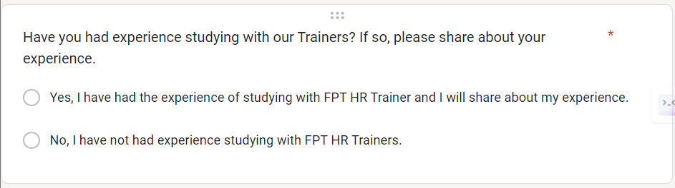

**Question 2 :** Did the Trainer convey information and knowledge in a clear and understandable way? Please give your opinion.

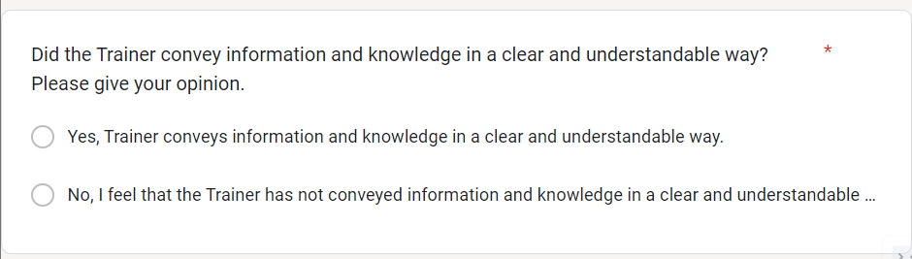

**Question 3 :** Did the trainer create a positive and inspiring learning environment for you? Please share your opinion on this.

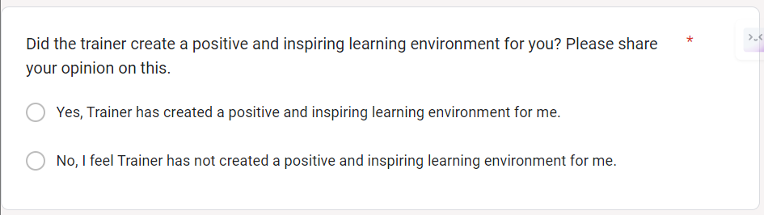

**Question 4 :** Did the Trainer use appropriate and effective training methods and tools? Please give your opinion.

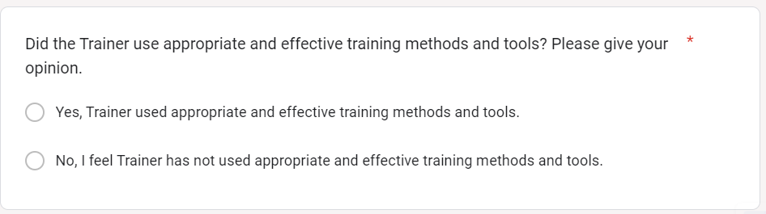

**Question 5 :** Has the trainer demonstrated the ability to listen and interact well with students? Please share your views on this.

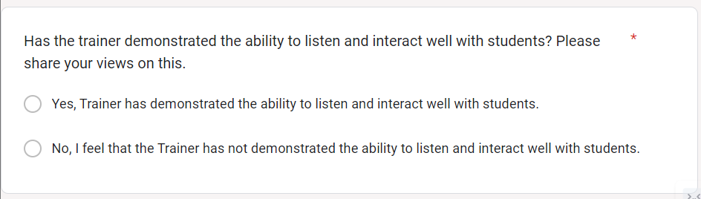

**Question 6 :** Did the trainer assist you in applying the knowledge you have learned to real work? Please share your experience.

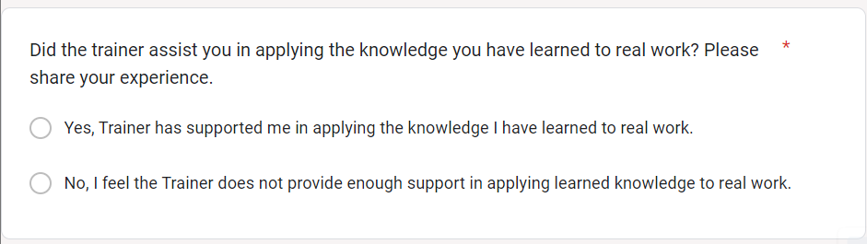

**Question 7 :** Do you believe that the Trainer's role is important in FPT HR's training process? Please give your opinion.

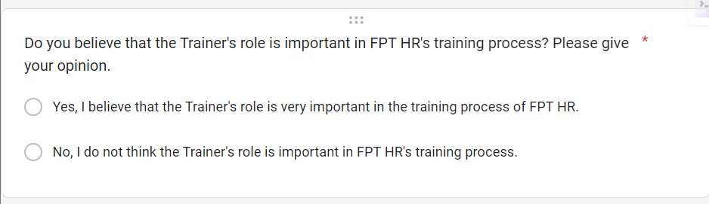

**Question 8 :** Do you have any comments, suggestions or suggestions to improve the Trainer's role in the training system? Please share with us.

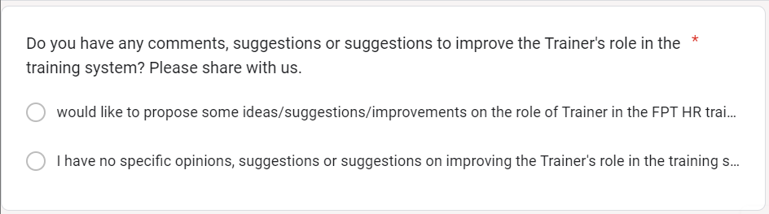

**Question 9 :** Did the Trainer meet FPT HR's training requirements and goals? Please share your views on this.

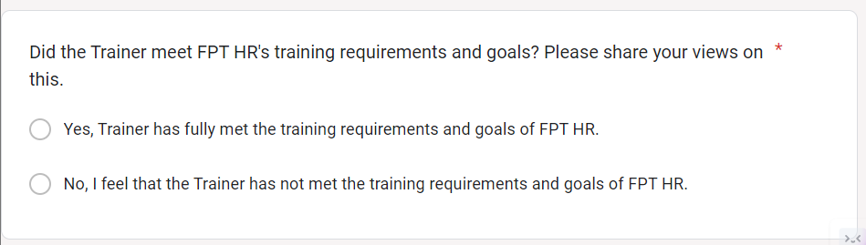

**Question 10 :** In your opinion, what qualities are important for a Trainer to be successful in his or her role? Please give your opinion.

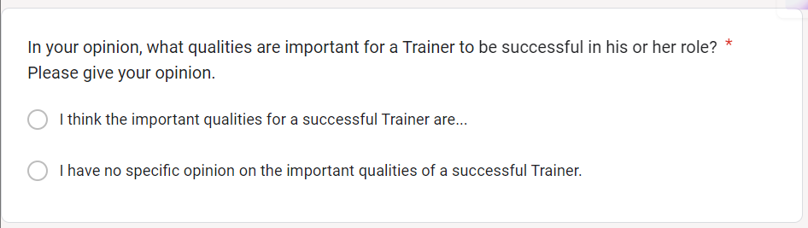

## **2. The result of survey**

### **2.1. Peronal Information**

Based on the above survey questions, the interviewees are members of FPT HR, including employees, lecturers, training managers or anyone using the FPT HR training system. These objects have direct experience and interaction with the system, and can provide valuable information about the performance and user experience within the system.

The above interview interviewed subjects such as:

Staff regularly use the training system to complete required courses or improve their capabilities.

Instructors, creators and managers of training content on the system.

Training manager, the person responsible for managing and supervising the implementation and use of training systems within the organization.

IT experts or system users have knowledge about how to deploy and manage systems.

**Administrator**

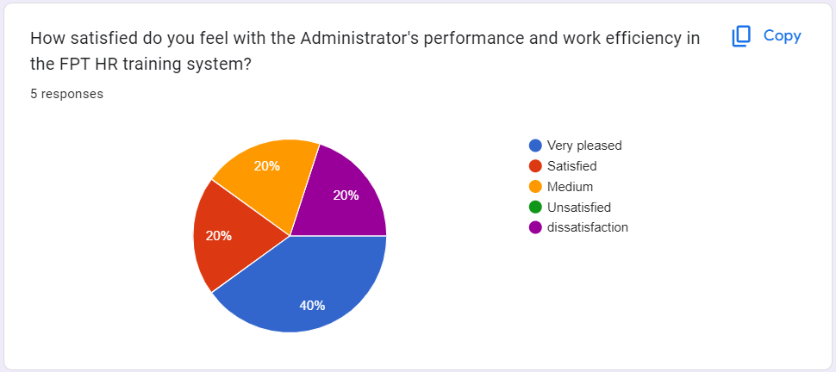

Based on the survey results, there is generally significant satisfaction from users with the administrator role in the FPT human resources training system. Specifically, 40% of respondents expressed satisfaction with the Administrator's work efficiency and effectiveness. This shows that a high percentage of users rate that the Admin achieves its goals and provides an effective working experience. Additionally, 20% of users said they felt satisfied or average with their Administrator's work efficiency and effectiveness. Although this percentage is not as high as the satisfied group, it shows that a portion of users are neutral about their experience. This survey data shows a high level of overall user satisfaction with the administrator role in the FPT HR training system, with a significant number stating that they are very satisfied. However, there is still a small portion of users with unsatisfied or neutral opinions, which may need to be considered to improve the Administrator's experience and work efficiency in the future.

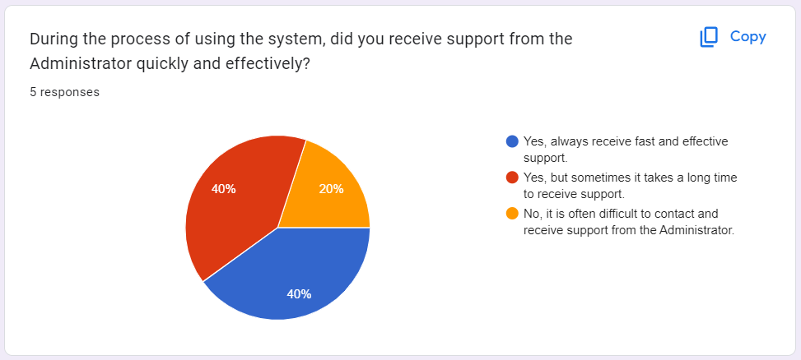

Based on the survey results, there is a large portion of users, accounting for 60% of the total respondents, who received support from Administrators in the system quickly and effectively, but there are also some users who accounting for 20%, said it sometimes takes a long time to receive support. However, 20% of users said that they had difficulty contacting and receiving support from Administrators. This result shows a difference in the level of support from Administrators during system use. Although there is a large portion of users who have received quick and effective support, there is also a small portion of users who have difficulty reaching and receiving support from Administrators. Based on these results, it may be recommended to enhance the support process from Administrators, to ensure that every user receives quick and effective support. At the same time, it is necessary to evaluate and improve the communication and outreach process with Administrators, in order to minimize the difficulties that some users have experienced.

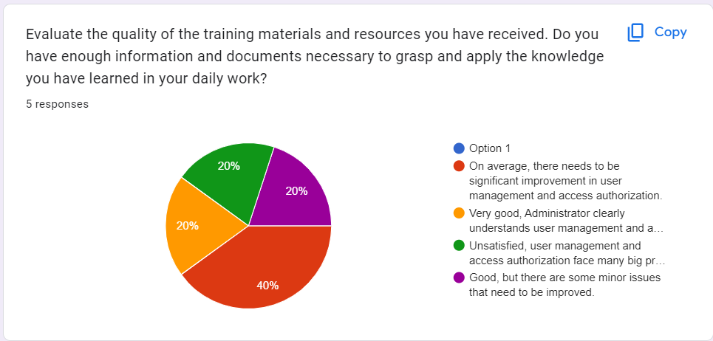

Based on the survey results, there is a difference in the quality of training materials and resources received. 20% of users said that documentation and resources were received very well, with Administrators understanding user management and access authorization. However, 20% of users said they were not satisfied with user management and access permissions, encountering many major problems. Meanwhile, 40% of users said there is a need for significant improvement in user management and access authorization. Finally, 20% of users rated the documentation and resources as good, but with some minor issues that could be improved. This result shows a difference in the assessment of the quality of training materials and resources received. Although there are some users who say that the documentation and resources are very good and fully meet their needs, there are also some users who are not satisfied and think that user management and permissions need to be improved access.

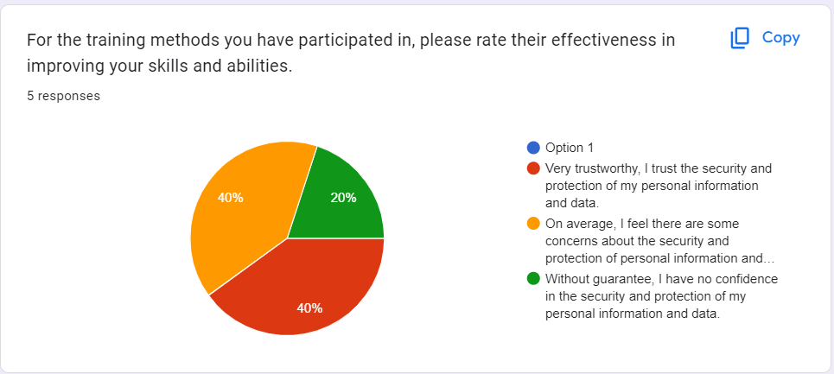

Based on the survey results, the effectiveness of training methods in improving participants' skills and abilities was evaluated differently. 40% of survey participants said they have confidence in the effectiveness of training methods, and rated them as very trustworthy. They have confidence in the security and protection of their personal information and data. Next, 40% of survey participants rated the effectiveness of training methods as average. They feel there are some concerns about the safety and protection of personal information and data. This suggests that improvements may be needed to address these concerns and ensure a higher level of safety. However, 20% of survey participants said they do not trust the security and protection of their personal information and data. This shows that some users do not have trust and confidence in the security level of training methods.

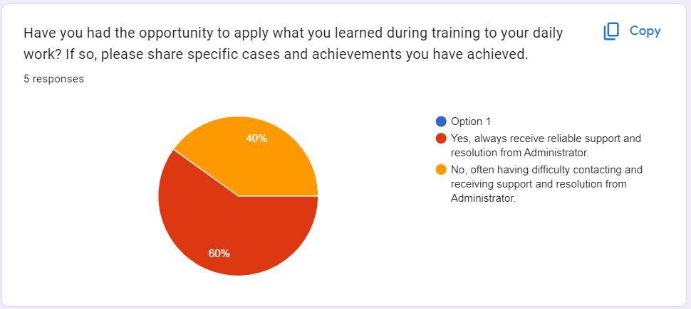

Based on the survey results, it can be seen that 60% of survey participants had the opportunity to apply what they learned during training in their daily work. They said they always received reliable support and resolution from the Administrator. This shows that the training was effective and they achieved specific results and achievements. However, 40% of survey participants said they often have difficulty contacting and receiving support and resolution from Administrators. This can affect their ability to apply what they have learned in their daily work and achieve the desired results.

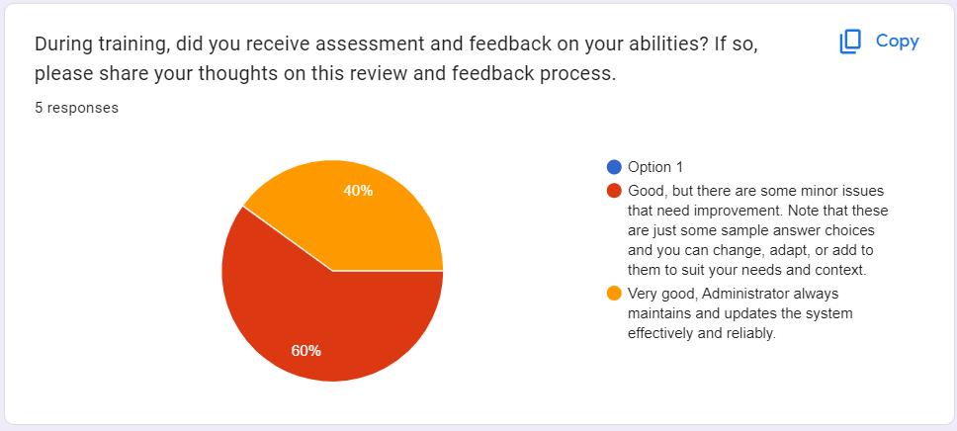

Based on the survey results, 60% of participants said that they evaluate the current situation as good, but there are still some small issues that need to be improved. This shows that we have made some progress in maintaining and updating the system effectively and reliably. However, we are aware that there are still some points that need to be improved to better meet user needs. Meanwhile, 40% of survey participants rated that Administrators always maintain and update the system effectively and reliably. This is a positive outcome and we are pleased to know that the Administrator's work is appreciated and meets user expectations.

**Training staff**

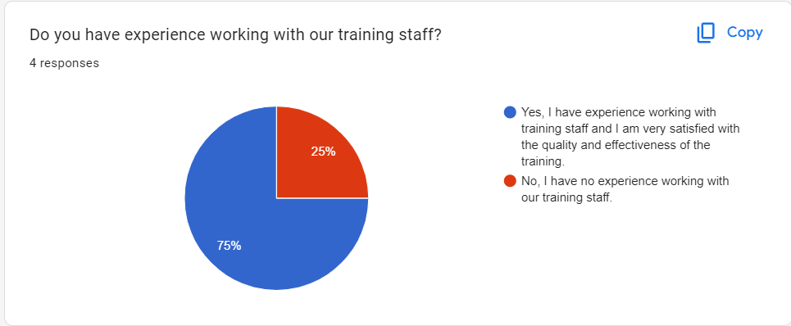

Based on the survey results, 75% of survey participants said they had experience working with our training team and they were very satisfied with the quality and effectiveness of the training process. This shows that our training team worked well and met users' expectations. However, 25% of survey participants said they have no experience working with our training team. This could mean they haven't benefited from our training, or it could be something we need to improve to meet the needs of all users.

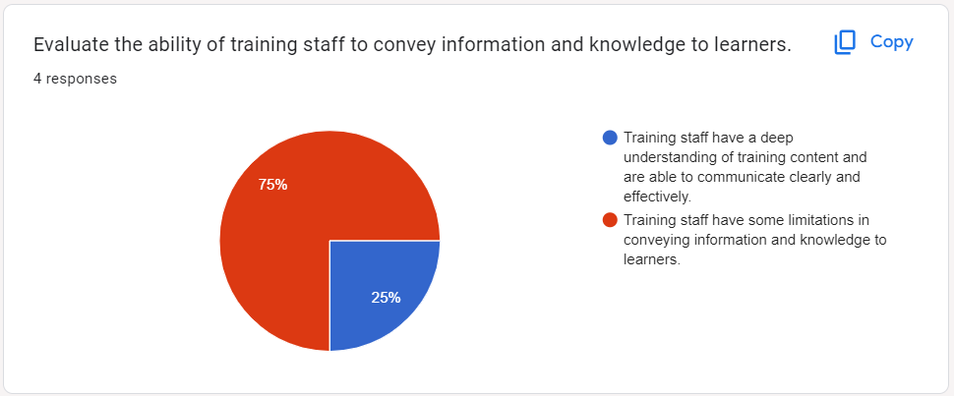

Based on the survey results, 25% of survey participants said the training team has a deep understanding of the training content and is able to communicate information clearly and effectively. This shows that the training team is able to respond well and bring satisfaction to learners. However, 75% of survey participants said the training team had some limitations in conveying information and knowledge to learners. This can make it difficult for learners to understand and absorb training content.

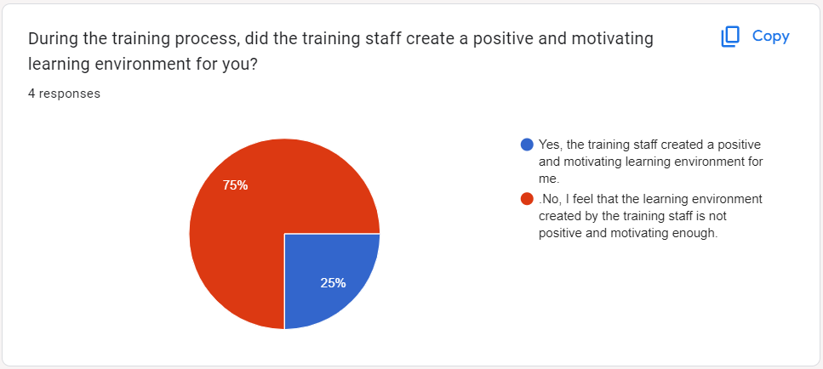

Based on the survey results, 25% of survey participants said the training team created a positive and motivating learning environment for them. This shows that the training team has been successful in creating a stimulating and motivating learning environment for learners. However, 75% of survey participants said they felt the learning environment created by the training team was not positive and motivating enough. This can affect learners' interest and motivation in the learning process.

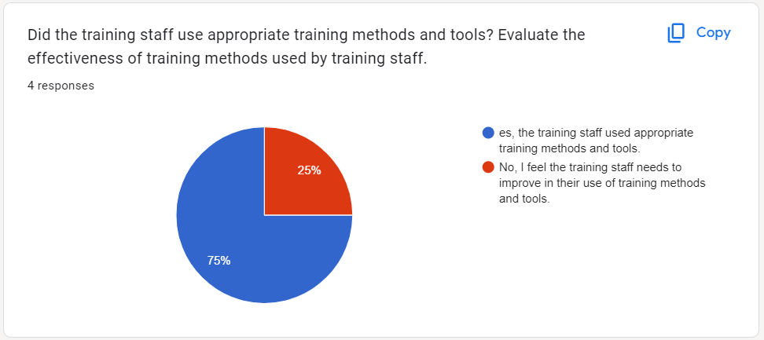

Based on the survey results, 75% of survey participants said the training team used appropriate training methods and tools. This shows that the training team has reached consensus in choosing appropriate methods and tools to impart knowledge and skills to learners. However, 25% of survey participants said they felt the training team needed improvement in using training methods and tools. This shows that some learners feel dissatisfied with the methods and tools used during the training process.

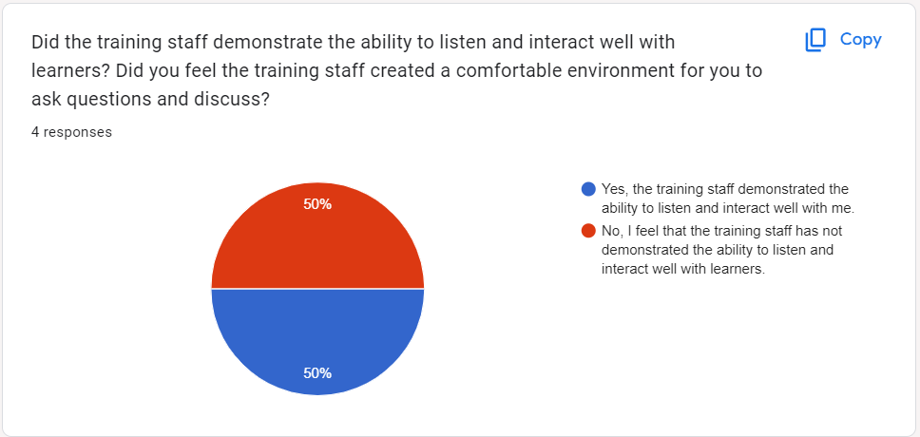

Based on the survey results, 50% of survey participants said the training team demonstrated the ability to listen and interact well with them. This shows that a portion of the learners had a positive experience when the training team listened and interacted with them well. However, 50% of survey participants said they felt the training team did not demonstrate the ability to listen and interact well with learners. This shows that some learners do not have a comfortable experience asking questions and discussing with the training team.

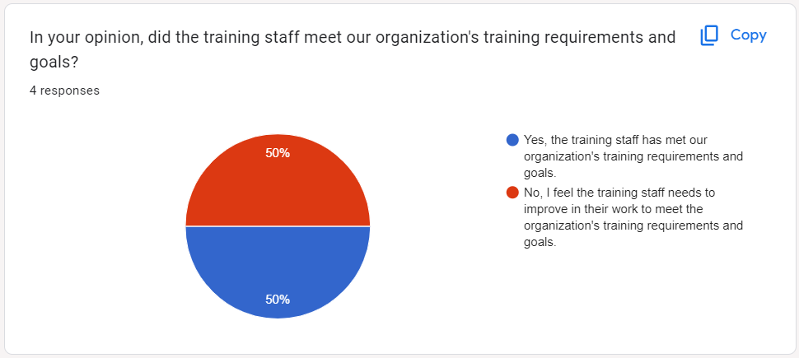

Based on the survey results, opinions are divided regarding whether the training staff has met the organization's training requirements and goals. While 50% of the respondents believe that the training staff has successfully met these requirements and goals, the other 50% feel that there is room for improvement. It is important to recognize that meeting the organization's training requirements and goals is crucial for the overall success of the training program. The feedback provided by the respondents who feel that improvements are needed can offer valuable insights for enhancing the effectiveness of the training staff's work.

# **II. Develop a functional business application based on a specified business problem**

## **Administrator's Role**

Administrators in the FPT human resources training system play an extremely important role in ensuring the smooth and effective operation of the system. Their responsibilities include not only supervision but also management and operation of all processes and functions related to human resource training. In this role, administrators ensure that training programs are implemented and executed effectively, from planning and organization, to monitoring and evaluating results. The administrator is responsible for establishing and maintaining the effectiveness of the system, ensuring that information and training materials are updated and distributed in a consistent and timely manner. They must also ensure that training procedures and standards are carried out in accordance with the organization's regulations and policies. These functions are described below:

### **Login by Administrator's account**

To start any administrative task in the FPT human resources training system, the administrator needs to use his/her designated administrator account to log in. This login function is not simply a necessary step, but also the basis for administrators to have seamless and secure access to the system. Administrator accounts provide special access rights, allowing them to perform comprehensive system administration and monitoring functions. This ensures that administrators can perform their tasks efficiently and securely, protecting data integrity and security during system management.

1. Functional parameters

To ensure that the process of logging into the FPT human resources training system takes place easily and safely, the functional parameters need to be set as follows:

When administrators visit the system's main landing page, they will easily find the path to the login page. At this page, they will be asked to provide their unique credentials, including username and password, to verify their identity.

The system must integrate strong security measures, including encryption and password hashing protocols, to ensure the security of administrator credentials and prevent any unauthorized access.

In the event of a failed login, the system will provide an informative error message, with options for password recovery or account support. This helps facilitate a smooth user experience and assists administrators in resolving issues quickly and effectively.

1. Non-functional requirements

To meet non-functional requirements during the process of logging into the FPT human resources training system, the following measures need to be applied:

Security: The login process must comply with industry security standards to minimize the risk of unauthorized access and protect sensitive data in the system. This includes using strong encryption mechanisms and access controls to ensure that only authorized users can access the system.

Usability: The login interface should be designed to be intuitive and user-friendly, minimizing the possibility of errors and facilitating a smooth login experience. Providing clear instructions and help features will make it easier for users during the login process.

Performance: The login process should be responsive and performant, with minimal latency and downtime. This helps facilitate efficient access to the system's administrative functions without disruption or delay for users.

#### **User account management**

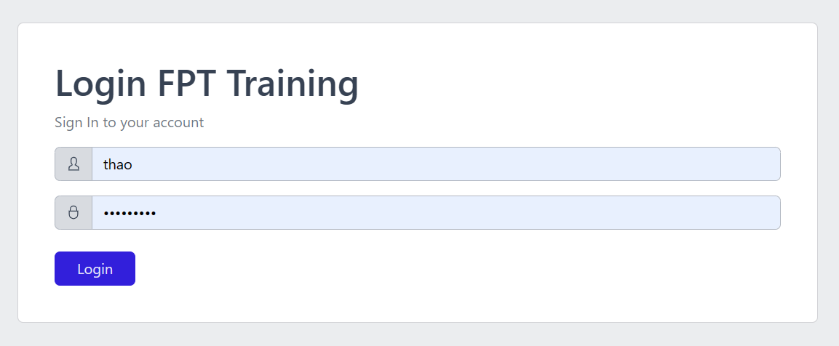

The login interface of the FPT human resources training system plays an important role as the main access point for users, including administrators, training staff, lecturers and students. When users access the login page, they will be asked to provide their credentials, including a unique account identifier and corresponding password. This helps ensure security and accuracy in authenticating users' identities before they are allowed access to the system. The login interface is designed to cater to a variety of user roles and provide an intuitive and convenient login experience, making it easy for users to access and use system features. The most convenient.

The login interface of the FPT personnel training system integrates many key features to ensure security, convenience and flexibility for users:

Account authentication: The login process requires users to enter account credentials to verify their identity and ensure legitimate access to the system. This helps prevent unauthorized access and protect users' personal information.

Differentiate user roles: The login interface differentiates and caters to different roles within the organization such as administrators, training staff, instructors, and students. After successful login, users will be redirected to the functions and dashboards appropriate to their role in the system.

Security measures: The system deploys strong security measures such as data encryption, secure password storage, and optional two-factor authentication to protect users' accounts and sensitive information.

Error handling: The interface provides error handling mechanisms to notify and guide users in the event of incorrect login information or other authentication-related problems.

User-friendly interface: Intuitive and user-friendly design makes it easy for users to use the login interface. Clear instructions and built-in accessibility features help users through the login process conveniently and easily

## **Training Staff's and trainer Role**

The role of the administrator in the FPT human resources training system includes basic functions such as managing the accounts of instructors and training staff. Administrators can perform operations such as creating, editing, and deleting user accounts assigned to training staff and coaches. This ensures the integrity and efficiency of the user base in the system, and helps administrators tailor and update user information according to the needs and requirements of the organization. Thereby, the administrator's role is not only the central point in managing users but also protecting and maintaining the accuracy of user data in the training system.

Create a user account

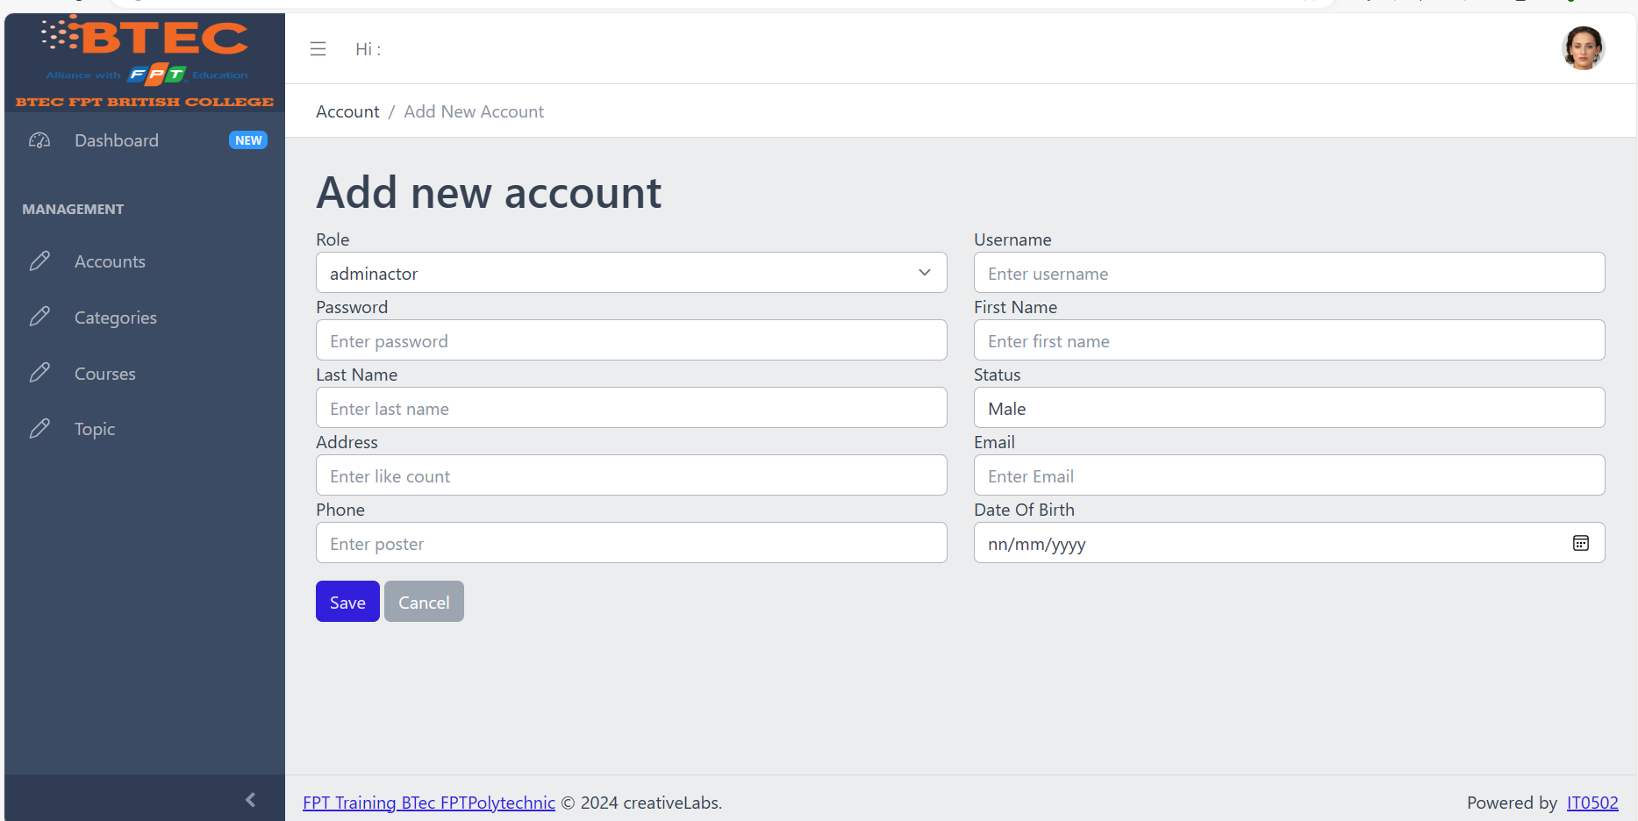

Edit account

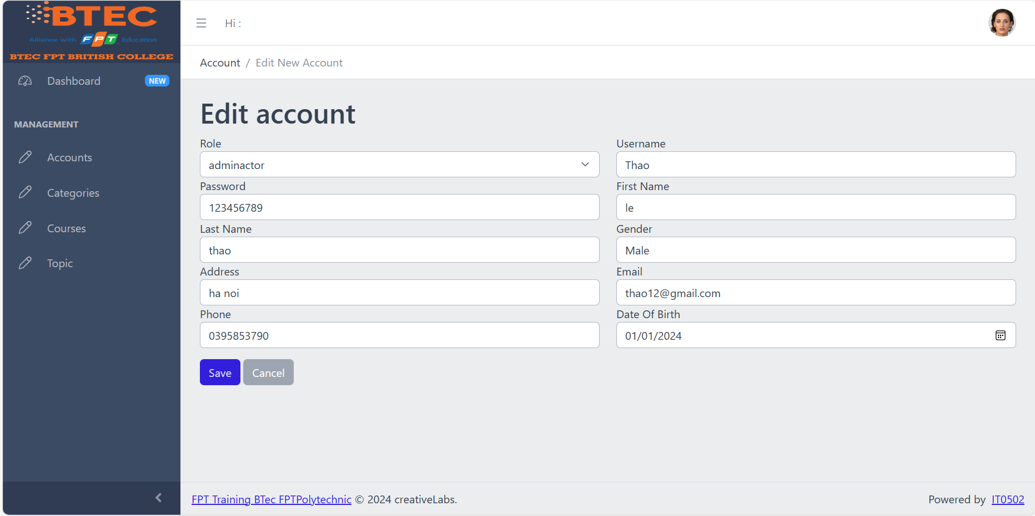

Delete account

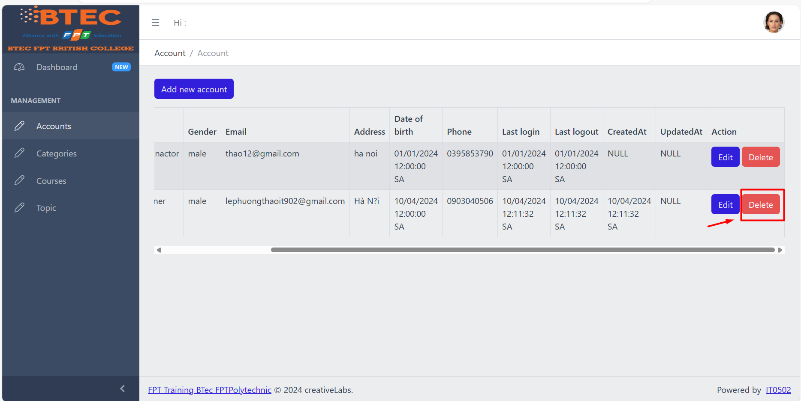

### **User category management**

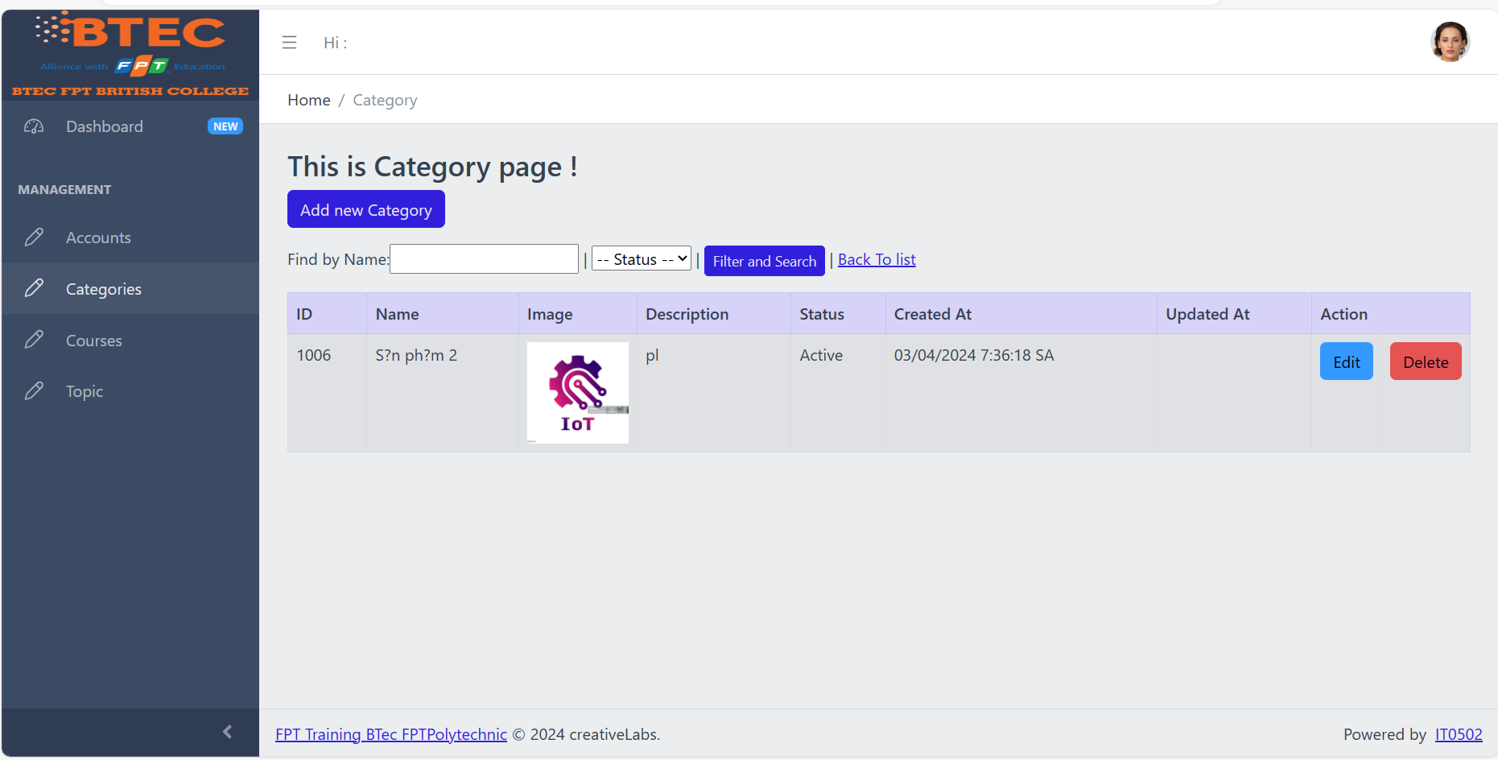

Available course catalogs can be searched

Add new course categories

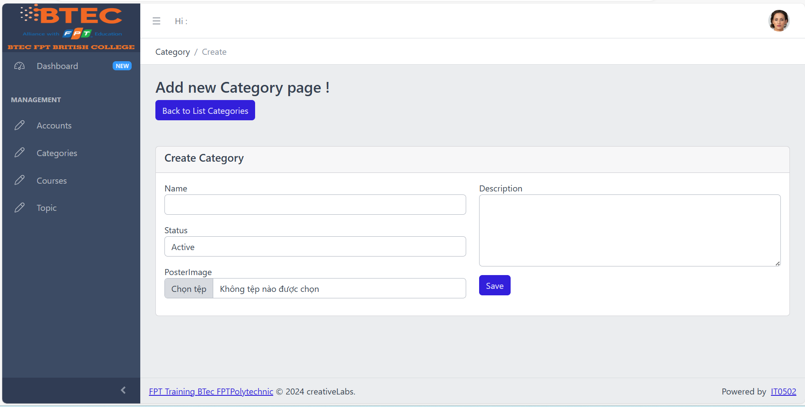

Update category information

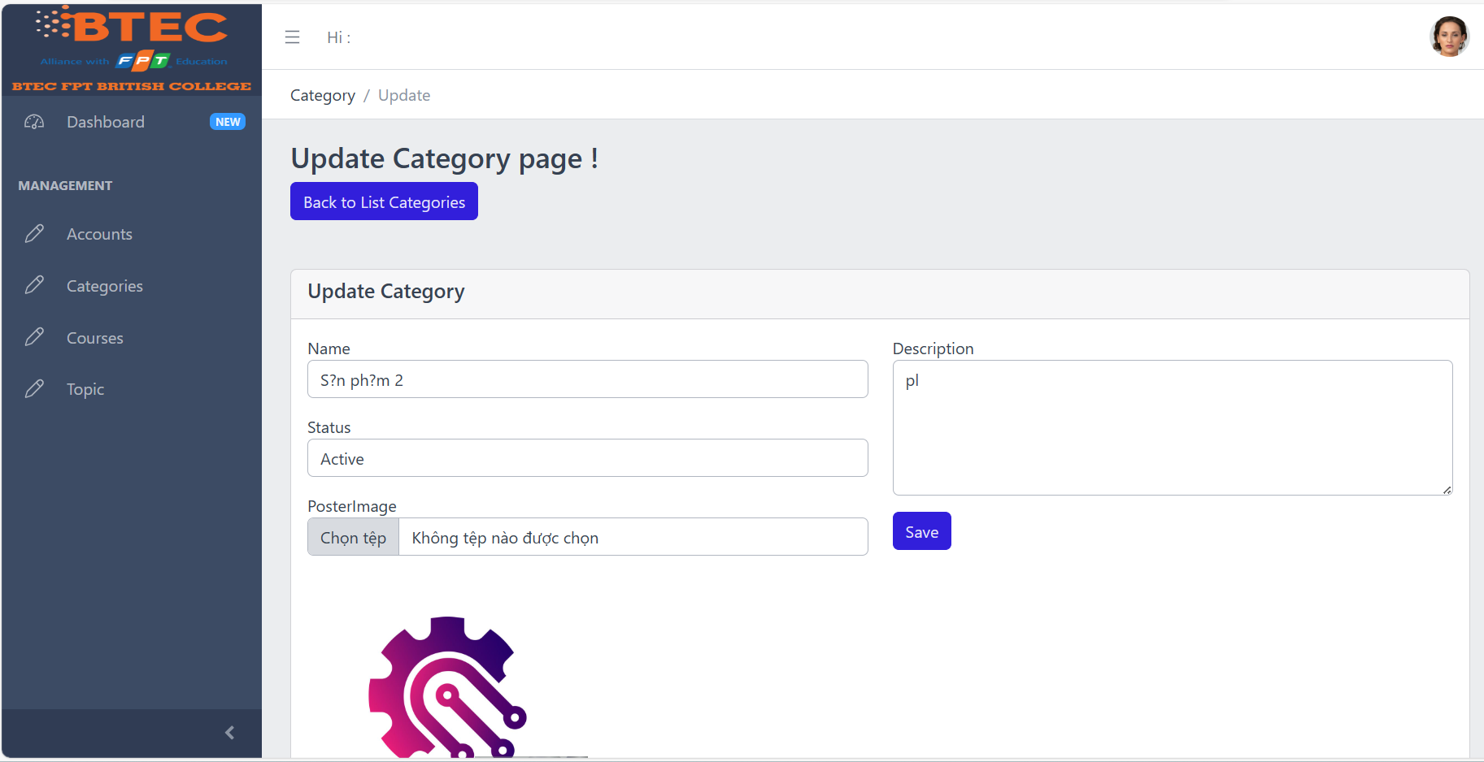

Delete course categories

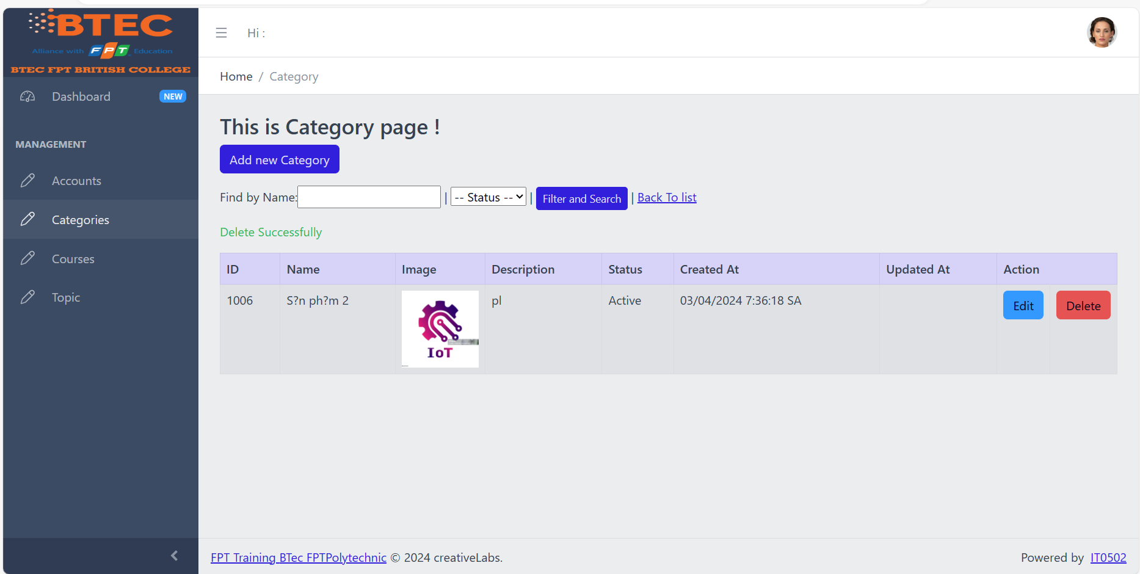

### **User Course management.**

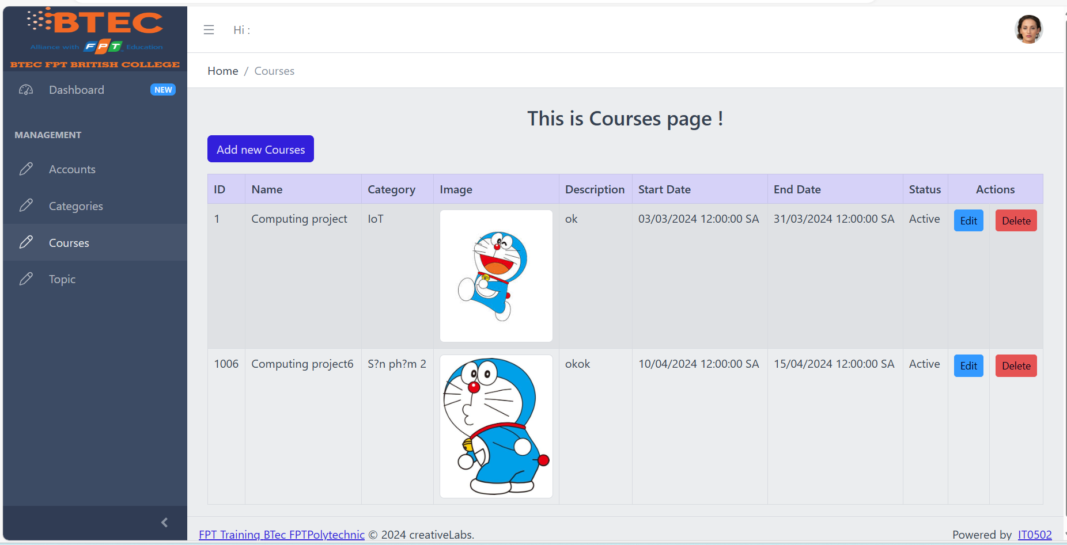

Add new courses helps provide more options for learners and meets new training needs within the organization.

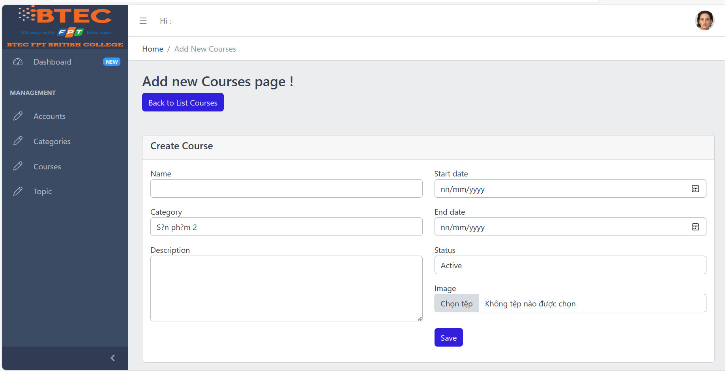

Update details of existing courses, including names and descriptions, to ensure accuracy and alignment with training objectives and learner requirements.

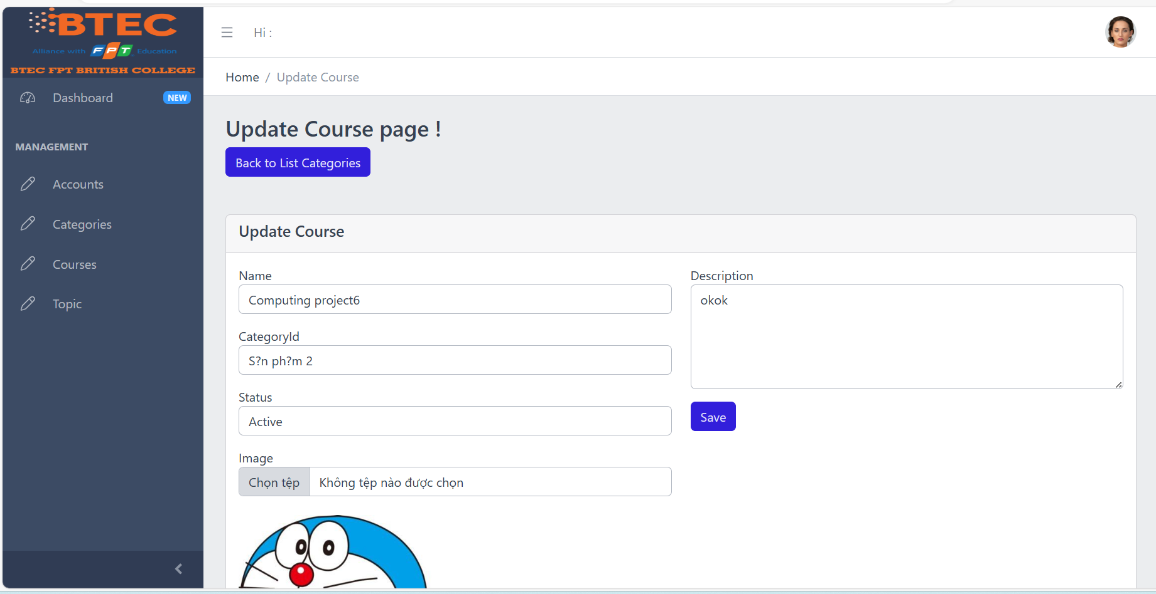

Delete outdated or no longer relevant courses helps maintain current course catalogs and enhances the effectiveness of the training system.

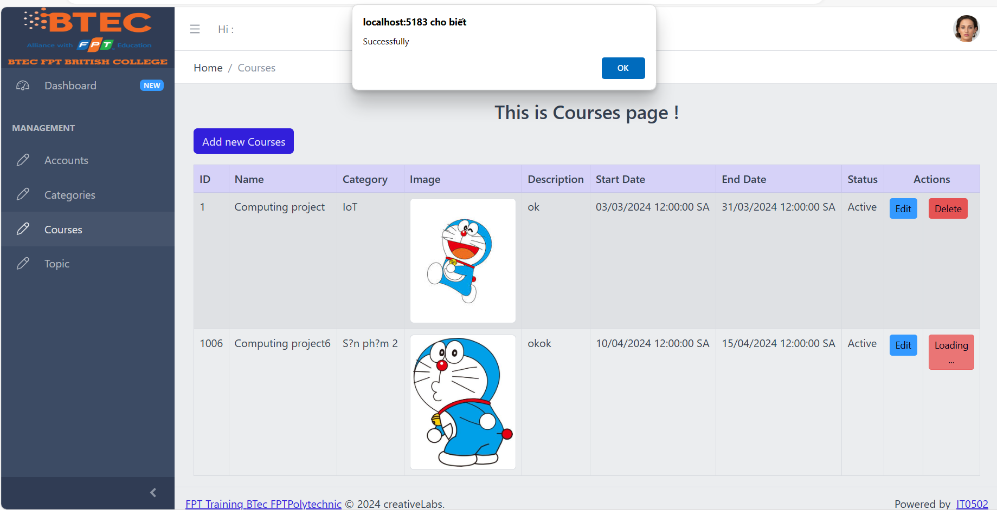

### **User Topic management.**

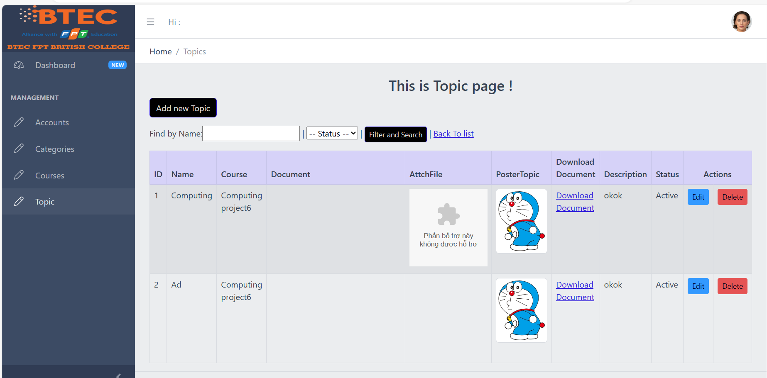

Add new topics to existing courses, providing additional learning resources for students.

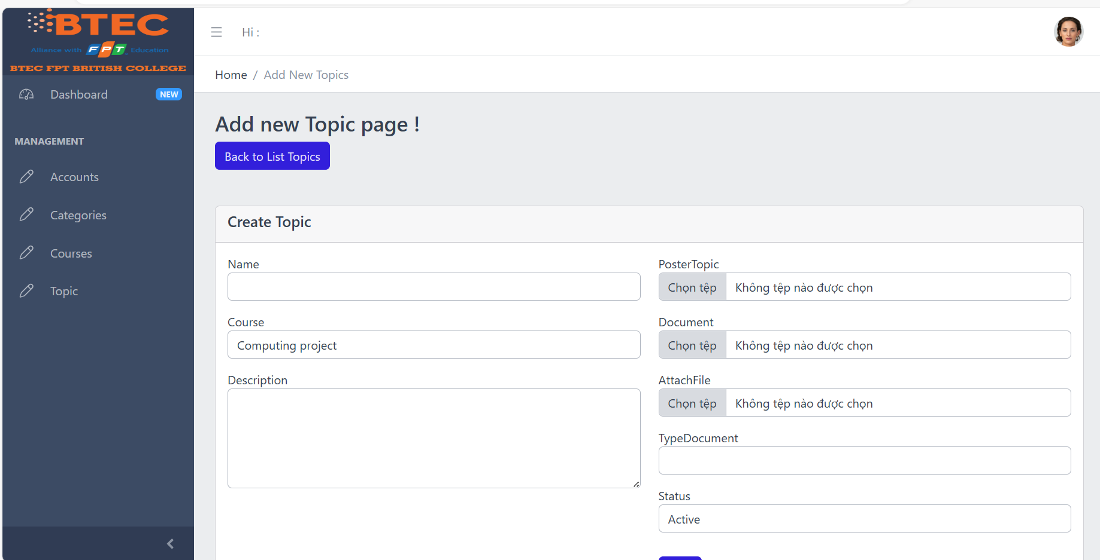

Edit topics into existing courses, provide additional learning materials new for students.

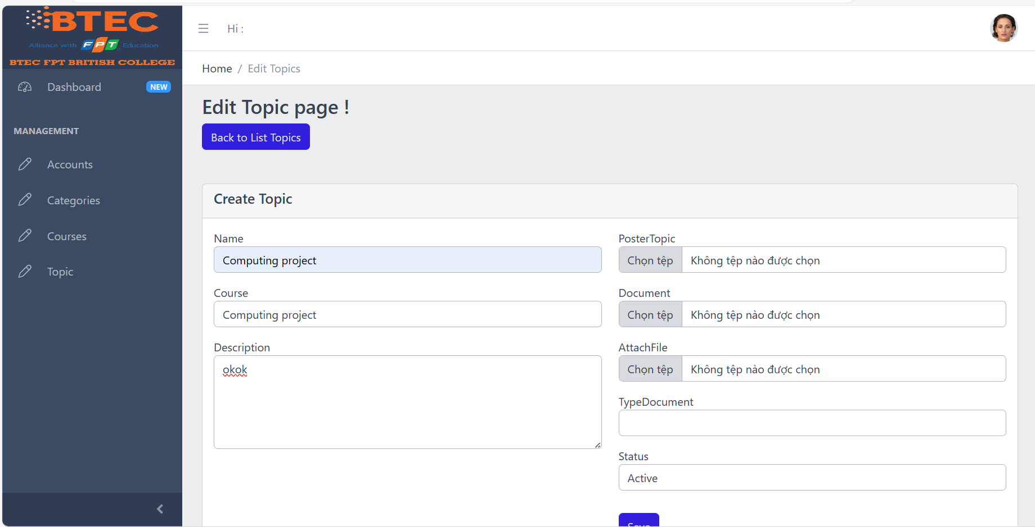

Delete topic

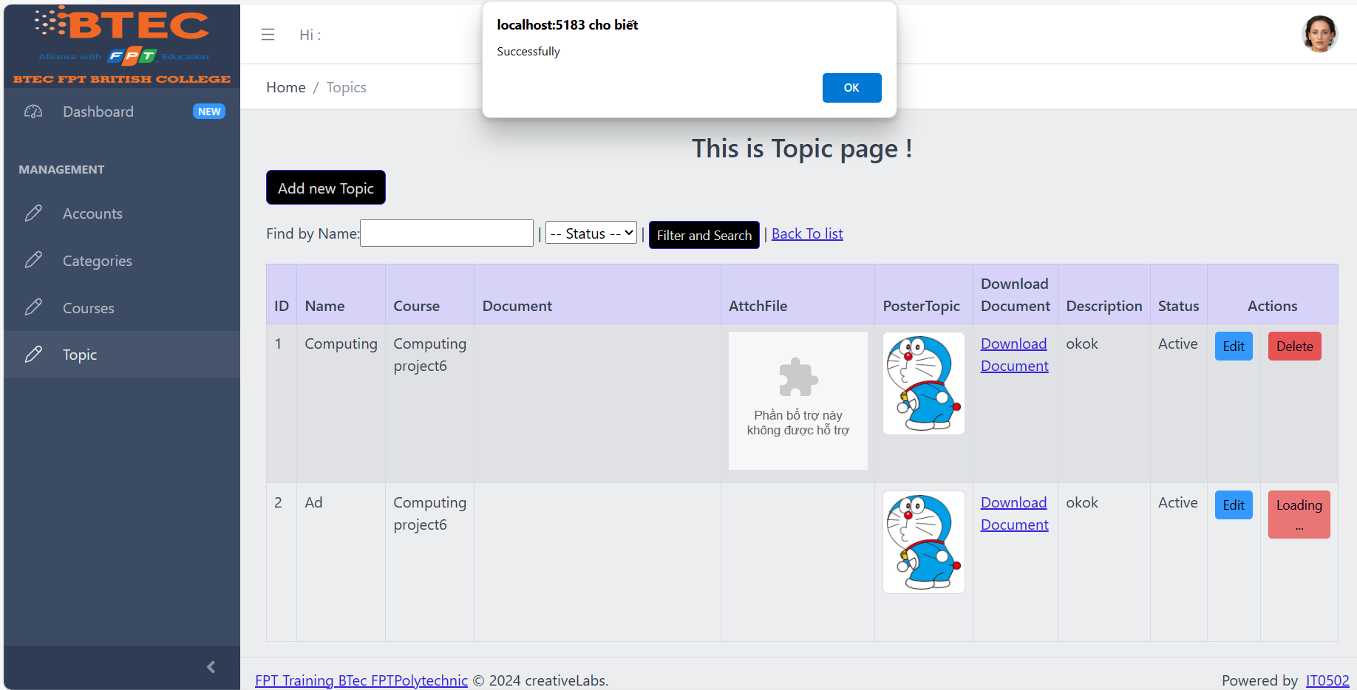

### **User TrainerTopic management.**

View and Update Personal Information: TrainerTopic can log in to the system and update its personal information, including name, type (External or Internal), education level, place of work, phone number and email address.

View Assigned Courses : TrainerTopic can view the list of courses they are assigned to. This helps them know the specific courses they are required to teach.

### **Trainee_course management.**

Create a new student account by entering detailed information such as name, age, date of birth, education level, primary programming language, TOEIC score, experience information, department, work location, etc.

Update and delete existing student accounts.

Manage course categories: Search, add, update and delete course categories. The course catalog includes information such as the catalog name and description.

Course management (courses): Search, add, update and delete courses. Courses include information such as course name and description.

Managing topics: Add new topics including topic name and description to the course. Add a course to the course catalog.

Trainer profile management: Add, update and delete trainer profile information including name, type (offsite or internal), place of work, phone number and email address. Assign trainer to a topic: Assign trainer to a specific topic.

Assign trainee to a course: Assign trainee to a specific course.

## **Trainer Role**

Login and Profile Management:

Coaches can log in to the system using the credentials provided by the administrator.

After successfully logging in, the coach can update personal profile information including coach name, external or internal type, education level, place of work, phone number and email address .

View Assigned Courses : The coach can view the courses to which he is assigned as a coach.

Suggested Course Profile Updates :

The coach can suggest updating information about the courses he takes.

This may include updating the course name, course description or start/finish times.

Course Feedback : The coach can provide feedback on the courses he takes, including feedback from students and suggestions for improvement.

Conducting Tests and Assessments : The trainer can conduct tests and assessments for the students in the course he is responsible for.

Student Support : Coaches can provide support to students during their studies, including answering questions and providing guidance.

### **Login Trainer account**

To log into your coach account in the system, you need to visit the login page and enter your login information. You will then be redirected to the trainer account interface, where you can manage your personal information and experience the courses you are assigned.

Records management:

Update personal information: Coaches can update personal information such as name, type (internal or external), education level, place of work, phone number and email address.

View Courses:

Access the list of courses the coach is assigned to teach.

View detailed information about courses, including names, descriptions, dates and locations.

Take the Test and Assessment:

Conduct tests and assessments for students in the courses the coach is in charge of.

View results of tests and assessments, and provide feedback to students.

Interaction with Students:

Provide support and answer questions for students during the learning process.

Send notifications or messages to students related to the course.

Managing Access to Learning Resources:

Access and use learning resources, documents or tools that the system provides for coaches and students.

1. **Functional requirements of system Below are the functional requirements for each actor of the system**

### **Functional requirements of Admin**

User Account Management:

Create, edit, and delete user accounts for coaches and training staff.

Assign access rights to each type of user.

User Profile Management:

Update users' personal information, including name, type (internal or external), education level, place of work, phone number, and email address.

Manage Coach Profile:

Add, update, and delete coach information, including name, type (internal or external), education level, place of employment, phone number, and email address.

Management of Training Staff Records:

Add, update, and delete training employee information, including name, location, department, and contact information.

Course and Topic Management:

Add, edit, and delete courses and topics.

Categorize and assign courses to different categories.

Managing Learning Resources:

Manage documents, resources, and learning tools used in courses.

Create and Manage Tests and Assessments:

Create tests and assessments for students.

View and manage results of tests and assessments.

Handling Feedback and Questions:

Handle feedback and inquiries from users and provide support when needed.

Security and Permission Management:

Ensure the safety and security of user and system data.

Manage access permissions to ensure only authorized users can access essential functions and data.

Data Backup and Recovery: Perform periodic data backup and recovery to ensure system data integrity and availability.

### **Functional requirements of Training staff.**

Managing Student Records:

Create, edit and delete student profile information, including name, age, date of birth, education level, primary programming language, TOEIC score, experience details, department and work location .

Create and Manage Courses:

Create, edit and delete courses.

Manage detailed information about courses, including name, description, time, location and maximum number of students.

Create and Manage Topics:

Create, edit and delete topics.

Categorize and assign topics to corresponding categories.

Add and Manage Course Topics: Add and manage topics to courses, including topic names and descriptions.

Classifying and Searching Students:

Sort students by criteria such as primary programming language, TOEIC score, department, etc.

Search and filter students based on defined criteria.

Administer Tests and Assessments: Create and manage tests and assessments for students. View and update results of tests and assessments.

Sending Notifications and Messages: Send notifications or messages to students regarding courses or events.

Student Support: Provide support and answer questions for students during the learning process.

View and Track Academic Progress: View and track each student's learning progress in courses.

### **Functional requirements of Trainer.**

Manage Personal Information: Update your personal information such as name, type (internal or external), education level, place of work, phone number and email address.

View Courses and Topics:

Access a list of courses and topics that the coach is assigned to teach.

View detailed information about courses and topics, including names, descriptions, dates and locations.

Take the Test and Assessment:

Conduct tests and assessments for students in the courses the coach is in charge of.

View results of tests and assessments, and provide feedback to students.

Interaction with Students:

Provide support and answer questions for students during the learning process.

Send notifications or messages to students regarding courses or events.

Managing Learning Resources: Access and use documents, resources and learning tools provided in the system.

View Learning Progress: View and track each student's learning progress in courses.

Register for Courses: Register to participate in courses or topics that the coach is interested in or assigned.

User Account Management (optional): Edit and update student account information, if authorized.

### **Functional requirements of Trainee.**

Login and Manage Account:

Log in to the system with your account.

Update personal information such as name, age, address, phone number, etc.

View Courses and Topics:

View the list of courses and topics available in the system.

View detailed information about each course and topic including descriptions, instructors, times, locations, and more.

Register and Join the Course:

Register to participate in courses or topics that interest students.

Participate in registered courses.

Participate in Learning Activities: Watch and participate in lectures, tutorials, discussions, and more according to the course schedule.

Complete Assignments and Tests: Complete assignments and tests assigned in the course. Submit assignments and tests upon completion.

View and Get Feedback: View results and feedback from instructors after completing assignments and tests.

Interaction and Communication: Participate in forums, discussions or chat groups to exchange ideas and learning experiences with fellow students.

Track Learning Progress: View and track your own learning progress in registered courses.

Evaluation and Feedback: Evaluate and provide feedback on course quality and learning experiences.

# **III. Review the performance of your business application against the Problem Definition Statement and initial requirements**

## **Test plan**

Before implementing the FPT Human Resources training system, I recommend implementing a detailed testing plan to ensure that the system's functions meet specific requirements and effectively serve the needs of the organization. training position. This plan will include designing various scenarios and test cases to evaluate the performance, usability, and reliability of the system. During testing, we will identify and resolve specific issues in scenarios such as login, account management, course management, user interface, and other system functions. Test cases will include both normal and edge cases, ensuring that the system operates smoothly and reliably in all situations.

|  |  |  |  |  |
| --- | --- | --- | --- | --- |
| **Test Item** | **Description** | **Test Objective** | **Test Type** | **Status** |
| **Login Function** | Test the login functionality | To check the user can log in:  Verify that users can enter their credentials (username and password) on the login page.  Make sure the system verifies and accepts correct user credentials.  Check that the user is redirected to the main UI after successful login. | Functional | Pass |
| **Account Creation** | Test the creation of new accounts | To ensure you can create a new account:  Test the new account creation feature on the admin interface.  Verify that the administrator can enter information for the new account including name, email, password, etc.  Ensure that the system stores and verifies newly created account information. | Functional | Pass |
| **Account Editing** | Test the editing of account details | To confirm users can update account details:  Test the account information update feature on the user interface or admin interface.  Verify that users or administrators can change account information such as name, email, password, etc.  Ensure that the system stores and updates account information accurately. | Functional | Pass |
| **Account Delettion** | Test the deletion of accounts | To confirm the user can delete the account:  Test the account deletion feature on the admin interface.  Verify that administrators can select and delete user accounts from the user list.  Ensure that the system removes account information and prevents user access after the account is deleted. | Functional | Pass |
| **Category Management** | Test the management of course categories | Make sure you can add, edit, and delete categories. | Functional | Pass |
| **Course Management** | Test the management of courses | Confirm that you can add, edit, and delete courses. | Functional | Pass |
| **Topic Management** | Test the management of topics | Make sure you can add, edit, and delete topics. | Functional | Pass |
| **Trainer Assignment** | Test the assignment of trainers | Confirm that you can assign instructors to topics and courses. | Functional | Pending |
| **Trainee Assignment** | Test the assignment of trainees | Make sure you can assign students to courses. | Functional | Pending |

## **Functional requirements of system**

Below is the functional requirement of the system

|  |  |  |
| --- | --- | --- |
| **ID** | **Functional Requirement** | **Description** |
| **F1** | User Authentication | The system must authenticate users' identities securely. |
| **F2** | Administrator Login | Administrators should be able to access the system's login page and log in using a unique username and password. |
| **F3** | User Account Management | Administrators must be able to create, modify, and delete user accounts for trainers and training staff. This involves assigning or updating usernames and passwords for these accounts. |
| **F4** | Training Staff Login | Registered training staff members, who have been assigned a username and password by the administrator, should be able to log in to the system. |
| **F5** | Trainee Account Creation | Training Staff upon successful login, training staff members should have the capability to create trainee accounts. This involves entering various details such as the trainee's name, age, date of birth, education, programming language proficiency, TOEIC score, experience details, department, and location |
| **F6** | Trainee Database | The system shall store trainee details entered by the training staff for future reference. |
| **F7** | Trainee List Management | Training staff shall have access to a list of trainees and the ability to search based on various criteria such as trainee account, programming language, and TOEIC score. |
| **F8** | Trainee Account Update/Delete | Training staff shall be empowered to update and delete trainee accounts as necessary. |
| **F9** | Course Category Management | Training staff shall be able to perform operations related to course categories, including searching, adding, updating, and deleting. Each category shall have a name and description. |
| **F10** | Course Management | Training staff shall have control over course management tasks, including searching, adding, updating, and deleting courses. Each course shall have a name and description. |
| **F11** | Topic Management | Training staff shall be capable of adding topics to courses and assigning courses to specific categories. Topics shall be defined by their name and description. |
| **F12** | Trainer Profile Management | Training staff shall manage trainer profiles, including adding, updating, and deleting information like trainer name, external or internal type, working place, telephone, and email address. |
| **F13** | Topic Assignment | Training staff members should have the capability to allocate trainers to particular topics within the training curriculum. |
| **F14** | Trainee Assignment | Training staff members are responsible for assigning trainees to specific courses within the training program. |
| **F15** | Trainer Login | Trainers who have been registered by the administrator should be able to access their accounts and update personal information, such as their name, classification (external or internal), educational background, place of work, contact number, and email address. |
| **F16** | Course Visibility | Trainers should be able to view the list of courses that have been assigned to them based on the topics they are responsible for delivering. |

### **Administrator**

Functional Requirements Analysis for Administrator :

Login function:

Administrators need to be able to access the system by logging in via the application's main page, using valid credentials.

User Account Management:

Administrators must have permission to create, modify, and delete user accounts for coaches and training staff.

Existing user accounts need to be edited, allowing username and password changes.

Test Case for Administrator:

|  |  |  |  |  |  |
| --- | --- | --- | --- | --- | --- |
| **ID** | **Description** | **Test Steps** | **Expected Result** | **Actual Result** | **Status** |
| **1** | Login Functionality Test | Go to the login page.  Enter administrator credentials.  Press the "Login" button. | Successful login redirects to the system dashboard | Successful login redirects to the system dashboard | **Pass** |
| **2** | User Account Creation Test (training staff and trainer) | Access user management.  Select the "Create New User" function.  Enter the new user's details.  Press the "Save" button. | New user account is created successfully | New user account is created successfully | **Pass** |
| **3** | User Account Editing Test (training staff and trainer) | Navigate to the user management section.  Select the user to edit.  Click on the "Edit" function.  Change the necessary information.  Press the "Save" button. | User account details are updated successfully | User account details are updated successfully | **Pass** |
| **4** | User Account Deletion Test (training staff and trainer) | Access user management.  Select the user you want to delete.  Tap the "Delete" function.  Confirm deletion. | User account is deleted from the system | User account is deleted from the system | **Pass** |
| **5** | Username and Password Change Test | Access account settings.  Select the "Change Username/Password" function.  Enter new information.  Press the "Save" button. | Username and password are updated successfully | Username and password are updated successfully | **Pass** |