**\*This document may only be written by project managers\***

**I. Certificates for project managers:**

**II. Certificates for contributors:**

**\*Certificate of Achievement for outstanding contributor**

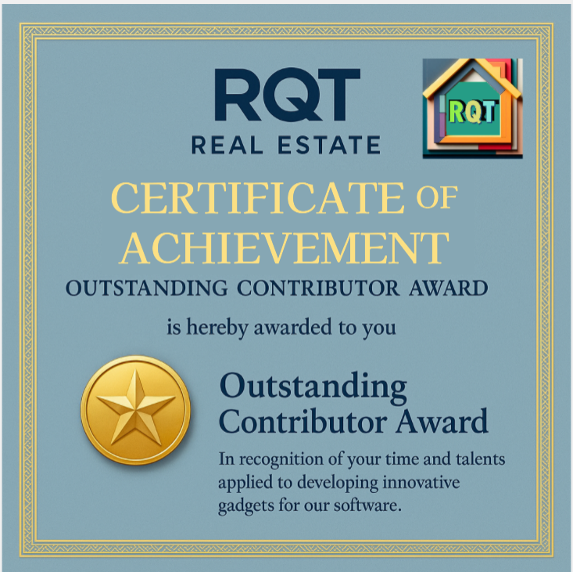

**I.Purposes/Missons:**

This certificate will be given to any contributor of this project after they complete the process of contributing anything to the project.

This certificate is placed in folder **RQT_Real_Estate\Certificates**

**Notice:**

*The original version doesn’t show any name on it, but we will redesign this certificate later to show the name of any contributor on it before we hand it to them as a reward.

*The original version can be put into any issue document on the RQT_Real_Estate repository on GitHub to let the contributor know that we will reward them with a special certificate like this