**+Contributors:**

Trieu Huu Phuong

In Eclipse, to help JavaFX works with SceneBuilder and CSS files

First, create CSS file in your **src/application** folder

Ex:

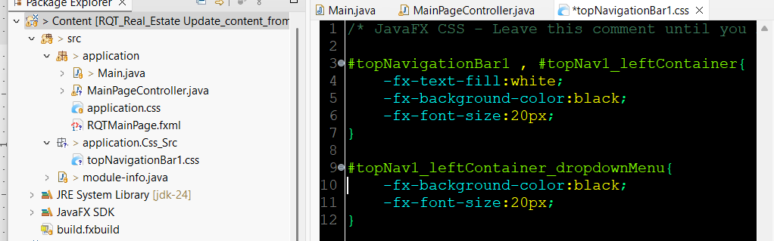

Import your CSS file into your JavaFX app’s scene

=>Syntax in your Main.java file should look something like this:

**package** application;

**import** java.io.*;

**import** javafx.application.Application;

**import** javafx.stage.Stage;

**import** javafx.scene.Scene;

**import** javafx.fxml.FXMLLoader;

**import** javafx.scene.Parent;

/*

* First, make sure any box in fxml file contains these attributes syntaxes

* xmlns="http://javafx.com/javafx/23.0.1" xmlns:fx="http://javafx.com/fxml/1"

fx:controller="application.MainPageController">

* */

**public** **class** Main **extends** Application {

**private** **static** Scene scene;

**@**Override

**public** **void** **start**(Stage **stage**) **throws** IOException {

scene = **new** Scene(loadFXML(**"RQTMainPage"**), **640**, **480**);

stage.setScene(scene);

scene.getStylesheets().add(**"src/application/Css_Src/topNavigationBar1.css"**);

stage.setTitle(**"RQT Real Estate"**);

stage.show();

}

**static** **void** **setRoot**(String **fxml**) **throws** IOException {

scene.setRoot(loadFXML(fxml));

}

**private** **static** Parent **loadFXML**(String **fxml**) **throws** IOException {

FXMLLoader **fxmlLoader** = **new** FXMLLoader(Main.**class**.getResource(fxml + **".fxml"**));

**return** fxmlLoader.load();

}

**public** **static** **void** **main**(String[] **args**) {

launch();

}

}

On your FXML file, make sure each features and tools on your page contains fx:id and id properties

Below are an example of one of my program in **RQTMainPage.fxml** file, you can build syntax for this file on **SceneBuilder** first:

<?xml version=*"1.0"* encoding=*"UTF-8"*?>

<?import javafx.geometry.Insets?>

<?import javafx.scene.control.ComboBox?>

<?import javafx.scene.control.Label?>

<?import javafx.scene.control.Menu?>

<?import javafx.scene.control.MenuBar?>

<?import javafx.scene.control.MenuItem?>

<?import javafx.scene.layout.AnchorPane?>

<?import javafx.scene.layout.BorderPane?>

<?import javafx.scene.layout.HBox?>

<?import javafx.scene.layout.StackPane?>

<?import javafx.scene.text.Font?>

<StackPane maxHeight=*"-Infinity"* maxWidth=*"-Infinity"* minHeight=*"-Infinity"* minWidth=*"-Infinity"* prefHeight=*"400.0"* prefWidth=*"600.0"* xmlns=*"http://javafx.com/javafx/23.0.1"* xmlns:fx=*"http://javafx.com/fxml/1"* fx:controller=*"application.MainPageController"*>

<children>

<AnchorPane id=*"topNavigationBar_anchorPane1"* fx:id=*"topNavigationBar_anchorPane1"* prefHeight=*"100.0"* prefWidth=*"620.0"*>

<children>

<BorderPane id=*"topNavigationBar1"* fx:id=*"topNavigationBar1"* prefHeight=*"43.0"* prefWidth=*"600.0"* style=*"-fx-background-color: black;"* AnchorPane.leftAnchor=*"0.0"* AnchorPane.topAnchor=*"0.0"*>

<center>

<Label id=*"topNav1_MiddleLogo"* fx:id=*"topNav1_MiddleLogo"* text=*"RQT"* textFill=*"#08dcfc"* BorderPane.alignment=*"CENTER"*>

<font>

<Font size=*"22.0"* />

</font>

</Label>

</center>

<left>

<HBox id=*"topNav1_leftContainer"* fx:id=*"topNav1_leftContainer"* prefHeight=*"100.0"* prefWidth=*"200.0"* BorderPane.alignment=*"CENTER"*>

<children>

<ComboBox id=*"topNav1_leftContainer_dropdownMenu"* fx:id=*"topNav1_leftContainer_dropdownMenu"* prefHeight=*"18.0"* prefWidth=*"76.0"* promptText=*"Menu"* />

</children>

<padding>

<Insets bottom=*"10.0"* left=*"10.0"* right=*"10.0"* top=*"10.0"* />

</padding>

</HBox>

</left>

<right>

<BorderPane id=*"topNav1_rightContainer"* fx:id=*"topNav1_rightContainer"* prefHeight=*"200.0"* prefWidth=*"200.0"* BorderPane.alignment=*"CENTER"*>

<right>

<MenuBar id=*"topNav1_rightContainer_menuBar"* fx:id=*"topNav1_rightContainer_menuBar"* BorderPane.alignment=*"CENTER"*>

<menus>

<Menu id=*"topNav1_rightContainer_menuBar_signUp_butt"* fx:id=*"topNav1_rightContainer_menuBar_signUp_butt"* mnemonicParsing=*"false"* text=*"Sign Up"*>

<items>

<MenuItem mnemonicParsing=*"false"* text=*"Close"* />

</items>

</Menu>

<Menu id=*"topNav1_rightContainer_menuBar_signUp_butt"* fx:id=*"topNav1_rightContainer_menuBar_help_butt"* mnemonicParsing=*"false"* text=*"Help"*>

<items>

<MenuItem mnemonicParsing=*"false"* text=*"About"* />

</items>

</Menu>

</menus>

</MenuBar>

</right>

<padding>

<Insets bottom=*"10.0"* left=*"10.0"* right=*"10.0"* top=*"10.0"* />

</padding>

</BorderPane>

</right>

</BorderPane>

</children>

</AnchorPane>

</children>

</StackPane>

*Here’s what happened on my SceneBuilder Gluon*

I’m not going to show every fx:id properties and their values on this SceneBuilder here in this document, but if you want the GUI to automatically update style whenever you make changes to your css files, please add those css files into your SceneBuilder through the steps below:

Go to Preview -> Scene Style Sheets -> Add a Style Sheet

Choose a css file and click Open

Now you can open your css file from SceneBuilder and edit it from a text editor

Since I’m still working on my Eclipse IDE, I’m going to edit this CSS file on it instead of any other text editor

Let’s say I’m going to change the topNav1_leftContainer_dropdownMenu’s background color to white, then save it, the GUI inside SceneBuilder will make changes too!

Save

