Sources:

CISC 190 Java Programming

<https://medium.com/@Satyam_Mishra/getting-started-with-javafx-in-vscode-beginner-way-9fed580fd4f>

**+Contributors:**

Trieu Huu Phuong

**Getting started with JavaFx in vscode (Beginner way)**

Java being one of the most used Programming language for software development, has several advance Gui packages in it. One of which is JavaFx the most recent and the most widely used. JavaFx can be used to make cross platform desktop and mobile applications, but I would recommend using it for desktop as there are several better options to opt of mobile applications.

To begin with this guide you must have Java JDK installed in your pc and it’s environment path set.

Then head to this site <https://gluonhq.com/products/javafx/> , scroll down to downloads section and find your OS specific JavaFX SDK. In my case it’s Windows x64 SDK and hit download.

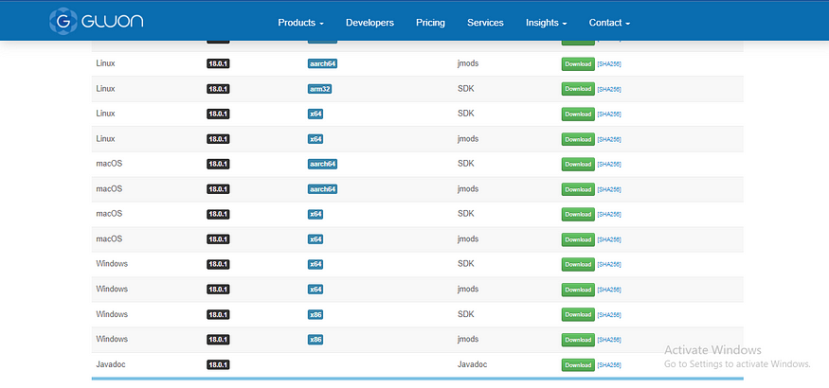

After your download is completed extract the zip file in your desirable location. I would recommend you to extract it any other place else than C drive. I personally install most of software’s in my second drive to help my c drive not get over populated.

Then open up your vscode and download the below extension pack. This extension for java is bundle of Java extensions for creating projects and debugging them. After this step you will be ready to start and create your project.

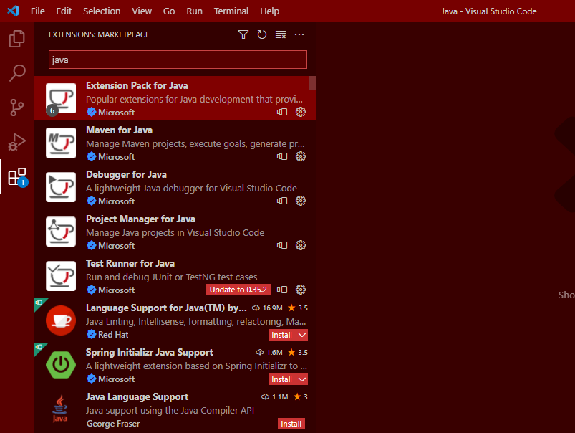

Now press shortcut ctrl + shift + p in your vscode screen to open all commands section and then type create java project in search bar to find below option.

Click the create java project option and you will be asked to create java projects using several other builds and bundle for this guide we will go simple and click no build option.

Then you will be asked to select the folder where you want this project to be made, choice accordingly and another option will be asked to type in project name.

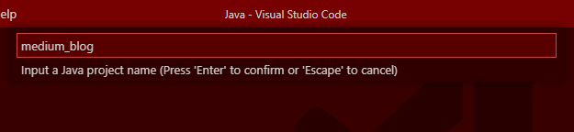

And your new project is ready.

Now find App.java file in src folder and write some test JavaFx code in it.

But wait why is it showing several errors in code. So, to fix that we need to add JavaFx package in our project. find and click the plus button side by to Referenced Libraries.

Find the folder where you extracted the JavaFx SDK files. Open that folder go inside lib and select all the jar files in it and click select jar libraries. And you are just one more step away from your first run.

On top panel you will find Run Tab click and select add configuration option.

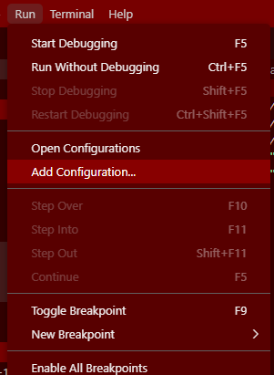

A new launch.json file will be created and opened in that add vmArgs field as in below images.

for Windows users :

--module-path "PATH_TO_FX" --add-modules javafx.controls,javafx.fxml

for Apple/Linux:

--module-path $PATH_TO_FX --add-modules javafx.controls,javafx.fxml

In my E:/Installed softwares/eclipse/javaFX/javafx-sdk-18.0.1/lib

After added value it should look like this. And you are all set to go and run.

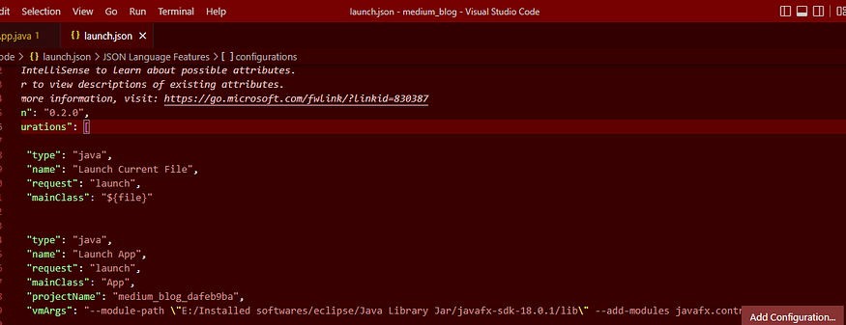

Now run the App.java file and your application is running.

For creating another project you can just repeat this process.