Sources:

CISC190 Java Programming

MS Bing Chat Copilot

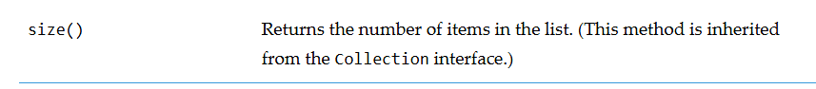

Ex:

**package** application;

**import** javafx.application.Application;

**import** javafx.stage.Stage;

**import** javafx.scene.Scene;

**import** javafx.scene.control.Label;

**import** javafx.scene.control.Button;

**import** javafx.scene.control.TextField;

**import** javafx.scene.image.Image;

**import** javafx.scene.image.ImageView;

**import** javafx.scene.layout.HBox;

**import** javafx.scene.layout.VBox;

**import** javafx.scene.layout.GridPane;

**import** javafx.scene.layout.BorderPane;

**import** javafx.event.ActionEvent;

**import** javafx.event.EventHandler;

**public** **class** **Main** **extends** Application {

**public** **Label** label1;

**public** **Button** button1;

**public** **Button** button2;

**public** **Button** button3;

**public** **Button** button4;

**public** **Button** searchButton;

**public** **Button** button5;

**public** **Button** button6;

**public** **Button** button7;

**public** **Button** bottomButt1;

**public** **Button** bottomButt2;

**public** **Button** bottomButt3;

**public** **Label** aboutLabel;

**public** **TextField** textField1;

**public** **Label** searchLabel;

**public** **Image** image1;

**public** **ImageView** imageView1;

**public** **Image** image2;

**public** **ImageView** imageView2;

**public** **Image** image3;

**public** **ImageView** imageView3;

**public** **HBox** hbox;

**public** **HBox** hbox2;

**public** **HBox** bottomHbox;

**public** **VBox** LeftVBox;

**public** **BorderPane** borderPane;

**public** **Scene** scene;

**public** **static** **void** **main**(**String**[] args) {

***launch***(args);

}

**@Override**

**public** **void** **start**(**Stage** primaryStage) {

primaryStage.**setTitle**(**"GUI Applicaiton"**);

label1 = **new** **Label**(**"Welcome"**);

button1 = **new** **Button**(**"🏠 HOME"**);

button2 = **new** **Button**(**"⏬ MENU"**);

button3 = **new** **Button**(**"! ABOUT"**);

button4 = **new** **Button**(**"? HELP"**);

aboutLabel = **new** **Label**(**"ABOUT: This is a Testing App"**);

textField1 = **new** **TextField**();

searchButton = **new** **Button**(**"🔎 SEARCH"**);

searchLabel = **new** **Label**(**""**);

button3.**setOnAction**(**new** **ButtonClickHandler**());

searchButton.**setOnAction**(**new** **ButtonClickHandler2**());

button5 = **new** **Button**(**"IMAGE"**);

button6 = **new** **Button**(**"STORAGE"**);

button7 = **new** **Button**(**"DESIGN"**);

image1 = **new** **Image**(**"file:wallpaper1.jpg"**);

imageView1 = **new** **ImageView**(image1);

imageView1.**setPreserveRatio**(**true**);

imageView1.**setFitWidth**(**300**);

imageView1.**setFitHeight**(**300**);

image2 = **new** **Image**(**"file:wallpaper2.jpg"**);

imageView2 = **new** **ImageView**(image2);

imageView2.**setPreserveRatio**(**true**);

imageView2.**setFitWidth**(**300**);

imageView2.**setFitHeight**(**300**);

image3 = **new** **Image**(**"file:wallpaper3.jpg"**);

imageView3 = **new** **ImageView**(image3);

imageView3.**setPreserveRatio**(**true**);

imageView3.**setFitWidth**(**300**);

imageView3.**setFitHeight**(**300**);

bottomButt1 = **new** **Button**(**"Privacy Policy"**);

bottomButt2 = **new** **Button**(**"Copyright"**);

bottomButt3 = **new** **Button**(**"Terms of Use"**);

hbox = **new** **HBox**(**10**, button1, button2, button3, button4, textField1, searchButton);

hbox2= **new** **HBox**(**10**,imageView1, imageView2, imageView3);

LeftVBox = **new** **VBox**(**10**, button5, button6, button7);

bottomHbox = **new** **HBox**(**10**, bottomButt1, bottomButt2, bottomButt3);

borderPane = **new** **BorderPane**();

borderPane.**setTop**(hbox);

borderPane.**setLeft**(LeftVBox);

borderPane.**setCenter**(hbox2);

borderPane.**setBottom**(bottomHbox);

scene = **new** **Scene**(borderPane);

primaryStage.**setScene**(scene);

primaryStage.**show**();

}

**class** **ButtonClickHandler** **implements** EventHandler<ActionEvent>{

**@Override**

**public** **void** **handle**(**ActionEvent** event) {

hbox.**getChildren**().**add**(aboutLabel);

}

}

**class** **ButtonClickHandler2** **implements** EventHandler<ActionEvent>{

**@Override**

**public** **void** **handle**(**ActionEvent** event) {

**String** **userInput** = textField1.**getText**();

searchLabel.**setText**(**"Search Result: "**+userInput);

hbox.**getChildren**().**add**(searchLabel);

}

}

}

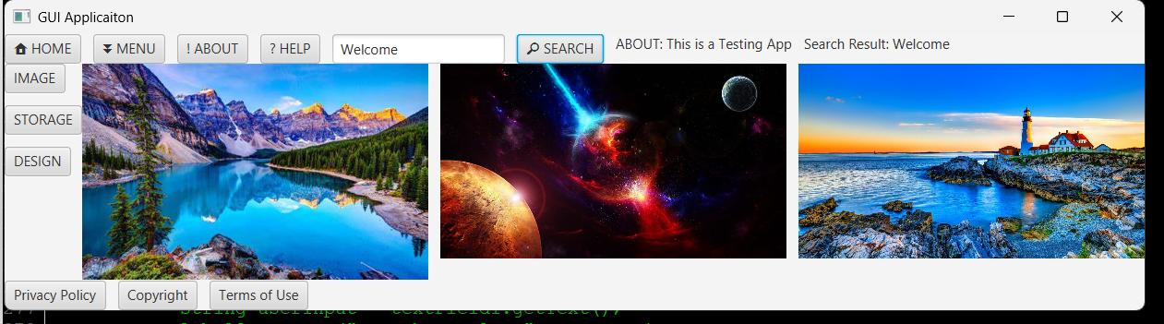

*To check if a node is in an ObservableList interface, here are some things to notice:

Ex:

import javafx.application.Application;

import javafx.collections.ObservableList;

import javafx.scene.Scene;

import javafx.scene.layout.VBox;

import javafx.scene.text.Text;

import javafx.stage.Stage;

public class CheckNodeInObservableList extends Application {

@Override

public void start(Stage stage) {

// Create a VBox and add some nodes

VBox vBox = new VBox();

Text text1 = new Text("Hello");

Text text2 = new Text("World");

vBox.getChildren().addAll(text1, text2);

// Get the ObservableList of children from VBox

ObservableList<Node> children = vBox.getChildren();

// Check if a specific node is in the ObservableList

boolean containsNode = children.contains(text1);

// Output the result

System.out.println("Contains text1: " + containsNode); // Should print: true

// Check for a node not in the list

Text text3 = new Text("JavaFX");

System.out.println("Contains text3: " + children.contains(text3)); // Should print: false

// Set up and show the scene

Scene scene = new Scene(vBox, 300, 200);

stage.setScene(scene);

stage.setTitle("Check Node in ObservableList");

stage.show();

}

public static void main(String[] args) {

launch();

}

}

