Sources:

CISC190 Java Programming

**You can go to this url below to learn more about how to install JavaFX**

**C:\Users\terro\OneDrive\Technology\Programming Languages_CLI\Java\Install_and_Running\CISC190_Appendix_F_Installing_and_Working_with_JavaFX**

**First, make sure your command line interface lead you to your workspace folder:**

**Then, make sure you have java file with some basic syntax to work with JavaFX**

**Syntax in MainClass.java**

**import** javafx.application.Application;

**import** javafx.stage.Stage;

/**

* A simple JavaFX GUI application

*/

**public** **class** **MainClass** **extends** **Application** {

**public** **static** **void** **main**(**String**[] args) {

launch(args);

}

**@Override**

**public** **void** **start**(**Stage** primaryStage) {

primaryStage.setTitle(**"My First GUI Application"**);

primaryStage.show();

}

}

**javac --module-path %PATH_TO_JAVAFX% --add-modules javafx.controls MyFirstFX.java**

**=>**

**javac --module-path "C:\Program Files\Java\javafx-sdk-23.0.2\lib" --add-modules javafx.controls MainClass.java**

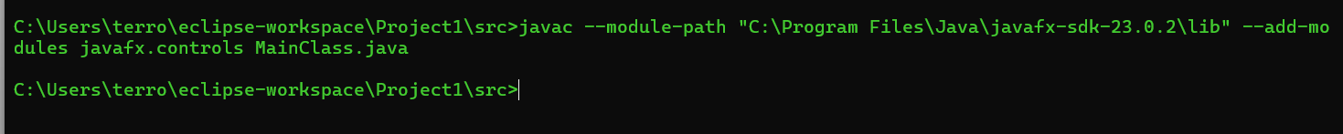

**Because my main class is MainClass.java, I used it in the command above**

**javac --module-path %PATH_TO_JAVAFX% --add-modules javafx.controls MyFirstFX.java**

**java --module-path %PATH_TO_JAVAFX% --add-modules javafx.controls MyFirstFX**

**=>**

**java --module-path "C:\Program Files\Java\javafx-sdk-23.0.2\lib" --add-modules javafx.controls MainClass**



**java --module-path %PATH_TO_JAVAFX% --add-modules javafx.controls MyFirstFX**

**In order to make it easier to work with JavaFX, you can install it to IDE like Eclipse, and so on to avoid the process of writing the complicated commands like above to run it**

**package** application;

**import** javafx.application.Application;

**import** javafx.stage.Stage;

//In case we want to run javaFX on the command line interface

//javac --module-path "C:\Program Files\Java\javafx-sdk-23.0.2\lib" --add-modules javafx.controls MainClass.java

//java --module-path "C:\Program Files\Java\javafx-sdk-23.0.2\lib" --add-modules javafx.controls MainClass

**public** **class** **Main** **extends** Application {

**public** **static** **void** **main**(**String**[] args) {

***launch***(args);

}

**@Override**

**public** **void** **start**(**Stage** primaryStage) {

primaryStage.**setTitle**(**"My First GUI Application"**);

primaryStage.**show**();

}

}

