Sources:

CISC190 Java Programming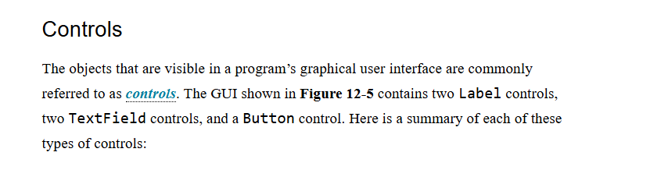

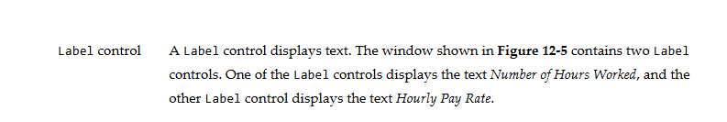

In addition to the **Label control** that displays text, **Text control** also displays text, but we’re not going to use it most of the time because it was designed to display non-editable, stylized text without the need for additional controls like background or alignment. You can find out more information about it online, I’m not going to talk more about it in this document

