Sources:

CISC190 Java Programming

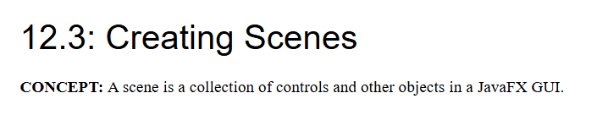



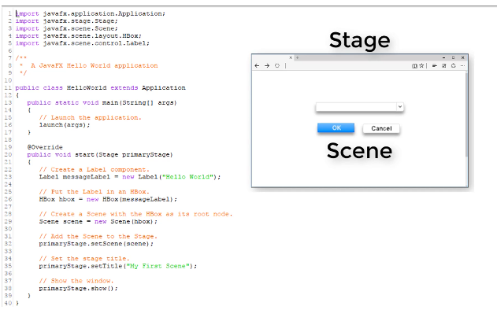

package application;

import javafx.application.Application;

import javafx.stage.Stage;

import javafx.scene.Scene;

import javafx.scene.layout.HBox;

import javafx.scene.control.Label;

public class Main extends Application{

public static void main(String[] args) {

launch(args);

}

@Override

public void start(Stage primaryStage) {

//Create a Label component

Label messageBox1 = new Label("Hello World");

//Put the Label in an HBox.

HBox hbox = new HBox(messageBox1);

//Create a Scene with the HBox as its root node.

Scene scene = new Scene(hbox);

//Add the Scene to the Stage.

primaryStage.setScene(scene);

//Set the Stage title.

primaryStage.setTitle("GUI Program");

//Show the window.

primaryStage.show();

}

}

