Sources:

CISC190 Java Programming

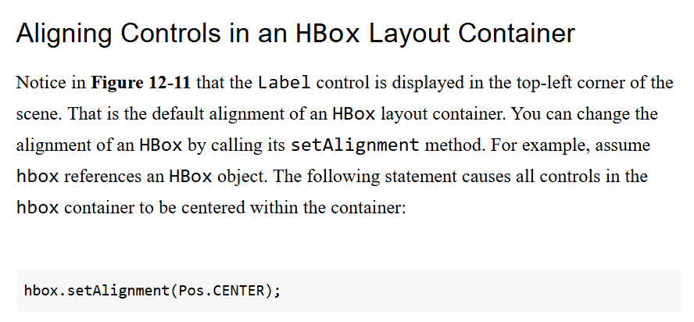

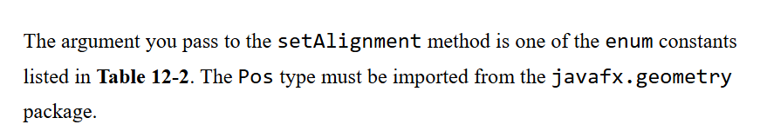

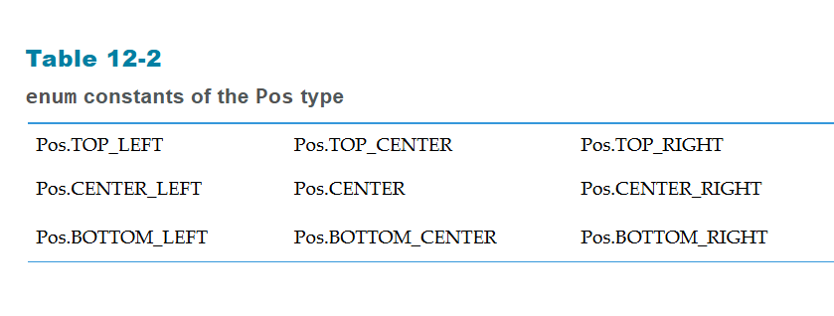

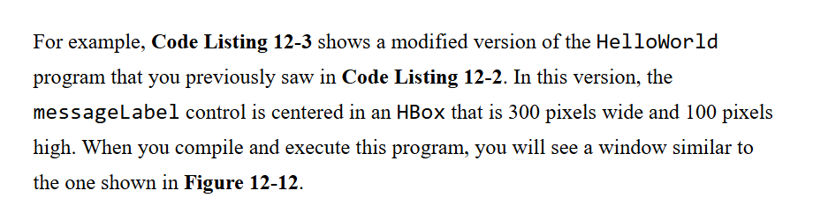

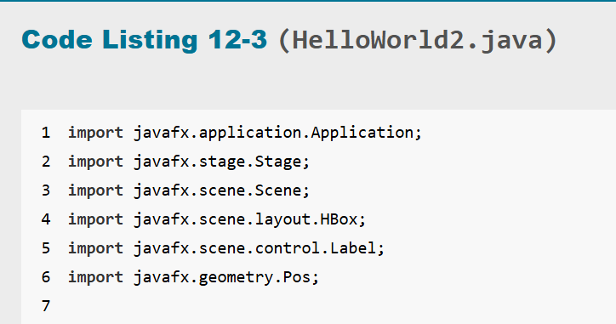

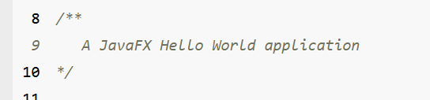

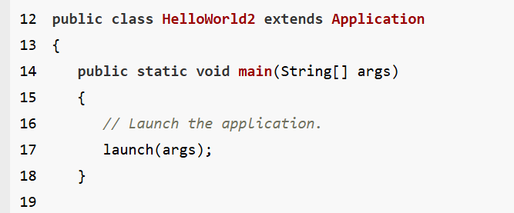

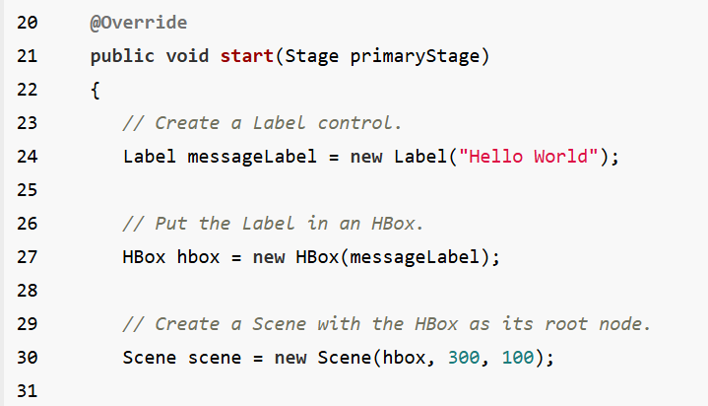

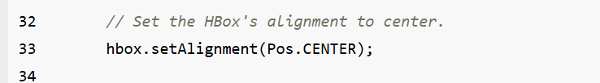

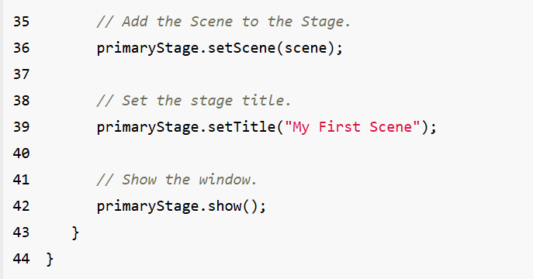

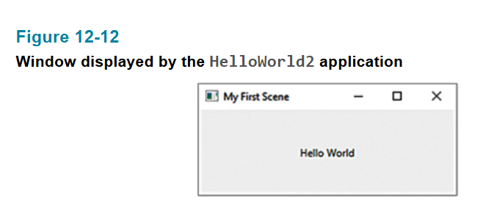

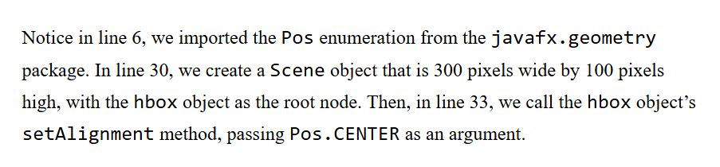

package application;

import javafx.application.Application;

import javafx.stage.Stage;

import javafx.scene.Scene;

import javafx.scene.layout.HBox;

import javafx.scene.control.Label;

import javafx.geometry.Pos;

public class Main extends Application {

public static void main(String[] args) {

launch(args);

}

@Override

public void start(Stage primaryStage) {

Label messageBox1 = new Label("Welcome!!!");

HBox hbox = new HBox(messageBox1);

Scene scene = new Scene(hbox,500,300);

hbox.setAlignment(Pos.TOP_CENTER);

primaryStage.setScene(scene);

primaryStage.setTitle("GUI Program");

primaryStage.show();

}

}

