Sources:

CISC190 Java Programming

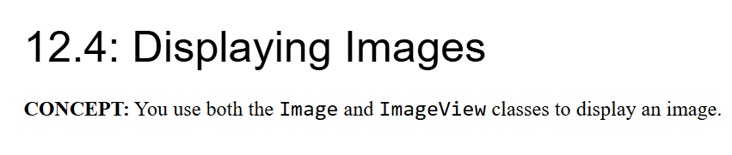



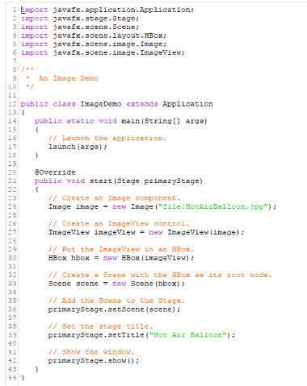

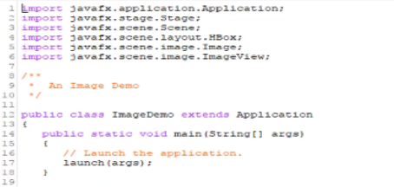

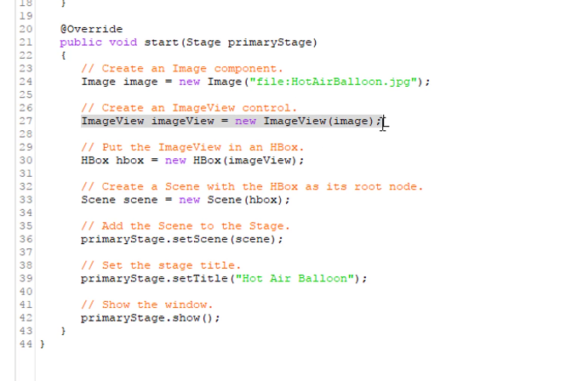

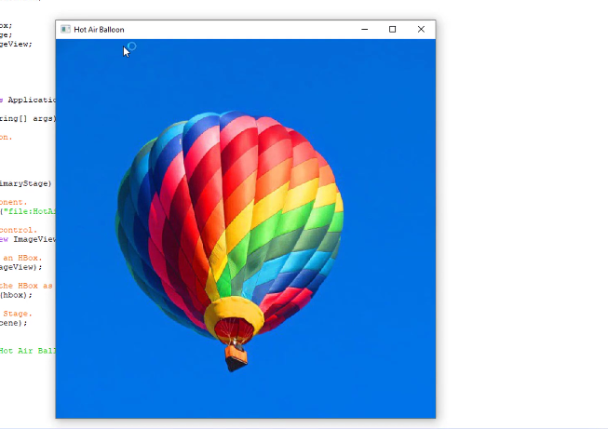

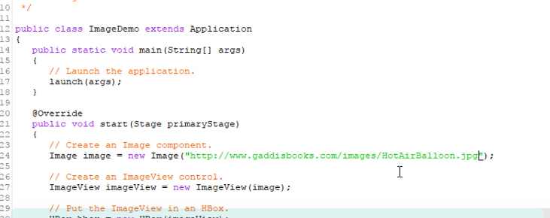

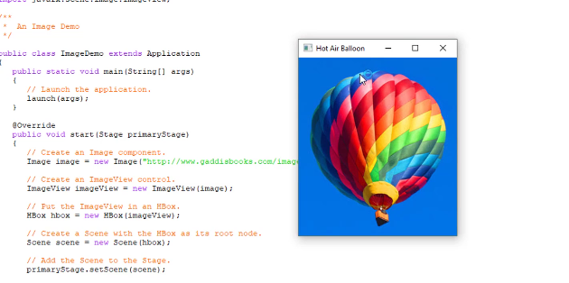

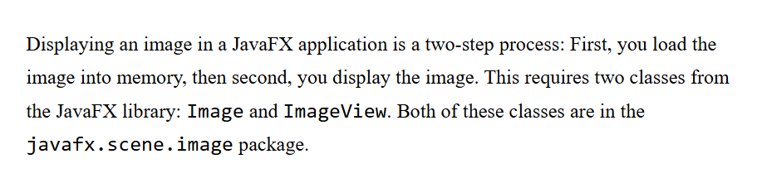

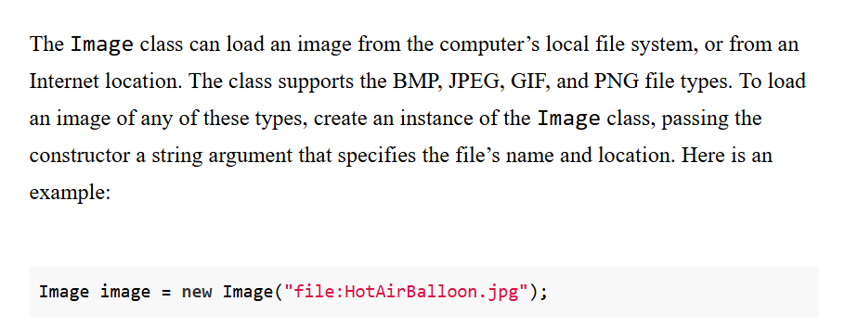

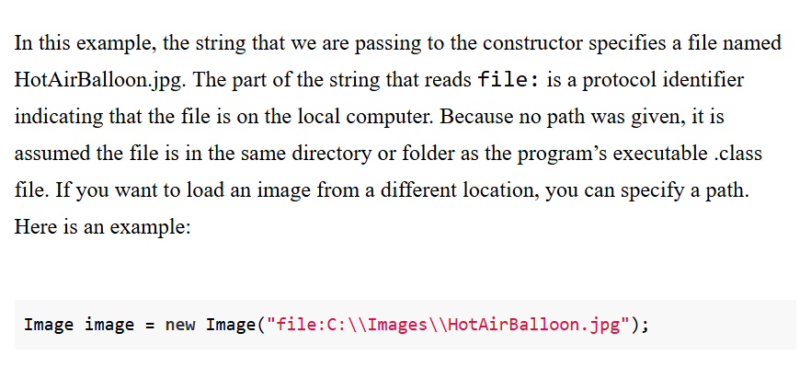

Notice that if your write

Image image = new Image("file:wallpaper1.jpg");

Then make sure that your image file is in a folder like this:



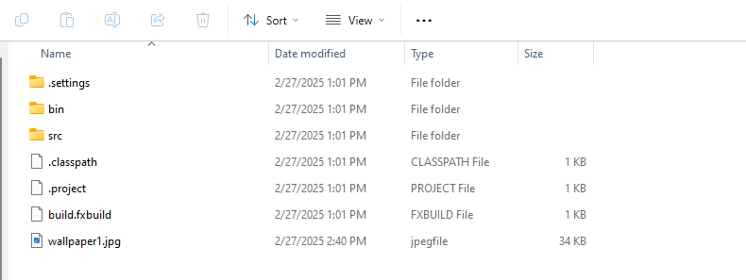

To avoid placing your image in the wrong folder, use the absolute path url:

Image image = new Image("file:C:\\Users\\0005766060\\eclipse-workspace\\JavaFXProject\\wallpaper1.jpg");

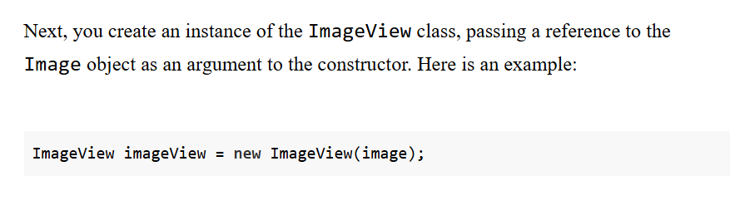

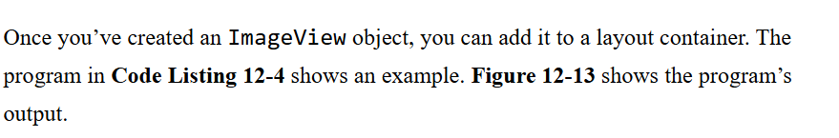



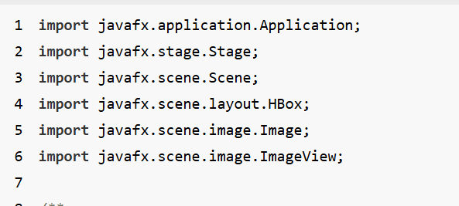

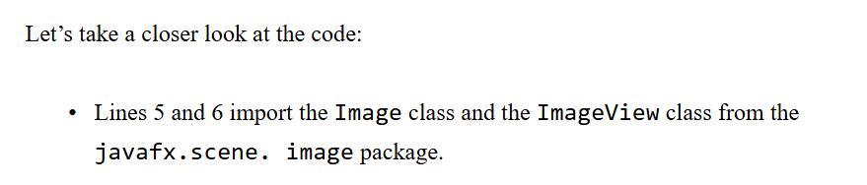

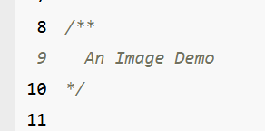

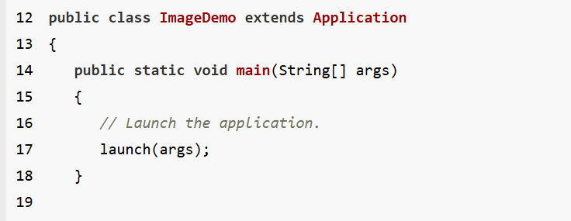

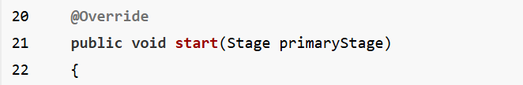

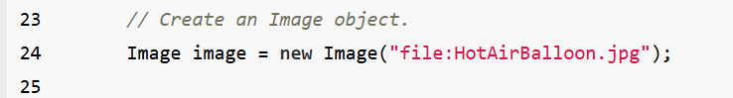

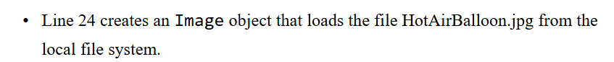

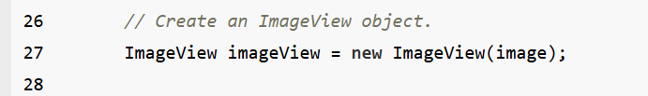

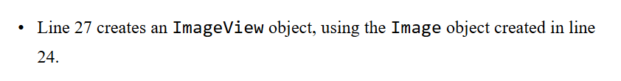

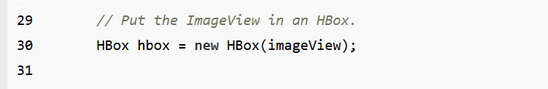

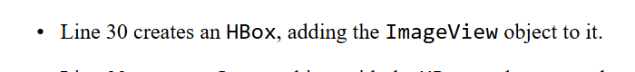

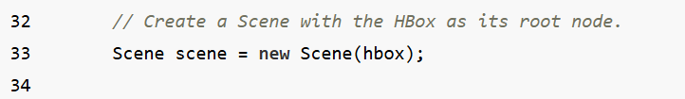

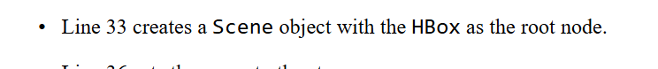

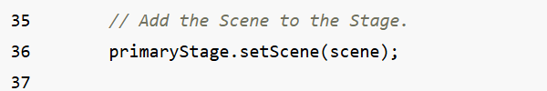

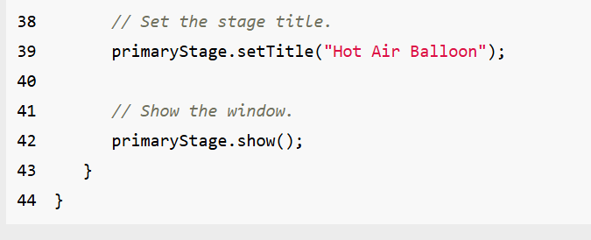

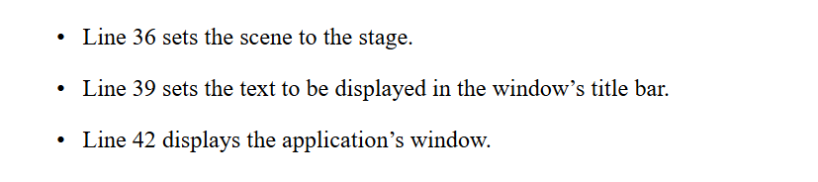

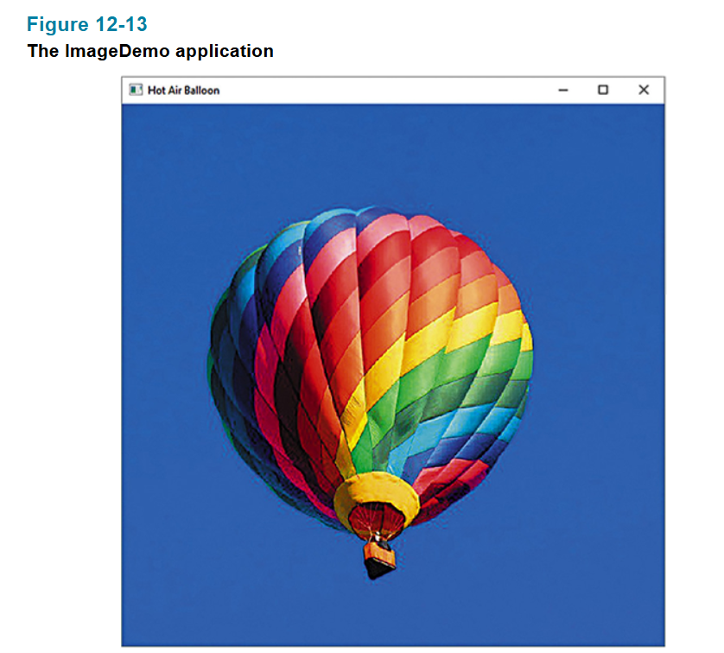

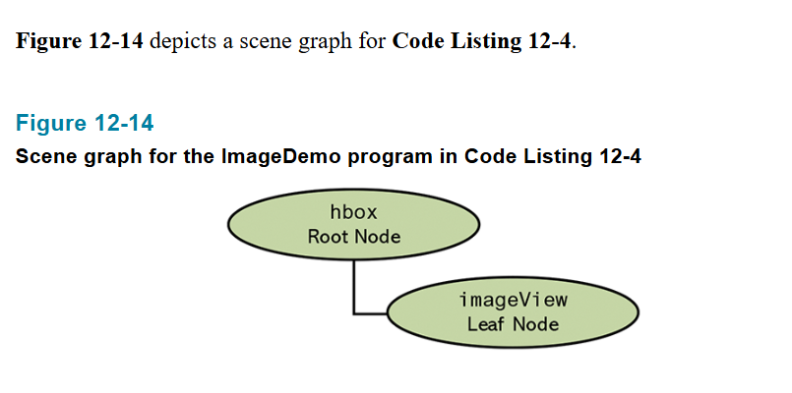

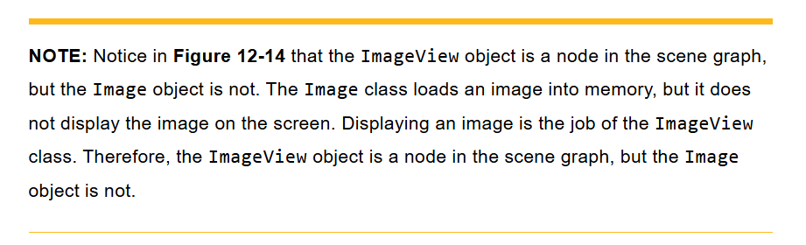

Ex:

package application;

import javafx.application.Application;

import javafx.stage.Stage;

import javafx.scene.Scene;

import javafx.scene.layout.HBox;

import javafx.scene.image.Image;

import javafx.scene.image.ImageView;

public class Main extends Application {

public static void main(String[] args) {

launch(args);

}

@Override

public void start(Stage primaryStage) {

Image image = new Image("file:wallpaper1.jpg");

ImageView imageView = new ImageView(image);

HBox hbox = new HBox(imageView);

Scene scene = new Scene(hbox,500,300);

primaryStage.setScene(scene);

primaryStage.setTitle("GUI Program");

primaryStage.show();

}

}

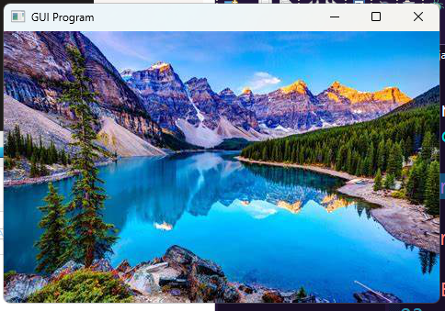

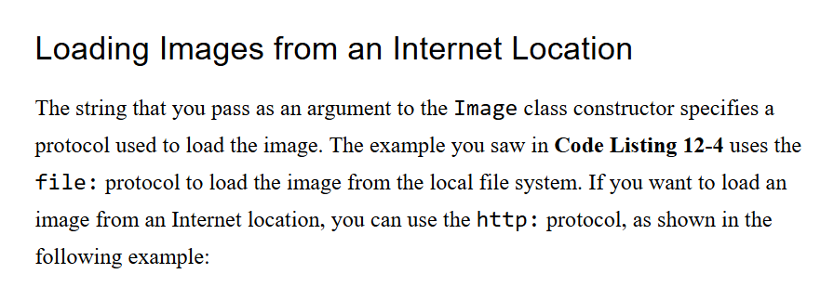



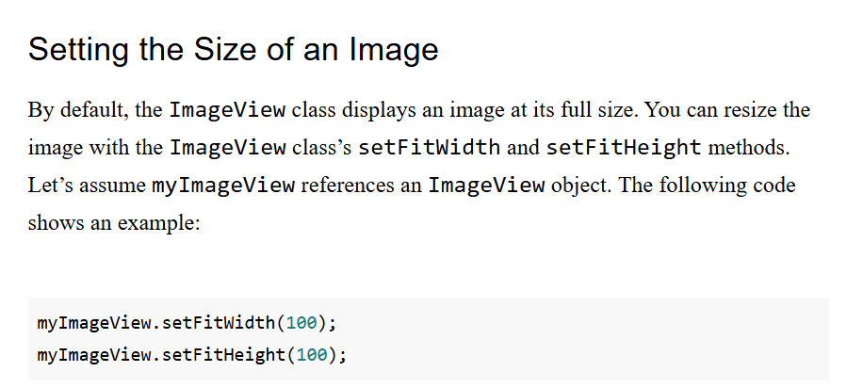

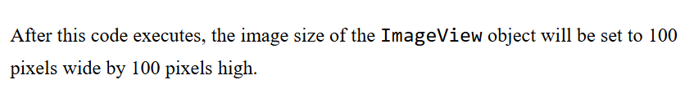

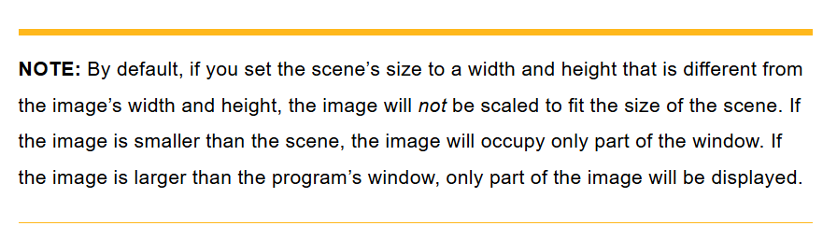

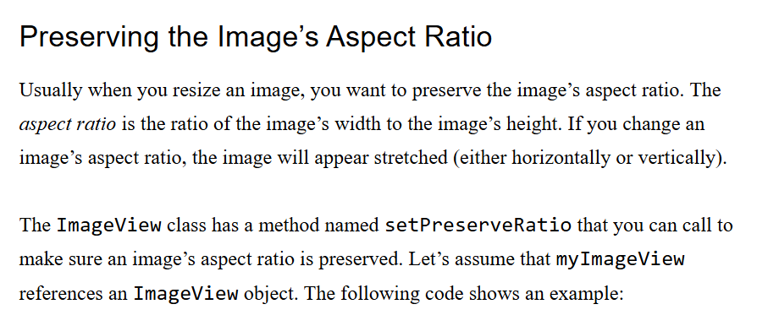

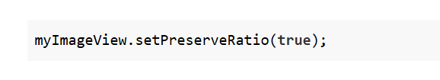

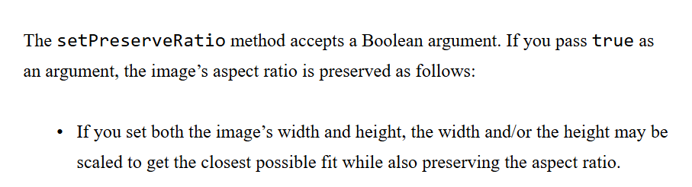

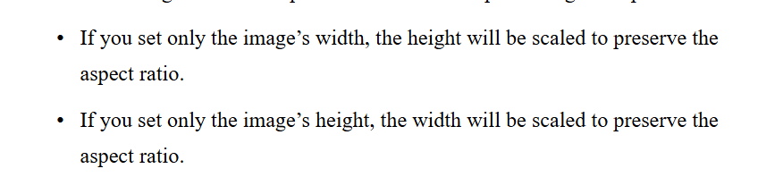

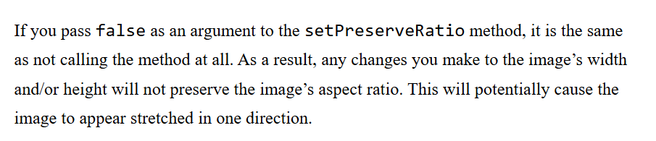

Ex:

package application;

import javafx.application.Application;

import javafx.stage.Stage;

import javafx.scene.Scene;

import javafx.scene.layout.HBox;

import javafx.scene.image.Image;

import javafx.scene.image.ImageView;

public class Main extends Application {

public static void main(String[] args) {

launch(args);

}

@Override

public void start(Stage primaryStage) {

Image image = new Image("file:C:\\Users\\0005766060\\eclipse-workspace\\JavaFXProject\\wallpaper1.jpg");

ImageView imageView = new ImageView(image);

imageView.setFitWidth(1000);

imageView.setFitHeight(700);

imageView.setPreserveRatio(true);

HBox hbox = new HBox(imageView);

Scene scene = new Scene(hbox);

primaryStage.setScene(scene);

primaryStage.setTitle("GUI Program");

primaryStage.show();

}

}

