Sources:

CISC190 Java Programming

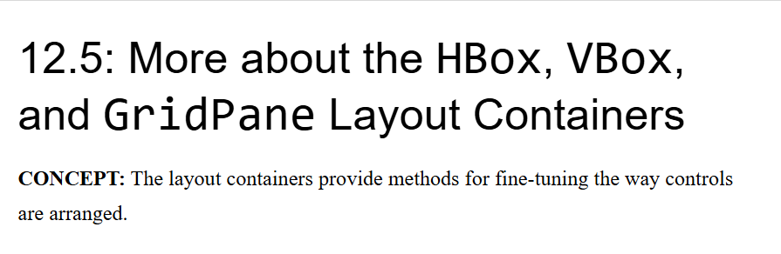

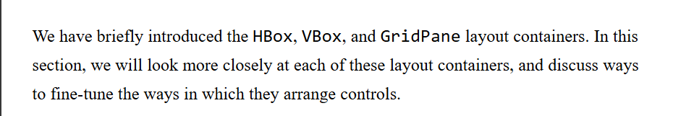





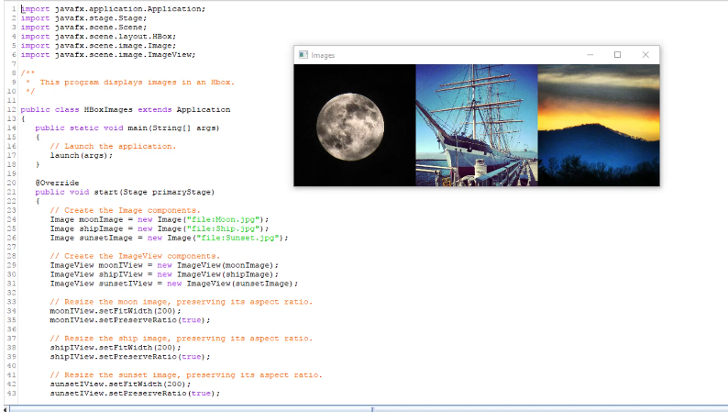

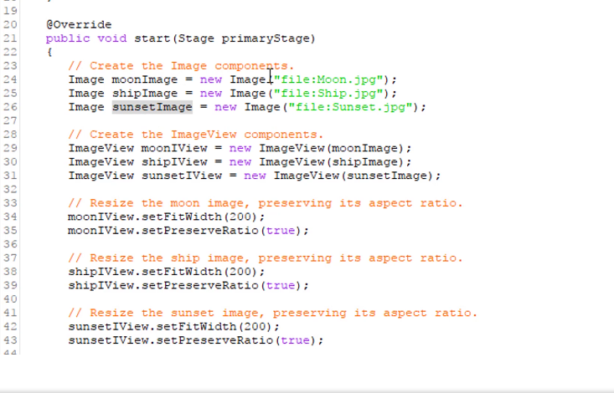

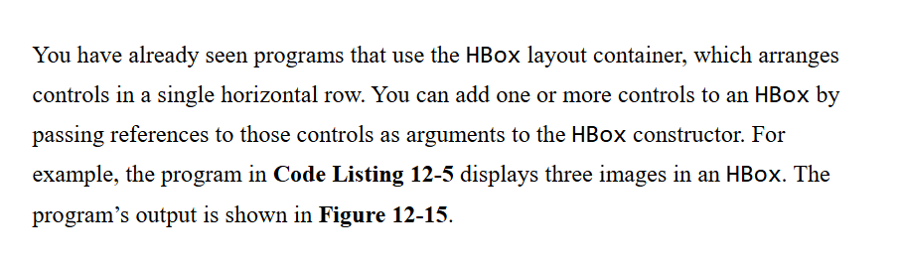

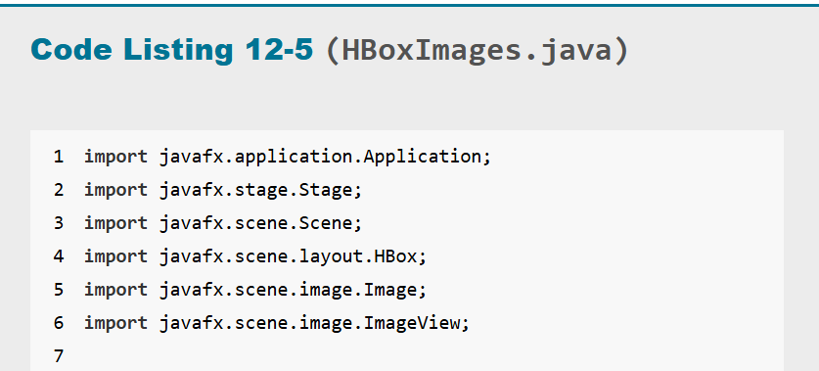



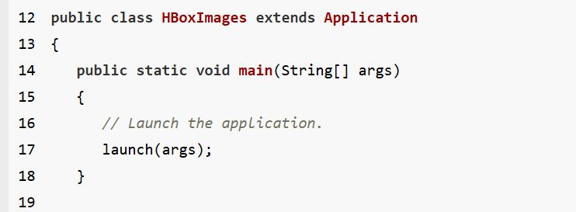



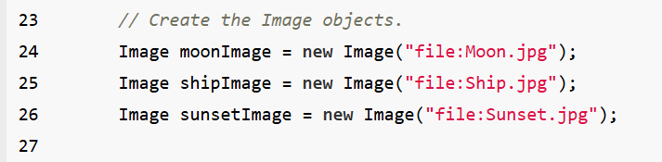

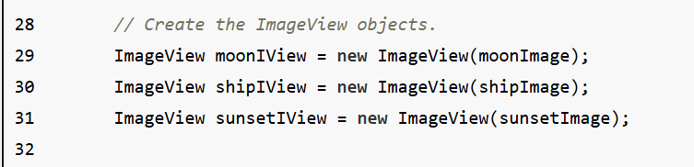

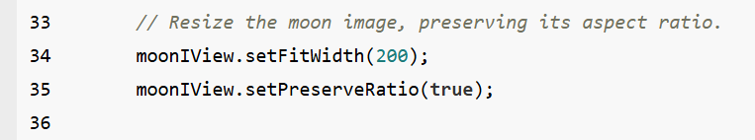

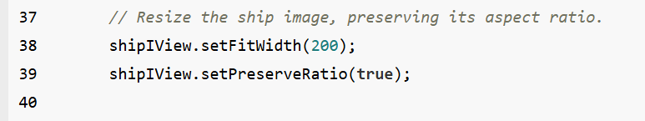

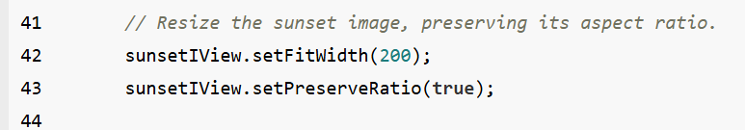

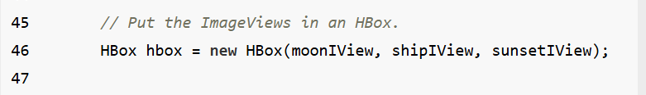

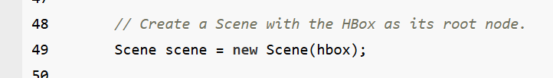

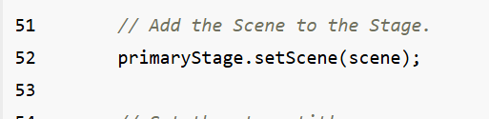



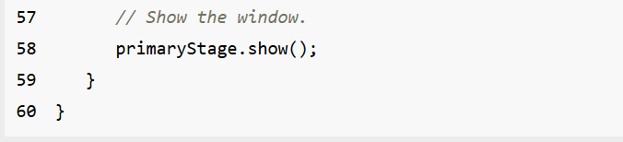

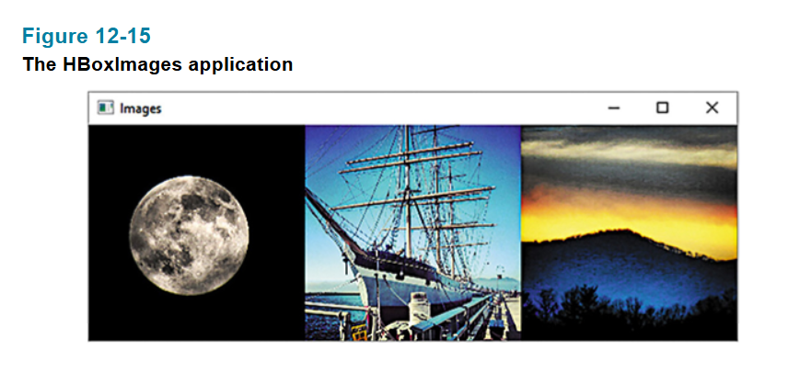

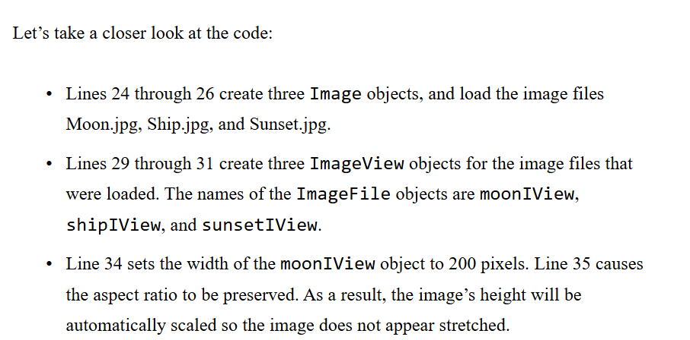

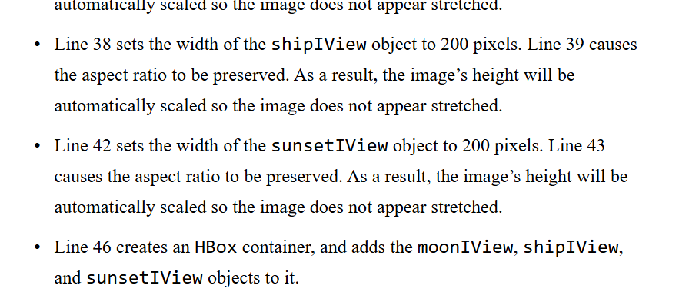

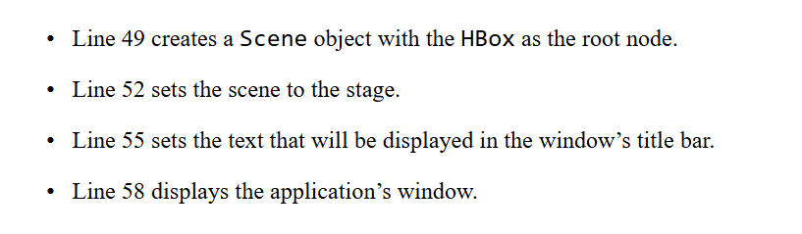

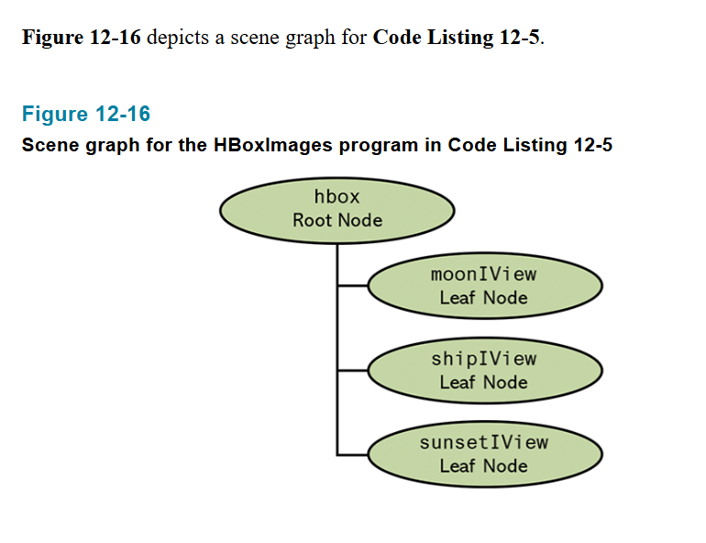

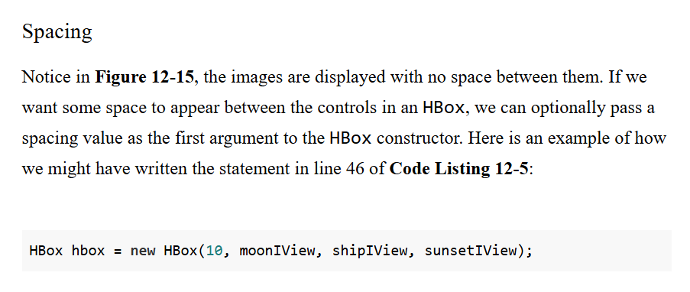

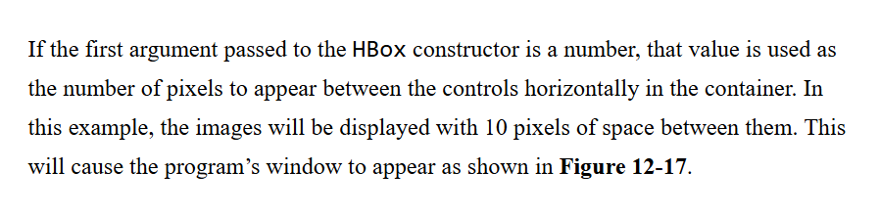

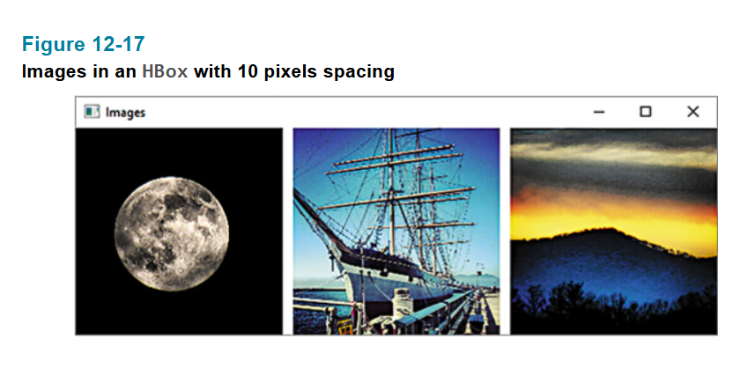

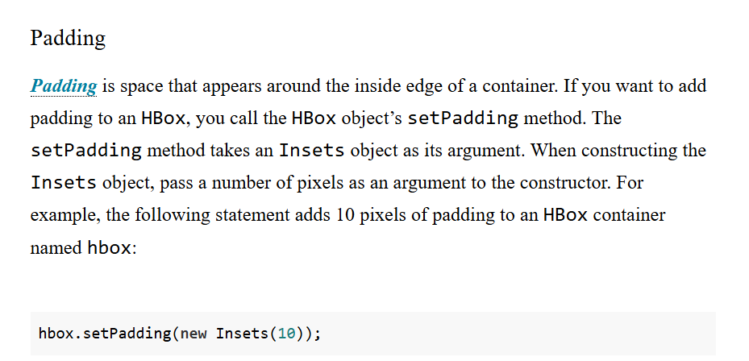

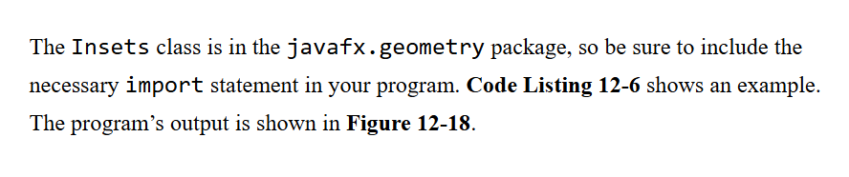

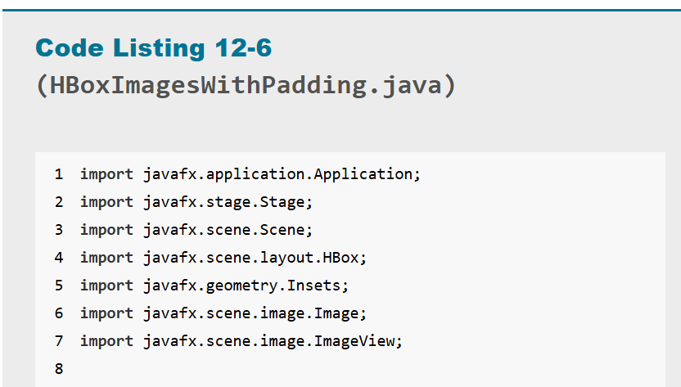

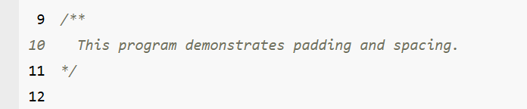

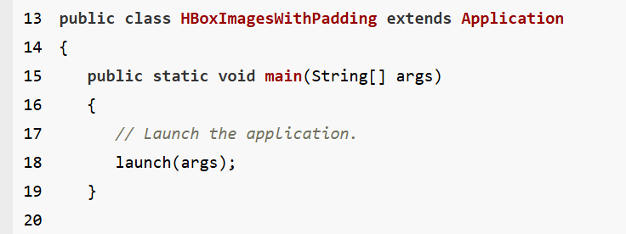

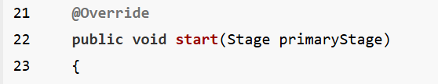

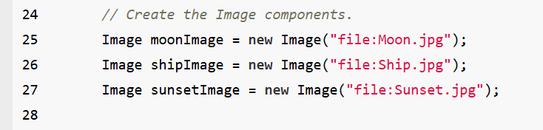

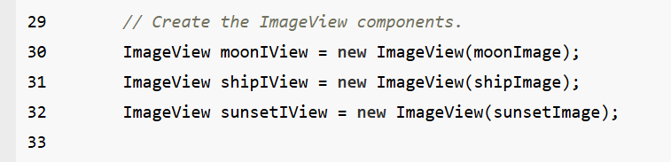

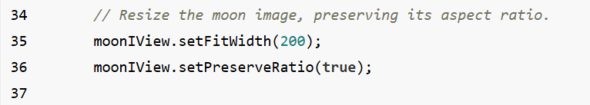

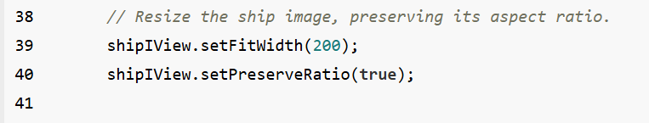

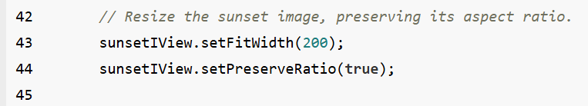

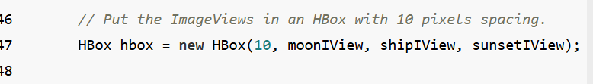





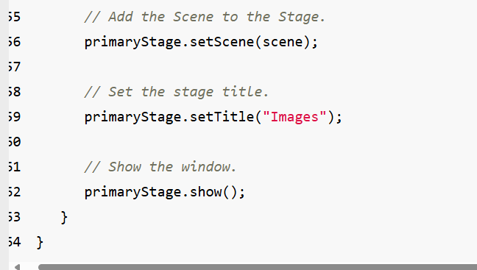

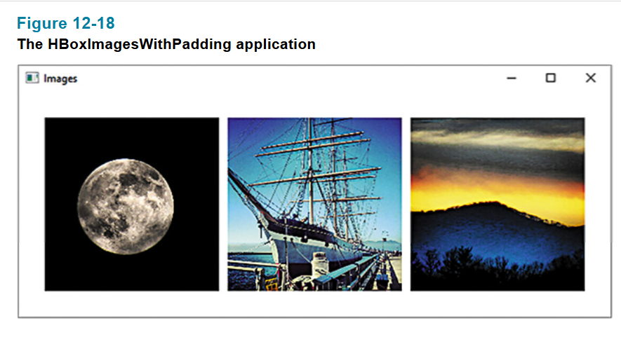

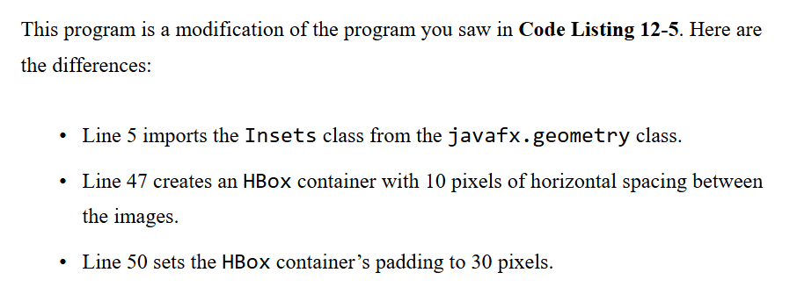

Ex:

package application;

import javafx.application.Application;

import javafx.stage.Stage;

import javafx.scene.Scene;

import javafx.scene.layout.HBox;

import javafx.scene.image.Image;

import javafx.scene.image.ImageView;

import javafx.geometry.Insets;

public class Main extends Application {

public static void main(String[] args) {

launch(args);

}

@Override

public void start(Stage primaryStage) {

Image image = new Image("file:C:\\Users\\0005766060\\eclipse-workspace\\JavaFXProject\\wallpaper1.jpg");

Image image2 = new Image("file:C:\\Users\\0005766060\\eclipse-workspace\\JavaFXProject\\wallpaper2.jpg");

Image image3 = new Image("file:C:\\Users\\0005766060\\eclipse-workspace\\JavaFXProject\\wallpaper3.jpg");

ImageView imageView = new ImageView(image);

ImageView imageView2 = new ImageView(image2);

ImageView imageView3 = new ImageView(image3);

imageView.setFitWidth(500);

imageView.setFitHeight(500);

imageView.setPreserveRatio(true);

imageView2.setFitWidth(500);

imageView2.setFitHeight(500);

imageView2.setPreserveRatio(true);

imageView3.setFitWidth(500);

imageView3.setFitHeight(500);

imageView3.setPreserveRatio(true);

HBox hbox = new HBox(10,imageView,imageView2,imageView3);

hbox.setPadding(new Insets(50));

Scene scene = new Scene(hbox);

primaryStage.setScene(scene);

primaryStage.setTitle("GUI Program");

primaryStage.show();

}

}

