Sources:

CISC190 Java Programming

MS Bing Chat Copilot

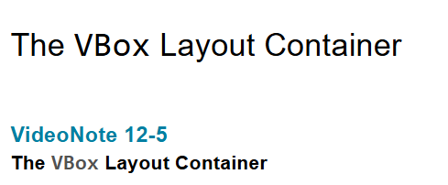

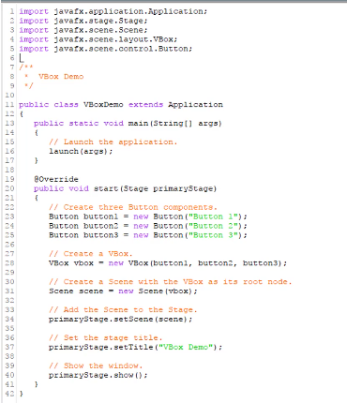

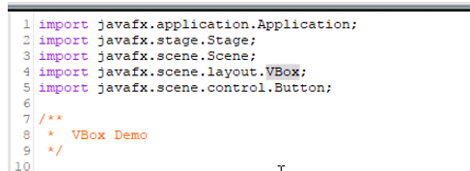

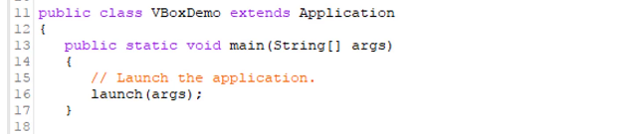

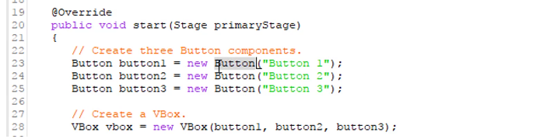

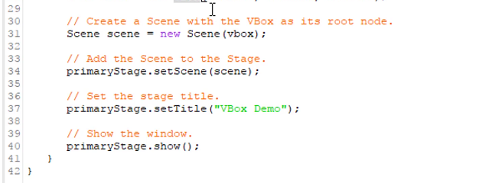

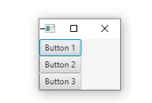

Ex:

package application;

import javafx.application.Application;

import javafx.stage.Stage;

import javafx.scene.Scene;

import javafx.scene.layout.HBox;

import javafx.scene.layout.VBox;

import javafx.scene.image.Image;

import javafx.scene.image.ImageView;

import javafx.geometry.Insets;

import javafx.geometry.Pos;

import javafx.scene.control.Button;

public class Main extends Application {

public static void main(String[] args) {

launch(args);

}

@Override

public void start(Stage primaryStage) {

Button button1 = new Button("🏠 HOME");

Button button2 = new Button("≡ Menu");

Image image = new Image("file:C:\\Users\\0005766060\\eclipse-workspace\\JavaFXProject\\wallpaper1.jpg");

Image image2 = new Image("file:C:\\Users\\0005766060\\eclipse-workspace\\JavaFXProject\\wallpaper2.jpg");

Image image3 = new Image("file:C:\\Users\\0005766060\\eclipse-workspace\\JavaFXProject\\wallpaper3.jpg");

ImageView imageView = new ImageView(image);

ImageView imageView2 = new ImageView(image2);

ImageView imageView3 = new ImageView(image3);

imageView.setFitWidth(500);

imageView.setFitHeight(500);

imageView.setPreserveRatio(true);

imageView2.setFitWidth(500);

imageView2.setFitHeight(500);

imageView2.setPreserveRatio(true);

imageView3.setFitWidth(500);

imageView3.setFitHeight(500);

imageView3.setPreserveRatio(true);

VBox vbox = new VBox(10,button1, button2);

vbox.setPadding(new Insets(30));

HBox hbox = new HBox(10,vbox,imageView,imageView2,imageView3);

hbox.setPadding(new Insets(50));

Scene scene = new Scene(hbox);

primaryStage.setScene(scene);

primaryStage.setTitle("GUI Program");

primaryStage.show();

}

}

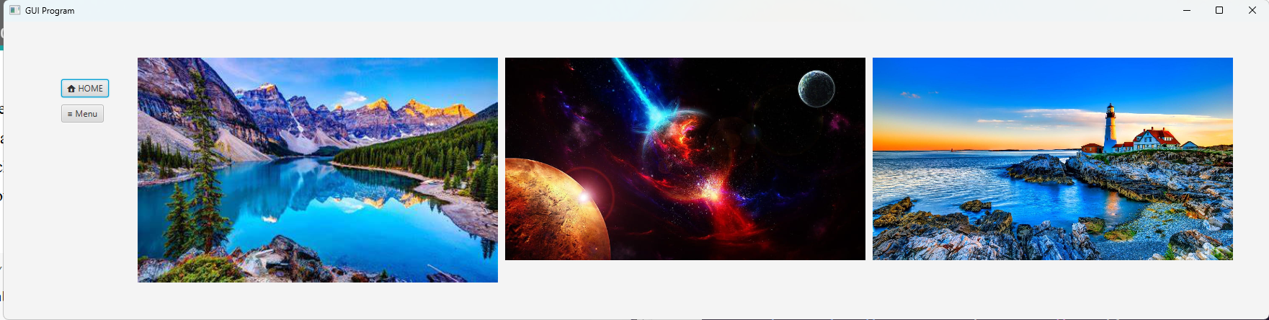

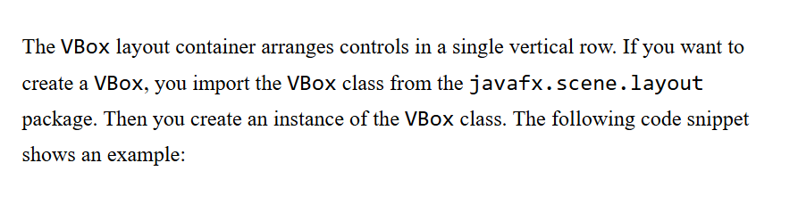

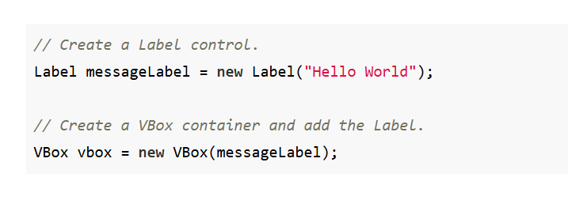

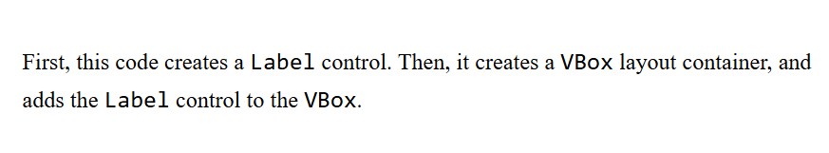

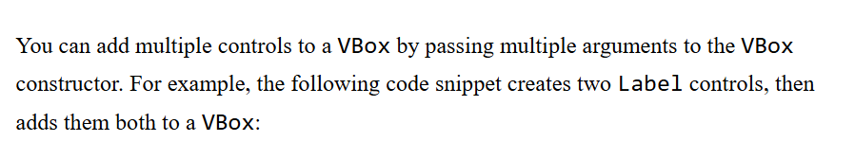

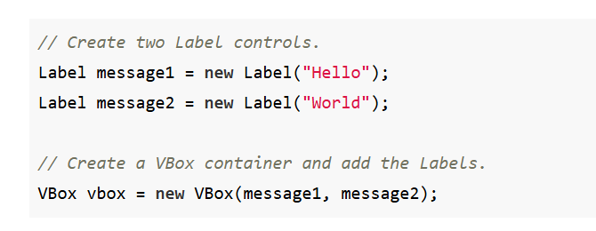

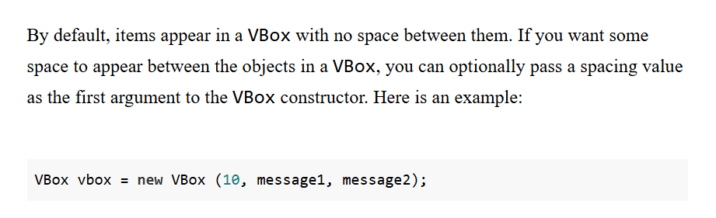

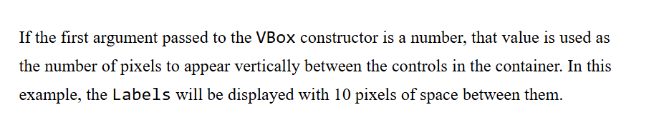

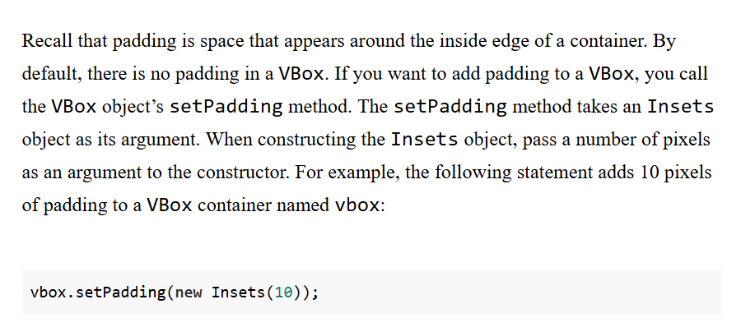

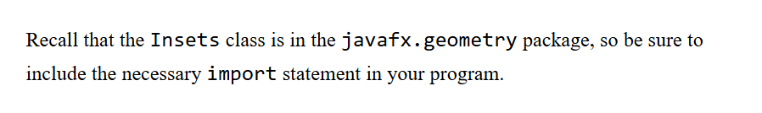

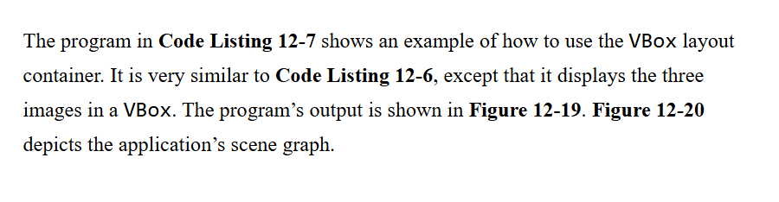

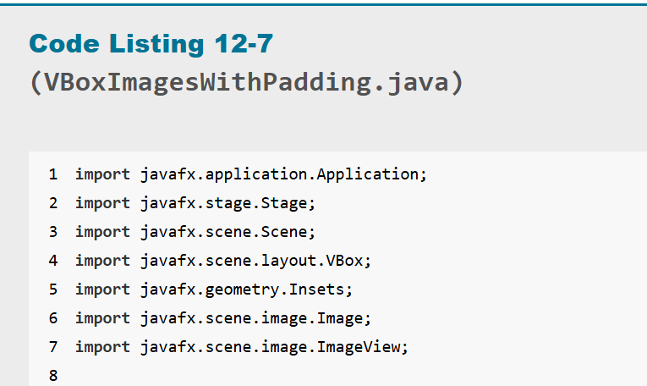

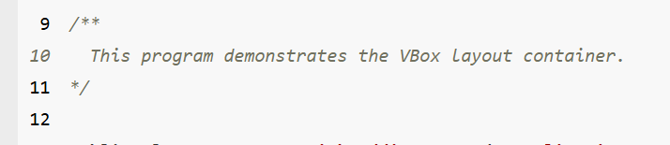

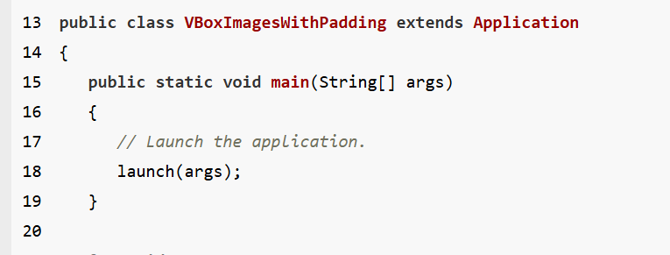

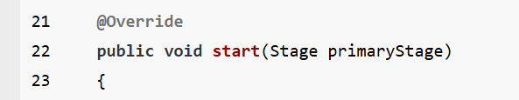

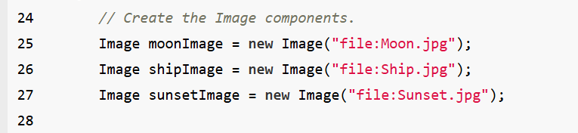

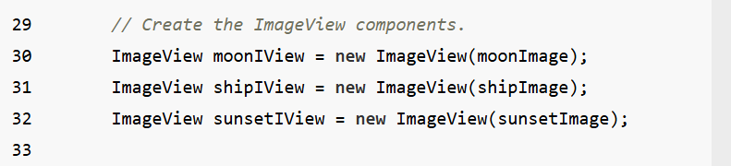

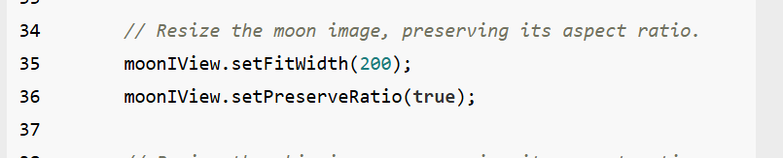

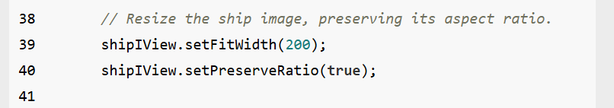

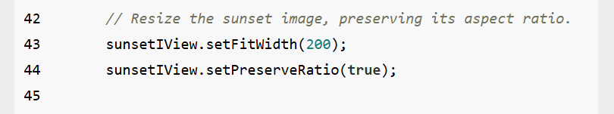\

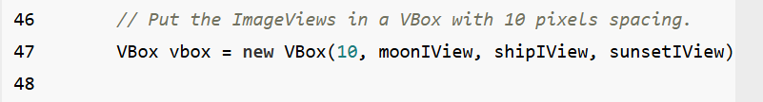

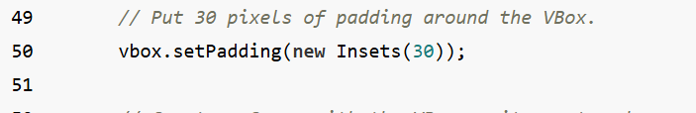

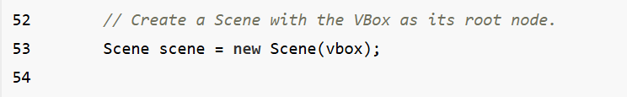

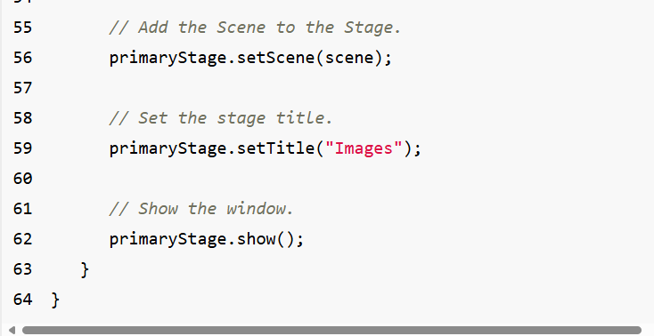



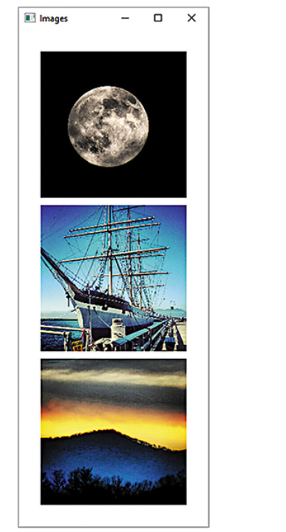

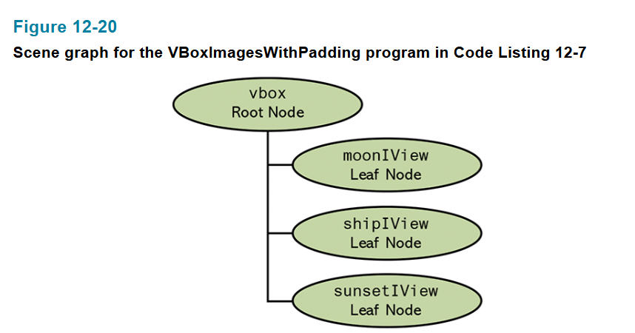

In some cases, you may want to adjust the width and height of VBox that contains too many tools to fit the size of your device’s screen.

**To solve this problem, you can write some code the adjust the size of your VBox, then put it into ScrollPane control so that you can use a vertical or horizontal scroll bar to scroll up and down or left and down to see contents inside your VBox**

**import javafx.application.Application;**

**import javafx.scene.Scene;**

**import javafx.scene.layout.VBox;**

**import javafx.stage.Stage;**

**public class VBoxExample extends Application {**

**@Override**

**public void start(Stage stage) {**

**// Create a VBox**

**VBox vbox = new VBox();**

**// Adjust width and height**

**vbox.setPrefWidth(300); // Preferred width**

**vbox.setPrefHeight(200); // Preferred height**

**// Optional: Set minimum and maximum dimensions**

**vbox.setMinWidth(200);**

**vbox.setMinHeight(150);**

**vbox.setMaxWidth(400);**

**vbox.setMaxHeight(300);**

**// Add VBox to the scene**

**Scene scene = new Scene(vbox, 500, 400);**

**stage.setScene(scene);**

**stage.setTitle("VBox Dimension Example");**

**stage.show();**

**}**

**public static void main(String[] args) {**

**launch();**

**}**

**}**

**Ex:**

**import javafx.application.Application;**

**import javafx.scene.Scene;**

**import javafx.scene.control.ScrollPane;**

**import javafx.scene.layout.VBox;**

**import javafx.scene.text.Text;**

**import javafx.stage.Stage;**

**public class VBoxWithScrollPaneExample extends Application {**

**@Override**

**public void start(Stage stage) {**

**// Create a VBox and add some content**

**VBox vBox = new VBox();**

**for (int i = 1; i <= 20; i++) {**

**vBox.getChildren().add(new Text("Item " + i));**

**}**

**// Wrap the VBox in a ScrollPane**

**ScrollPane scrollPane = new ScrollPane(vBox);**

**// Set preferred size for the ScrollPane**

**scrollPane.setPrefWidth(300);**

**scrollPane.setPrefHeight(200);**

**// Optional: Configure scroll behavior**

**scrollPane.setFitToWidth(true); // Ensures content fits the width of the ScrollPane**

**scrollPane.setVbarPolicy(ScrollPane.ScrollBarPolicy.ALWAYS); // Always show vertical scrollbar**

**// Create the scene and display it**

**Scene scene = new Scene(scrollPane, 400, 300);**

**stage.setScene(scene);**

**stage.setTitle("VBox with ScrollPane Example");**

**stage.show();**

**}**

**public static void main(String[] args) {**

**launch();**

**}**

**}**

