Sources:

CISC190 Java Programming

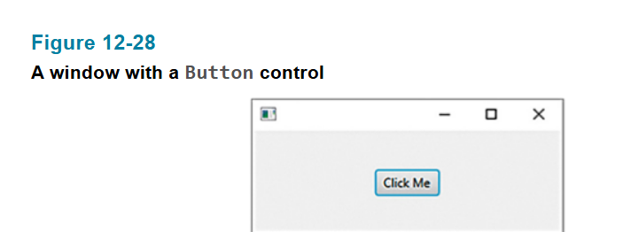

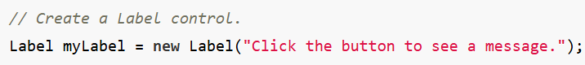

Ex:

**package** application;

**import** javafx.application.Application;

**import** javafx.stage.Stage;

**import** javafx.scene.Scene;

**import** javafx.scene.layout.HBox;

**import** javafx.scene.layout.VBox;

**import** javafx.scene.layout.GridPane;

**import** javafx.scene.control.Button;

**import** javafx.scene.control.Label;

**import** javafx.geometry.Pos;

**import** javafx.geometry.Insets;

**import** javafx.scene.image.Image;

**import** javafx.scene.image.ImageView;

**public** **class** **Main** **extends** Application {

**public** **static** **void** **main**(**String**[] args) {

***launch***(args);

}

**@Override**

**public** **void** **start**(**Stage** primaryStage) {

**Label** **label1** = **new** **Label**(**"Click this Button"**);

**Button** **button1** = **new** **Button**(**"Click Me!!!"**);

**VBox** **vbox** = **new** **VBox**(**10**, label1, button1);

vbox.**setAlignment**(Pos.**CENTER**);

vbox.**setPadding**(**new** **Insets**(**20**));

**Scene** **scene** = **new** **Scene**(vbox);

primaryStage.**setScene**(scene);

primaryStage.**setTitle**(**"GUI Program"**);

primaryStage.**show**();

}

}

