Sources:

CISC190 Java Programming

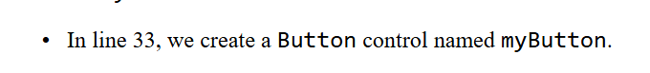

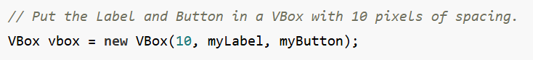

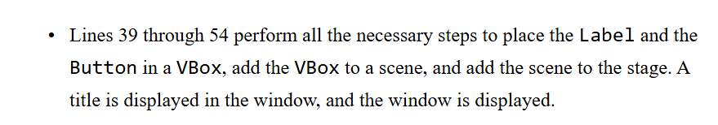

**package** application;

**import** javafx.application.Application;

**import** javafx.stage.Stage;

**import** javafx.scene.Scene;

**import** javafx.scene.layout.HBox;

**import** javafx.scene.layout.VBox;

**import** javafx.scene.layout.GridPane;

**import** javafx.scene.control.Button;

**import** javafx.scene.control.Label;

**import** javafx.geometry.Pos;

**import** javafx.geometry.Insets;

**import** javafx.event.EventHandler;

**import** javafx.event.ActionEvent;

**public** **class** **Main** **extends** Application {

**private** **Label** label1;

**public** **static** **void** **main**(**String**[] args) {

***launch***(args);

}

**@Override**

**public** **void** **start**(**Stage** primaryStage) {

label1 = **new** **Label**(**"Click this Button"**);

**Button** **button1** = **new** **Button**(**"Click Me!!!"**);

button1.**setOnAction**(**new** **ButtonClickHandler**());

**VBox** **vbox** = **new** **VBox**(**10**, label1, button1);

vbox.**setAlignment**(Pos.**CENTER**);

vbox.**setPadding**(**new** **Insets**(**20**));

**Scene** **scene** = **new** **Scene**(vbox);

primaryStage.**setScene**(scene);

primaryStage.**setTitle**(**"GUI Program"**);

primaryStage.**show**();

}

**class** **ButtonClickHandler** **implements** EventHandler<ActionEvent> {

**@Override**

**public** **void** **handle**(**ActionEvent** event) {

label1.**setText**(**"Thanks for clicking!!!"**);

}

}

}

Ex2:

**package** application;

**import** javafx.application.Application;

**import** javafx.stage.Stage;

**import** javafx.scene.Scene;

**import** javafx.scene.control.Label;

**import** javafx.scene.control.Button;

**import** javafx.scene.image.Image;

**import** javafx.scene.image.ImageView;

**import** javafx.scene.layout.HBox;

**import** javafx.scene.layout.VBox;

**import** javafx.scene.layout.GridPane;

**import** javafx.event.ActionEvent;

**import** javafx.event.EventHandler;

**public** **class** **Main** **extends** Application {

**public** **Label** label1;

**public** **Button** button1;

**public** **Button** button2;

**public** **Button** button3;

**public** **Button** button4;

**public** **Label** textField1;

**public** **Image** image1;

**public** **ImageView** imageView1;

**public** **Image** image2;

**public** **ImageView** imageView2;

**public** **Image** image3;

**public** **ImageView** imageView3;

**public** **HBox** hbox;

**public** **HBox** hbox2;

**public** **VBox** mainVBox;

**public** **Scene** scene;

**public** **static** **void** **main**(**String**[] args) {

***launch***(args);

}

**@Override**

**public** **void** **start**(**Stage** primaryStage) {

primaryStage.**setTitle**(**"GUI Applicaiton"**);

label1 = **new** **Label**(**"Welcome"**);

button1 = **new** **Button**(**"🏠 HOME"**);

button2 = **new** **Button**(**"⏬ MENU"**);

button3 = **new** **Button**(**"! ABOUT"**);

button4 = **new** **Button**(**"? HELP"**);

textField1 = **new** **Label**(**""**);

button3.**setOnAction**(**new** **ButtonClickHandler**());

image1 = **new** **Image**(**"file:wallpaper1.jpg"**);

imageView1 = **new** **ImageView**(image1);

imageView1.**setPreserveRatio**(**true**);

imageView1.**setFitWidth**(**300**);

imageView1.**setFitHeight**(**300**);

image2 = **new** **Image**(**"file:wallpaper2.jpg"**);

imageView2 = **new** **ImageView**(image2);

imageView2.**setPreserveRatio**(**true**);

imageView2.**setFitWidth**(**300**);

imageView2.**setFitHeight**(**300**);

image3 = **new** **Image**(**"file:wallpaper3.jpg"**);

imageView3 = **new** **ImageView**(image3);

imageView3.**setPreserveRatio**(**true**);

imageView3.**setFitWidth**(**300**);

imageView3.**setFitHeight**(**300**);

hbox = **new** **HBox**(**10**, button1, button2, button3, button4, textField1);

hbox2= **new** **HBox**(**10**,imageView1, imageView2, imageView3);

mainVBox= **new** **VBox**(**10**,hbox, hbox2);

scene = **new** **Scene**(mainVBox);

primaryStage.**setScene**(scene);

primaryStage.**show**();

}

**class** **ButtonClickHandler** **implements** EventHandler<ActionEvent>{

**@Override**

**public** **void** **handle**(**ActionEvent** event) {

textField1.**setText**(**"This is Testing App"**);

}

}

}

