Sources:

CISC190 Java Programming

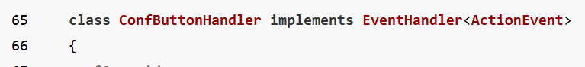

**package** application;

**import** javafx.application.Application;

**import** javafx.stage.Stage;

**import** javafx.scene.Scene;

**import** javafx.scene.layout.HBox;

**import** javafx.scene.layout.VBox;

**import** javafx.scene.layout.GridPane;

**import** javafx.scene.control.Button;

**import** javafx.scene.control.ButtonType;

**import** javafx.scene.control.Label;

**import** javafx.scene.control.TextField;

**import** javafx.scene.control.Alert;

**import** javafx.scene.control.Alert.AlertType;

**import** javafx.geometry.Pos;

**import** javafx.geometry.Insets;

**import** javafx.event.EventHandler;

**import** javafx.event.ActionEvent;

**import** java.util.Optional;

**public** **class** **Main** **extends** Application {

**private** **Label** userInputLabel;

**private** **TextField** textField1;

**public** **static** **void** **main**(**String**[] args) {

***launch***(args);

}

**@Override**

**public** **void** **start**(**Stage** primaryStage) {

**Label** **label1** = **new** **Label**(**"Click this Button"**);

textField1 = **new** **TextField**();

**Button** **button1** = **new** **Button**(**"Click Me!!!"**);

userInputLabel = **new** **Label**(**"Result: "**);

button1.**setOnAction**(**new** **ButtonClickHandler**());

**VBox** **vbox** = **new** **VBox**(**20**, label1, textField1, button1, userInputLabel);

vbox.**setAlignment**(Pos.**CENTER**);

vbox.**setPadding**(**new** **Insets**(**40**));

**Scene** **scene** = **new** **Scene**(vbox);

primaryStage.**setScene**(scene);

primaryStage.**setTitle**(**"GUI Program"**);

primaryStage.**show**();

}

**class** **ButtonClickHandler** **implements** EventHandler<ActionEvent> {

**@Override**

**public** **void** **handle**(**ActionEvent** event) {

**String** **info** = **"Result: "**+textField1.**getText**();

**Alert** **alert** = **new** **Alert**(AlertType.**INFORMATION**);

alert.**setContentText**(**"Is that all you want to say?"**);

**Optional**<ButtonType> **result** = alert.**showAndWait**();

**if**(result.**get**() == **ButtonType**.**OK**) {

userInputLabel.**setText**(info);

}**else** {

userInputLabel.**setText**(**"Result: "**);

}

}

}

}

If I click OK=>

