Sources:

CISC190 Java Programming

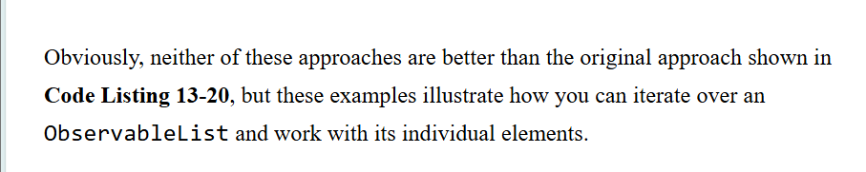

Ex:

package application;

import java.util.ArrayList;

import javafx.application.Application;

import javafx.stage.Stage;

import javafx.scene.Scene;

import javafx.scene.control.Label;

import javafx.scene.control.Button;

import javafx.scene.control.TextField;

import javafx.scene.image.Image;

import javafx.scene.image.ImageView;

import javafx.scene.control.ListView;

import javafx.scene.control.SelectionMode;

import javafx.collections.ObservableList;

import javafx.scene.layout.HBox;

import javafx.scene.layout.VBox;

import javafx.scene.layout.GridPane;

import javafx.scene.layout.BorderPane;

import javafx.scene.layout.StackPane;

import javafx.scene.layout.AnchorPane;

import javafx.geometry.Insets;

import javafx.geometry.Pos;

import javafx.event.ActionEvent;

import javafx.event.EventHandler;

public class Main extends Application {

public Label label1;

public Button button1;

public ListView<String> listView1;

public HBox hbox1;

public VBox vbox1;

public BorderPane borderPane1;

public Scene scene;

public static void main(String[] args) {

launch(args);

}

@Override

public void start(Stage primaryStage) {

primaryStage.setTitle("GUI Applicaiton");

listView1 = new ListView<String>();

listView1.getItems().addAll(

"1. Getting Started.",

"2. Issues with this app.",

"3. Contact.",

"4. Other issues.");

listView1.setPrefSize(150,150);

listView1.setId("listView1");

listView1.getSelectionModel().setSelectionMode(SelectionMode.MULTIPLE);

button1 = new Button("👉 Click Me!!!");

label1 = new Label("Result: ");

button1.setOnAction(event->{

ObservableList<String> selections =

listView1.getSelectionModel().getSelectedItems();

String selectionString = "";

for(int i=0; i<selections.size(); i++) {

selectionString+=selections.get(i)+", ";

}

label1.setText("Result: "+selectionString);

});

vbox1 = new VBox(10, listView1,button1, label1);

vbox1.getStyleClass().add("main_content1");

vbox1.setPadding(new Insets(10));

vbox1.setAlignment(Pos.CENTER);

borderPane1 = new BorderPane();

borderPane1.setCenter(vbox1);

scene = new Scene(borderPane1);

scene.getStylesheets().add("file:style1.css");

primaryStage.setScene(scene);

primaryStage.show();

}

}

